Campus Energy Saver
Student Energy Consumption & Saving Habits Study

1. SDG Alignment
SDG 7 – Affordable and Clean Energy
SDG 13 – Climate Action
2. Problem Statement
Students use electricity every day for laptops, lights, fans and other electronic devices. However, everyday habits such as leaving chargers connected, leaving lights or fans running, keeping devices in standby mode, and forgetting to switch devices off can contribute to unnecessary electricity consumption. This project investigates these habits among students and identifies simple, practical actions that can encourage more responsible electricity use.
3. Objectives
1. To understand students' everyday electricity-use habits.
2. To identify common behaviors that may lead to unnecessary electricity consumption.
3. To measure students' awareness of their personal electricity consumption.
4. To understand the main barriers to electricity-saving behavior.
5. To assess students' willingness to adopt energy-saving habits.
6. To propose simple and practical actions for reducing unnecessary electricity use.
4. Survey Methodology
1. Survey Method : Online questionnaire using Google Forms.
2. Number of Responses : 20 responses were collected.
3. Target Participants : Students and young learners.
4. Survey Focus : The survey focused on daily electricity-use habits, energy-saving practices, awareness of electricity consumption, barriers to saving electricity, and willingness to change habits.
5. Survey Duration : The questionnaire was designed to take approximately 2–3 minutes to complete.
5. Survey Results
5.1 Respondent Profile
A total of 20 responses were collected through the online survey. The respondents included undergraduate students, postgraduate students, and one graduated respondent.
Student Status | Number of Responses | Percentage
Undergraduate student |  | 50%
  10
Postgraduate student | 9 | 45%
Graduated | 1 | 5%
Total | 20 | 100%

5.2 Daily Laptop/Computer Usage
The survey examined how much time respondents spend using a laptop or computer each day. The results show that most respondents use these devices for several hours daily, making device energy-management practices an important area for energy conservation.
Daily Laptop/Computer Usage | Number of Responses | Percentage
Less than 2 hours | 5 | 25%
2–4 hours | 4 | 20%
4–6 hours | 8 | 40%
6–8 hours | 3 | 15%
More than 8 hours | 0 | 0%
Total | 20 | 100%

Key Finding:
55% of respondents reported using a laptop or computer for 4 hours or more per day, indicating that responsible device-energy management can be an important part of reducing unnecessary electricity consumption.
5.3 Laptop Charger Habits
The survey examined how frequently students leave their laptop chargers plugged in after their devices are fully charged. The responses show that students have different charging habits, with some respondents unplugging chargers regularly while others leave them connected more frequently.
Charger Habit | Number of Responses | Percentage
Never | 3 | 15%
Rarely | 6 | 15%
Sometimes | 6 | 30%
Often | 2 | 10%
Almost always | 3 | 15%
Total | 20 | 100%

Key Finding:
55% of respondents reported leaving their laptop charger plugged in at least sometimes after their device was fully charged. This indicates an opportunity to promote better charging and unplugging habits among students.
5.4 Lights Usage Habits
The survey asked respondents how often they leave lights switched on when leaving a room. The responses indicate that this behavior occurs among a considerable portion of respondents, showing an opportunity to encourage simple switch-off habits.

Lights Habit | Number of Responses | Percentage
Never | 3 | 15%
Rarely | 4 | 20%
Sometimes | 4 | 20%
Often | 3 | 15%
Almost always | 6 | 30%
Total | 20 | 100%

Key Finding:
65% of respondents reported leaving lights switched on when leaving a room at least sometimes. This highlights a simple behavioral opportunity for reducing unnecessary electricity consumption.
5.5 Fan Usage Habits
The survey also examined how often respondents leave fans running when nobody is using the room. The responses show that this behavior occurs at different frequencies among respondents and can be addressed through simple reminders and awareness.
Fan Habit | Number of Responses | Percentage
Never | 4 | 20%
Rarely | 6 | 30%
Sometimes | 6 | 30%
Often | 2 | 10%
Almost always | 2 | 10%
Total | 20 | 100%

Key Finding:
50% of respondents reported leaving fans running when nobody is using the room at least sometimes. This suggests that switch-off reminders could help reduce unnecessary electricity use.
5.6 Standby Device Habits
The survey examined how often respondents leave electronic devices in standby mode instead of switching them off completely. The responses indicate that standby usage is common among respondents, suggesting an opportunity to promote complete shutdown of devices when they are not in use.
Standby Habit | Number of Responses | Percentage
Never | 5 | 25%
Rarely | 4 | 20%
Sometimes | 3 | 15%
Often | 2 | 10%
Almost always | 6 | 30%
Total | 20 | 100%

Key Finding:
55% of respondents reported leaving electronic devices in standby mode at least sometimes. This indicates that encouraging students to completely switch off unused devices could help reduce unnecessary electricity consumption.
5.7 Power-Saving Features
The survey examined how frequently respondents use power-saving features such as Sleep Mode, Battery Saver, or Energy Saver on their devices. The results show that most respondents use these features to some extent, although the frequency of use varies among students.
Power-Saving Feature Usage | Number of Responses | Percentage
Always | 5 | 25%
Often | 3 | 15%
Sometimes | 8 | 40%
Rarely | 0 | 0%
Never | 4 | 20%
I don’t know how | 0 | 0%
Total | 20 | 100%

Key Finding:
80% of respondents reported using power-saving features at least sometimes. This shows that most students are already aware of device energy-saving features, but encouraging more consistent use could further improve energy-saving habits.

5.8 Electricity Consumption Awareness
The survey measured respondents’ awareness of their personal electricity consumption using a scale from 1 to 5, where 1 represents low awareness and 5 represents high awareness. The results show a moderate overall level of awareness among the respondents.
Awareness Score | Number of Responses | Percentage
1 | 3 | 15%
2 | 5 | 25%
3 | 5 | 25%
4 | 6 | 30%
5 | 1 | 5%
Total | 20 | 100%

Key Finding:
The average electricity-consumption awareness score was 3.1 out of 5, indicating a moderate level of awareness. While some respondents showed high awareness, the results suggest that additional awareness activities could help students better understand their individual electricity consumption.
5.9 Easiest Energy-Saving Action
The survey asked respondents to identify the easiest action they could take to reduce unnecessary electricity consumption. The responses show that simple actions such as switching off unused lights and fans and unplugging chargers were considered the most practical options.
Easiest Energy-Saving Action | Number of Responses | Percentage
Switch off unused lights/fans | 7 | 35%
Unplug chargers | 7 | 35%
Use laptop power-saving | 1 | 5%
Reduce unnecessary AC | 2 | 10%
Switch off computers/devices | 2 | 10%
Energy-efficient appliances | 1 | 5%
Total | 20 | 100%

Key Finding:
The most commonly selected actions were switching off unused lights and fans and unplugging chargers, with 35% of respondents selecting each option. This suggests that simple and easily understandable actions may be the most suitable starting point for encouraging energy-saving behavior among students.
5.10 Biggest Challenge
The survey asked respondents about the main challenges that may prevent them from consistently following electricity-saving habits. The responses show that daily habits and convenience are important barriers, while lack of awareness and information also affect energy-saving behavior.
Biggest Challenge | Number of Responses | Percentage
Forget to switch devices off | 4 | 20%
Not aware of consumption | 3 | 15%
Don’t think individual actions make much difference | 3 | 15%
Convenience/habit | 6 | 30%
Lack of information | 3 | 15%
Other | 1 | 5%
Total | 20 | 100%

Key Finding:
The most common challenge was convenience or habit, reported by 30% of respondents. Forgetting to switch devices off was another important challenge, reported by 20% of respondents. These findings suggest that reminders and simple habit-building strategies could help students maintain energy-saving practices more consistently.
5.11 Willingness to Change Energy-Saving Habits
The survey assessed respondents’ willingness to adopt better electricity-saving habits in their daily lives. The results indicate that most respondents are willing to make changes, although some respondents remain uncertain about changing their current habits.
Willingness to Change | Number of Responses | Percentage
Definitely yes | 8 | 40%
Probably yes | 6 | 30%
Not sure | 5 | 25%
Probably no | 1 | 5%
Definitely no | 0 | 0%
Total | 20 | 100%

Key Finding:
70% of respondents indicated that they would definitely or probably change their electricity-use habits. This shows a positive willingness among most respondents to adopt more responsible energy-saving practices.
6. Key Findings
The survey findings provide an overview of students’ electricity-use habits, awareness levels, and willingness to adopt energy-saving practices. The major findings from the 20 responses are summarized below.
1. Laptop/computer usage: 55% of respondents use a laptop or computer for 4 hours or more per day.
2. Charger habits: 55% of respondents leave their laptop charger plugged in at least sometimes after the device is fully charged.
3. Lights usage: 65% of respondents leave lights switched on when leaving a room at least sometimes.
4. Fan usage: 50% of respondents leave fans running when nobody is using the room at least sometimes.
5. Standby devices: 55% of respondents leave electronic devices in standby mode at least sometimes.
6. Energy-saving features: 80% of respondents use power-saving features at least sometimes, showing that most respondents have some awareness of energy-saving options.
7. Willingness to change: 70% of respondents are definitely or probably willing to change their electricity-use habits.
7. Proposed Solution
Based on the survey findings, the proposed solution is a simple student-focused energy awareness and habit-change framework. The aim is to encourage students to reduce unnecessary electricity consumption through practical reminders, awareness activities, and a simple daily energy-saving checklist. The solution does not require expensive technology and can be implemented within a college or campus environment.
7.1 Student Energy-Saving Checklist
1. Switch off lights when leaving a room.
2. Switch off fans when the room is not in use.
3. Unplug laptop chargers after charging is complete.
4. Completely switch off computers and electronic devices when they are not required.
5. Enable appropriate power-saving features such as Sleep Mode or Battery Saver.
7.2 Awareness and Reminder Activities
The proposed approach also includes simple awareness and reminder activities. Posters, digital messages, classroom announcements, and reminder stickers can be used to encourage students to switch off unused electrical devices. Short awareness campaigns can also explain how small daily actions can contribute to responsible electricity consumption.
7.3 Monitoring and Habit Improvement
The effectiveness of the proposed approach can be monitored through short follow-up surveys or periodic student feedback. Students can be encouraged to review their daily energy-saving checklist and identify which habits they have improved. Comparing responses before and after an awareness activity can help determine whether students’ awareness and energy-saving behavior have improved.
7.4 Expected Practical Approach
The proposed solution focuses on simple behavioral changes rather than costly infrastructure. By combining awareness, reminders, and regular self-checking, students can gradually develop more responsible electricity-use habits. The approach can also be adapted for classrooms, computer laboratories, libraries, hostels, and other campus areas.
8. Recommendations
Based on the survey findings, the following recommendations can help students and educational institutions encourage more responsible electricity-use habits.
1. Promote switch-off habits: Students should be encouraged to switch off lights and fans whenever they leave an unused room.
2. Encourage charger unplugging: Students should unplug laptop and mobile chargers after charging is complete instead of leaving them connected unnecessarily.
3. Use power-saving features: Students should regularly use Sleep Mode, Battery Saver, or other suitable energy-saving settings on their devices.
4. Reduce standby usage: Electronic devices should be completely switched off when they are not required for extended periods.
5. Use reminders: Simple posters, stickers, classroom notices, and digital reminders can help students remember energy-saving actions.
6. Conduct awareness activities: Colleges can organize short awareness campaigns or activities to explain responsible electricity consumption and its environmental importance.
7. Repeat surveys periodically: Similar surveys can be conducted at regular intervals to measure changes in students’ awareness and energy-saving habits.
9. Expected Impact
The proposed Campus Energy Saver approach is expected to improve students’ awareness of everyday electricity consumption and encourage practical energy-saving behavior. Since the recommended actions are simple and low-cost, they can be easily adopted in daily student life and campus environments.
1. Improved awareness: Students may develop a better understanding of how everyday actions affect electricity consumption.
2. Reduced unnecessary usage: Regular switch-off and unplugging habits can help reduce avoidable electricity use.
3. Better device management: Students can develop more responsible habits for using laptops, chargers, fans, lights, and other electronic devices.
4. Positive habit formation: Repeated reminders and self-checking can help turn energy-saving actions into regular habits.
5. Campus-level awareness: The approach can encourage wider participation in responsible energy use across classrooms, laboratories, libraries, hostels, and other campus areas.
6. Environmental contribution: More responsible electricity use can support broader efforts related to SDG 7 – Affordable and Clean Energy and SDG 13 – Climate Action.
10. Conclusion
The Campus Energy Saver study examined everyday electricity-use habits among 20 student respondents. The survey identified several areas where unnecessary electricity consumption may occur, including leaving lights and fans running, keeping chargers connected after charging, and leaving electronic devices in standby mode. The results also showed that students have a moderate level of awareness about their personal electricity consumption.
At the same time, the survey showed a positive willingness to adopt better energy-saving habits, with 70% of respondents indicating that they would definitely or probably change their current habits. Based on these findings, simple actions such as switch-off reminders, charger awareness, power-saving features, and student energy checklists can help encourage more responsible electricity use. The project supports the objectives of SDG 7 – Affordable and Clean Energy and SDG 13 – Climate Action by promoting practical awareness and behavioral change.
11. Survey Evidence
The survey evidence was collected through Google Forms and includes the response summary and charts generated from the 20 survey responses. These screenshots provide supporting evidence for the survey results presented in this report.
11.1 Google Forms Response Summary
The following screenshots show the Google Forms response summary used for analyzing the survey data.
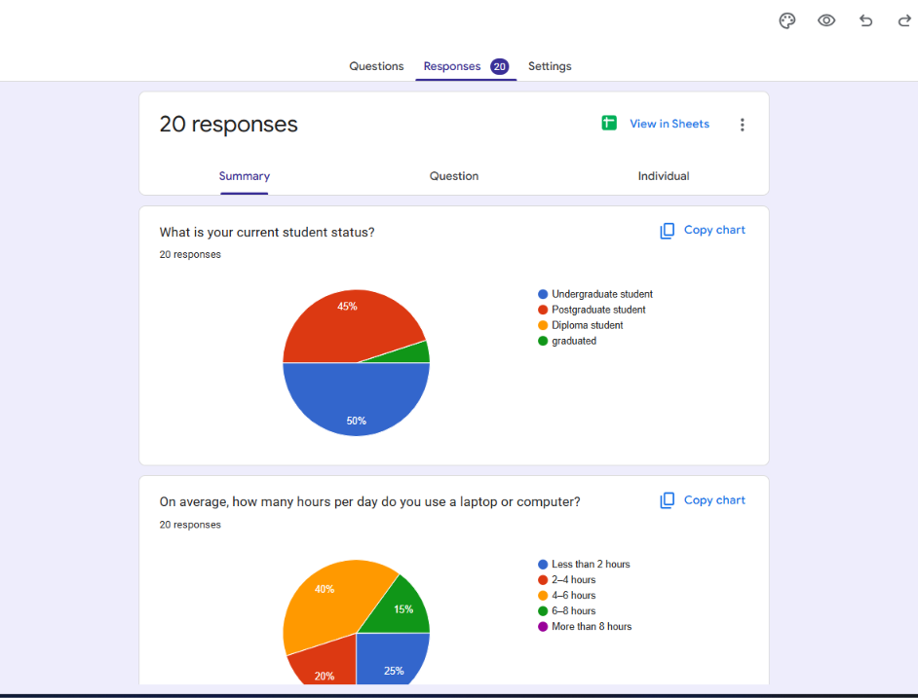
Figure 1: Google Forms response summary

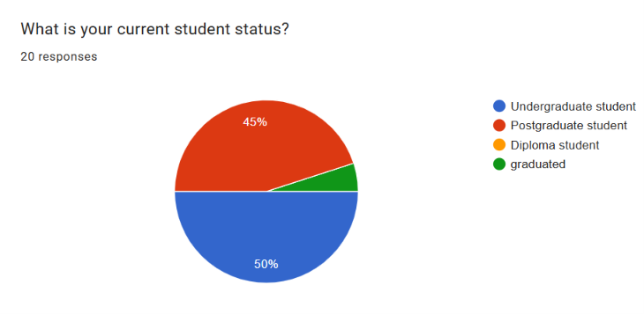
Figure 2: Distribution of respondents by student status

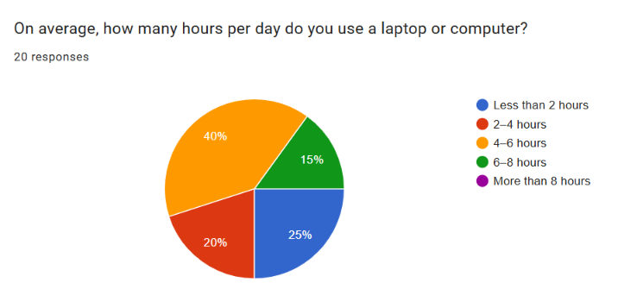
Figure 3: Daily laptop/computer usage among respondents
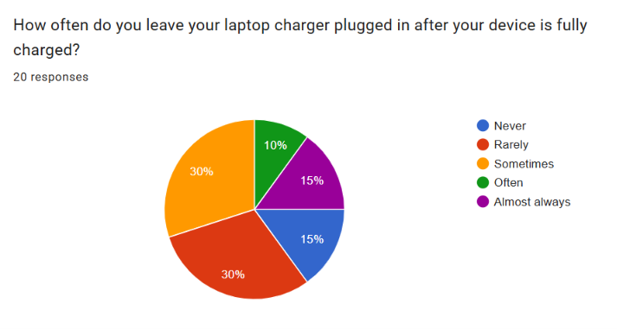
Figure 4: Laptop charger usage habits
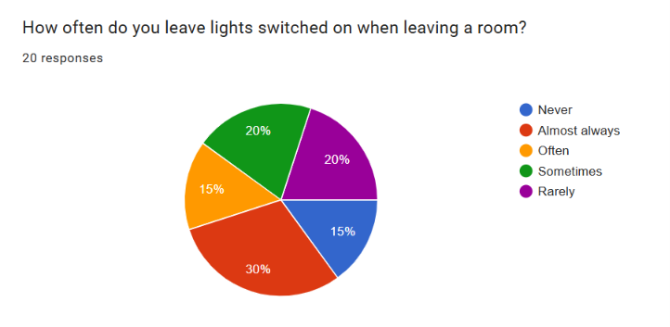
Figure 5: Lights and fan usage habits
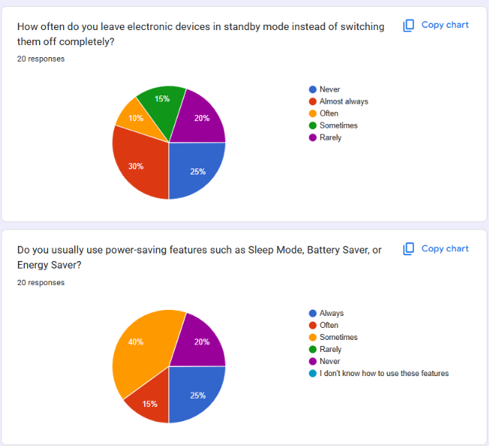
Figure 6: Standby device and power-saving feature usage
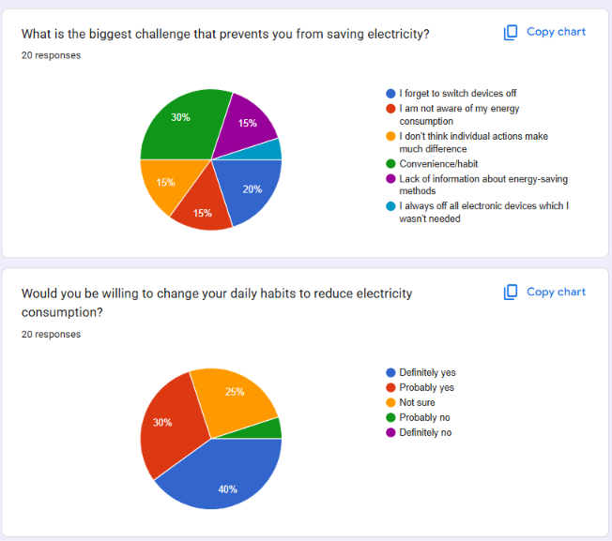
Figure 7: Electricity awareness, challenges, and willingness to adopt energy-saving habits

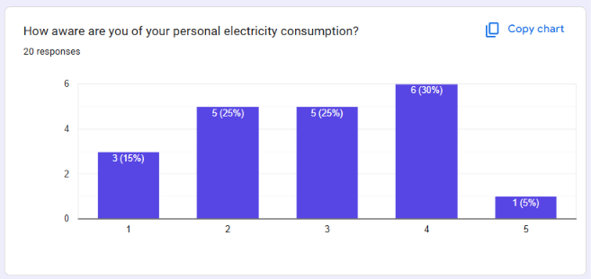
Figure 8: Respondents’ awareness of personal electricity consumption

