Retail Performance Report: Simple Analysis
Source: Retail Performance & Profitability Diagnostic Report (2023–2025)

1. Report Overview
This report is a diagnostic of retail sales and profit for 2023–2025, built from a Power BI dashboard. Its goal is to understand why sales fluctuate and why profit margins are shrinking.
Key KPIs:
Metric | Value | Meaning
Total Sales | $22.96K | Total revenue
Total Profit | $4.60K | Total earnings after costs
Quantity Sold | 528 | Units sold
Avg. Discount | 0.09 (9%) | Average discount given

Profit margin = 4.60 ÷ 22.96 ≈ 20%. In other words, roughly $20 of profit for every $100 of sales. Overall this is healthy, but as shown below, a few products pull the average down.
Note on the dashboard: The dashboard image in the original PDF (Figure 1.1) did not load, so the original visuals could not be extracted. The figures below are rebuilt from the numbers printed in the report and are not copies of the original Power BI visuals.
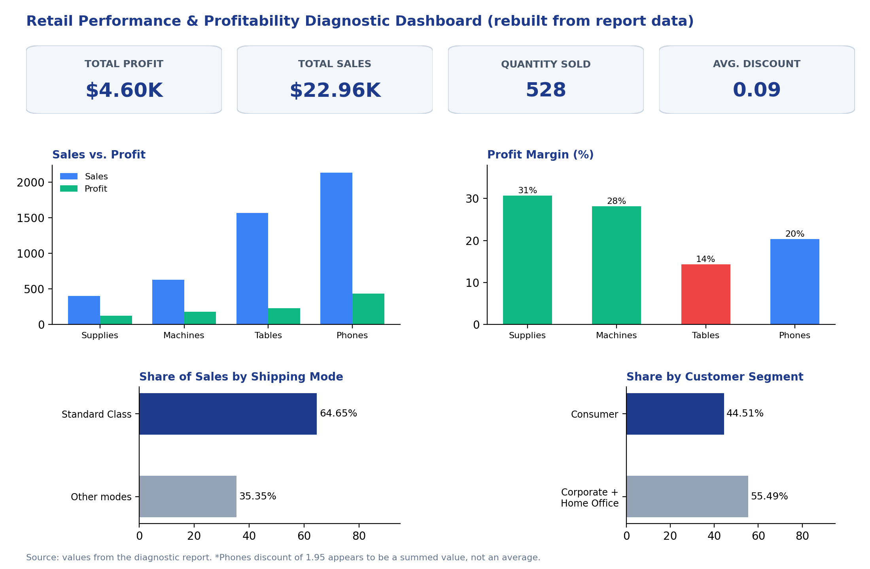
Figure 1: Dashboard-style overview rebuilt from the report's data

2. Biggest Problem: High Discounts, Low Profit
The report's core finding is that Phones have very high sales and volume, but also receive heavy discounts, so relatively little profit is left over.
Sub-category analysis (profit margin calculated by me):
Sub-Category | Sales | Profit | Profit Margin | Discount
Supplies | $400.63 | $122.86 | ~30.7% | 0.00
Machines | $625.13 | $175.98 | ~28.2% | 0.40
Tables | $1,569.35 | $224.32 | ~14.3% | 0.75
Phones | $2,135.39 | $434.56 | ~20.4% | 1.95 (?)

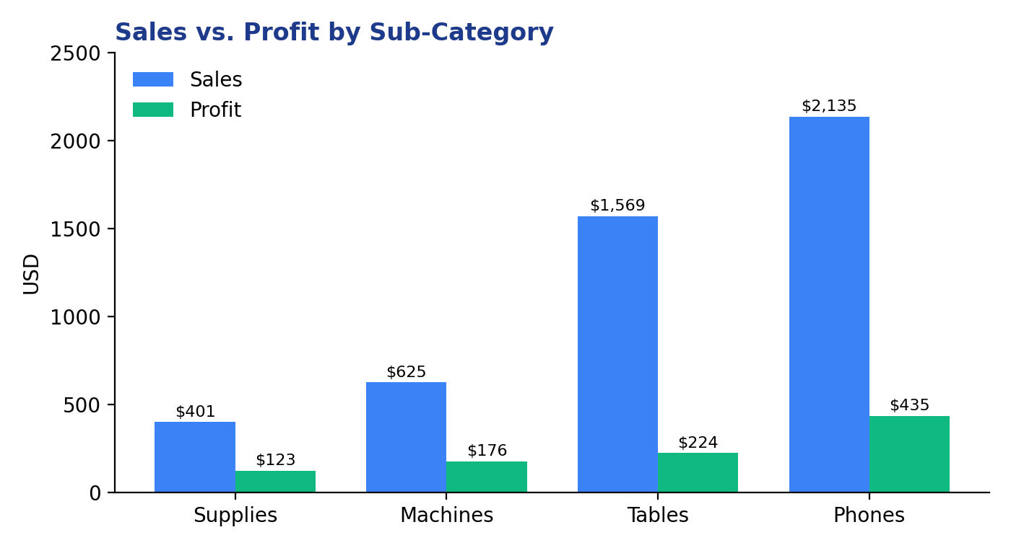
Figure 2: Sales vs. profit by sub-category
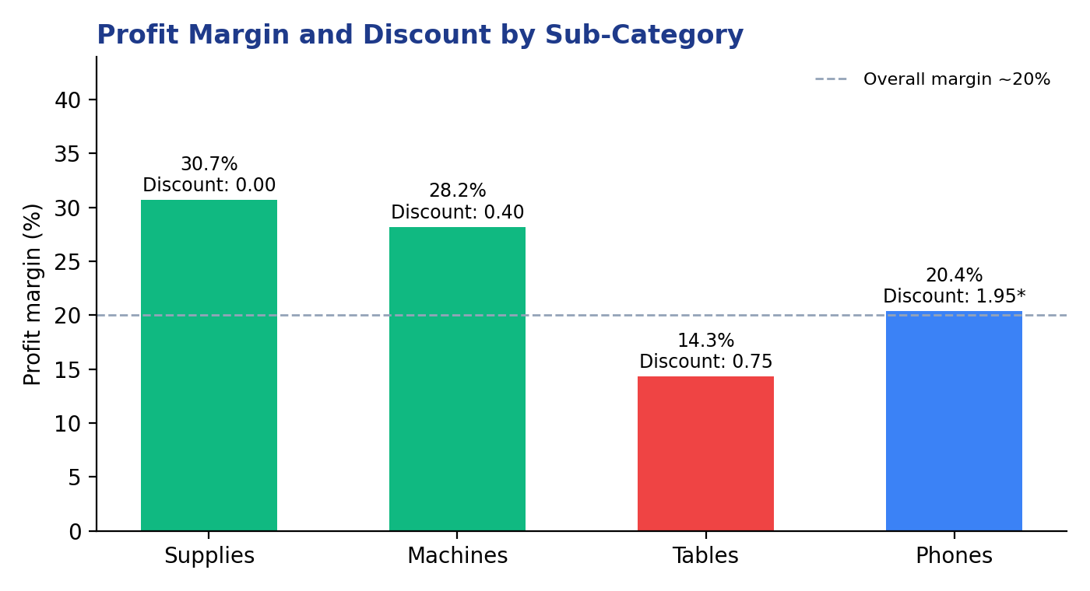
Figure 3: Profit margin and discount by sub-category (*1.95 likely a summed value)
What this tells us:
- Supplies has the best margin (~31%) with zero discount. It is the healthiest product line.
- Tables has the weakest margin (~14%). Sales are high ($1,569) but profit is only $224. Its discount is 0.75 (75%), which is very high.
- Phones generates the most sales ($2,135) and the most profit ($434), but the report says profit is "dangerously low" relative to top performers.
- Machines has a good margin (~28%) even with a 0.40 discount, so it earns well despite discounting.
Data caution: The report shows "1.95" as the discount figure next to Phones, but it appears outside the Phones row in the table. Discounts normally range from 0 to 1 (0%–100%), so 1.95 is most likely a sum of discounts rather than an average. Do not read it as a "195% discount". Please check in the dashboard whether it is a sum or an average.

3. Customer and Shipping Findings
- Customer segment: Consumer leads at ~44.51%, followed by Corporate and Home Office.
- Shipping mode: Standard Class accounts for 64.65% of sales, nearly two-thirds. The report says its logistics cost is lower.
- Geography: Profit depends on a few core states. The report names Texas as a high-yield zone.
Risk: If the business relies on a few segments, one shipping mode and a few states, a drop in any one of them could hurt the whole business.

4. Report Recommendations (in Plain Language)
- Discount control: Require approval for discounts above 15–20% so products like Phones do not lose margin.
- Focus on Standard Class: Plan inventory and marketing around this channel.
- Geographic reallocation: Move promotional budget away from weak states and into strong ones such as Texas.

5. Honest Assessment
What is good:
- The problem is clear (discount vs. profit).
- The recommendations are practical and actionable.
- The dashboard structure (KPIs top-left, slicers on the right) is well planned.
Gaps and points to watch:
- Small dataset: Total sales are only $22.96K across 528 units. Making big decisions from such a small sample is risky.
- Dashboard image missing: Figure 1.1 in the PDF is broken, so the original charts, trend lines and map could not be analyzed. The analysis uses only the text and tables.
- Only 4 sub-categories are shown, not the full breakdown.
- No trend data: The report covers 2023–2025 but gives no year-wise numbers, so the claimed "margin compression" is not evidenced in this document.
- Discount-profit correlation is not proven with numbers. Tables has the highest discount and lowest margin, which supports the idea, but Phones keeps a ~20% margin despite heavy discounting, so the relationship is not straightforward.
- The "15–20% threshold" is not explained; the report does not say what data it came from.

6. Next Steps
- Share the dashboard screenshot or .pbix file so the charts and trends can be properly analyzed.
- Review year-wise and state-wise data to confirm the margin compression.
- Compare profit across discount bands (0–10%, 10–20%, 20%+) to find the right discount limit.

