Final Report
Potential Habitability Parameter Analysis in Exoplanets
H-option: STAT 53100 Data Analysis
Tanisha Raskar

Index

- Purpose and Background 3
  - Habitability
  - Description
  - Data Transformation
- Exploratory Data Analysis 8
  - Univariate Analysis
  - Visual Exploratory Analysis
  - Planets Closest to Their Host Stars and to Earth
  - Correlation Analysis
  - Principal Component Analysis
  - EDA Summary
- Model Building 14
  - Linear Regression: Determinants of Planetary Temperature
  - Reduced Temperature Model
  - Candidate Counts Based on Temperature
  - Cluster Analysis
3.4.1 Cluster Distribution by Stellar Energy and Temperature
3.4.2 Planetary Mass - Radius Distribution by Cluster
  - Model Summary
- Summary of Conclusions 19
  - Conclusion
  - Cautions and Limitations
  - Answers to Research Questions
- Resources and Appendix 22

- Purpose and Background
"Two possibilities exist: either we are alone in the Universe or we are not. Both are equally terrifying" - British science fiction writer Arthur C. Clarke
Humans have long pondered whether life exists beyond Earth, and with the discovery of thousands of planets beyond our solar system, that question has moved from philosophy towards research. To date, despite the detection of thousands of exoplanets in our galaxy, no definitive evidence of extraterrestrial life has been found. However, astronomical observations reveal that many stars host planets in regions where conditions might permit life suggesting that worlds with Earth-like characteristics could exist in significant numbers. NASA’s exoplanet exploration programs emphasize that understanding the potential for life requires looking at specific environmental conditions that make life possible.
One such ongoing research is on the planet of Mars. Mars’ exploration missions have focused extensively on reconstructing the planet’s environmental history, seeking evidence of past water activity and assessing whether the planet may once have supported life. Although Mars is currently inhospitable, its study has demonstrated how planetary conditions can change over time and how subtle differences in environment can determine whether a planet remains livable (NASA, 2022). This same perspective motivates the study of exoplanets: by examining distant worlds with a range of environmental characteristics, researchers can better understand the conditions that allow planets to sustain life and how Earth fits within this broader planetary spectrum. NASA’s exoplanet exploration programs emphasize that identifying such conditions is essential not only for the search for life, but also for understanding planetary evolution and the long-term prospects of human exploration beyond Earth (NASA, 2023).
The goal of this project is to study observable characteristics of exoplanets and their host stars in order to evaluate how closely these environments resemble Earth. By using statistical analysis to compare planetary and stellar conditions across a large dataset, this research aims to identify patterns and indicators associated with potentially livable environments. The focus is on understanding how frequently Earth-like conditions occur and which factors most strongly differentiate planets that resemble Earth from those that do not.
This study is guided by the following research questions:
- How do key planetary and stellar characteristics vary across known exoplanets?
- Which observable conditions most closely resemble those found on Earth?
- Is there a possibility of liquid water on the planet surface?
- Can statistical comparisons help identify exoplanets that look into further scientific research?

  - Habitability
To address the research questions of this study, habitability is defined using observable, physically motivated criteria that reflect conditions required for the long-term presence of surface liquid water, the most widely accepted necessity for life. This analysis thus focuses on Earth-like planetary, orbital and stellar characteristics that are measurable and theoretically well-established.
Planetary Size and Composition: Earth-like habitability is most plausible on rocky planets rather than gas bodies. Recent analyses using Kepler and TESS data show that planets with radii larger than approximately 1.6 -2.0 Earth radii and planets exceeding ~10 Earth masses are likely to have thick atmosphere and evaporative substances alike gases, making Earth-like surface conditions unlikely for the extra-terrestrial beings (Rogers, 2015; Neil & Rogers, 2020). Thus, planetary radius and mass are used as primary indicators of Earth like structure.
Stellar Energy Input and Habitable Zone: The ability to sustain liquid water depends critically on stellar energy input. Modern habitable zone (HZ) models define this by using insolation flux, normalized to Earth. Updated climate models define conservative habitable zone limits between approximately 0.25- and 2.0-times Earth’s insolation, accounting for atmospheric greenhouse effects, cloud feedback and differences in stellar radiation (Kopparapu et al., 2013; Kopparapu et al., 2014; Kane et al., 2021). Equilibrium temperature is used as a supporting thermal measure, where values between 200–350 K are consistent with conditions that can sustain liquid water under a range of plausible atmospheric scenarios.
Orbital Stability and Climate Regulation: Orbital eccentricity affects climate stability by determining how evenly a planet receives energy from its star. Planets with highly elongated orbits undergo large temperature swings, which can disrupt the long-term presence of liquid water. Recent studies indicate that eccentricities below approximately 0.3 are more favorable for maintaining stable climates over geological timescales (Barnes et al., 2013; Laskar et al., 2019). Including eccentricity as a habitability criterion helps ensure that candidate planets receive relatively steady stellar energy, improving the reliability of habitability assessments.
Host Star Characteristics: Stellar properties play a vital role in shaping both the location and long-term stability of habitable environments. Sun-like and cooler stars tend to have stable luminosities over billions of years, providing sufficient time for planetary climate regulation and the potential development of life (Shields et al., 2016; NASA Exoplanet Exploration Program). Although stellar mass and effective temperature are not applied as strict selection thresholds, they are included to account for shifts in habitable zone location, especially for lower-mass M-dwarf stars where habitable zones occur at much smaller orbital distances.

  - Description
The dataset used in this study was obtained from the NASA Exoplanet Archive, which provides publicly available data on confirmed exoplanets and their host stars. Relevant variables were selected based on their relevance to planetary and stellar conditions commonly examined in exoplanet research. After preprocessing and variable selection, the resulting dataset, referred to as exodf, contains 5,788 observations and 47 variables, including 15 categorical and 32 numerical variables. The dataset includes information on planetary characteristics, orbital parameters, host star properties, and system-level attributes, offering a comprehensive foundation for statistical analysis and comparison across exoplanetary systems.
Following is the list of variables and their descriptions:
Variable Name | Type | Unit | Description
planet_name | Categorical | N/A | The official name or designation of the exoplanet.
host_star_name | Categorical | N/A | Name or catalog ID of the star the planet orbits.
planet_letter | Categorical | N/A | Letter assigned to the planet within its star system (b = first discovered).
num_stars_in_system | Numerical (Integer) | count | Number of stars in the planetary system.
num_planets_in_system | Numerical (Integer) | count | Number of confirmed planets in the same system.
is_circumbinary | Categorical (0/1) | N/A | Whether the planet orbits two stars instead of one (1 = yes).
discovery_method | Categorical | N/A | Technique used to detect the planet (e.g., Transit, Radial Velocity).
detected_by_transit | Categorical (0/1) | N/A | Indicates if the planet was discovered via the transit method.
detected_by_radial_velocity | Categorical (0/1) | N/A | Indicates if detected via stellar wobble (radial velocity).
is_controversial | Categorical (0/1) | N/A | Whether the planet’s existence is debated (1 = controversial).
orbital_period_days | Numerical | days | Time the planet takes to complete one orbit around its star (days).
orbit_semi_major_axis_au | Numerical | AU (astronomical units) | Average orbital distance from the star, in astronomical units (AU).
eccentricity | Numerical | dimensionless | Measure of orbital shape (0 = circular; closer to 1 = more elliptical).
inclination_deg | Numerical | degrees (°) | Tilt of the planet’s orbit relative to Earth’s line of sight (degrees).
insolation_flux_earth_flux | Numerical | Earth flux (relative) | Stellar energy received by the planet relative to Earth = 1 Earth flux.
equilibrium_temperature_k | Numerical | Kelvin (K) | Estimated surface temperature (Kelvin) assuming no atmosphere.
planet_radius_earth_radius | Numerical | Earth radii (R⊕) | Planet’s radius expressed in Earth radii.
planet_radius_upper_unc_earth_radius | Numerical | Earth radii (R⊕) | Upper uncertainty in Earth-radius measurement.
planet_radius_lower_unc_earth_radius | Numerical | Earth radii (R⊕) | Lower uncertainty in Earth-radius measurement.
planet_radius_earth_limit_flag | Categorical (0/1) | N/A | Indicates if the Earth-radius value is an upper/lower limit rather than a precise measure.
planet_radius_jupiter_radius | Numerical | Jupiter radii (R♃) | Planet’s radius in Jupiter radii (useful for large gas giants).
planet_radius_upper_unc_jupiter_radius | Numerical | Jupiter radii (R♃) | Upper uncertainty for radius in Jupiter radii.
planet_radius_lower_unc_jupiter_radius | Numerical | Jupiter radii (R♃) | Lower uncertainty for radius in Jupiter radii.
planet_radius_jupiter_limit_flag | Categorical (0/1) | N/A | Indicates if Jupiter-radius value is a limit rather than exact.
planet_mass_earth_mass | Numerical | Earth masses (M⊕) | Planet’s mass in Earth masses.
planet_mass_upper_unc_earth_mass | Numerical | Earth masses (M⊕) | Upper uncertainty in Earth-mass estimate.
planet_mass_lower_unc_earth_mass | Numerical | Earth masses (M⊕) | Lower uncertainty in Earth-mass estimate.
planet_mass_earth_limit_flag | Categorical (0/1) | N/A | Flag showing if Earth-mass value is a limit.
planet_mass_jupiter_mass | Numerical | Jupiter masses (M♃) | Planet’s mass in Jupiter masses.
planet_mass_upper_unc_jupiter_mass | Numerical | Jupiter masses (M♃) | Upper uncertainty for Jupiter-mass measurement.
planet_mass_lower_unc_jupiter_mass | Numerical | Jupiter masses (M♃) | Lower uncertainty for Jupiter-mass measurement.
planet_mass_jupiter_limit_flag | Categorical (0/1) | N/A | Flag for limited Jupiter-mass data.
planet_mass_provenance | Categorical | N/A | Source or method of the mass estimate (e.g., Msini = minimum mass from RV).
planet_density_gcm3 | Numerical | g/cm³ | Planet’s mean density in grams per cubic centimeter.
planet_density_upper_unc_gcm3 | Numerical | g/cm³ | Upper uncertainty of density measurement.
planet_density_lower_unc_gcm3 | Numerical | g/cm³ | Lower uncertainty of density measurement.
planet_density_limit_flag | Categorical (0/1) | N/A | Flag if density value represents a limit.
stellar_effective_temp_k | Numerical | Kelvin (K) | Star’s surface temperature in Kelvin (controls energy output).
stellar_radius_solar_radius | Numerical | Solar radii (R☉) | Star’s radius in solar radii.
stellar_mass_solar_mass | Numerical | Solar masses (M☉) | Star’s mass in solar masses.
stellar_luminosity_log_solar | Numerical | log₁₀(L/L☉) | Logarithm of star’s luminosity relative to Sun’s.
stellar_metallicity_dex | Numerical | dex ([Fe/H]) | Star’s heavy-element abundance relative to Sun (higher = more metals).
stellar_age_gyr | Numerical | Gyr (billion years) | Age of the star in billion years (Gyr).
stellar_density_gcm3 | Numerical | g/cm³ | Mean stellar density in grams per cubic centimeter.
distance_pc | Numerical | parsecs (pc) | Distance from Earth to the system in parsecs (1 pc ≈ 3.26 light years).
ra_deg | Numerical | degrees (°) | Right ascension coordinate of the star in degrees (sky position).
dec_deg | Numerical | degrees (°) | Declination coordinate of the star in degrees (sky position).

  - Data Transformation
The original exoplanet dataset contained 5,789 observations and 210 variables, with all variables initially imported as character types. This structure resulted from the first row of the dataset containing variable names rather than observational data. To correct this, the first row was reassigned as column headers. The dataset consisted of 5,788 valid observations, each corresponding to a unique confirmed exoplanet. To improve interpretability a variable selection process was applied. Variables were retained based on their relevance to planetary properties, orbital parameters, stellar characteristics, discovery methods and habitability-related indicators. This dimensionality reduction step decreased the dataset from 210 variables to 47 variables.
Several variables contained placeholders such as "NULL" and empty strings, which were not recognized as missing values. These placeholders were replaced with NA values. Missingness was not uniformly distributed across variables. Uncertainty-related fields, such as upper and lower uncertainty bounds for planetary mass, radius and density, had higher missingness, with some exceeding from 50% to 80%. In contrast, planetary and stellar measurements including planet radius, planet mass, orbital period, semi-major axis, stellar temperature and distance had low levels of missing data, below 5%. Since the missing values primarily reflect observational limitations rather than data errors, no imputation was performed at this stage.
All quantitative variables were originally stored as character strings. Variables representing numerical measurements such as orbital periods, semi-major axes, planetary mass and radius, stellar properties, distances and angular coordinates were converted to numeric format. This conversion ensures compatibility with statistical summaries, visualizations and modeling procedures while preserving missing values as NA. Binary indicator variables describing system configuration and detection methods were also transformed. Specifically, four binary variables is_circumbinary, detected_by_transit, detected_by_radial_velocity and is_controversial were recoded from numeric character values into categorical factors with meaningful labels. The resulting distributions show that 48 planets are circumbinary systems, 4,357 planets were detected via the transit method, 2,177 planets were detected using radial velocity, and only 30 planets are labeled as controversial. These distributions highlight strong observational biases toward transit-based detection and indicate that rare system configurations and disputed discoveries form a very small portion of the dataset.
An initial review of numerical variables showed extreme values in measurements such as planetary mass, radius, insolation flux, and orbital period. These extremes reflect known astrophysical diversity rather than data errors. Therefore, no outliers were removed at this stage to preserve the full range of observed planetary systems. Outlier handling, if required will be addressed during model-specific analysis.
- Exploratory Data Analysis
The exploratory data analysis (EDA) aims to examine the structure and relationships within the exoplanet dataset to assess conditions relevant to planetary habitability, particularly the potential for surface liquid water. Both numerical summaries and visual methods are used to identify skewness, outliers and meaningful relationships influencing planetary climate. This EDA provides the foundation for identifying temperate, Earth-like planets and motivating further multivariate analysis.
  - Univariate Analysis
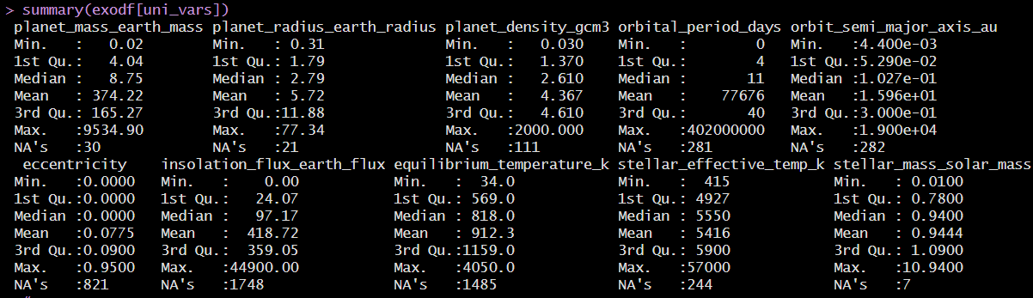
Figure 2.1: Univariate Summary
- The univariate summary statistics shows variability across planetary, orbital and stellar properties. Planetary mass ranges from 0.02 Earth masses to 9534.9 Earth masses, with a median of 8.75 Earth masses and a much larger mean of 374.22 Earth masses, indicating extreme right skewness driven by massive gas giants. Similarly, planetary radius spans 0.31 to 77.34 Earth radii, with a median of 2.79 Earth radii, suggesting that the majority of detected planets are significantly larger than Earth. From a habitability standpoint, planets most likely to support liquid water are expected to fall closer to Earth-like ranges typically below ~10 Earth masses and below ~2 Earth radii which constitute only a subset of the observed population. Although not necessary that the planet needs to be of same dimensions in order to be habitable.
- Planet density varies widely from 0.03 g/cm³ to 2000 g/cm³ with a median of 2.61 g/cm³. This range shows coexistence of low-density gas giants and denser rocky planets. Densities comparable to Earth’s (~5.5 g/cm³) are more favorable for having surface liquid water. The wide spread in density shows that composition cannot be inferred solely from mass or radius when assessing habitability.
- Orbital properties show detection bias toward extreme environments. Orbital period ranges from near zero days to 402 million days, with a median of 11 days while semi-major axis goes from 0.0044 AU to 19000 AU with a median of 0.103 AU. These medians indicate that most detected planets orbit very close to their host stars. Since habitable zones for Sun-like stars typically lie near 1 AU, the scarcity of planets at larger orbital distances suggests that many potentially water-supporting planets remain undetected rather than absent.
- Insolation flux shows extreme variability ranging from 0 to 44900 Earth flux units with a median of 97.17 Earth units. Equilibrium temperature ranges from 34 K to 4050 K with a median of 818 K. These values indicate that the typical detected planet is far hotter than Earth, where equilibrium temperatures near 250 - 300 K are most conducive to liquid water. The high medians confirm that planets receiving Earth-like stellar energy are rare in the observed sample.
- Orbital eccentricity has a median of 0 and a mean of 0.078, indicating that most planets follow nearly circular orbits. This is favorable for habitability, as low eccentricity shows climate stability and reduces extreme seasonal temperature variation. Although, the presence of eccentricities up to 0.95 shows that some systems experience highly variable stellar heating which would challenge long-term liquid water stability.
- Stellar properties are comparatively less variable. Stellar effective temperature ranges from 415 K to 57000 K with a median of 5550 K while stellar mass ranges from 0.01 to 10.94 solar masses, with a median of 0.94 solar masses. This indicates that most detected planets orbit Sun-like or cooler stars, which is favorable for habitability because such stars provide stable energy output over long timescales. Cooler stars, in particular, allow habitable zones to exist at smaller orbital distances.

  - Visual Exploratory Analysis
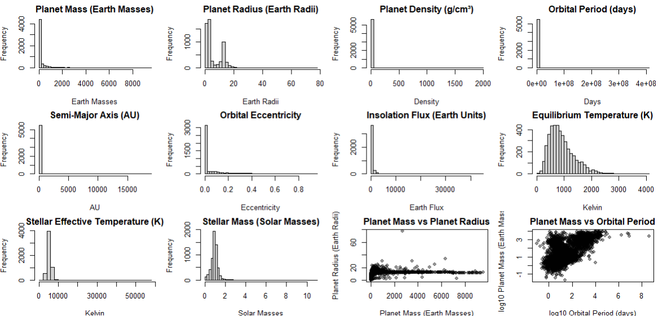
Figure 2.2.1: Plot 1

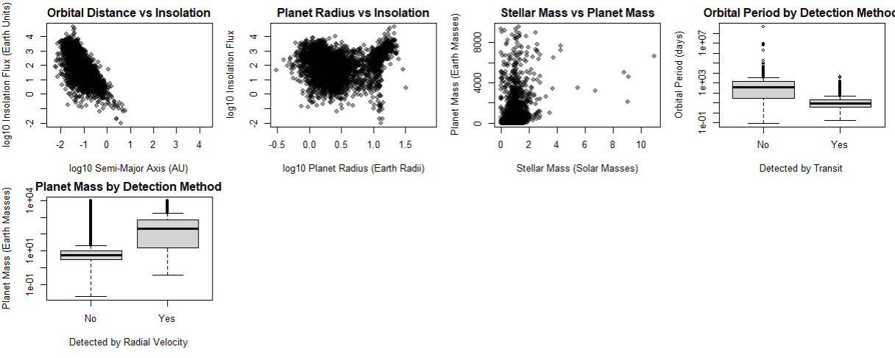
Figure 2.2.2: Plot 2
- Histograms of planetary mass and radius show extreme right skewness, with the majority of planets concentrated at relatively low masses and radii and a long tail extending to very large gas giants. Most planets lie below roughly 20 Earth masses and 10 Earth radii, while a small number extend to several thousand Earth masses and tens of Earth radii. This visual pattern confirms that the mean values have outliers and that Earth-like planets occupy a narrow region of the distribution. From a habitability perspective, this highlights that planets most capable of sustaining surface liquid water those with moderate mass and radius consistent with rocky compositions.
- The planet density histogram further shows compositional diversity. Density is heavily concentrated at low values with extreme upper tail. This suggests that many detected planets are gas-dominated, while fewer exhibit densities compared to Earth.
- Distributions of orbital period and semi-major axis show that most planets orbit extremely close to their host stars. The majority have orbital periods well below 100 days and semi-major axes below 0.5 AU, with only a small fraction occupying wider orbits. Since habitable zones for Sun-like stars typically lie near 1 AU, the visual scarcity of planets at larger orbital distances demonstrates a strong detection bias against temperate planets.
- The orbital eccentricity histogram is peaked near zero, indicating that most planets have nearly circular orbits. This is favorable for habitability, as low eccentricity supports stable climates and minimizes extreme temperature variation over an orbit.
- Plots of insolation flux and equilibrium temperature reveal that most detected planets receive far more stellar energy than Earth. Insolation flux is heavily right-skewed, with many planets experiencing tens to thousands of times Earth’s incident flux. Equilibrium temperatures cluster around 500-1500 K with relatively few planets near the 250-300 K range. This indicates that hot planets dominate current detections.
- The stellar effective temperature and stellar mass histograms show comparatively tighter distributions with most host stars clustered around Sun-like or cooler values.
- Bivariate scatterplots show that the orbital distance versus insolation flux plot shows a strong inverse relationship, confirming that stellar energy drops rapidly with increasing distance. This tells that orbital distance as the dominant control on surface temperature. The planet radius versus insolation flux plot shows that large planets cluster at high irradiation levels, reflecting atmospheric inflation and detection bias toward hot gas giants. Smaller planets are present across a wide range of insolation values, including lower-energy regimes more compatible with habitability, though they are fewer in number.
- The planet mass versus planet radius scatterplot shows a nonlinear relationship: radius increases with mass at low values but flattens at high masses. This visual pattern distinguishes rocky planets from gas giants and highlights the narrow region where Earth-like planets reside. The planet mass versus orbital period (log–log) plot shows that massive planets are detected across a wide range of periods, while lower-mass planets cluster at shorter periods, again reflecting detection bias rather than intrinsic absence.
- Categorical boxplots show that planets detected via the transit method exhibit significantly shorter orbital periods, while those detected via radial velocity tend to have much higher masses.

  - Correlation Analysis
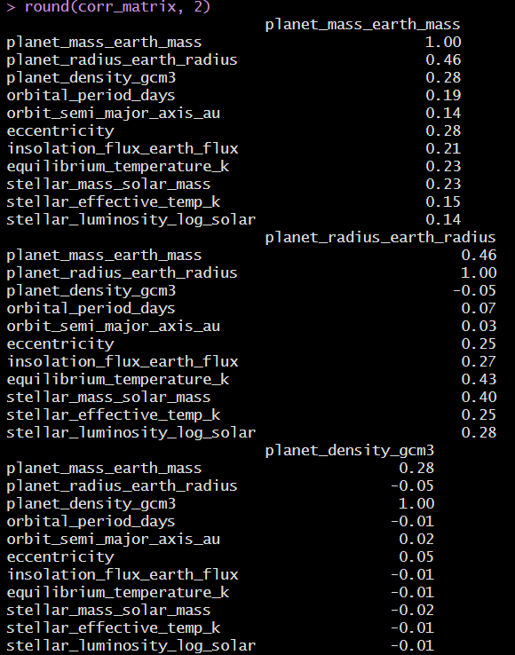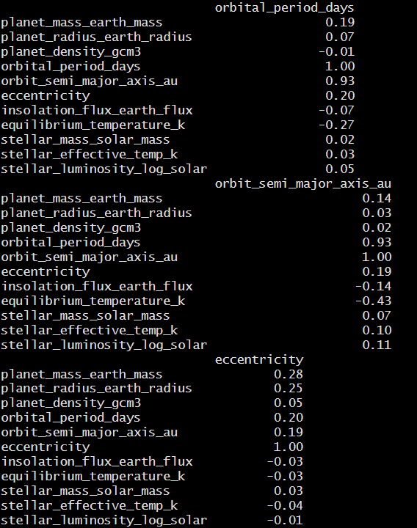
Figure 2.3.1: Matrix 1 Figure 2.3.2: Matrix 2
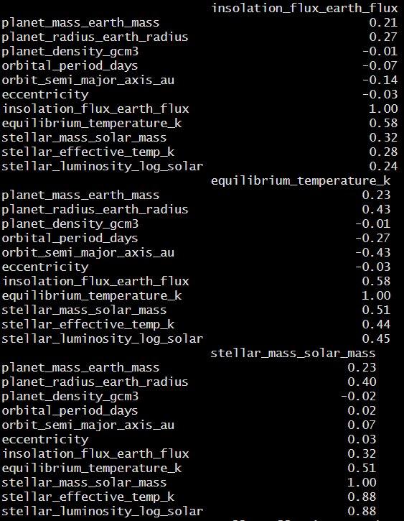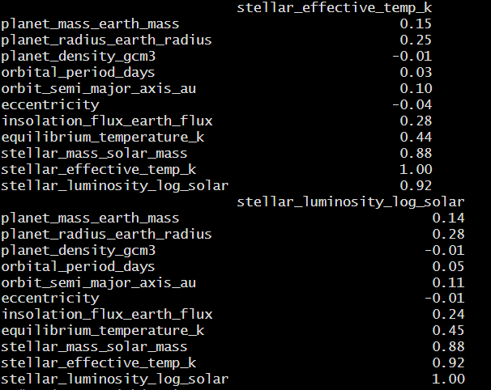
Figure 2.3.3: Matrix 3 Figure 2.3.4: Matrix 4
- Planet mass and planet radius show a moderate positive correlation (r=0.46), indicating that larger planets tend to be more massive, though not proportionally. This nonlinear pattern arises from differences in planetary composition: rocky planets show only limited radius growth with increasing mass, whereas gas giants can gain substantial mass with little change in radius. Planet density shows weak correlation with both mass (r = 0.28) and radius (r=−0.05) suggesting that planetary composition varies independently of size.
- Orbital parameters show strongest correlation in the dataset. Orbital period and semi-major axis are very strongly correlated (r = 0.93) consistent with Kepler’s Third Law*. Both variables show negative correlations with temperature (orbital period: r = −0.27, semi-major axis: r = −0.43) thus indicating that planets farther from their host stars experience cooler thermal environments.
- Insolation flux is strongly correlated with equilibrium temperature (r = 0.58): stellar radiation is important for planetary climate. Insolation flux also shows moderate positive correlations with stellar mass (r = 0.32) stellar effective temperature (r = 0.28) and stellar luminosity (r = 0.24) indicating that hotter and more massive stars give out higher energy to orbiting planets at comparable distances.
- Stellar mass, stellar effective temperature, and stellar luminosity are very strongly correlated with each other (approx. r = 0.88–0.92). Their moderate correlations with equilibrium temperature (r = 0.44–0.51) show that stellar properties significantly influence planetary thermal environments.
- Orbital eccentricity shows weak correlations with nearly all variables, including insolation flux (r = −0.03) and equilibrium temperature (r = −0.03). This suggests that eccentricity does not vary with stellar energy or orbital distance.
  - Principal Component Analysis
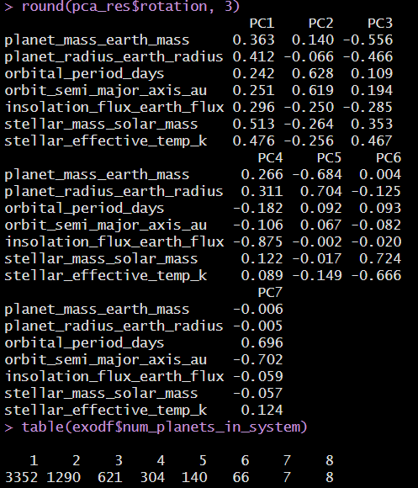 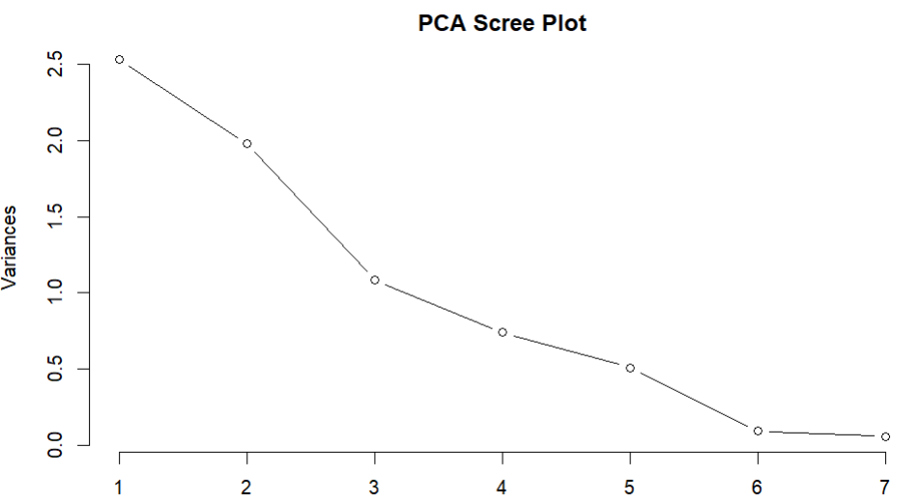 Figure 2.4.1: Principal Component Analysis Figure 2.4.2: Scree Plot
Principal Component Analysis was performed on standardized planetary, orbital, and stellar variables to identify dominant sources of variability and to understand how habitability-relevant conditions, particularly those associated with surface liquid water.
- The scree plot shows a clear elbow at the third principal component, indicating that the first three components capture most of the meaningful variance. PC1 explains 36.1%, PC2 explains 28.3% and PC3 explains 15.5% of the total variance with a cumulative variance of ~80% by the first three components. Other components each explain less than 11% of the variance.
- The first principal component (PC1) has strong positive loadings from stellar mass (0.513), stellar effective temperature (0.476), planet radius (0.412), planet mass (0.363) and insolation flux (0.296). This component represents an overall system scale and energy dimension, separating large, massive planets orbiting hotter, more massive stars from smaller planets around cooler stars.
- The second principal component (PC2) explains around 28.3% of the variance by orbital period (0.628) and semi-major axis (0.619) with smaller negative contributions from insolation flux (−0.250) and stellar properties. PC2 represents orbital configuration, effectively separating close-in planets from those in wider orbits.
- The third principal component (PC3), accounting for 15.5% of the variance contrasts planetary mass (−0.556) and planetary radius (−0.466) against stellar mass (0.353) and stellar effective temperature (0.467). This component reflects a planet–star contrast dimension distinguishing systems with relatively large planets orbiting cooler stars from systems with smaller planets around hotter stars.
- PC4 is dominated by insolation flux (−0.875). PC5 contrasts planet radius (0.704) with planet mass (−0.684) reflecting compositional differences between rocky and gas-dominated planets.

  - EDA Summary
The exploratory data analysis reveals that the known exoplanet population is highly skewed toward environments unfavorable for surface liquid water. Univariate and visual analyses show that most detected planets are large, massive, and highly irradiated* with median equilibrium temperatures (~818 K), insolation levels (~97 Earth units), and orbital distances (~0.10 AU) far from Earth-like conditions. Rocky, Earth-sized planets occupy only a small fraction of the observed parameter space, highlighting both astrophysical rarity and strong detection bias toward close-in, hot planets.
Correlation analysis confirms that stellar energy input and orbital distance dominate planetary climate, with strong relationships between semi-major axis, insolation flux, and equilibrium temperature. Stellar mass, luminosity, and effective temperature are tightly coupled and significantly influence planetary thermal environments, while planetary composition (density) varies largely independently of mass and radius. Orbital eccentricity shows weak correlations overall, indicating that climate stability must be assessed separately from stellar energy considerations.
Principal Component Analysis further consolidates these findings, showing that nearly 80% of the variance is explained by three dimensions: stellar energy scale, orbital configuration, and planet–star contrast. Together, the EDA demonstrates that Earth-like conditions are statistical outliers in the current dataset and that identifying potentially habitable planets requires multivariate evaluation rather than reliance on any single planetary or stellar characteristic.

- Model Building
  - Linear Regression: Determinants of Planetary Temperature
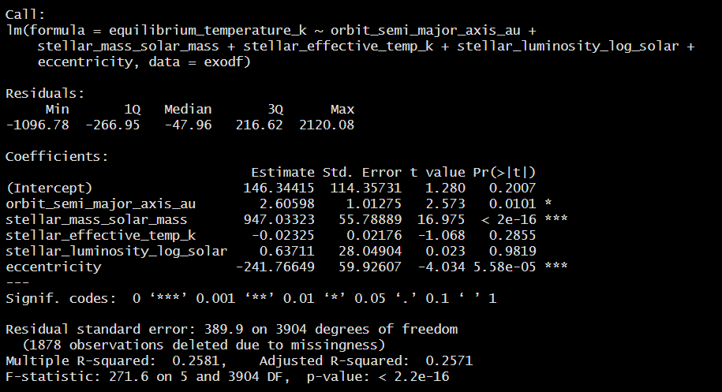Figure 3.1: Linear Regression: Determinants of Planetary Temperature
To evaluate which observable factors most strongly influence planetary surface conditions relevant to liquid water, a multiple linear regression model was fitted with equilibrium temperature as the response variable. The model included orbital distance, stellar properties, and orbital eccentricity.
- The model explains 25.8% of the total variation in equilibrium temperature with R² = 0.258 and p < 2×10⁻¹⁶ indicating that a large portion of planetary thermal conditions can be explained by measurable orbital and stellar characteristics.
- Stellar mass is a dominant predictor. A one solar-mass increase in stellar mass is associated with an average increase of 947 K in planetary equilibrium temperature p < 2×10⁻¹⁶. This confirms that planets orbiting more massive stars are far less likely to sustain surface liquid water due to excessive stellar heating.
- Orbital eccentricity shows a significant negative effect with −242 K and p=5.6 × 10⁻⁵. While eccentric orbits may reduce average equilibrium temperature, they introduce large seasonal temperature fluctuations, which are unfavorable for long-term climate stability and surface liquid water retention.
- Semi-major axis has a smaller but statistically significant effect (+2.6 K per AU, p = 0.01) telling the fact that orbital distance alone does not fully determine temperature without accounting for stellar luminosity and mass.
- This linear regression model explains approximately 26% of the variation in planetary equilibrium temperature (Adjusted R² = 0.257 & p < 2×10⁻¹⁶), indicating a meaningful but incomplete explanation of planetary climate. Stellar mass is the dominant factor with a one solar mass increase raising equilibrium temperature by nearly 950 K making surface liquid water highly unlikely.

  - Reduced Temperature Model
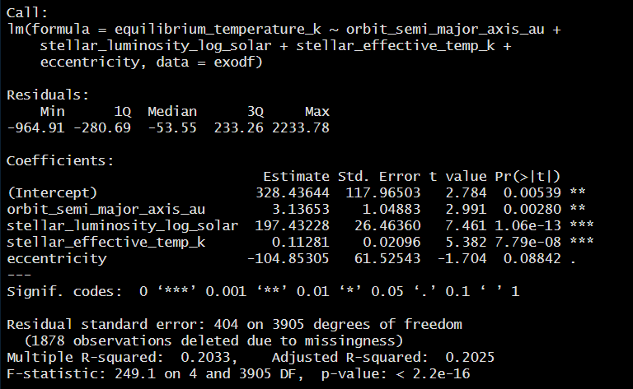
Figure 3.2: Reduced Temperature Model

This is a simplified regression model retaining only physically dominant predictors (orbital distance, stellar luminosity, stellar temperature and eccentricity) was fitted to test robustness.
- This model explains 20.3% of temperature variation with adjusted R² = 0.203 and p < 2 × 10⁻¹⁶ telling that stellar energy output remains the primary driver of planetary temperature even after removing weaker predictors.
- Stellar luminosity shows a strong positive effect, increasing equilibrium temperature by approximately 197 K per unit increase in log luminosity (p =1×10⁻¹³). Stellar effective temperature also contributes positively (+0.11 K per Kelvin, p =8×10⁻⁸).
- These results show that the conclusion that habitable conditions cannot be assessed from orbital distance alone and must be evaluated in the context of stellar energy output.
- This reduced temperature model explains ~20% of the variation in equilibrium temperature which is a robust but simplified fit. Stellar luminosity is the strongest predictor with a one-unit increase in log luminosity raising equilibrium temperature by ~197 K directly reducing the likelihood of surface liquid water. Stellar effective temperature also has a significant positive effect, reinforcing that stellar energy output dominates planetary climate

  - Candidate Counts Based on Temperature
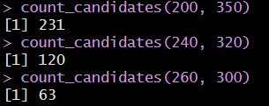
Figure 3.3: Candidate Counts Based on Temperature
Using equilibrium temperature as a necessary condition for liquid water:
- 200–350 K: 231 planets
- 240–320 K: 120 planets
- 260–300 K: 63 planets
This decline demonstrates that Earth-like thermal conditions are increasingly rare as constraints tighten even before accounting for composition or orbital stability.
  - Cluster Analysis: Natural Groupings of Exoplanets
Unsupervised clustering was performed using planetary mass, radius, orbital distance, insolation flux and equilibrium temperature to identify natural groupings without imposing habitability labels.

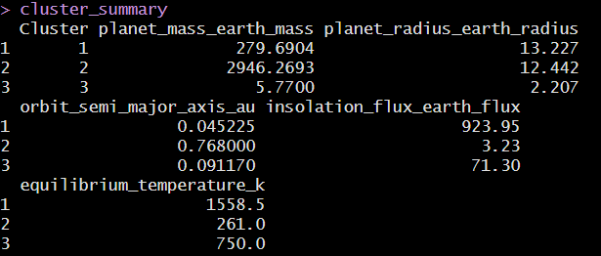
Figure 3.4: Natural Groupings of Exoplanets
Cluster 1 consists of hot, highly irradiated gas giants with equilibrium temperatures exceeding 1500 K which far beyond conditions compatible with liquid water.
Cluster 2 contains very massive planets at wider orbits, receiving near-Earth insolation levels and exhibiting median temperatures of ~261 K, directly overlapping the temperature range required for liquid water. Although, their extremely large masses suggest gas-dominated compositions, making surface liquid water unlikely.
Cluster 3 is composed of low-mass, small-radius planets, closer to rocky compositions, but with median temperatures around 750 K indicating excessive stellar heating.
Importantly, no cluster simultaneously satisfies Earth-like mass, radius, and temperature, highlighting the rarity of Earth-analog conditions in the observed exoplanet population.

    - Cluster Distribution by Stellar Energy and Temperature
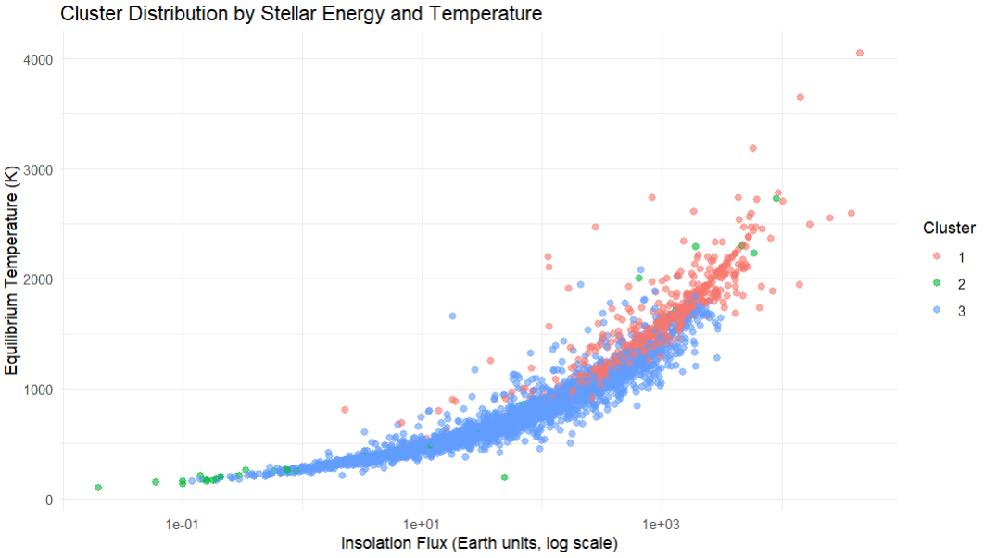
Figure 3.4.1: Cluster Distribution by Stellar Energy and Temperature
The insolation and temperature plot highlights how stellar energy input separates planetary environments.
Cluster 1 (red) occupies the high-insolation part around 10²–10⁴ Earth flux units with equilibrium temperatures exceeding 1500 K. These planets are strongly irradiated hot worlds where surface liquid water is physically impossible.
Cluster 3 (blue) lies in an intermediate region with insolation values mostly between 10–100 Earth units and equilibrium temperatures clustering around 600–1000 K. While structurally closer to rocky planets, these temperatures remain far above the 200–350 K range required for stable liquid water.
Cluster 2 (green) is the coldest group with median equilibrium temperatures near 260 K and insolation close to 1-5 Earth units thus, directly overlapping conservative habitable zone estimates. When combined with the mass-radius results, these planets are shown to be extremely massive, suggesting gas-dominated compositions rather than Earth-like surfaces.
    - Planetary Mass - Radius Distribution by Cluster
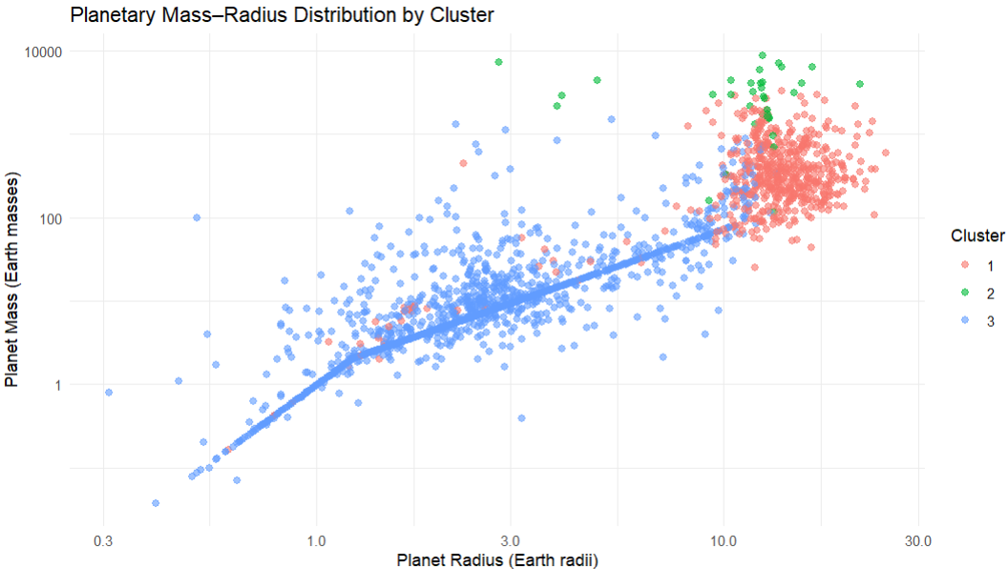
Figure 3.4.2: Planetary Mass - Radius Distribution by Cluster
The mass-radius plot reveals three physically distinct planetary populations.
Cluster 3 (blue) the lower-left region has radii between 1-3 Earth radii and masses below 10 Earth masses. This cluster shows the rocky-planet mass-radius trend, where mass increases steeply with radius at small sizes, consistent with terrestrial compositions. So, from a habitability perspective this cluster contains the most structurally Earth-like planets, although composition alone does not guarantee surface water.
Cluster 1 (red) is concentrated at large radii with 8–20 Earth radii and high masses 100–1000 Earth masses characteristic of gas giants. Despite some spread, these planets lie well beyond the rocky type and are unlikely to support surface liquid water due to thick gaseous atmospheres and the absence of solid surfaces.
Cluster 2 (green) has extreme outliers with very large masses around >1000 Earth masses and radii comparable to gas giants. Although fewer in number, these planets occupy a clearly non-terrestrial regime and are entirely incompatible with Earth-like habitability.
  - Model Summary
The modeling results collectively tell that stellar energy output is the primary determinant of planetary thermal conditions, while orbital and planetary properties play secondary but important roles. Linear regression models show that stellar mass and luminosity dominate equilibrium temperature thus explaining 20–26% of temperature variability with stellar mass alone increasing planetary temperature by nearly 950 K per solar mass. Orbital distance contributes significantly confirming that distance alone is insufficient for assessing habitability. Orbital eccentricity further affects climate stability by introducing thermal variability reducing the likelihood of long-term surface liquid water.
Temperature-based candidate counts reveal that Earth-like thermal conditions are rare, with only 63 planets falling within the narrow 260–300 K range, even before considering composition or orbital stability. Cluster analysis reinforces this rarity by showing that no natural planetary group simultaneously satisfies Earth-like size, mass, and temperature. Rocky planets tend to be excessively hot, while temperate planets are usually gas-dominated.
- Summary of Conclusions
  - Conclusion
- This study systematically examined planetary, orbital, and stellar characteristics of confirmed exoplanets to assess conditions relevant to surface liquid water. Exploratory analysis showed that the detected exoplanet population is strongly dominated by large, massive, and highly irradiated planets, with median temperatures and insolation levels far exceeding Earth-like conditions. Rocky, Earth-sized planets with moderate stellar energy input occupy only a narrow and sparsely populated region of the parameter space, showing both astrophysical rarity and strong observational bias toward close-in, hot planets.
- Statistical modeling tells that stellar energy output and orbital configuration are the primary drivers of planetary climate. Linear regression results show that stellar mass, luminosity and orbital distance explain a meaningful portion of equilibrium temperature variability of 20–26% while eccentricity plays a secondary role by affecting climate stability rather than average temperature. These results emphasize that orbital distance alone is insufficient to determine habitability without accounting for stellar properties.
- Unsupervised clustering shows three physically distinct planetary populations: hot, highly irradiated gas giants, cold but extremely massive planets with near-Earth temperatures and small, rocky planets subjected to excessive heating. No cluster simultaneously satisfies Earth-like mass, radius, and temperature, highlighting the scarcity of true Earth analogs among known exoplanets. Even when thermal conditions overlap the habitable zone, planetary composition often remains incompatible with surface liquid water.

  - Cautions and Limitations
This study is subject to several important limitations. The exoplanet dataset is strongly influenced by observational bias, as current detection methods favor large, close-in planets, leading to an underrepresentation of small, temperate, Earth-sized planets. Missing data and measurement uncertainty further reduce effective sample sizes and limit model precision, particularly for planetary mass, eccentricity and equilibrium temperature.
Habitability is assessed using necessary but not sufficient conditions based on observable parameters. Equilibrium temperature is a simplified proxy for climate and does not capture atmospheric or surface processes. Statistical models explain only 20–26% of temperature variability, indicating that many drivers of habitability remain unmodeled. Clustering highlights physical groupings rather than true habitability classes and should not be interpreted as definitive classifications.
  - Answers to Research Questions
  - How do key planetary and stellar characteristics vary across known exoplanets?
Known exoplanets exhibit extreme variability across planetary, orbital and stellar properties. Planetary mass spans from 0.02 to over 9500 Earth masses and planetary radius ranges from 0.31 to 77 Earth radii, indicating a large scale of planets is dominated by gas giants rather than Earth-like planets. Orbital distances are heavily skewed toward short periods with a median semi-major axis of 0.10 AU far inside the habitable zones of Sun-like stars. Insolation flux and equilibrium temperature also show wide dispersion with median temperatures near 818 K reflecting environments much hotter than Earth. In contrast, stellar properties are comparatively constrained with most planets orbiting Sun-like or cooler stars which indicates that planetary and orbital diversity drives most environmental variation.
  - Which observable conditions most closely resemble those found on Earth?
Earth-like conditions are best approximated by planets that are small ≤2 Earth radii low-mass ≤10 Earth masses moderately irradiated 0.25–2 Earth flux units and thermally temperate 200–350 K. A small subset of planets falls within these ranges individually, particularly in temperature or insolation. The multivariate analysis shows that few planets satisfy multiple Earth-like conditions simultaneously. Correlation and PCA results indicate that stellar energy output and orbital placement jointly determine planetary climate, meaning that Earth-like conditions emerge only when planetary size, orbital distance and stellar properties align within narrow bounds.
  - Is there a possibility of liquid water on the planet surface?
The analysis indicates that liquid water is possible but rare among currently detected exoplanets. Temperature-based screening identifies 231 planets within the broad 200–350 K range, narrowing to 63 planets within the 260–300 K range. However, clustering reveals that planets with Earth-like temperatures are often too massive and gas-dominated, while small, rocky planets are typically too hot. Thus, while some planets meet necessary thermal conditions for liquid water, very few meet both thermal and structural requirements, making sustained surface liquid water unlikely for most planets without further atmospheric validation.
  - Can statistical comparisons help identify exoplanets for further scientific research?
Yes. Statistical methods such as regression, correlation analysis, PCA and clustering are highly effective for narrowing large exoplanet catalogs to scientifically promising subsets. Modeling confirms that stellar energy output is the dominant climate driver, while clustering reveals natural planetary groupings that distinguish rocky planets from gas giants and temperate worlds from hot planets. Although no cluster contains perfect Earth analogs, these techniques successfully highlight outliers and edge cases that warrant targeted follow-up. Therefore, statistical comparisons provide a powerful, data-driven framework for prioritizing exoplanets for detailed atmospheric characterization and future observational missions.

- References and Citations
- Kaltenegger, L. (2017). How to characterize habitable worlds and signs of life.
Annual Review of Astronomy and Astrophysics, 55, 433–485.
https://www.annualreviews.org/doi/10.1146/annurev-astro-081915-023323
- NASA. (2023). Exoplanets and the search for life. NASA Science.
https://science.nasa.gov/exoplanets/search-for-life/
- NASA. (2022). Mars exploration program: Science goals.
https://mars.nasa.gov/mars-exploration/
- NASA’s Exoplanet Exploration programs
  - https://pmc.ncbi.nlm.nih.gov/articles/PMC4156715/?utm_source
- NASA Exoplanet Exploration Program (2023). What is the Habitable Zone?
- Rogers, L. A. (2015). Most 1.6 Earth-Radius Planets Are Not Rocky. The Astrophysical Journal.
- Neil, A. R., & Rogers, L. A. (2020). A Rocky Origin for Sub-Neptune Exoplanets. The Astrophysical Journal.
- Kopparapu, R. K., et al. (2013). Habitable Zones around Main-Sequence Stars. The Astrophysical Journal.
- Kopparapu, R. K., et al. (2014). HZ Revisions and Planetary Climate Limits. The Astrophysical Journal Letters.
- Kane, S. R., et al. (2021). Exoplanet Habitability and Stellar Radiation. The Astronomical Journal.
- Barnes, R., et al. (2013). Tidal Limits to Planetary Habitability. Astrobiology.
- Shields, A. L., et al. (2016). The Habitability of Planets Orbiting M-Dwarf Stars. Physics Reports.
- * Kepler’s third law: The square of a planet's orbital period (T) is directly proportional to the cube of the semi-major axis (a) of its orbit, expressed as T² ∝ a³, meaning planets farther from the Sun take significantly longer to complete one orbit. This relationship, also known as the Law of Periods, links orbital time and distance, forming a crucial basis for understanding solar system dynamics and celestial mechanics, and can be refined using Newton's gravity to include the masses of the orbiting bodies.
- *irradiate: expose to radiation.

Appendix:
- Univariate Analysis
corr_vars <- c(
"planet_mass_earth_mass",
"planet_radius_earth_radius",
"planet_density_gcm3",
"orbital_period_days",
"orbit_semi_major_axis_au",
"eccentricity",
"insolation_flux_earth_flux",
"equilibrium_temperature_k",
"stellar_mass_solar_mass",
"stellar_effective_temp_k",
"stellar_luminosity_log_solar"
)
corr_matrix <- cor(exodf[corr_vars], use = "complete.obs")
round(corr_matrix, 2)

- Correlation Analysis
corr_vars <- c(
"planet_mass_earth_mass",
"planet_radius_earth_radius",
"planet_density_gcm3",
"orbital_period_days",
"orbit_semi_major_axis_au",
"eccentricity",
"insolation_flux_earth_flux",
"equilibrium_temperature_k",
"stellar_mass_solar_mass",
"stellar_effective_temp_k",
"stellar_luminosity_log_solar"
)

corr_matrix <- cor(exodf[corr_vars], use = "complete.obs")
round(corr_matrix, 2)

- PCA
pca_vars <- c(
"planet_mass_earth_mass",
"planet_radius_earth_radius",
"orbital_period_days",
"orbit_semi_major_axis_au",
"insolation_flux_earth_flux",
"stellar_mass_solar_mass",
"stellar_effective_temp_k"
)
pca_data <- na.omit(exodf[pca_vars])
pca_res <- prcomp(pca_data, scale. = TRUE)
summary(pca_res)
round(pca_res$rotation, 3)
- Linear Regression model (temperature)
temp_lm <- lm(
equilibrium_temperature_k ~
orbit_semi_major_axis_au +
stellar_mass_solar_mass +
stellar_effective_temp_k +
stellar_luminosity_log_solar +
eccentricity,
data = exodf
)
summary(temp_lm)
- Linear Regression model (Reduced Model)
temp_model <- lm(
equilibrium_temperature_k ~
orbit_semi_major_axis_au +
stellar_luminosity_log_solar +
stellar_effective_temp_k +
eccentricity,
data = exodf
)
summary(temp_model)

