Project Report Part 2
Close Approaches: Mapping Near-Earth Asteroids
STAT 53100 Data Analysis
Tanisha Raskar

- Purpose and Background
In Chelyabinsk, Russia on 15th of February 2013, a 20 meter asteroid entered the atmosphere and exploded mid-air. The explosion was around 500 kilotons of TNT that sent a shockwave across the city of Chelyabinsk further shattering thousands of windows of buildings and injuring more than 1600 people. In a matter of a few minutes the celestial event became a public safety incident. Chelyabinsk is now one of the largest asteroid explosions in over a century. This incident highlighted the reality that even relatively small asteroids can have significant effects.
Research about the asteroids claims that smaller asteroids around 10 meters in diameter strike Earth roughly once every decade, producing fireballs strong enough to shatter windows. Larger ones are about 50 meters wide and are expected to hit about once every 1000 years, causing local devastation. When asteroids reach 140 meters, they collide with Earth approximately once every 20000 years forming 1-2 kilometers wide craters and inflicting damage across metropolitan or regional areas such objects are classified as Potentially Hazardous Asteroids (PHAs). One such case is Arizona’s Barringer Crater. The crater is about 1.2 kilometers wide and 180 meters deep. The asteroid that created the crater about 50,000 years ago is thought to have been between 100 to 170 feet (30 to 50 meters) in size. Most of the asteroid melted or vaporized on impact. This shows that planetary defense is a data problem that can help avoid these situations.
Looking at the data collected by NASA about outer space bodies it’s visible to us that apart from the Moon, the Earth’s outer space is crowded with small bodies and debris. Asteroids are a part of these bodies, and they span in a wide range of sizes. Most of them are harmless, some burn up before even reaching the ground due to the Earth’s atmosphere. Yet objects around 4 meters in size (car sized) strike Earth’s atmosphere about once a year, and larger bodies, although rarely, strike Earth and further cause major devastation. Understanding these risks therefore means knowing how size, brightness, speed, and distance help in determining NASA’s potentially hazardous bodies. The purpose of this research is to understand what are the factors that cause these asteroids to potentially be termed as hazardous to planet Earth. This involves using Near Earth object (NEO) to identify patterns and relationships among these variables and determine which combinations pose a significant risk to Earth.

  - Potential Hazardous Asteroids (PHA) Criterion
Asteroids that approach Earth’s orbit are categorized based on their orbital dynamics and physical properties, which together determine their potential threat level. Using data and classification standards established by NASA’s Near-Earth Object research programs, a Potentially Hazardous Asteroid (PHA) can be identified according to the following criteria:
Minimum orbit intersection distance (MOID): the smallest distance between the asteroid’s orbit and Earth’s orbit. An asteroid is considered potentially hazardous if its MOID is less than or equal to 0.05 AU, which is about 7.48 million kilometers (4.65 million miles). This distance threshold marks the region where gravitational influences could shift the asteroid’s trajectory enough to create a possible impact. Objects within this boundary are therefore monitored closely for any changes in their orbital paths.
Absolute magnitude (h), which estimates its size and brightness. Asteroids with an h value of 22.0 or lower are large enough around 140 meters in diameter or more to cause regional or continental damage if they were to collide with Earth. Smaller and dimmer objects (h > 22) generally disintegrate in the atmosphere or cause limited local damage and are thus not classified as hazardous.
Asteroids that fall outside these criterions, like those with MOID values slightly above 0.05 AU or h magnitudes between 22 and 25, are often termed “near hazardous”. Since they are not immediately under threatening, they remain under observation because small orbital changes or gravitational changes could make them into hazardous proximity over time. Therefore, these criteria will enable to detect potential hazardous objects or near risk objects that might/might not impact Earth.
Research Questions:
- What measurable factors determine whether an asteroid is classified as a Potentially Hazardous Asteroid (PHA)?
- What patterns or thresholds can be identified in the data to help improve early detection of hazardous asteroids?

  - Description
The study uses a Near Earth object (NEO) dataset exported from NASA’s public NEO API (produced by NASA’s Jet Propulsion Laboratory using observations curated by the International Astronomical Union’s Minor Planet Center: Website: https://ssd-api.jpl.nasa.gov/doc/cad.html (Imported dataset: https://ssd-api.jpl.nasa.gov/cad.api?body=Earth&date-min=1900-01-01&date-max=2100-01-01&neo=true )). The file has 39585 rows and 11 variables with each variable segregated into categorical and numerical values.
Following are the variables:
Variable | Type | Unit | Context
des | Categorical | — | The asteroid’s official ID or short name.
orbit_id | Number /Character | — | The version of the asteroid’s orbit is used by NASA to make calculations.
jd | Number | Julian date | A special number used by astronomers to mark time.
cd | Character / Date | Date and time | The actual date and time (in UTC) when the asteroid come closest to Earth.
dist | Number | AU | How far the asteroid gets from Earth during its closest approach. 1 AU = the distance from Earth to the Sun.
dist_min | Number | AU | The smallest possible distance it might get to Earth, based on uncertainty.
dist_max | Number | AU | The largest possible distance it might get to Earth, based on uncertainty.
v_rel | Number | km/s | The asteroid’s speed is relative to Earth when it passes by.
v_inf | Number | km/s | Its speed is far away from Earth, before Earth’s gravity pulls on it.
t_sigma_f | Character | Days:Hours:Minutes | How uncertain NASA is about the exact timing of the close approach (like “±2 days, 9 hours”).
h | Number | Magnitude | A measure of how bright the asteroid looks — brighter usually means bigger.
uncertainity_hours | Number | Hours and minutes | Added: The estimated variation in the asteroid’s predicted position in hours and minutes, to show orbital uncertainty.
days | Number | — | Added: Indicates the uncertainty duration in days for the asteroid’s closest approach
vel_change | Number | km/s | Added: Measures the difference between near-Earth and far-space velocity, showing how much the asteroid accelerates due to Earth’s gravity by taking a difference (v_rel – v_inf).
year | Number | — | Added: asteroid encounters across years
obs_id | Number | — | Added: unique numeric identifier for each observation.

The dataset has asteroids’ orbital paths, physical characteristics, proximity to Earth and other variables that help us in gaining further insight on how the object is navigating. It focuses on the quantitative aspects (measurable parameters) that define an asteroid’s behavior and potential threat. It has essential information such as orbital distance, velocity, brightness, and estimated size, each contributing to understanding how these celestial bodies interact with Earth’s orbit. By analyzing this data, we can identify patterns that distinguish harmless objects from those posing real danger. The dataset’s structure allows for examining correlations between distance, velocity, and size factors that collectively determine an asteroid’s classification as hazardous. This information not only supports risk assessment and early detection but also contributes to improving predictive models used in planetary defense and impact prevention strategies.

  - Data Transformation
The dataset initially contained raw observational data that required some transformations for analysis. There were a few missing observations in the variables v_inf (22 entries) and h (9 entries), which were replaced with NA values to maintain data consistency. The variable t_sigma_f presented a combined time format with days, hours, and minutes together, which was segregated into two new column uncertainty_hours and days for easier interpretation of the time range within which the asteroid’s trajectory may deflect. The date column was also reformatted into a more standardized format. Modifications were made to the data column by adding vel_change (v_rel – v_inf) to better understand the change in velocity after Earth’s gravitational influence.
While reviewing the dataset, no significant outliers were removed. The few extreme values observed in velocity (v_rel, v_inf) and brightness (h) were retained, as they represent meaningful insights rather than errors. These high or low values correspond to asteroids with special speed, size, or reflectivity helping in understanding of further near-Earth object (NEO) characteristics. Removing them might risk losing critical information about rare and important cases. Overall, the dataset was cleaned to keep the data accurate while making it easier to understand through transformations.

- Exploratory Data Analysis
The purpose of Exploratory analysis was to examine the key characteristics of the Near-Earth object dataset and identify how variables such as velocity, approach distance, and brightness contribute to determining whether an asteroid may be classified as Potentially Hazardous (PHA).
  - Summary statistics
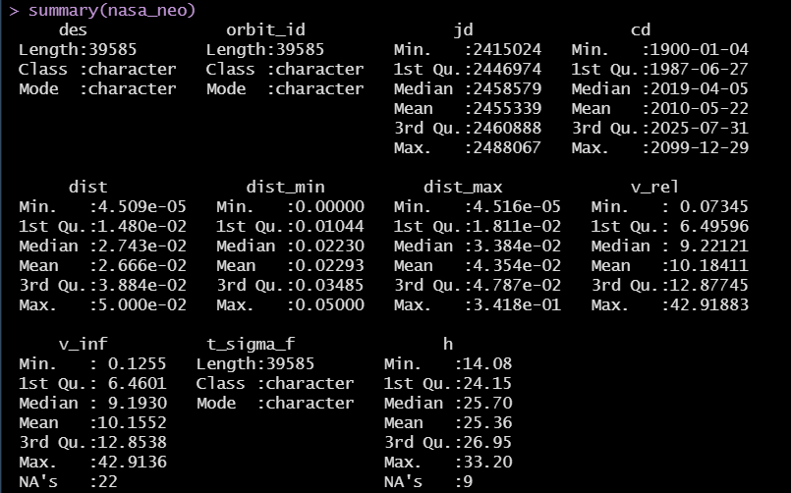
Figure 2.1: Summary statistics
Based on the summary statistics, asteroid distances range between 0.000045 AU, and 0.05 AU have a mean of 0.0266 AU. This indicates that although most asteroids pass at a safe distance, a small subset approaches Earth more closely. Relative velocity (v_rel) values ranged from 0.07 km/s to 42.9 km/s have a mean of 10.18 km/s showing that there is significant variation in asteroid motion. The absolute magnitude (h) ranged from 14.08 to 33.20 has a mean of 25.36 and shows that the dataset includes bright large asteroids and dim smaller ones.
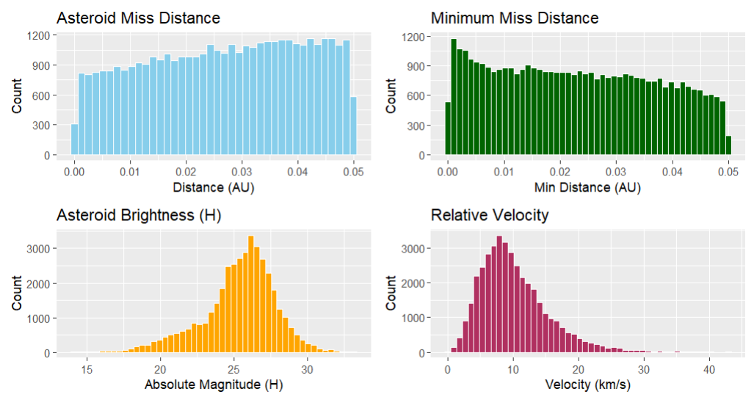
Figure 2.2: Distributional analysis

  - Distributional analysis
The histograms for distance, brightness, and velocity provided following insights:
- Asteroid missed distance: The distribution of miss distance by the asteroid is uniform but has an increasing graph, indicating that asteroids pass Earth at a range of distances 0.05 AU. This increases towards larger distances thus showing that most NEOs tend to pass at moderate to far distances while close approaches are comparatively rare.
- Minimum missed distance: The minimum missed distance graph has a right skew, with higher values near 0 AU and a tail towards 0.05 AU. This indicates that although most asteroids do not come very close, there are a few numbers that fall in the near encounters. These can be the ones classified under Potentially Hazardous Asteroids
- Asteroid brightness (h): The absolute magnitude (h) plot is approximately normal since it has a bell-shape curve and is centered around h = 25. Since lower H values indicate greater brightness and larger size, this distribution tells that most observed asteroids are of moderate size, while very large (bright) and very small (dim) objects are less frequent.
- Relative Velocity (v_rel): The distribution of relative velocity is right-skewed, peaking around 9–10 km/s and then reducing towards higher speeds up to 35 km/s. Most asteroids therefore travel at moderate velocities when crossing Earth’s orbit, but the right tail shows a smaller number of fast-moving asteroids that may possess higher impact potential. This is important to further understand how the gravity of the Earth affects Asteroid velocity.

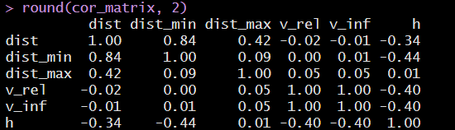
Figure 2.3: Correlation analysis

  - Correlation analysis
The correlation matrix highlights several meaningful relationships:
- Distance and Minimum Distance (r = 0.84): Strong positive correlation, showing that both measures move consistently.
- Distance and Absolute Magnitude (r = –0.34 to –0.44): Show a negative correlation, suggesting that brighter (larger) asteroids tend to pass closer to Earth stating that larger objects are easier to detect at closer ranges.
- Velocity (v_rel, v_inf) and Brightness (h): Moderate negative correlations (–0.40) indicate that faster asteroids tend to be dimmer and smaller and hence the smaller bodies are more easily accelerated by the gravitational forces.
- Distance vs. Velocity: Very weak correlation (almost zero), suggesting that distance between the object and the Earth does not necessarily determine the asteroid’s speed.

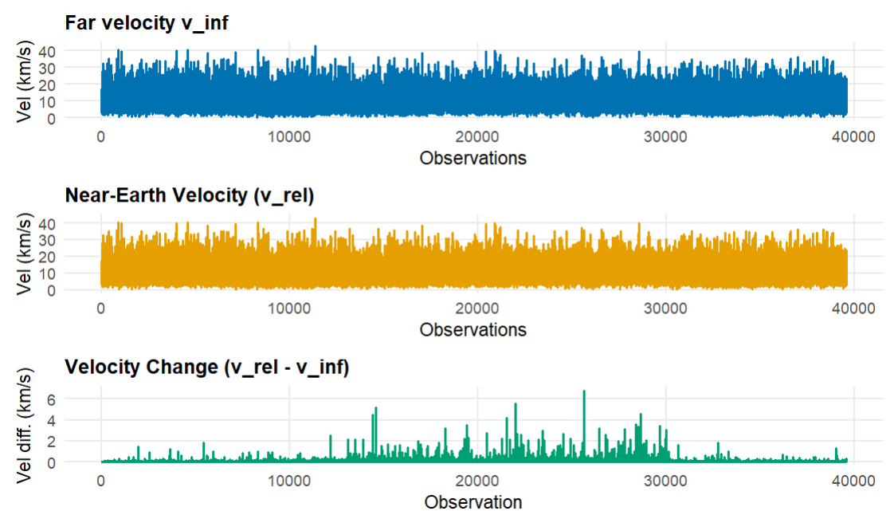
Figure 2.4: Velocity Analysis: Effect of Earth’s gravity

  - Velocity Analysis: Effect of Earth’s gravity
The graph has three velocities:
- Far velocity (v_inf)
- Near Earth velocity (v_rel)
- Velocity change (vel_change)
The far velocity plot shows asteroid speeds before entering Earth’s gravitational field, with most values between 0 and 40 km/s. The near-Earth velocity plot has a similar range but has some greater variability showing that the gravitational acceleration increases asteroid velocity when it approaches Earth’s gravity. The velocity change plot shows that most asteroids have small acceleration (under 2 km/s) while as, a few have larger acceleration (4–5 km/s) probably due to passing closely or they have highly elliptical orbits.

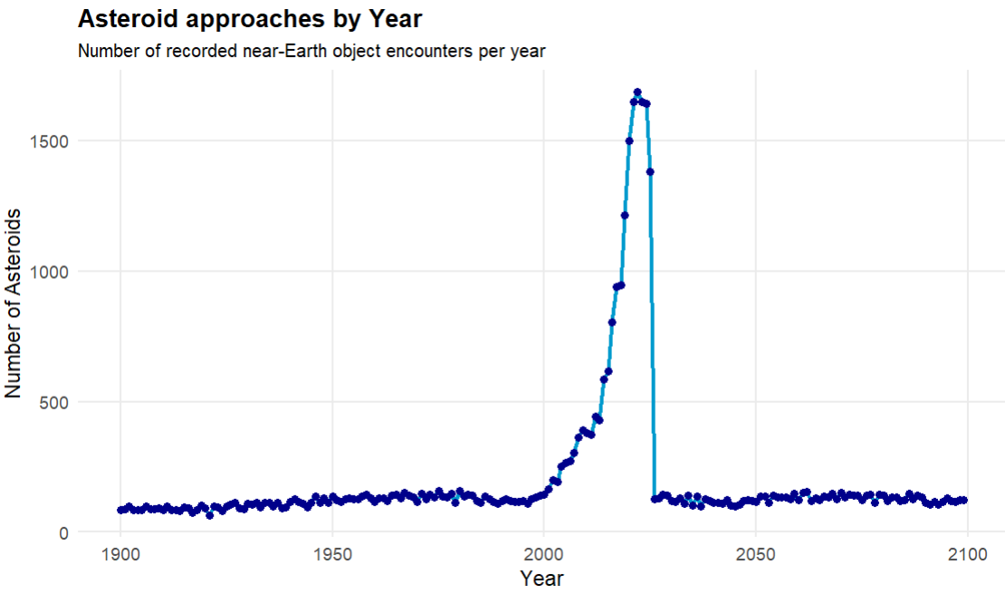
Figure 2.5: Asteroid close approaches by Year

  - Asteroid close approaches by Year
The graph shows that from 1900 to around 1990s, asteroid detections comparatively low constant. A rise is visible in the early 2000s peaking around 2015–2020, after which the findings are again constant. This highlights the importance of detection ways when interpreting the data since earlier years had less findings due to limited observation capacity while as recent years have improved detection efficiency.

Resources
https://www.esa.int/Space_Safety/Russia_asteroid_impact_ESA_update_and_assessment
https://science.nasa.gov/solar-system/asteroids/facts/
https://earthobservatory.nasa.gov/images/148384/arizonas-meteor-crater
https://www.nasa.gov/wpcontent/uploads/2015/12/nasem_report_finding_hazardous_asteroids.pdf
https://ssd-api.jpl.nasa.gov/doc/cad.html
https://ssd-api.jpl.nasa.gov/cad.api?body=Earth&date-min=1900-01-01&date-max=2100-01-01&neo=true

