

**University of Asia Paciﬁc**

Department of Computer Science & Engineering

**Course Title: Software Engineering Lab**

**Course Code: CSE 314**

**Submitted By**

Tanisha Taranoon Hridy 22201169

Md. Sajid Shahan Rahman 22201186

Sanjida Rahman 22201187

**Submitted To**

Tahmid Taki Rahman

*Lecturer*

Department of Computer Science & Engineering,

University of Asia Pacific

**Rare Tree Locator**

*A Website for identifying, tracking, and preserving rare and unique trees in urban Dhaka.*

GitHub Link: (https://github.com/tanishataranoon/Rare-tree-Locator)

Contents

Introduction 5

Objective 5

Project Description 5

Description of Project 5

Motivation 6

Literature Reviews 6

1. **PlantNet** *(https://plantnet.org/en/)* 6

2. **iNaturalist** *(https://www.inaturalist.org/)* 7

3. **Flora of Bangladesh (Bangladesh National Herbarium)** *(https://www.floraofbangladesh.com/)* 7

Summary Table 8

Unique Value of Our Project 8

Feasibility Analysis 8

Economic Feasibility 8

**Estimated Initial Development Costs** 9

**Operational Costs (Annual)** 9

**Potential Funding Sources** 9

Technical Feasibility 9

Project Timeline 10

Gantt Chart 11

Questionnaires 11

Survey 11

Overall Survey Summary 15

Interview 16

Interviewee 1 16

Interviewee 2 18

Interviewee 3 19

Interviewee 4 20

Requirement Analysis 21

Functional Requirements (FRs) 21

Viewer Functional Requirements 21

Contributor Functional Requirements 21

Admin Functional Requirements 22

Non-Functional Requirements (NFRs) 22

Methodology 23

Diagrams 23

Entity-Relationship (ER) Diagram (Hi-Resolution Image) 23

Data Flow Diagram (Hi-Resolution Image) 24

Use Case Diagram (Hi-Resolution Image) 25

# Introduction

## Objective

Urbanization is rapidly reshaping the natural landscape of cities, often at the expense of biodiversity. In densely populated urban environments like Dhaka, rare and unique tree species are often overlooked, under-documented, or forgotten. With limited public engagement in ecological monitoring and a lack of localized identification tools, valuable biodiversity is at risk of being lost silently. The **"***Rare Tree Locator***"** website aims to bridge this gap by enabling citizens to discover, document, and engage with Dhaka’s rare or unique trees through an intuitive and interactive platform. This project promotes community participation in tree discovery and awareness without falling into the domain of structured e-learning or e-commerce.

# Project Description

## Description of Project

The Rare Tree Locator is a website that allows users to:

* Browse and explore rare or unique trees on a map-based interface.
* View tree profiles including images, species name, origin, ecological importance, and exact location.
* Contribute sightings of rare or interesting trees (for verified contributors).
* Submit requests for information if a tree is not already listed.
* Engage with informational posts written by contributors, such as tree facts, seasonal changes, or conservation notes.
* Access a tree archive (knowledge base), categorized by tree type (e.g., flowering, native, endangered), to learn more about Dhaka’s urban biodiversity.

**The website involves three user types:**

* **Viewers**: Can browse Tree entries and their location on the map, read contributor posts, request new information, and comment.
* **Contributors**: Can upload tree sightings with geotagged images and write tree-related posts or observations.
* **Admins**: Manage user roles, approve content, and maintain the integrity of the database.

This is not an e-learning application; there are no structured lessons, tutorials, or certification systems. The aim is to crowdsource knowledge about rare urban flora in an exploratory, non-instructional format.

## Motivation

Dhaka’s green landscape is shrinking due to unchecked urban expansion. While many people walk past unusual or rare trees every day, they lack the means to identify or appreciate them. Current plant identification apps or websites are global and generic, with little relevance to local ecosystems or rare species found specifically in Dhaka.

Our motivation stems from the need to:

* Preserve ecological memory in an ever-changing city.
* Create a tool for real-time, location-based biodiversity tracking.
* Encourage students, nature lovers, and ordinary citizens to be part of an urban conservation movement.
* Build a system that is interactive, community-based, and practical—not a formal learning platform, but an exploration tool.

This project is also an opportunity to promote citizen science by allowing everyday people to meaningfully contribute to biodiversity documentation without requiring specialized knowledge or formal training.

# Literature Reviews

This section presents an analysis of three existing systems relevant to the development of the proposed project, Rare Tree Locator. Each system is evaluated in terms of its core functionalities, strengths, limitations, and relevance to urban tree mapping and public engagement. The aim is to position the proposed project within the context of current solutions and highlight its unique value.

## 1. **PlantNet** *(https://plantnet.org/en/)*

PlantNet is a widely used mobile application designed for plant identification through image recognition. It leverages deep learning models trained on a large database of plant images contributed by users.

**Strengths:**

* High accuracy in identifying a wide range of plant species using photographs.
* Simple and intuitive interface suitable for non-experts.
* Encourages crowdsourced image contributions to enhance the database.

**Limitations:**

* Primarily focused on individual plant identification, not tree-specific.
* Lacks map-based exploration or geotagged tracking of plant sightings.
* Does not support community discussions, seasonal observations, or conservation posts.
* No categorization by ecological value or urban biodiversity.

## 2. **iNaturalist** *(https://www.inaturalist.org/)*

iNaturalist is a citizen science platform that enables users to record and share observations of all living organisms. It includes mobile and web interfaces and uses AI to assist in species identification.

**Strengths:**

* Robust geolocation and mapping of user-submitted sightings.
* Large, active community including scientists for observation verification.
* AI-assisted species suggestion improves accessibility for novices.
* Supports global biodiversity documentation with real-time data.

**Limitations:**

* Covers a broad spectrum of life (insects, birds, fungi), not tree-focused.
* Interface complexity may deter casual or urban-focused users.
* Limited filtering for urban contexts such as city-specific flora.
* Less emphasis on localized educational content or community storytelling.

## 3. **Flora of Bangladesh (Bangladesh National Herbarium)** *(https://www.floraofbangladesh.com/)*

The Flora of Bangladesh is an academic initiative that documents the country’s plant diversity, particularly its native and rare species. It provides taxonomic details and species lists.

**Strengths:**

* Provides scientifically verified information on native plant species.
* Acts as a credible national reference for plant researchers and conservationists.

**Limitations:**

* Designed for researchers; not interactive or accessible to the general public.
* No user contribution mechanism or geotagging of species.
* Lacks images, maps, or seasonal data that encourage public exploration.
* The interface and data structure are outdated and not optimized for modern devices.

## Summary Table

|  |  |  |  |  |
| --- | --- | --- | --- | --- |
| Feature | Rare Tree Locator | PlantNet | iNaturalist | Flora of Bangladesh |
| Focus on Trees | Urban Trees | All Plants | All Organisms | Trees (native focus) |
| Map-Based Interface | Yes | No | Yes | No |
| Geotagged Observations | Yes | Yes | Yes | No |
| Contributor Roles & Moderation | Viewer/Contributor/Admin | No | Limited | No |
| Public Posts and Conservation Notes | Yes | No | Yes | No |
| Urban Biodiversity Context | Dhaka-Focused | Global | Global | National |

## Unique Value of Our Project

|  |  |
| --- | --- |
| Feature | Your System |
| City-specific rare tree tracking | Focused on Dhaka |
| Role-based structure | viewer, contributor, admin |
| Tree submission with approval | Yes |
| Map visualization & nearby trees | Google Maps API |
| Mobile compatibility | optional |
| Modern UI for ease of use | HTML/CSS/JS/Django-based |

# Feasibility Analysis

## Economic Feasibility

The development and maintenance of the proposed tree identification and tracking application is **economically feasible**, especially considering potential support from environmental NGOs, universities, and smart city initiatives.

### **Estimated Initial Development Costs**

|  |  |  |
| --- | --- | --- |
| Component | Cost (BDT) | Description |
| UI/UX Design | 15,000 | Clean & responsive Web design tailored for mobile and desktop users |
| Frontend Development | 20,000 | Django-based web interface |
| Backend Development | 25,000 | Server, database, APIs, user roles, geo-tagging |
| Hosting & Infrastructure | 5000 | Cloud server setup, domain, and CDN |
| Testing & QA | 5000 | Manual and automated testing |
| Storage | Free | GitHub repo |
| Marketing | Free | Via local events and the University |
| **Total Estimated Cost** | **70,000BDT** |  |

### **Operational Costs (Annual)**

* Hosting + Maintenance: 6000 BDT
* Admin/Moderator Honorariums: 1000BDT
* Community Events/Workshops: 50,000 BDT (optional, for public engagement)

### **Potential Funding Sources**

* Local/International **environmental grants** (UNDP, GEF, World Bank).
* Partnerships with **universities** and **botanical institutions**
* CSR programs from **tech or telecom companies** in Bangladesh.
* Government **smart city** and **climate resilience** programs

Given the modest development and recurring costs, and the availability of **open-source frameworks**, the project is **economically sustainable,** especially with phased feature deployment.

## Technical Feasibility

The proposed system can be developed using **mature, widely supported technologies,** with a scalable architecture to accommodate future growth.

|  |  |
| --- | --- |
| Requirement | Tools/Tech |
| Web Framework | Django (Python), HTML, CSS, JS |
| Frontend UI | Bootstrap/Tailwind or custom HTML/CSS |
| Tree Map | Leaflet.js or Google Maps API |
| File Upload (Tree Photos) | Django Media + Storage |
| Role Management | Django built-in Auth |
| Optional PWA/Mobile | WebView (for mobile) or React Native (future) |

# **Project Timeline**

**To ensure systematic progress and timely delivery of the Rare Tree Locator project, a project timeline has been developed outlining key activities from July to December.** **his timeline also helps in resource planning and tracking the project's milestones effectively.**

## Gantt Chart

# Questionnaires

## Survey

1. 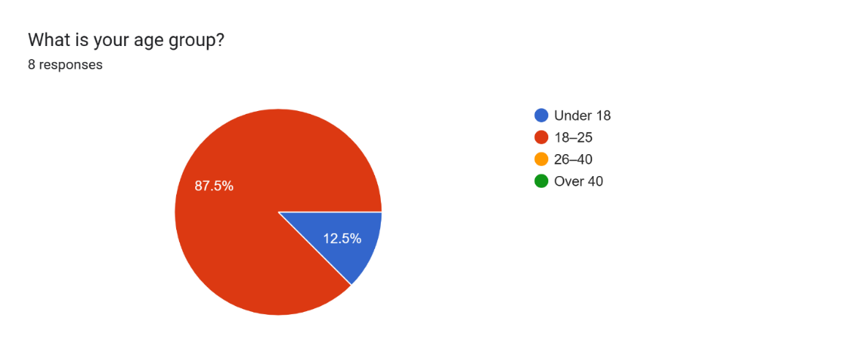***What is your age group?***



1. 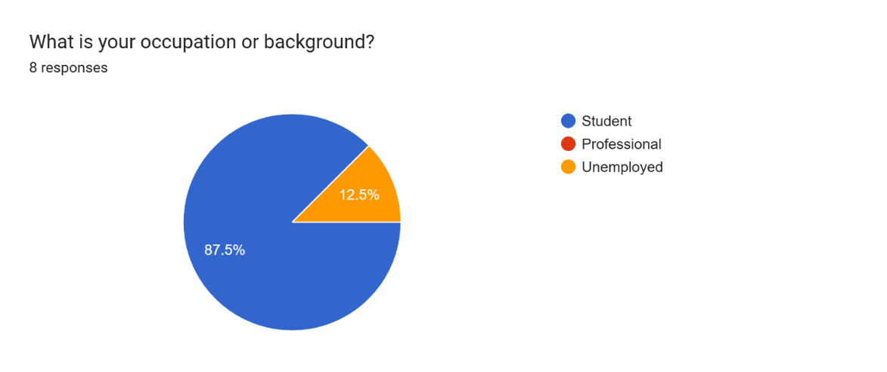***What is your occupation or background?***



A large portion of respondents were university students, followed by hobbyist photographers and nature enthusiasts.

**Conclusion:** Early adoption may come from academic and environmentally aware communities.



1. 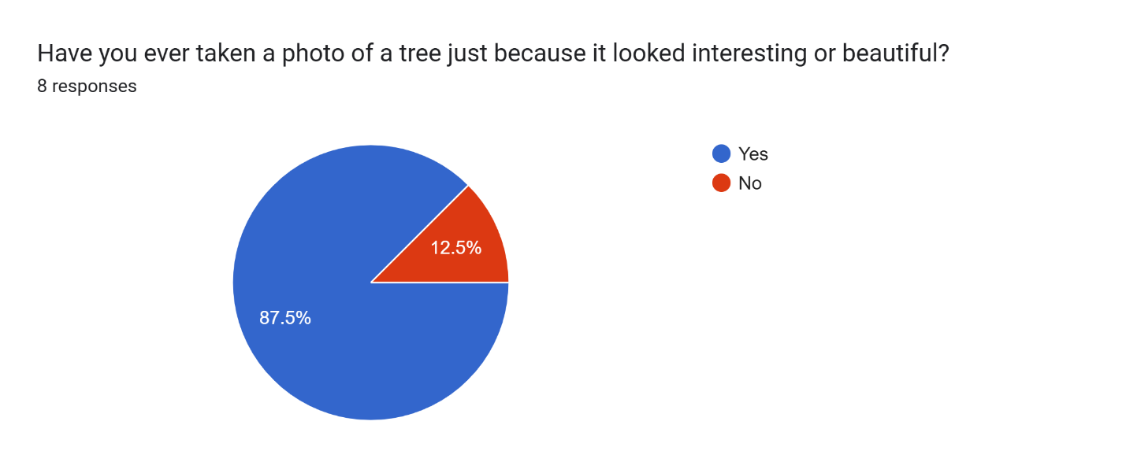***Have you ever taken a photo of a tree just because it looked interesting or beautiful?***

The majority answered Yes, suggesting that many already engage in casual nature photography.

**Conclusion:** This habit can be leveraged by encouraging photo-sharing through the platform.

1. 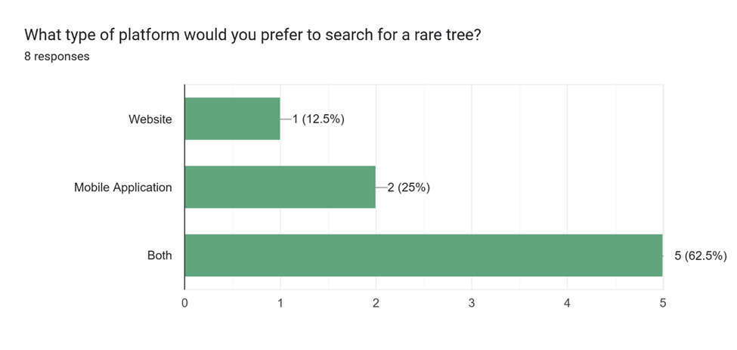***What type of platform would you prefer to search for a rare tree?***

Most chose a website or mobile app, with some preferring a hybrid approach.

**Conclusion:** A responsive web platform with potential mobile integration would meet most needs.

1. ***Which features would be most useful to you?***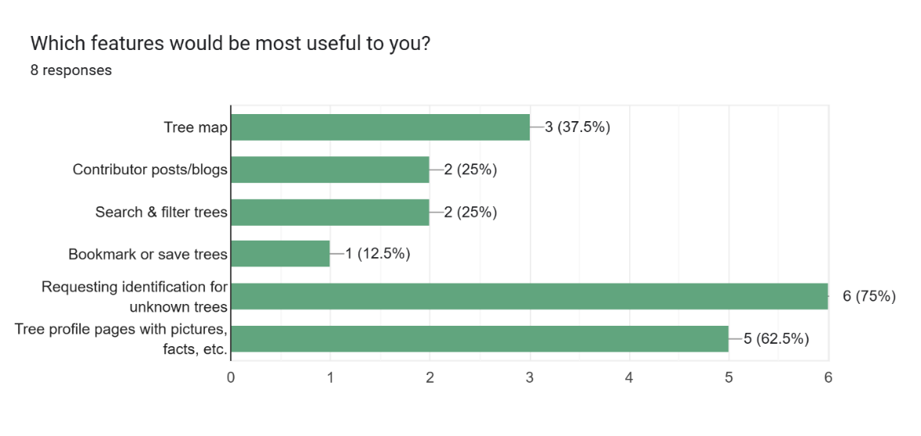

Top choices included: Requesting identification for unknown trees, Tree profile with photos and details, and Tree map.

**Conclusion:** The core features align well with planned system functionality.

1. 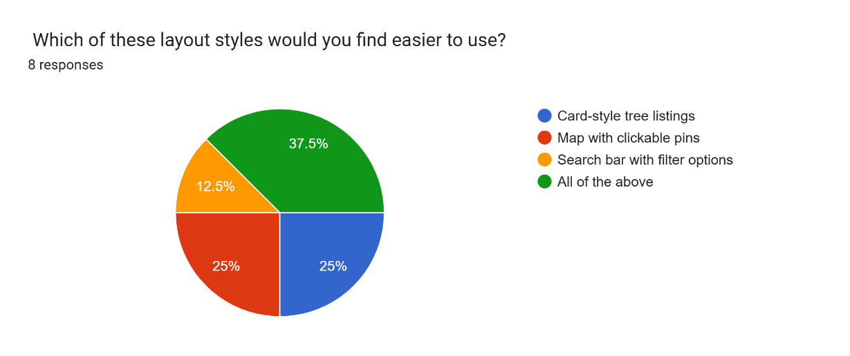***Which of these layout styles would you find easier to use?***

Respondents favored simple, clean layouts over complex designs.

**Conclusion:** UI/UX should prioritize minimalism and intuitive navigation.

1. 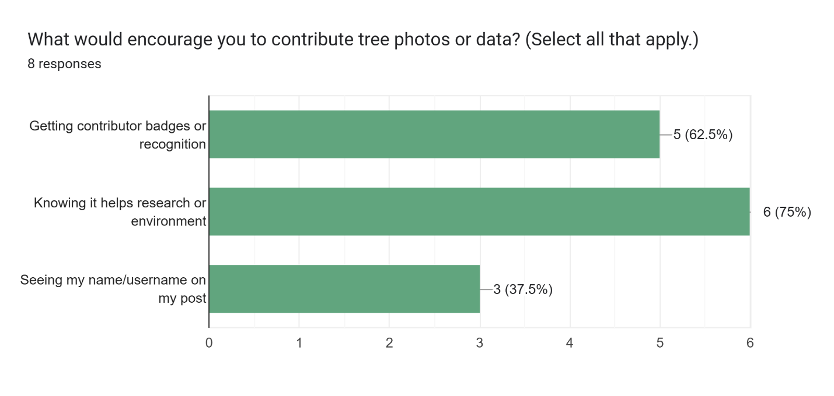***What would encourage you to contribute tree photos or data?***



Most respondents said they would support environmental research, motivated by gaining recognition and public credit for their posts.

**Conclusion:** Gamification and contributor acknowledgment can boost engagement.

1. ***What would make you want to visit this platform regularly?***

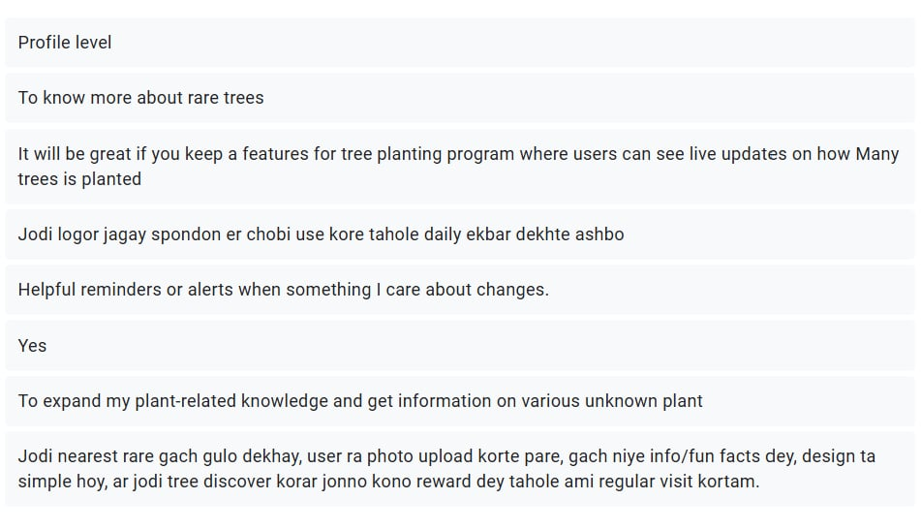Popular answers included Regular updates with new trees, Seasonal tree-related posts, and Community discussions.

**Conclusion:** Frequent, fresh content is critical for user retention.

1. 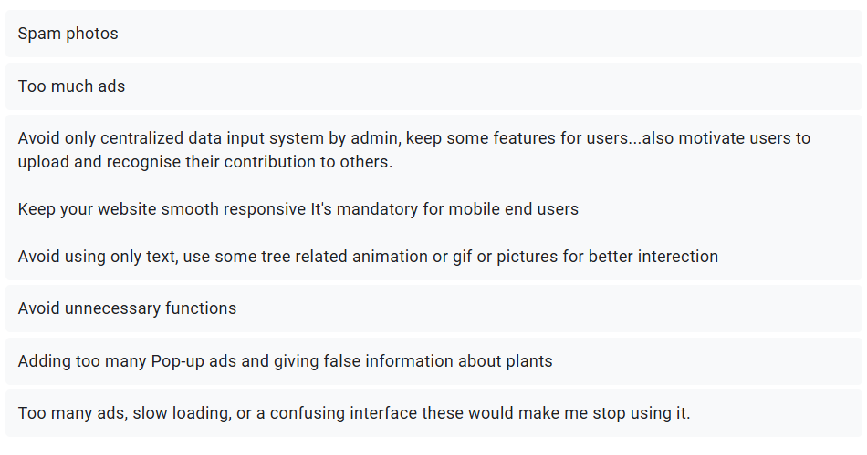***What is one thing we must avoid when designing this website—something that would make you stop using it?***

Participants warned against slow loading times, too many ads, and cluttered interfaces.

**Conclusion:** Performance optimization and clean design should be priorities.

1. 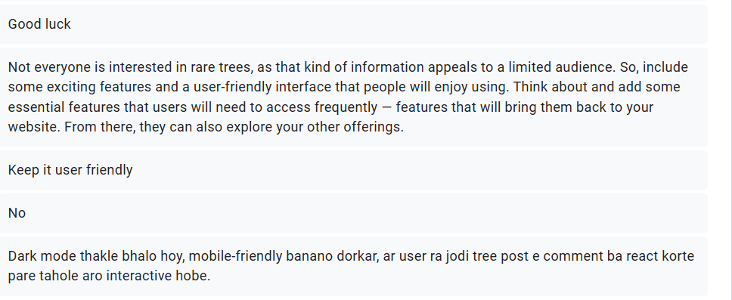***Any other feedback or suggestions?***

Respondents advised keeping the website user-friendly, mobile-friendly, and interactive, adding features like dark mode, comments/reactions on posts, and ensuring engaging, frequently used features to attract and retain a broader audience.

### Overall Survey Summary

The survey responses indicate that the primary user base will be young, tech-friendly individuals with a strong interest in nature and environmental conservation. There is high demand for map-based exploration, user contributions, and detailed tree profiles. Simplicity in design, quick performance, and recognition of contributors are key to user satisfaction. Respondents emphasized avoiding clutter and technical issues, while suggesting features such as offline mode and collaborations with educational institutions. These insights validate the project’s planned direction and provide clear guidance for prioritizing features in development.

## Interview

### Interviewee 1

**Name:** Noor Mairukh Khan Arnob

**Occupation:** Teacher

**Designation:** Lecturer, Department of Computer Science & Engineering, University of Asia Pacific

1. **Have you ever come across a tree that you found unique or rare?**

*“Yes, I have frequently come across many trees that look very interesting, but I do not know which species they belong to. So, when I come across such trees, because I could not identify which species they belong to, I cannot collect them, or know more about them, or how I can distribute these species for their conservation. So, it is a very important issue to me and the people who are concerned about the environment and species conservation.”*

1. **Did you do anything afterward to find it?**

*“I tried to search on Google, describing the species or taking their photos, but many times I do not take photos. So, I just forget, and many times it is the exploration of such species that goes unchecked. So that is why I think there is a need for some sort of standardized application procedure to identify such species.”*

1. **Do you think a website that shows rare trees on a map in Dhaka would be helpful to people like you?**

*“Yes, I think it would be a very good service to provide, especially for botanists or students who study wildlife or any kind of enthusiasts who are interested in gardening as well. So, I think it would be a good service.”*

1. **Do you think there is any feature that would make you come here, come to the website again and again? Any particular features?**

*“If that application is very rich with a diverse collection of databases of trees that are relevant to that ecosystem, or that are more frequent, or they are species that need preservation, I think that kind of diverse database, which is accessible and open for all, I think that kind of database or application would be very helpful.”*

1. **If there is a section of a blog where people share their tree stories or memories, would you like it?**

***“****Yes, in that application, there can also be a different section where plant enthusiasts can share their stories of finding new trees and growing them, and distributing them. Many people can post, like on Facebook, and they post many meetups where they distribute seeds of these rare trees. So, I think that can also be very helpful for species conservation.”*

1. **Have you ever taken a photo of a tree, wondered what kind of tree it is?**

*“Yes, I try to remember which species is which tree, but many of the time I forget, and many of these trees have very interesting names, like our poet who wrote our national anthology, he named many trees, like recently I came across a name he gave, which is Tarajola. Recently, it has become very popular, this kind of flower plant. So many of these trees have very beautiful names, and getting to know these names as well, it is a very interesting, thought-provoking experience. Many stories and also the books that are written about these trees, like the famous naturalist of Bangladesh, Jijan Sharma, who has written very beautiful books, which contain amazing pictures of these local Bangladeshi trees. And I think that the biodiversity of Bangladeshi plants, which is also very unique, can be comparable to any other beautiful country that we consider beautiful, like Switzerland or America, or England. Bangladesh has very beautiful plants which are rare, and they are also relevant to the global economy and global biodiversity.”*

1. **If you saw a tree labelled rare tree on a public map on the app, would you be curious enough to visit it?**

*“Yes, if I come to know that a rare tree is there on this map, I would definitely visit it. For example, I was recently looking for cashew nut trees. I don't know if you are aware of how a cashew nut grows, but in a cashew nut, there are two parts of the fruit. The top part is like a mango, or something like that, which is very fishy, and at the bottom part, there is the nut. So, we basically eat the bottom part where the nut is found, and the top part we never get to see or eat, but the top part is also edible. So, the only way we could see or eat that kind of delicacy is by visiting such trees, and if we do not know where these trees are present, then we cannot avail ourselves of such an experience. So, I think having this kind of map is very helpful, and one thing we also have to make sure of is that when people come to know about these trees, many of the time they will try to exploit such a tree. So recently, there has been a trend on Facebook, wherein the gardening groups always promote this Kath Golap. Recently, the price of Kath Golap plants has skyrocketed. Many Kath Golap species they sold for 500, 1,000, or 2,000 takas. So many times, whenever they see the Kath Golap plant, they just cut the plant. So many Kath Golap plants are cut off in this way. So, if we are distributing such information, we also have to make sure that those trees are protected as well, because if people just go and come and analyze it for their personal economic gain, it can be harmful for the trees. Recently in India, there was not a discovery, but some of you might be familiar with the palash tree. So, you will see that palash is a red flower, but palash can also be yellow, and white palash also exists in nature, which was prevalent maybe 100 years ago, but recently it is going extinct. This was how rare the genome is, and there is no conservation procedure taking place right now. So, in India, there are some palash trees, which are being seen in Purulia, in a place in India. There are a lot of palash trees there. So, in Purulia, they found out where those white palash trees are, but the people who found those trees did not disclose the exact location of those trees because they didn't want those trees to be harmed. I actually saw some photos of the white palash trees, but I saw that in the tree, there are marks of having cut the tree. So, people are actually, because these trees are very valuable, working with these valuable trees, which are very rare, so there is a chance of these trees being missing. So, we have to be careful and find out the way to distribute information, but we have to distribute it very carefully.”*

### Interviewee 2

**Name:** Syeda Sharmeen Sultana

**Occupation:** Teacher

**Designation:** Professor, Department of Botany, University of Dhaka

1. **You are an expert in plant identification, but how feasible do you think it is for the general public to identify plants and provide accurate information?**

*“For the general public, one accessible tool for plant identification is* ***Google Lens****, which allows users to photograph a specimen and receive an instant preliminary identification. For greater accuracy, reference can be made to the* ***Encyclopedia of Flora and Fauna of Bangladesh****. By comparing the photograph with the taxonomic descriptions of the relevant genus or family in this reference, the species can often be confirmed.”*

1. **From your perspective, could you name 2–3 trees in Dhaka that you consider truly “rare” or “unique” so we can highlight them from the beginning?**

*“For example, Gymnosperms like* ***Cycas*** *and* ***Pinus*** *are found in front of the Botany Department at Curzon Hall, University of Dhaka, but nowhere else are these quite rare plants.”*

1. **What does the term “rare tree” mean to you? Do you think it is important for the general public to know about these trees? Why?**

*“Historical accounts suggest that plant diversity was greater one or two centuries ago. Hybridization within the same genus, as well as between closely related families, has given rise to novel plant forms. Many such hybrids have become* ***polyploid****, a condition associated with increased size of the plant, flowers, and fruits. Polyploid plants often reproduce vegetatively, through grafting or cuttings, rendering pollen or gamete viability irrelevant. Over time, this has led to the disappearance of certain original parental species.”*

1. **How do you see a platform like this one that identifies and preserves rare trees benefiting our city or the environment?**

“*Of course, this can be useful.”*

1. **As a botany professor, in what ways would you like to contribute to this platform?**

*“Since I work with plant chromosomes, if someone brings me a new plant, I can analyze its chromosomes to determine whether it belongs to a different generation. However, I will not be able to provide the plant’s name. But I can connect you with those who can, and facilitate collaboration between them and your team.”*

1. **Do you think there are certain actions or behaviors that, if done unknowingly by the public, could harm rare trees? What should we be careful about?**

*“People may sometimes unknowingly cut down rare trees. We need to raise awareness about this. However, there are also some rare trees that can harm us.”*

1. **Do you think this system could be used in the future for academic research, urban planning, or education? How?**

*“This project has the potential for significant impact. While multiple botanical references exist, a* ***systematic plant mapping initiative*** *— especially if made accessible to the public — would greatly enhance the ability to detect the emergence of new plant species and promote conservation awareness.”*

### Interviewee 3

**Name:** Imran Nazir Emon

**Occupation:** Software Engineer

**Designation:** Software Engineer, Techsist

1. **We are using Django for the backend — do you think this is a good choice for a platform like this? Why or why not?**

*“Yes, absolutely. Since your idea is primarily machine learning–based and involves a kind of detection system, I prefer that everything be done using Python/Django.”*

1. **For users who are not very skilled with technology, what features or design decisions do you think are most important to make the platform user-friendly?**

*“For the design, it is essential to think in a way that makes the interface very beautiful and attractive, while also understanding the user’s behavior and psychology. Some features should be point-based so that users can use these points to access various opportunities and benefits.”*

1. **Do you think a map-based interface would be user-friendly for finding trees? In that case, what factors should we be careful about?**

*“Actually, this is a very difficult matter. I don’t think using a map will be very effective for finding a tree. But if you work with a database and enter the data properly, you will be able to visually guide the user. For example, you can show arrow signs to guide them. You can visually guide them through Google Maps.”*

1. **What is one feature you think could make this project stand out?**

*“This app will inspire environmentalists even more. At the same time, those who love trees or are looking for various medicinal plants that are hard to find will be able to locate them easily.”*

1. **Do you recommend any tools or platforms to make deployment, monitoring, or analytics easier?**

*“I would recommend using a platform like AWS for deployment, as it offers a complete solution. For instance, you can utilize EC2(Elastic Compute Cloud) for scalable computing resources and access a variety of tools for machine learning.”*

1. **If there are no financial benefits, how can we encourage people to contribute to this platform?**

*“It actually depends. Those who care deeply about the environment can contribute if they want to.”*

1. **As a senior, alumnus, or developer, what advice would you give us to make sure this project becomes something real and impactful, not just a project for grades?**

*“My advice would be to stay focused on the real problem you want to solve and keep the user in mind at every step. Don’t just aim to finish it for grades, think about how your project can actually help people or make a difference.”*

### Interviewee 4

**Name:** Lubaba Hasan

**Occupation:** Student

**Designation:** A 3rd-year student at the University of Asia Pacific

1. **Have you ever come across a tree that you found unique or rare? And you want to know about it?**

*“Maybe not the whole tree, but the leaves or the flowers.”*

1. **What did you do afterward?**

*“This happens all the time. Once, I was on a bus going to Comilla, and when I looked outside, I suddenly saw a unique tree. So, I asked my mom, “Ammu, what is this?” Usually, my mom is the source of information, just like your app or the web app is supposed to be. Then Ammu told me, “This is this tree,” and I was like, “Yeah, I remember now, this is what it’s called, this is what it does.” That’s usually how it goes.”*

1. **Do you think a website that shows rare trees on a map in Dhaka would be helpful to people like you?**

*“Yeah, personally, I would, especially if it has a good UI. For example, if you try to make it like a game, you gamify it. Let’s say there are three species you can find in Dhaka along a certain route. Then the app could ask, “Have you seen this tree?” or “You’re near this tree, can you spot it?” Something like that. I think I’d be more engaged that way. I’d have to keep my eyes open just so I can spot the tree. And that could also work like an achievement, right? If I’m the user and I finally spot the tree, I could be like, “Okay, great. Now I get a badge for it.” Then I can show off that badge on my profile, something like that. Okay, okay. Actually, that sounds pretty interesting.”*

1. **What features would make you return to use this platform more than once?**

*“Actually, this is a really great idea. I feel like people might use it more. People aren’t completely detached from social media; let’s give them that connection. So what would happen is, if there’s something interesting going on, something visually appealing, like if it’s gamified, then people will take screenshots and be like, “Hey, look what I achieved today.” At least some of them will. So I think this would be a good way to attract more users. Personally, as a user, I would want to use it more if it were fun and had a purpose like that.”*

1. **Would you enjoy reading other people's tree memories or experiences?**

*“Oh, yeah, yeah, this would be... I mean, this is such a nice thing. I know that when people get involved in niche things, they do it really beautifully. For example, the big tree at TSC, people could write stories about it. This could become a nice community activity. We could write stories about trees or stories related to trees, and there could even be some sad stories, like if a tree used to be here but doesn’t exist anymore.”*

# Requirement Analysis

The requirements for a system are the descriptions of the services it provides and its operational constraints.

## Functional Requirements (FRs)

Functional requirements define the specific behaviors and actions that a system or software must perform to meet user needs. The following section presents the Requirement Analysis for this project, identified and refined based on the project description, stakeholder interviews, and survey findings.

### Viewer Functional Requirements

* The system shall allow viewers to browse and search for trees by name, category, or location. (**High**)
* The system shall display trees on an interactive map with markers. (**High**)
* The system shall provide detailed tree profiles (images, species name, origin, ecological importance, location). (**High**)
* The system shall allow viewers to request identification for unknown trees. (**Medium**)
* The system shall allow viewers to comment on tree profiles and posts. (**Medium**)
* The system shall display the number of people who have bookmarked or visited a specific tree entry. (**Low**)
* The system shall allow viewers to rate tree locations. (**Medium**)
* The system shall allow filtering of search results by tree type, location, or rarity. (**High**)

### Contributor Functional Requirements

* The system shall allow contributors to register and log in. (**High**)
* The system shall allow contributors to upload tree sightings with geotagged photos. (**High**)
* The system shall allow contributors to create informational posts (tree facts, seasonal updates, conservation notes). (**Medium**)
* The system shall allow contributors to update or delete their own submissions. (**Medium**)
* The system shall categorize trees by type (e.g., flowering, native, endangered). (**Medium**)
* The system shall send notifications for new tree posts or updates. (**Low**)
* The system shall store and display user-contributed feedback for each tree. (**Medium**)

### Admin Functional Requirements

* The system shall allow admins to approve or reject submitted content. (**High**)
* The system shall allow admins to manage user roles (viewer, contributor, admin). (**High**)
* The system shall allow admins to update or delete any user-submitted content. (**High**)
* The system shall maintain an archive of all documented trees. (**Medium**)
* The system shall allow exporting of tree data (e.g., CSV, JSON) for research purposes. (**Low**)

## Non-Functional Requirements (NFRs)

* **Performance** – Map and search results should load in under 3 seconds.
* **Scalability** – The system should handle at least 10,000 tree entries.
* **Security** – All passwords must be stored with encryption (e.g., bcrypt).
* **Usability** – The UI must be mobile-friendly and intuitive.
* **Compatibility** – Support for Chrome, Firefox, Safari, and mobile browsers.
* **Reliability** – Ensure 99% uptime for the hosting server.
* **Maintainability** – Code should be modular for easy updates.
* **Accessibility** – Meet WCAG accessibility standards for visually impaired users.
* **Localization** – Support both English and Bangla languages.
* **Backup & Recovery** – Automatic database backups every 24 hours.

# Methodology

## Diagrams

For "Rare Tree Locator", several types of diagrams have been created to provide comprehensive system documentation and understanding of the system architecture.

### Entity-Relationship (ER) Diagram ([Hi-Resolution Image](https://github.com/tanishataranoon/Rare-tree-Locator/blob/84fc54cbf92b20207713122f5e2b55757745809b/ERDiagram.png))

The ER diagram for the Rare Tree Locator system models how different entities interact to support tree identification, contribution, and community engagement.

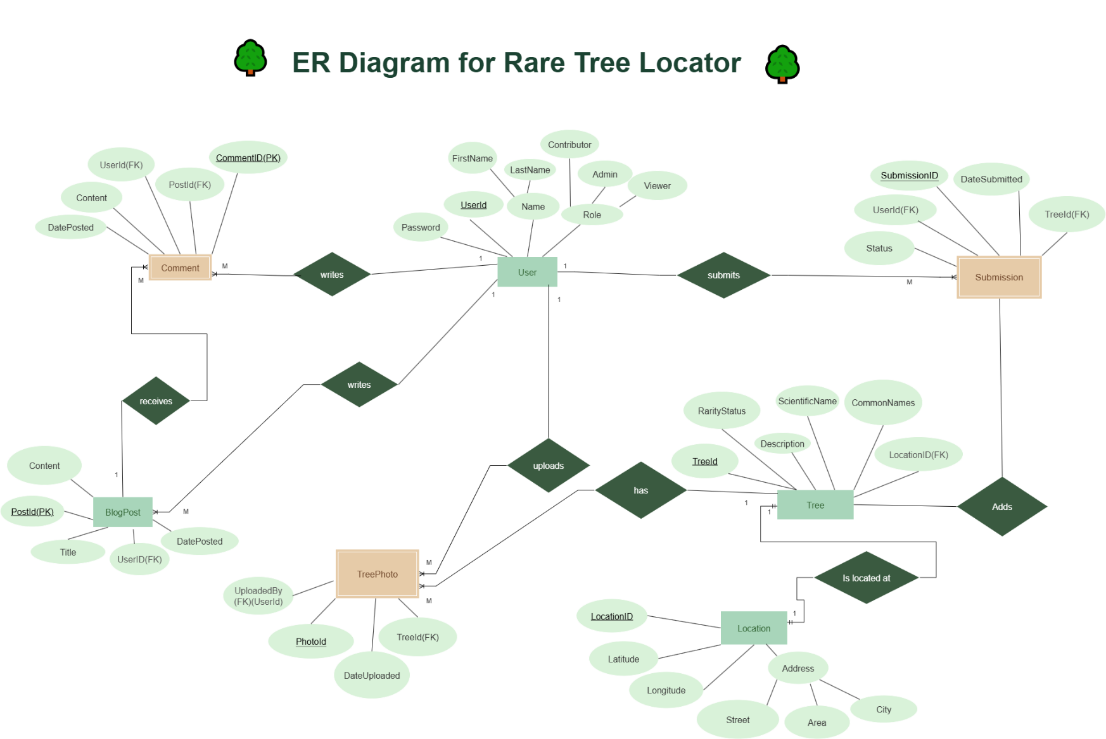

This diagram represents the core data model for the Rare Tree Locator system. The main entities include **User, Tree, Location, Submission, TreePhoto, BlogPost, and Comment.**

* **Users** can take on different roles (Viewer, Contributor, Admin) and perform activities such as submitting new trees, uploading photos, writing blog posts, and commenting.
* **Trees** are the central entity, each with attributes such as scientific name, description, rarity status, and multiple common names (multivalued).
* Each tree is associated with exactly one **Location**, which contains a composite address.
* **Submissions** are created when contributors add new trees, and admins verify them.
* **TreePhotos** are weak entities, since they depend on both the tree and the user who uploaded them.
* **BlogPosts** and **Comments** allow community engagement.
* The relationships reflect key interactions, such as User submits Submission, Tree is located at Location, and User uploads TreePhoto.

Overall, this ER diagram highlights how structured data relationships ensure accuracy, scalability, and collaborative participation in preserving rare and unique trees in Dhaka.

### Data Flow Diagram ([Hi-Resolution Image](https://github.com/tanishataranoon/Rare-tree-Locator/blob/main/DFD_Sajid.png))

This diagram is a Data Flow Diagram (DFD) representing the workflow of a tree information and management system. It illustrates how different users (such as viewers, contributors, admins, and external researchers) interact with the system’s processes and databases.

It illustrates how different users (such as viewers, contributors, admins, and external researchers) interact with the system’s processes and databases. The system supports functionalities such as user management, tree identification requests, browsing and searching tree data, submitting sightings, creating and managing posts, and commenting or rating content. Key processes include content approval, archiving/exporting data, and managing interactions between the **Tree Database**, **User Database**, and **Posts/Comments Database**. The diagram also highlights how external organizations can request data exports, and how feedback flows through various components to ensure a structured and interactive platform.

### Use Case Diagram ([Hi-Resolution Image](https://github.com/tanishataranoon/Rare-tree-Locator/blob/main/UseCaseDiagram.drawio.png))

This use case diagram illustrates the Tree Information System, highlighting the roles of four distinct actors and their interactions with system functionalities:

**Viewer** – explores tree data through search and identification requests, while optionally engaging with content by bookmarking, rating, and commenting.

**Contributor** – enriches the system by submitting tree sightings and managing posts.

**Admin** – oversees platform governance through user management and content approval.

**External** **Researcher** – interacts with the system primarily for data export and analysis.

**System Highlights:**

Browse/Search Trees → includes View Tree Profile, since searching naturally leads to viewing details.

View Tree Profile → extends Bookmark, Rate, Comment, as these are optional actions while exploring.

Contributor Functions → Submit Tree Sighting and Create/Manage Posts to ensure content growth.

Admin Functions → Manage Users and Content Approval, secure data quality, and user authenticity.

Data Functions → Archive & Export Data and Request Data Export, giving researchers structured access.