WEEK 3 INTERNSHIP SUBMISSION REPORT
Advanced Data Analysis and Visualization in Logistics
Project: Inventory Management and Demand Forecasting for a Retail Supply Chain
Submitted by: Tanisha Yezarkar

1. Objective
The objective of Week 3 was to perform exploratory data analysis (EDA) on the cleaned retail sales and inventory dataset prepared in Week 2. The analysis focused on sales performance, inventory levels, product categories, store locations, lead time, relationships between variables, and visual communication of findings using Python.

2. Dataset and Methodology
The analysis used 150 cleaned records from the Week 2 preprocessing stage. The dataset includes sales date, product category, store location, quantity sold, inventory level, order quantity, lead time, unit price, promotion status, sales value, weekly demand, and stockout-risk indicators. The main tools used were Python, Pandas, NumPy, and Matplotlib.
Analysis Area | Method Used | Purpose
Descriptive statistics | Mean, median, minimum, maximum, standard deviation | Understand central tendency and spread
Category analysis | Groupby and aggregation | Compare sales across product categories
Location analysis | Groupby and aggregation | Compare store-level sales contribution
Correlation analysis | Pearson correlation | Study relationships among numerical variables
Trend analysis | Date grouping and line chart | Observe daily sales movement
Visualization | Bar, scatter, and line charts | Communicate patterns clearly

3. Descriptive Statistics and Key Metrics
Metric | Calculated Result
Total records analysed | 150
Total sales value | ₹23,773,271.33
Average quantity sold | 59.43 units
Median quantity sold | 57.50 units
Average inventory level | 229.13 units
Median inventory level | 231.00 units
Average lead time | 7.85 days
Median lead time | 8.00 days
High stockout-risk records | 22

4. Analysis by Product Category
The category-level analysis showed that Electronics generated the highest sales value, approximately ₹6,165,084.35. Grouping by category helps identify which product groups contribute most to revenue and where inventory planning may need more attention.
Product Category | Sales Value (INR)
Electronics | ₹6,165,084.35
Stationery | ₹5,516,537.83
Grocery | ₹5,172,153.02
Home | ₹3,554,500.38
Beauty | ₹3,364,995.75

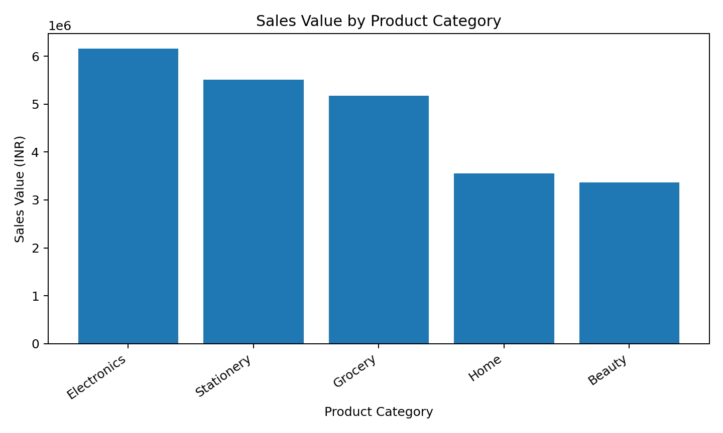
Figure 1: Sales value by product category

5. Analysis by Store Location
The store-level analysis identified Mumbai as the location with the highest sales value, approximately ₹4,425,316.15. This comparison can help management review location-wise demand, stock allocation, and replenishment priorities.
Store Location | Sales Value (INR)
Mumbai | ₹4,425,316.15
Surat | ₹4,419,861.96
Nashik | ₹4,406,367.97
Ahmedabad | ₹4,147,026.88
Nagpur | ₹3,570,033.28
Pune | ₹2,804,665.09

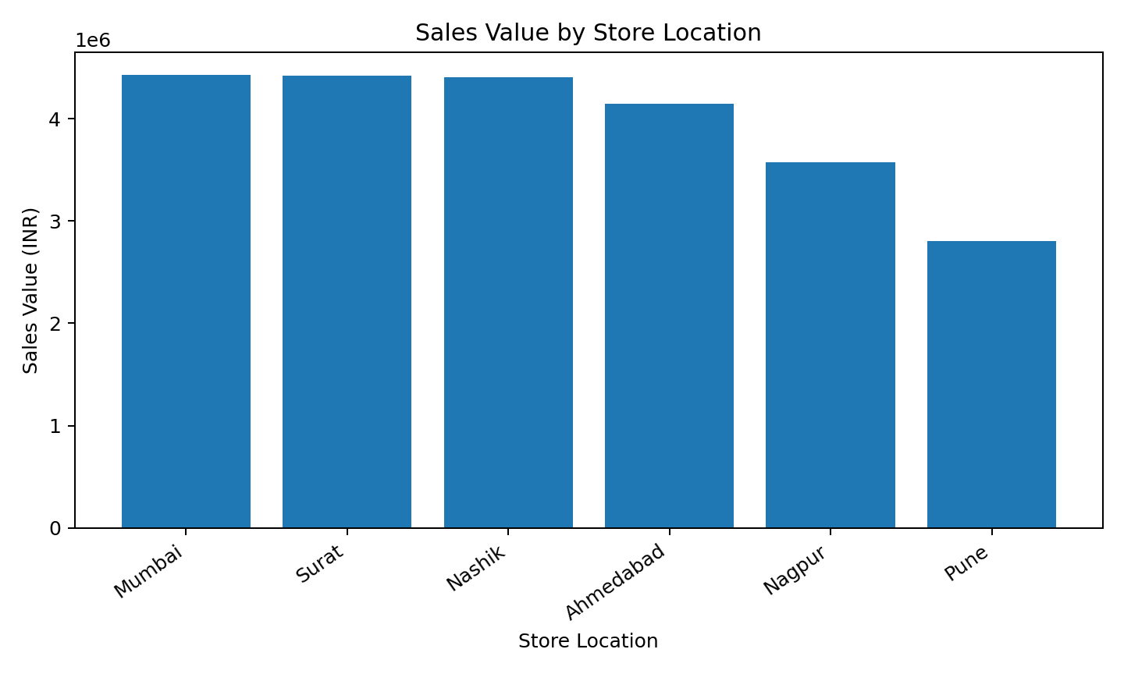
Figure 2: Sales value by store location

6. Relationship and Correlation Analysis
The Pearson correlation between Quantity_Sold and Inventory_Level was -0.180, while the correlation between Quantity_Sold and Lead_Time_Days was 0.065. Correlation measures the strength and direction of a linear relationship; it does not prove that one variable causes another. These values should therefore be interpreted as exploratory evidence.
Variable Pair | Pearson Correlation
Quantity Sold vs Inventory Level | -0.180
Quantity Sold vs Lead Time | 0.065

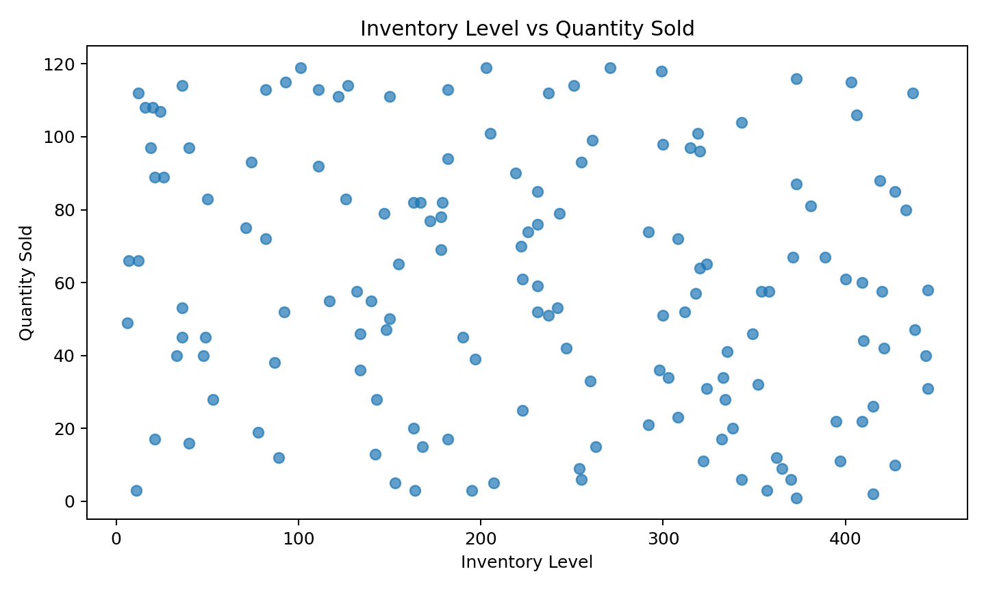
Figure 3: Inventory level versus quantity sold

7. Daily Sales Trend
The daily aggregation was used to examine changes in sales value over time. The highest daily sales value in the analysed data occurred on 2026-03-23, with approximately ₹1,439,867.13. A line chart was selected because it shows movement across dates and makes peaks or lower-sales periods easier to observe.
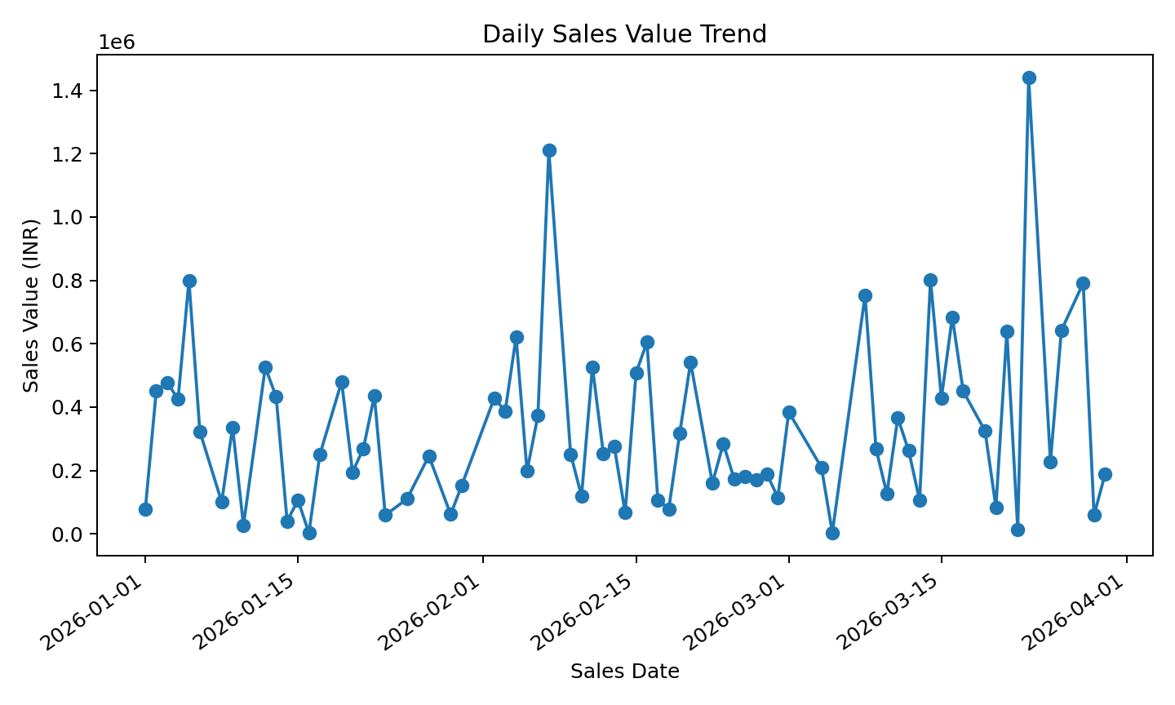
Figure 4: Daily sales value trend

8. Analytical Insights
- Electronics was the highest-sales category in the analysed dataset, so its demand pattern may deserve closer monitoring.
- Mumbai generated the highest store-level sales value, which can support location-wise inventory planning.
- The calculated correlation values provide an initial view of relationships between demand, inventory, and lead time, but they are not proof of causation.
- 22 records were marked as high stockout risk using the rule-based indicator from Week 2. This flag should be validated with actual stockout and replenishment history.
- Visualizations make aggregated results easier to compare and help identify patterns that may not be obvious from a raw table alone.

9. Visualization Selection Justification
Visualization | Reason for Selection
Bar chart – category sales | Useful for comparing sales totals across discrete product categories.
Bar chart – store sales | Makes differences between store locations easy to compare.
Scatter plot – inventory vs quantity | Shows the direction, spread, and possible clusters or unusual observations between two numerical variables.
Line chart – daily sales | Appropriate for displaying changes and peaks over a sequence of dates.

10. Challenges and Limitations
The dataset is simulated and therefore may not represent the complete complexity of a real retail logistics operation. The stockout-risk flag is a simple rule-based feature, not a trained predictive model. Correlation results may be affected by sample size, simulated patterns, and omitted variables. Future work should include real historical demand, promotional effects, supplier reliability, seasonality, and actual stockout records.

11. Reflection and Learning
During Week 3, I learned how exploratory data analysis converts cleaned data into meaningful business information. I calculated descriptive statistics for 150 records and compared sales across categories and store locations. I also used a scatter plot to examine the relationship between inventory and quantity sold and used correlation values as an initial numerical summary. The charts helped me understand why the choice of visualization should depend on the type of question being answered. Bar charts were useful for comparisons, scatter plots were useful for relationships, and line charts were useful for time-based trends.
I also learned that analytical findings must be explained carefully. A high sales category does not automatically mean that it has the highest profit, and correlation does not establish causation. The stockout-risk indicator should be treated as a preliminary business rule rather than a final prediction. This task improved my skills in Pandas grouping, aggregation, descriptive statistics, correlation, visualization, and communicating results in a structured report.

12. Conclusion and Recommendations
The Week 3 analysis provided a structured view of sales performance, store contribution, inventory relationships, and daily sales movement. The results can support further investigation into demand patterns and stock allocation. Recommended next steps are to analyse seasonality, compare promotional and non-promotional demand, build a forecasting model, and validate the stockout-risk rule with real operational data.

13. Files Used for Submission
- Tanisha_Yezarkar_Week3_Advanced_Data_Analysis_Report.docx
- week3_eda_visualization.py
- sales_inventory_cleaned_week2.csv (supporting dataset)
End of Week 3 Report

