LOGISTICS DATA ANALYST INTERNSHIP – WEEK 2 TASK
Data Collection, Cleaning, and Preprocessing for Inventory & Demand Analysis
Student Name: Tanisha Yezarkar
Project: Inventory Management and Demand Forecasting for a Retail Supply Chain
Role: Data Analyst Intern
Tools: Python, Pandas, NumPy, Matplotlib

1. Connection with Week 1 Project
This Week 2 task continues the Week 1 project, “Inventory Management and Demand Forecasting for a Retail Supply Chain.” Week 1 defined the business problem as reducing stockouts and excess inventory through demand analysis and forecasting. Week 2 focuses on preparing the underlying sales and inventory data so that reliable exploratory analysis and forecasting can be performed in later stages.

2. Objective
- Collect or simulate sales and inventory records relevant to retail logistics.
- Inspect the dataset for missing values, duplicates, invalid values, inconsistent categories, and outliers.
- Clean and preprocess the data using Python and Pandas.
- Create useful analytical features related to sales, inventory, and stockout risk.
- Normalize selected numerical variables for future analytical or machine-learning use.
- Document the complete preprocessing methodology in a reproducible form.

3. Dataset Description
A simulated retail sales and inventory dataset was prepared to represent product-level records across multiple store locations. The raw dataset contains 152 rows, including two deliberately duplicated records and common data-quality problems. The variables cover product information, sales date, location, supplier, quantity sold, inventory level, order quantity, supplier lead time, unit price, and promotion status.
Column | Description | Type
Record_ID | Unique record identifier | Integer
Product_ID | Product identifier | Categorical
Product_Category | Product category | Categorical
Sales_Date | Date of sales record | Date
Store_Location | Store/warehouse location | Categorical
Supplier | Supplier name | Categorical
Quantity_Sold | Units sold | Numeric
Inventory_Level | Units currently in inventory | Numeric
Order_Quantity | Units ordered for replenishment | Numeric
Lead_Time_Days | Supplier delivery lead time | Numeric
Unit_Price_INR | Price per unit | Numeric
Promotion | Whether promotion was active | Categorical

4. Data Quality Assessment
The raw dataset was checked before preprocessing. Missing values were present in important numerical columns. Duplicate records were also included. Some categorical fields contained inconsistent capitalization or extra spaces. Negative quantities/inventory levels represented invalid business values, while unusually high unit price and lead-time values represented potential outliers.
Issue | Observation | Treatment
Missing values | Several sales, inventory, lead-time and price values were missing. | Median imputation for numerical fields.
Duplicate records | 2 duplicate rows were detected. | Remove exact duplicate records.
Inconsistent text | Examples include 'electronics ', 'yes', and 'mumbai '. | Trim spaces and standardize case.
Invalid values | Negative quantity sold and negative inventory are not valid for this business context. | Convert invalid negatives to missing and impute.
Outliers | Extreme price and lead-time observations can distort analysis. | Detect with IQR and cap extreme values.
Different scales | Sales, inventory, lead time and price use different ranges. | Create min-max normalized variables.
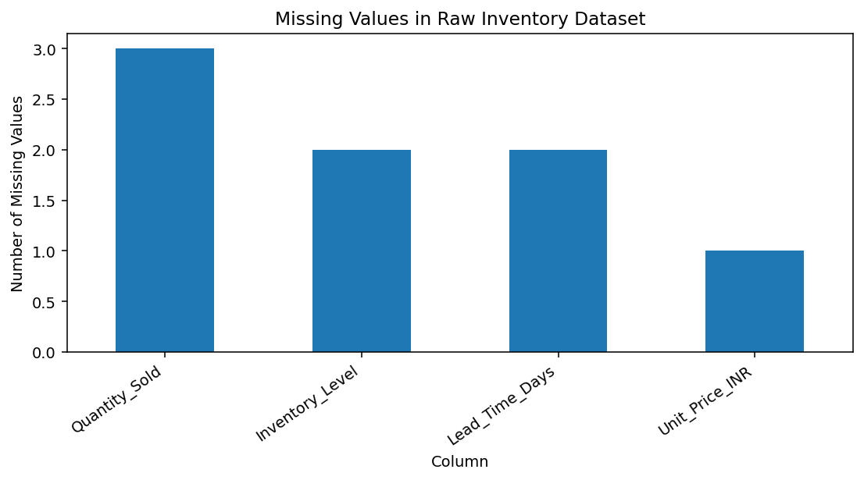
Figure 1. Missing values identified before cleaning.

5. Cleaning and Preprocessing Methodology

5.1 Date and Text Standardization
Sales_Date was converted to a proper date format. Categorical fields were stripped of extra spaces and standardized to title case so that the same category is not represented by multiple labels.
clean["Sales_Date"] = pd.to_datetime(clean["Sales_Date"], errors="coerce")
for col in ["Product_Category","Store_Location","Supplier","Promotion"]:
clean[col] = clean[col].astype("string").str.strip().str.title()

5.2 Duplicate Removal
Two exact duplicate records were removed. Duplicate removal prevents the same transaction from being counted twice and protects measures such as total sales and demand estimates from artificial inflation.
clean = clean.drop_duplicates()

5.3 Missing Values
The median was selected for numerical missing values because inventory and sales data can contain extreme observations, and the median is more robust than the mean. Categorical missing values were filled using the most frequent category.
for col in ["Quantity_Sold","Inventory_Level","Lead_Time_Days","Unit_Price_INR"]:
clean[col] = clean[col].fillna(clean[col].median())

5.4 Invalid Business Values
Negative quantity sold and negative inventory are not meaningful in this retail context. These values were converted to missing and then imputed using the numerical median rather than being silently retained.
clean.loc[clean["Quantity_Sold"] < 0, "Quantity_Sold"] = np.nan
clean.loc[clean["Inventory_Level"] < 0, "Inventory_Level"] = np.nan

5.5 Outlier Treatment Using IQR
Potential outliers were identified with the Interquartile Range method. For each numerical variable, Q1 and Q3 were calculated and the acceptable range was defined as Q1 − 1.5×IQR to Q3 + 1.5×IQR. Extreme observations were capped at these limits. Capping was chosen instead of deleting complete records so that useful transaction information was preserved.
q1 = clean[col].quantile(0.25)
q3 = clean[col].quantile(0.75)
iqr = q3 - q1
lower = q1 - 1.5 * iqr
upper = q3 + 1.5 * iqr
clean[col] = clean[col].clip(lower, upper)
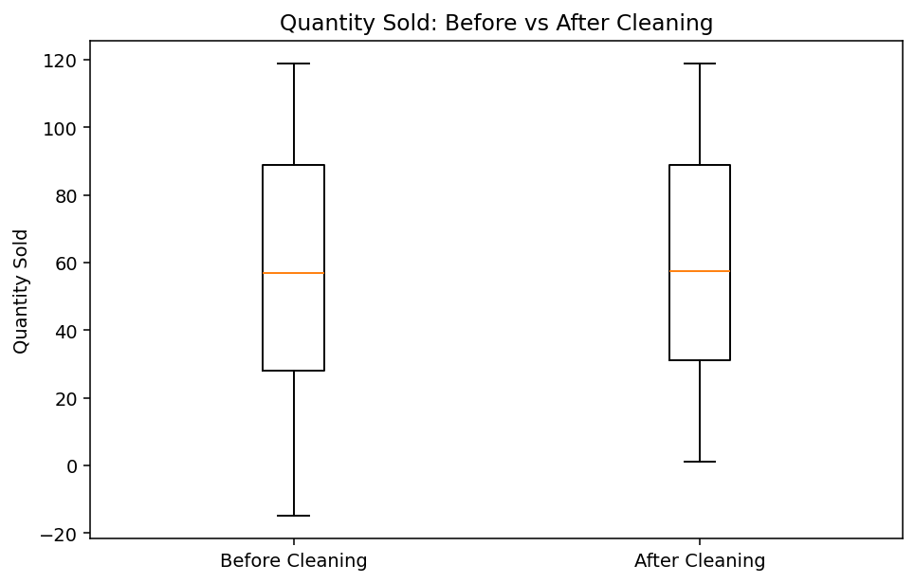
Figure 2. Quantity sold before and after cleaning.

5.6 Feature Engineering
Features were created to connect the cleaned dataset directly with the Week 1 business objectives. Sales_Value_INR estimates sales value, Inventory_Turnover_Proxy compares units sold with inventory, Stockout_Risk_Flag identifies records where demand is at least as high as available inventory, and Weekly_Demand provides a product-level average demand signal.
clean["Sales_Value_INR"] = clean["Quantity_Sold"] * clean["Unit_Price_INR"]
clean["Inventory_Turnover_Proxy"] = clean["Quantity_Sold"] / clean["Inventory_Level"]
clean["Stockout_Risk_Flag"] = np.where(clean["Inventory_Level"] <= clean["Quantity_Sold"], "High", "Normal")
clean["Weekly_Demand"] = clean.groupby("Product_ID")["Quantity_Sold"].transform("mean")

5.7 Normalization
Min-max normalization was applied to selected numerical variables. This transforms each variable to a 0–1 range and can help when variables with different units are later used in analytical or machine-learning workflows.
Normalized value = (value − minimum) / (maximum − minimum)

6. Preprocessing Pipeline
- Load the sales and inventory CSV dataset.
- Inspect rows, columns, data types, missing values and duplicates.
- Convert dates and standardize categorical text.
- Remove duplicate records.
- Convert invalid negative business values to missing.
- Impute missing numerical values using the median and categorical values using the mode.
- Detect and cap numerical outliers using IQR.
- Create sales value, inventory turnover proxy, weekly demand and stockout-risk features.
- Create normalized numerical variables.
- Validate the cleaned dataset and export it as a new CSV file.

7. Validation Results
Metric | Result
Raw rows | 152
Duplicate rows removed | 2
Cleaned rows | 150
Missing cells after cleaning | 0
New business/normalized features | 8
The validation confirms that duplicate records were removed and the handled missing/invalid values were resolved. The resulting dataset is suitable for the next stage of the Week 1 roadmap: exploratory data analysis and demand-pattern analysis.

8. Preliminary Visual Analysis
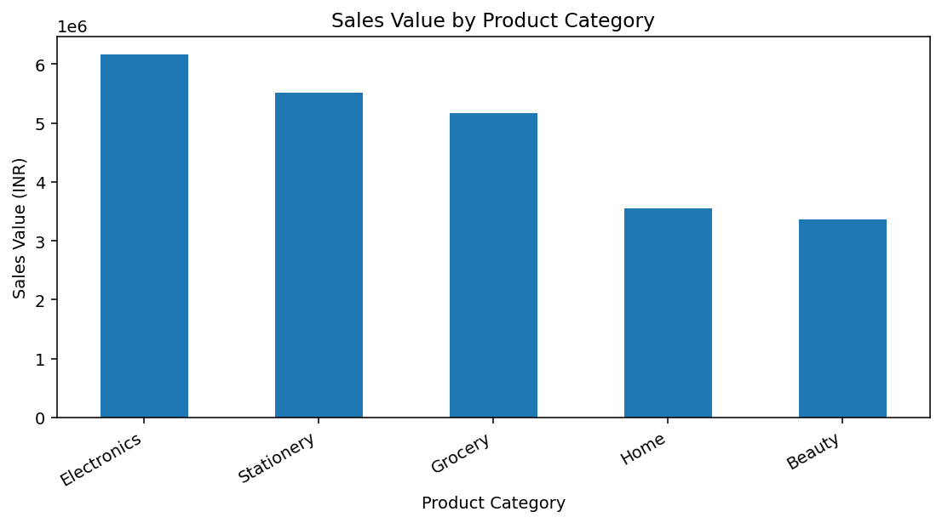
Figure 3. Sales value by product category.
This chart provides an initial comparison of sales value across categories. In a later EDA stage, the same categories can be examined by month, store, promotion, and product to identify high-demand and slow-moving segments.
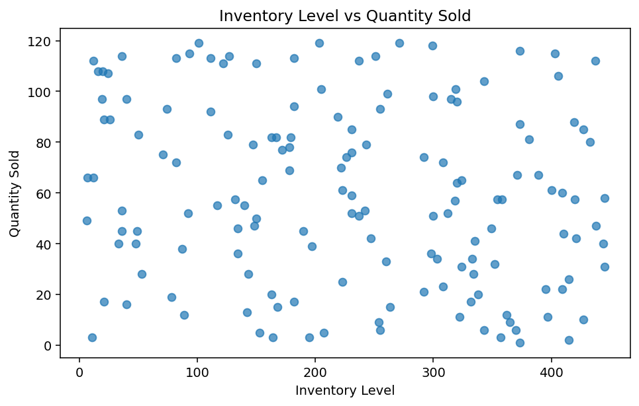
Figure 4. Inventory level compared with quantity sold.
Comparing inventory with quantity sold can help identify records where available stock may be insufficient relative to demand. This supports the Week 1 objective of reducing stockout risk while avoiding unnecessary excess inventory.

9. Challenges and Solutions
Missing or incomplete records: Used robust median imputation and mode imputation while retaining useful rows.
Duplicate transactions: Removed exact duplicates before calculating business features.
Inconsistent category labels: Standardized spaces and capitalization.
Invalid negative values: Treated them as invalid business values and converted them to missing before imputation.
Extreme observations: Used IQR-based capping to reduce distortion without deleting whole records.
Different variable scales: Created normalized versions for future modelling and comparison.

10. Conclusion
Week 2 converted the conceptual Week 1 inventory-management project into a practical data-preparation workflow. The cleaned dataset now provides a consistent foundation for exploratory data analysis, demand forecasting, inventory-risk analysis, and later modelling. The preprocessing decisions were selected to preserve useful business records while reducing the impact of missing, duplicated, inconsistent, invalid, and extreme observations.
The next analytical stage can use this cleaned data to study demand trends, seasonality, high- and low-demand products, store-level patterns, and inventory behaviour before building a forecasting model.

11. Tools and References
Python, Pandas, NumPy and Matplotlib were used for this task.
Dataset: Simulated retail sales and inventory records created for the internship exercise.
Project context: Week 1 – Inventory Management and Demand Forecasting for a Retail Supply Chain.

