**Exercise 1: Configuring a Basic Spring Application**

**Scenario:**

Your company is developing a web application for managing a library. You need to use the Spring Framework to handle the backend operations.

**Steps:**

1. **Set Up a Spring Project:**
   * Create a Maven project named **LibraryManagement**.
   * Add Spring Core dependencies in the **pom.xml** file.
2. **Configure the Application Context:**
   * Create an XML configuration file named **applicationContext.xml** in the **src/main/resources** directory.
   * Define beans for **BookService** and **BookRepository** in the XML file.
3. **Define Service and Repository Classes:**
   * Create a package **com.library.service** and add a class **BookService**.
   * Create a package **com.library.repository** and add a class **BookRepository**.
4. **Run the Application:**
   * Create a main class to load the Spring context and test the configuration.

**Solution:**

**1. Set Up a Spring Project:**

* + - * Created a Maven Project named LibraryManagement.
      * Added Spring Core dependencies in the **pom.xml** file.

<?xml version="1.0" encoding="UTF-8"?>

<project xmlns="http://maven.apache.org/POM/4.0.0"

xmlns:xsi="http://www.w3.org/2001/XMLSchema-instance"

xsi:schemaLocation="http://maven.apache.org/POM/4.0.0 http://maven.apache.org/xsd/maven-4.0.0.xsd">

<modelVersion>4.0.0</modelVersion>

<groupId>org.example</groupId>

<artifactId>LibraryManagment</artifactId>

<version>1.0-SNAPSHOT</version>

<properties>

<maven.compiler.source>23</maven.compiler.source>

<maven.compiler.target>23</maven.compiler.target>

<project.build.sourceEncoding>UTF-8</project.build.sourceEncoding>

</properties>

<dependencies>

<!-- https://mvnrepository.com/artifact/org.springframework/spring-context -->

<dependency>

<groupId>org.springframework</groupId>

<artifactId>spring-context</artifactId>

<version>6.2.7</version>

</dependency>

</dependencies>

</project>

**2. Configure the Application Context:**

* + - Created a XML configuration file named **applicationContext.xml** in the **src/main/resources** directory.
    - Define beans for **BookService** and **BookRepository** in the XML file.

**applicationContext.xml:**

<?xml version="1.0" encoding="UTF-8"?>

<beans xmlns="http://www.springframework.org/schema/beans"

xmlns:xsi="http://www.w3.org/2001/XMLSchema-instance"

xmlns:context="http://www.springframework.org/schema/context"

xsi:schemaLocation="http://www.springframework.org/schema/beans

http://www.springframework.org/schema/beans/spring-beans.xsd

http://www.springframework.org/schema/context

http://www.springframework.org/schema/context/spring-context.xsd">

<context:annotation-config/>

<context:component-scan base-package="com.baeldung.applicationcontext"/>

<bean id="bookRepository" class="com.library.repository.BookRepository" />

<bean id="bookService" class=“com.library.service.BookService"/>

</beans>

**3. Define Service and Repository Classes:**

* + - Create a package **com.library.service** and add a class **BookService**.
    - Create a package **com.library.repository** and add a class **BookRepository**.

**package com.library.service;**

import com.library.repository.BookRepository;

public class **BookService** {

public void printMessage() {

System.out.println("BookService bean is working.");

}

}

package **com.library.repository**;

public class **BookRepository** {

public void printMessage() {

System.out.println("BookRepository bean is working.");

}

}

**4. Run the Application:**

* + - Created a main class to load the Spring context and test the configuration.

package com.library;

import com.library.service.BookService;

import org.springframework.context.ApplicationContext;

import org.springframework.context.support.ClassPathXmlApplicationContext;

public class **Main** {

public static void main(String[] args) {

ApplicationContext context=new ClassPathXmlApplicationContext("applicationContext.xml");

BookService bookService=context.getBean("bookService",BookService.class);

bookService.printMessage();

BookRepository bookRepository=context.getBean("bookRepository",BookRepository.class);

bookRepository.printMessage();

}

}

**OUTPUT:**

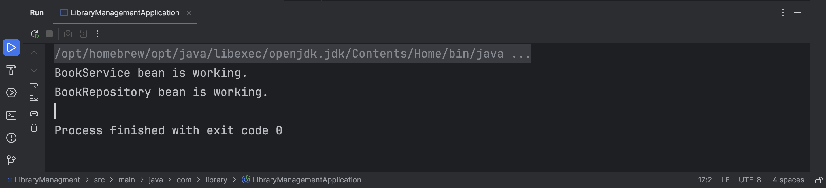

**Exercise 2: Implementing Dependency Injection**

**Scenario:**

In the library management application, you need to manage the dependencies between the BookService and BookRepository classes using Spring's IoC and DI.

**Steps:**

1. **Modify the XML Configuration:**
   * Update **applicationContext.xml** to wire **BookRepository** into **BookService**.
2. **Update the BookService Class:**
   * Ensure that **BookService** class has a setter method for **BookRepository**.
3. **Test the Configuration:**
   * Run the **LibraryManagementApplication** main class to verify the dependency injection.

**Solution :**

**1. Modify the XML Configuration:**

* + - * Update **applicationContext.xml** to wire **BookRepository** into **BookService**.

**applicationContext.xml:**

<?xml version="1.0" encoding="UTF-8"?>

<beans xmlns="http://www.springframework.org/schema/beans"

xmlns:xsi="http://www.w3.org/2001/XMLSchema-instance"

xmlns:context="http://www.springframework.org/schema/context"

xsi:schemaLocation="http://www.springframework.org/schema/beans

http://www.springframework.org/schema/beans/spring-beans.xsd

http://www.springframework.org/schema/context

http://www.springframework.org/schema/context/spring-context.xsd">

<context:annotation-config/>

<context:component-scan base-package="com.baeldung.applicationcontext"/>

<bean id="bookRepository" class="com.library.repository.BookRepository" />

<bean id="bookService" class="com.library.service.BookService">

<property name="bookRepository" ref="bookRepository" />

</bean>

</beans>

**2. Update the BookService Class:**

* + - * Ensure that **BookService** class has a setter method for **BookRepository**.

**package com.library.service;**

import com.library.repository.BookRepository;

public class **BookService** {

private BookRepository bookRepository;

public void setBookRepository(BookRepository bookRepository) {

this.bookRepository = bookRepository;

}

public void addBook(String title) {

System.out.println("Adding book: " + title);

bookRepository.saveBook(title);

}

}

**3. Test the Configuration:**

* + - * Run the **LibraryManagementApplication** main class to verify the dependency injection.

package com.library;

import com.library.service.BookService;

import org.springframework.context.ApplicationContext;

import org.springframework.context.support.ClassPathXmlApplicationContext;

public class **LibraryManagementApplication** {

public static void main(String[] args) {

ApplicationContext context=new ClassPathXmlApplicationContext("applicationContext.xml");

BookService bookService=context.getBean("bookService",BookService.class);

bookService.addBook("Ultimate Guide to Spring");

}

}

**OUTPUT:**

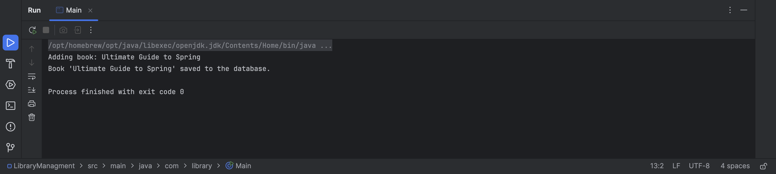

**Exercise 4: Creating and Configuring a Maven Project**

**Scenario:**

You need to set up a new Maven project for the library management application and add Spring dependencies.

**Steps:**

1. **Create a New Maven Project:**
   * Create a new Maven project named **LibraryManagement**.
2. **Add Spring Dependencies in pom.xml:**
   * Include dependencies for Spring Context, Spring AOP, and Spring WebMVC.
3. **Configure Maven Plugins:**
   * Configure the Maven Compiler Plugin for Java version 1.8 in the pom.xml file.

**Solution :**

**pom.xml**

<project xmlns="http://maven.apache.org/POM/4.0.0"

xmlns:xsi="http://www.w3.org/2001/XMLSchema-instance"

xsi:schemaLocation="http://maven.apache.org/POM/4.0.0 https://maven.apache.org/xsd/maven-4.0.0.xsd">

<modelVersion>4.0.0</modelVersion>

<groupId>com.library</groupId>

<artifactId>LibraryManagement</artifactId>

<version>0.0.1-SNAPSHOT</version>

<dependencies>

<!--

https://mvnrepository.com/artifact/org.springframework/spring-context -->

<dependency>

<groupId>org.springframework</groupId>

<artifactId>spring-context</artifactId>

<version>6.2.7</version>

</dependency>

<!--

https://mvnrepository.com/artifact/org.springframework/spring-webmvc -->

<dependency>

<groupId>org.springframework</groupId>

<artifactId>spring-webmvc</artifactId>

<version>6.2.6</version>

</dependency>

<!-- https://mvnrepository.com/artifact/org.springframework/spring-aop -->

<dependency>

<groupId>org.springframework</groupId>

<artifactId>spring-aop</artifactId>

<version>6.2.6</version>

</dependency>

</dependencies>

<build>

<plugins>

<plugin>

<groupId>org.apache.maven.plugins</groupId>

<artifactId>maven-compiler-plugin</artifactId>

<version>3.8.1</version>

<configuration>

<source>1.8</source>

<target>1.8</target>

</configuration>

</plugin>

</plugins>

</build>

</project>