DOCKER — DEVOPS ASSIGNMENT
Node.js / Express Frontend + Flask Backend
Prepared by Tanishk Singh

1. Objective
Containerize a full-stack application with a Node.js/Express frontend and a Flask backend. Each service has its own Dockerfile; Docker Compose connects both services on a shared network. The source code is published to GitHub and both container images are published to Docker Hub.

2. Application architecture
- Frontend: Node.js and Express serves a form with name, email, and message fields on port 3000.
- Backend: Flask exposes POST /api/submit for validating and processing form data and GET /health for a health check.
- Networking: The frontend calls http://backend:5000 using the backend service name provided by Docker Compose.
- Compose: Both services are attached to the assignment-network bridge network; ports 3000 and 5000 are mapped to the host.

3. Run and verify locally
From PowerShell in the project directory, run:
docker compose up --build -d
docker compose ps
Invoke-RestMethod http://localhost:5000/health
Verification completed: both Compose services reported an Up status, the Flask health endpoint returned service = flask-backend and status = ok, and submitting the form displayed a success page confirming that the Flask backend received the data.

4. Actual execution evidence
The screenshots below were captured during the actual local run. They replace the illustrative sample images from the earlier draft.

4.1 Frontend form
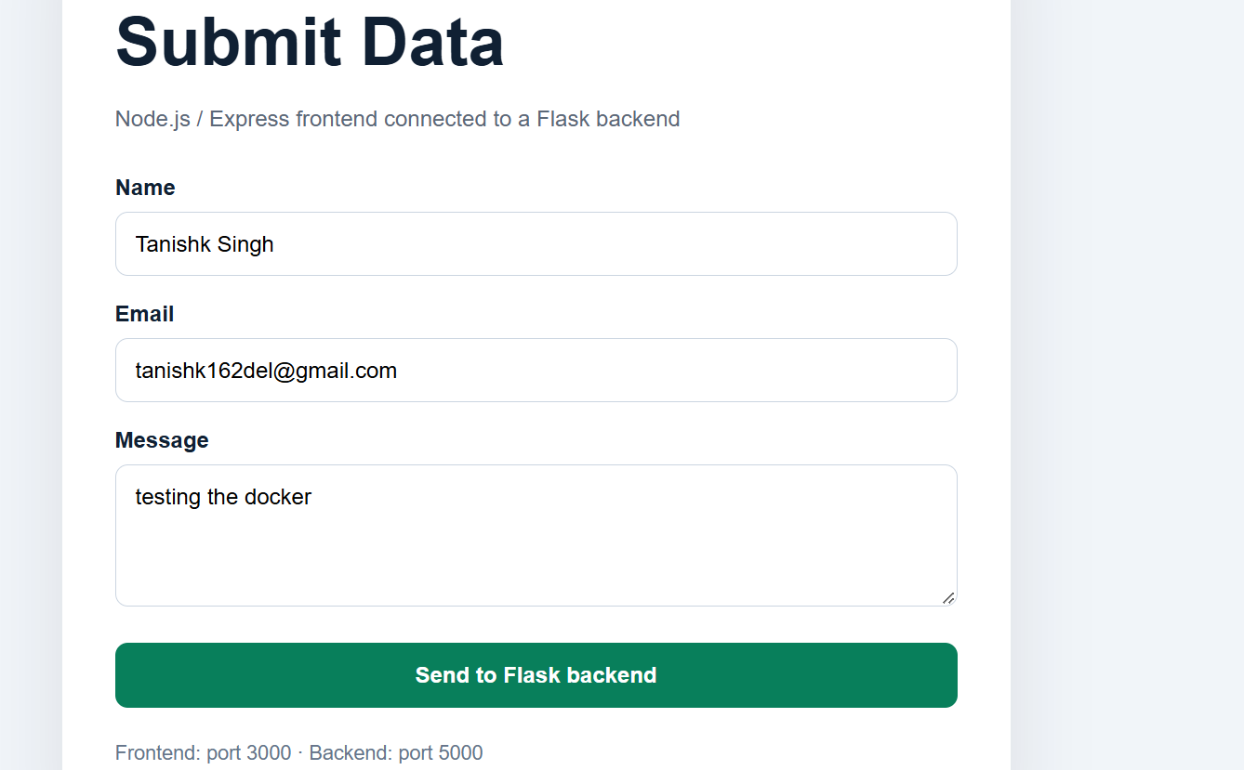
Figure 1. The Node.js/Express form running locally at port 3000.

4.2 Successful submission
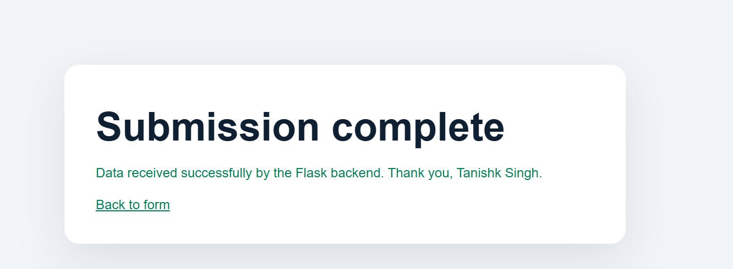
Figure 2. The frontend confirms that the Flask backend received the submitted data.

4.3 Containers and backend health check
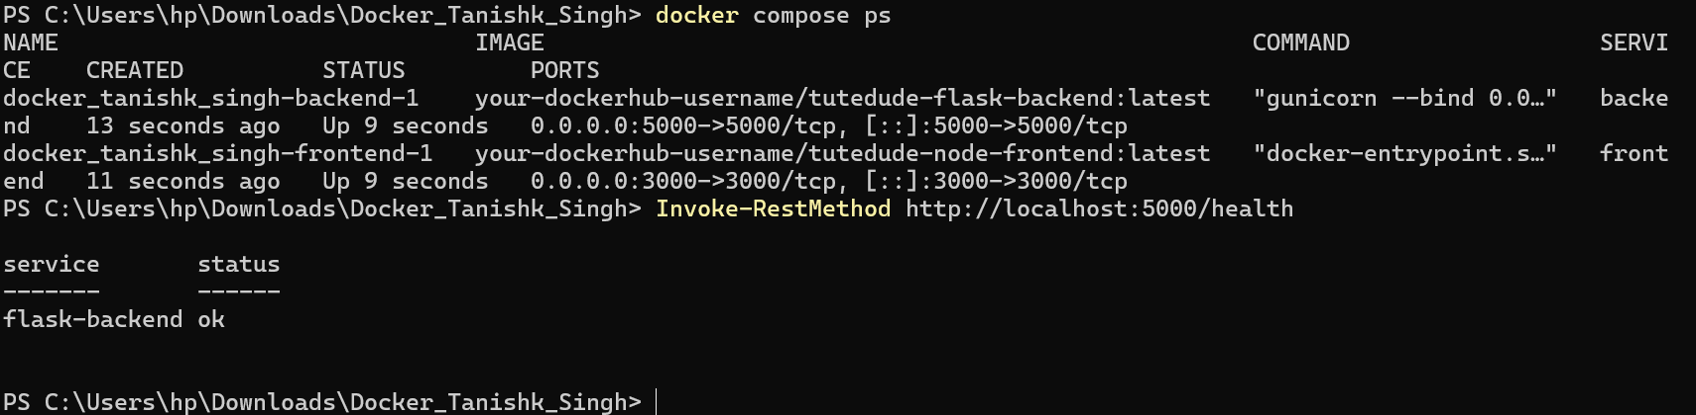
Figure 3. Docker Compose shows both services running; the Flask health endpoint returns ok.

5. Docker Hub publication
Both images were pushed to Docker Hub under the account tanishk111:
- Flask backend: https://hub.docker.com/r/tanishk111/tutedude-flask-backend
- Node.js frontend: https://hub.docker.com/r/tanishk111/tutedude-node-frontend
Image names:
- tanishk111/tutedude-flask-backend:latest
- tanishk111/tutedude-node-frontend:latest

6. GitHub publication
Project repository: https://github.com/tanishk162del-create/Docker_Tanishk_Singh
The repository contains the frontend and backend source code, their Dockerfiles, docker-compose.yml, README.md, .gitignore, documentation, and actual local execution screenshots.

7. Submission checklist
- Express frontend source included.
- Flask backend source included.
- Separate Dockerfiles included.
- Docker Compose connects both services on a shared network.
- .gitignore excludes .env, node_modules, caches, and editor files.
- Actual frontend, submission, container status, and health-check screenshots included.
- Both Docker images published to Docker Hub.
- Project source pushed to GitHub.

8. Security note
Credentials and Docker Hub access tokens must remain private and must not be included in this submission. The .env file is excluded by .gitignore; only .env.example is included.

