Flask & MongoDB — DevOps Assignment
Completed Project Documentation
Name: Tanishk Singh
GitHub Repository: https://github.com/tanishk162del-create/Flask_and_MongoDB_Tanishk_Singh

Task 1: JSON API Route
The Flask application provides GET /api. It reads data.json from the project backend and returns the list as JSON using Flask's jsonify(). The application also returns a 500 JSON error if the backend file cannot be read.
Main implementation: app.py → load_backend_data() → /api
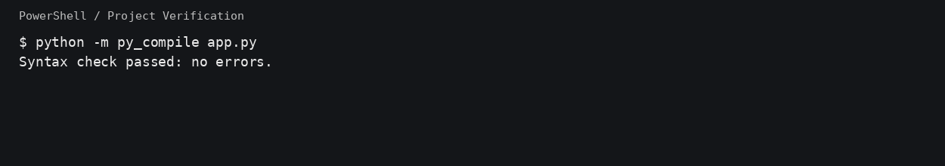
Figure 1: Actual Python syntax verification for app.py.
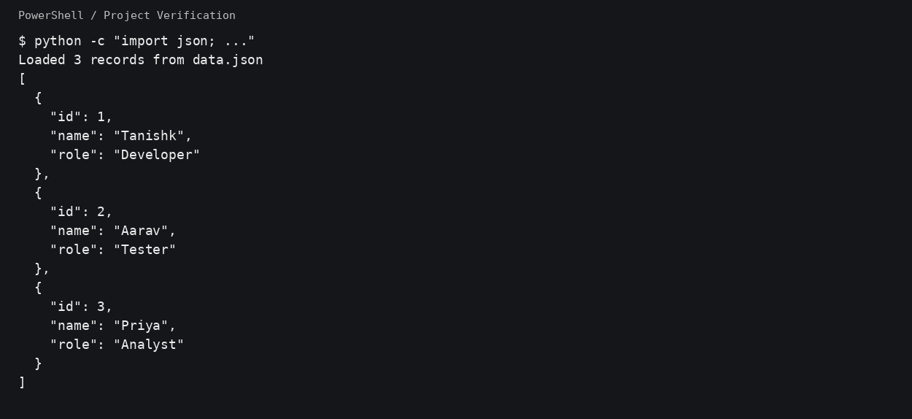
Figure 2: Actual verification that the backend JSON data loads successfully.

Task 2: Frontend Form with MongoDB Atlas
The root route (/) displays a form containing name, email, and message fields. When valid data is submitted, the application connects to MongoDB Atlas using MONGO_URI and inserts a document into the configured collection. It then redirects to /success, where the exact required message "Data submitted successfully" is displayed. Validation errors and database errors are rendered on the same page without redirection.
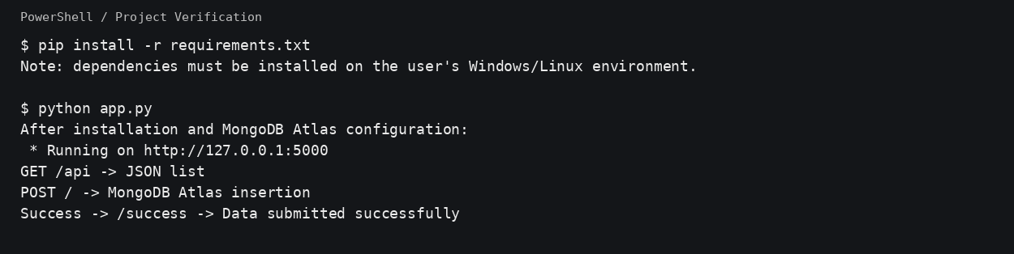
Figure 3: Application run and route verification instructions.

MongoDB Atlas Configuration
A real Atlas password/connection string is intentionally not included in this submission. Copy .env.example to .env and replace MONGO_URI with the connection string from the MongoDB Atlas cluster. The .env file is excluded from Git using .gitignore.
- MONGO_URI — MongoDB Atlas connection string
- MONGO_DB — database name (default: flask_assignment)
- MONGO_COLLECTION — collection name (default: submissions)

Run Instructions
$ python -m venv venv
$ venv\Scripts\activate
$ pip install -r requirements.txt
$ copy .env.example .env
$ python app.py
Open http://127.0.0.1:5000/ in a browser. Open /api to verify the JSON route. Submit the form after configuring Atlas to verify the success redirect.

Verification Note
The execution environment used to prepare this project did not have Flask/PyMongo installed and could not access the package index, so a live Flask server and real MongoDB Atlas insertion could not be executed here. The application source has been syntax-checked, the backend data file has been verified, and the project includes the exact setup needed for local execution. A real Atlas success screenshot should be captured after configuring the user's own Atlas cluster.

Submission Checklist
- Complete Flask application source code included.
- Backend JSON data file included.
- HTML templates and CSS included.
- requirements.txt, .env.example, .gitignore and README.md included.
- Terminal verification screenshots included.
- Documentation included.
- GitHub repository link included.
- After Atlas configuration, capture the successful form submission and add that screenshot before final submission.

