GIT & GITHUB
ASSIGNMENT 4
DevOps • Flask project workflow
Submitted by: Tanishk Singh
GitHub repository: https://github.com/tanishk162del-create/Git_and_GitHub_Tanishk_Singh

Objective
Practise repository setup with SSH, branch creation, merging, JSON conflict resolution, parallel feature development, sequential commits, git reset, and rebasing using a Flask project.

Repository
Repository URL: https://github.com/tanishk162del-create/Git_and_GitHub_Tanishk_Singh
The project contains a Flask application, JSON data for the /api endpoint, templates for the frontend, and a MongoDB-backed POST endpoint for To-Do submissions. The .env file and virtual environment should not be committed or included in the submission archive.

Task 1 — Repository setup and first branch
SSH authentication was configured and verified with GitHub. The repository was initialized locally, the Flask project was committed on the username branch Tanishk, and that branch was merged into main. The remote repository was configured over SSH and branches were pushed.
Commands used (representative):
- ssh -T git@github.com
- git switch -c Tanishk
- git add .
- git commit -m "Add Flask and MongoDB project"
- git switch main
- git merge Tanishk
- git push -u origin main

Task 2 — JSON update and conflict resolution
A branch named Tanishk_new was used to update data.json, which supplies data to the /api route. A competing change was made on main to create a merge conflict. During resolution, the Tanishk_new version of data.json was selected, staged, committed, and pushed.
Representative commands:
- git switch -c Tanishk_new
- git add data.json && git commit -m "Update API JSON data on Tanishk_new"
- git switch main
- git merge Tanishk_new
- git checkout --theirs data.json
- git add data.json
- git commit -m "Resolve JSON conflict using Tanishk_new changes"
- git push origin main

Task 3 — Parallel feature development
Two feature branches were used. master_1 contains the To-Do frontend page with Item Name and Item Description fields. master_2 contains the /submittodoitem POST route, which validates the form fields and stores the submission in MongoDB. Both branches were merged into main.
Representative commands:
- git switch -c master_1
- git commit -m "Add To-Do form frontend"
- git switch main
- git switch -c master_2
- git commit -m "Add MongoDB To-Do submission API"
- git switch main
- git merge master_1
- git merge master_2
- git push origin main

Task 4 — Sequential commits, merge, reset and rebase
The three To-Do form fields were committed separately on master_1 in the required order:
- 8450e07 — Add Item ID field to To-Do form
- bb73859 — Add Item UUID field to To-Do form
- fa4743d — Add Item Hash field to To-Do form
The master_1 branch was merged into main in commit bef221c and pushed to GitHub. The command `git reset --soft 8450e07` was attempted on main to demonstrate a soft reset; it left later changes staged. The reset was then undone by restoring the safety branch `backup-before-soft-reset` to protect the working project. Consequently, the final published history does not retain a separate reset-and-recommit result. The command `git rebase main` was run while on master_1; because main already contained the same commits, Git reported success without replaying new commits. This limitation is recorded transparently rather than claiming that the final history demonstrates a rewritten rebase.
Commands used during verification:
- git log --oneline --graph --decorate --all -15
- git merge master_1
- git push origin main
- git switch master_1
- git rebase main
- git push origin master_1

Verification notes
The Flask application was previously checked with `python -m py_compile app.py`. Earlier test output showed GET /api returning HTTP 200 and an empty form submission returning HTTP 400. `python -m unittest` reported `Ran 0 tests`, so this should not be described as a passing automated test suite.
At the last reported Git check, main and master_1 were both at commit bef221c, tracking origin/main and origin/master_1 respectively, with a clean working tree.

Screenshot evidence
The screenshots below were available in the conversation and show SSH authentication, branch pushes, JSON conflict resolution, and feature branch work. Add the additional screenshots saved locally in `screenshots/git_assignment/` before submitting, especially the final branch history and the main/master_1/master_2/Tanishk_new branch commit views.
SSH authentication verification
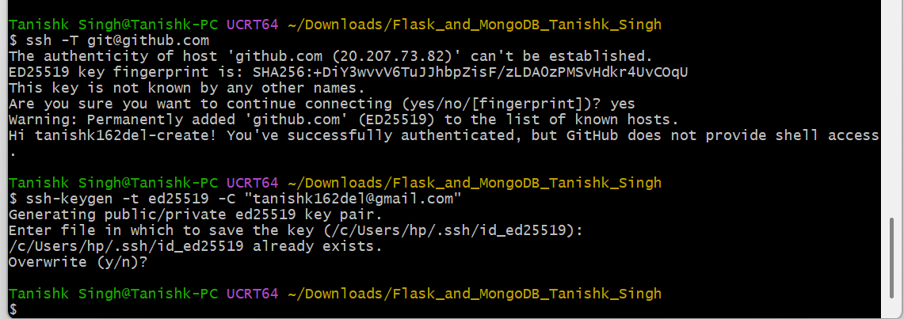
JSON conflict resolution on main
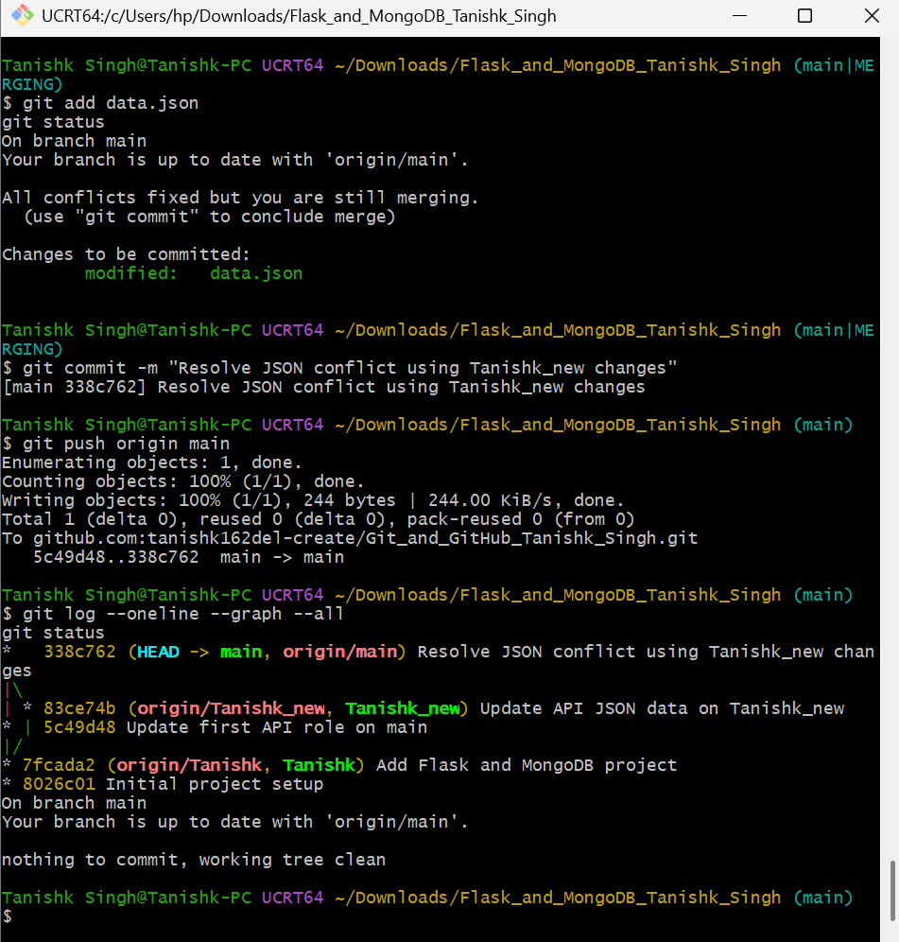
Push of Tanishk_new branch
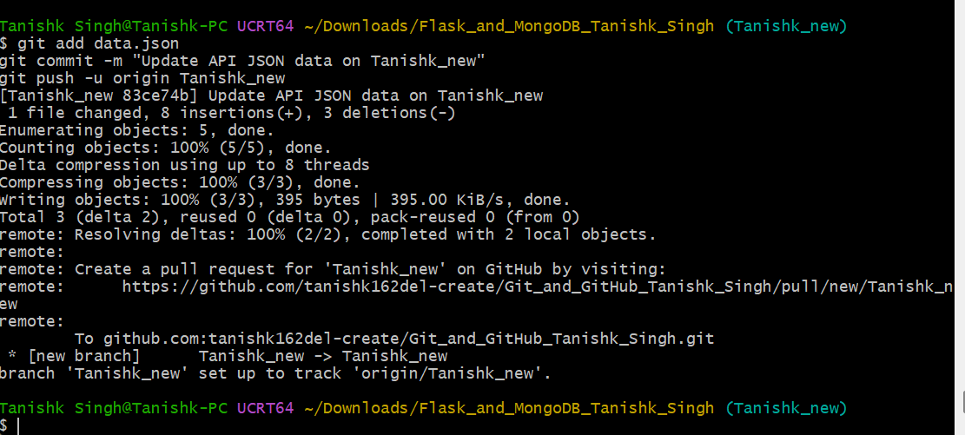
master_2 MongoDB To-Do API commit and push
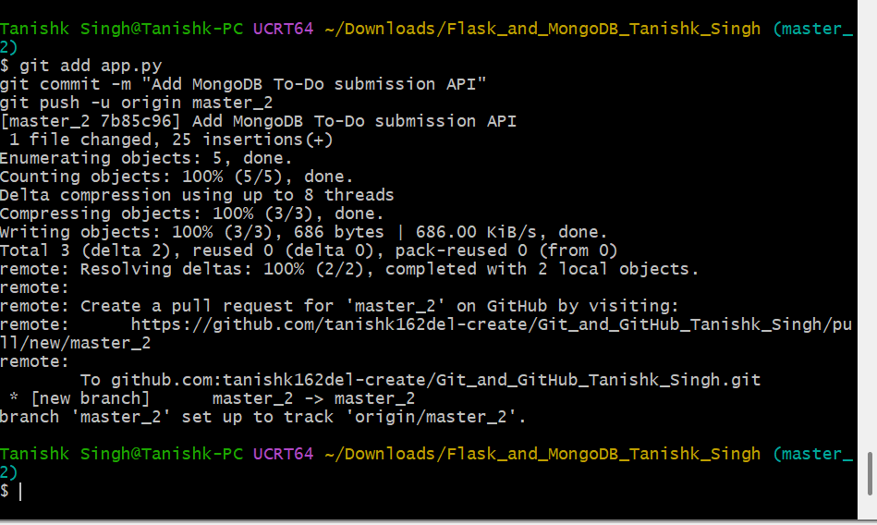
master_1 To-Do frontend commit and push
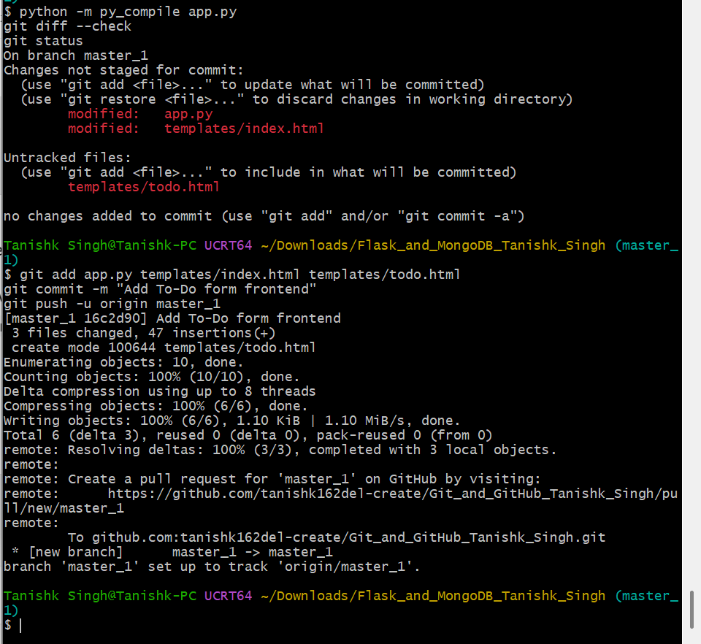

Submission checklist
- Include the complete project source code.
- Include this documentation file.
- Include all assignment screenshots and command/output evidence.
- Include the GitHub repository link: https://github.com/tanishk162del-create/Git_and_GitHub_Tanishk_Singh
- Compress the folder as Git_and_GitHub_Tanishk_Singh.zip.

