INTERNSHIP PROJECT REPORT
on
Sales & Revenue Analysis Dashboard
Business Intelligence and Data Visualization Project

Submitted By | TANISHKA RUPESHKUMAR BELLALE
Roll Number | RBT24CS207
Department | COMPUTER SCIENCE
Programme | B.TECH
Institute | JSPM RSCOE
Internship At | THIRANEX
Submission Date | 21/05/2026
Academic Year | 2025 – 2026

Declaration
I, TANISHKA RUPESHKUMAR BELLALE
Roll No. RBT24CS207 a student of B.TECH at JSPM RSCOE hereby declare that this project report titled "Sales & Revenue Analysis Dashboard" is a record of original work undertaken by me during my internship at THIRANEX

This report has not been submitted, either in part or in full, to any other university or institution for the award of any degree or diploma. All data, observations, and inferences presented in this report are genuine and have been collected during the period of my internship.

All external sources referenced have been duly cited and acknowledged. This work is entirely my own and does not constitute plagiarism in any form.

Date: 21/05/2026

Place: NANDED

Signature of Student: TANISHKA RUPESHKUMAR BELLALE

Project Completion Declaration

Internship Project Declaration

This is to declare that Tanishka, Roll No. RBT24CS207], a student of COMPUTER ENGINEERING at JSPM RSCOE has successfully completed the assigned internship project titled "Sales & Revenue Analysis Dashboard" using Microsoft Power BI as part of the ongoing internship programme.

The project involved analyzing sales data and developing an interactive dashboard containing KPI metrics, sales trends, regional analysis, top-performing products, and interactive filters for business insights.

This report is submitted as part of the internship task assigned during the internship period.

Date: 21/05/2026

Acknowledgement
I would like to express my sincere gratitude and appreciation to all those who contributed to the successful completion of this project and internship.

I am grateful to the management and staff at THIRANEX for providing me with the opportunity to work in a professional environment and for extending all necessary resources and support during the internship period.

I would also like to sincerely thank SEEMA KEDAR, Head of the Department of COMPUTER ENGINEERING, and the faculty members of JSPM RSCOE for their academic guidance and for facilitating this internship opportunity.

My profound gratitude goes to my parents and family members whose unconditional support, motivation, and encouragement have been a constant source of strength throughout my academic journey.

Finally, I acknowledge the developers and contributors to the Microsoft Power BI platform and the Superstore Sales Dataset, which formed the technical foundation of this project.

TANISHKA RUPESHKUMAR BELLALE
RBT24CS207 | B.TECH CS | JSPM RSCOE

Abstract
In today's highly competitive and data-driven business landscape, the ability to analyse sales performance and revenue patterns in real time is a critical differentiator for organisations. This project presents the design and development of a comprehensive Sales & Revenue Analysis Dashboard using Microsoft Power BI — one of the most widely adopted Business Intelligence platforms globally.

The dashboard was built using the Superstore Sales Dataset, a widely used sample dataset that simulates real-world retail business data encompassing product categories, customer segments, geographic regions, order quantities, sales figures, and profit margins. The project involved end-to-end BI development — from raw data ingestion and cleaning via Power Query Editor, to the creation of DAX-based KPI measures and interactive visualisations.

Key deliverables of the project include: KPI Cards displaying Total Sales, Total Profit, and Total Quantity; a Monthly Sales Trend Line Chart for temporal analysis; a Regional Sales Distribution Pie Chart; a Top 10 Products by Sales Bar Chart; and interactive Slicers for Region, Category, and Segment filtering. Together, these components enable dynamic, multi-dimensional analysis of business performance.

The insights generated from the dashboard reveal significant patterns in product performance, seasonal sales trends, regional revenue distribution, and segment-level profitability — all of which can directly inform strategic business decisions. The project demonstrates how BI tools can transform raw, unstructured data into actionable intelligence, supporting decision-makers with visual, real-time reporting.

This report documents every stage of the development process, including problem identification, tool selection, data preparation, visual design, and the interpretation of business insights. It also discusses challenges encountered, lessons learnt, and potential improvements for future iterations of the dashboard.

Table of Contents

1. Introduction Page 7
2. Project Objectives Page 8
3. Problem Statement Page 9
4. Tools and Technologies Used Page 9
5. Dataset Description Page 10
6. Data Cleaning and Preparation Page 11
7. Dashboard Development Process Page 12
8. Explanation of Each Visualisation Page 13
9. Dashboard Features Page 15
10. Business Insights Generated Page 15
11. Advantages of Power BI Page 16
12. Challenges Faced During Development Page 17
13. Learning Outcomes Page 17
14. Conclusion Page 18
15. Future Improvements Page 18
16. References Page 19

1. Introduction
In the modern era of digital commerce and data proliferation, organisations are constantly generating large volumes of transactional data. However, raw data in isolation offers little value unless it is systematically analysed, interpreted, and presented in a format that is easily understandable to decision-makers at all levels of management. This is where Business Intelligence (BI) tools play a pivotal role.

Business Intelligence refers to the technologies, strategies, and practices used by enterprises to analyse business information and support better decision-making. Among the leading BI tools available today, Microsoft Power BI stands out for its powerful data connectivity options, intuitive drag-and-drop interface, rich visualisation library, and seamless integration with Microsoft Office products.

This internship project involves the creation of a Sales & Revenue Analysis Dashboard using Microsoft Power BI, powered by the Superstore Sales Dataset. The Superstore dataset is a well-known sample retail dataset that captures order-level transactional data across multiple dimensions — including product categories, customer segments, geographic regions, and time periods. It is an ideal dataset for practising BI development and understanding real-world retail business dynamics.

The developed dashboard serves as an interactive reporting tool that enables stakeholders to monitor sales performance, track profitability trends, and identify top-performing products and regions — all in one consolidated view. The project encompasses the complete BI development lifecycle: from data sourcing and cleaning to visual design and insight generation.

This report documents each phase of the project in detail and is structured to provide both technical depth and business context, making it suitable for academic evaluation and professional reference.

1.1 Scope of the Project
The scope of this project is limited to the Superstore Sales Dataset and focuses on the following analytical dimensions:
- Sales performance analysis across regions and product categories
- Monthly and seasonal revenue trend identification
- Product-level revenue ranking and profitability assessment
- Customer segment analysis — Consumer, Corporate, and Home Office
- Interactive filtering and dynamic cross-visual data exploration

2. Project Objectives
The following objectives were defined at the outset of the project to provide a clear direction for the internship work:

- To gain hands-on experience with Microsoft Power BI, including data loading, transformation, and dashboard design.
- To connect, import, and process the Superstore Sales CSV dataset within the Power BI environment.
- To apply data cleaning and transformation techniques using Power Query Editor to ensure data quality and accuracy.
- To design and develop interactive KPI Cards that display key business metrics — Total Sales, Total Profit, and Total Quantity — using DAX measures.
- To build a Monthly Sales Trend Line Chart that reveals temporal patterns and seasonality in sales performance.
- To create a Sales by Region Pie Chart providing a clear visual breakdown of geographic revenue distribution.
- To develop a Top 10 Products by Sales Bar Chart to identify the highest revenue-generating products in the portfolio.
- To implement interactive Slicers for Region, Category, and Segment to enable dynamic, user-driven data exploration.
- To extract and document meaningful business insights from the dashboard that can support strategic decision-making.
- To develop professional documentation covering all stages of the BI project lifecycle for academic and professional submission.

3. Problem Statement
Retail and e-commerce businesses typically handle enormous volumes of sales and order data, often stored in flat files, spreadsheets, or databases. Without a structured analytical framework, this data remains unutilised and fails to provide actionable insights. Traditional reports in the form of Excel tables or static PDFs are neither interactive nor visually intuitive, making it difficult for business stakeholders to quickly identify trends, anomalies, or opportunities.

In this context, the core problem addressed by this project is:

"How can raw, multi-dimensional sales data be transformed into an interactive, visually rich, and business-ready dashboard that enables stakeholders to monitor performance KPIs, analyse trends, and make informed decisions — without requiring specialised technical knowledge?"

Specifically, the project addresses the following challenges:
- The Superstore Sales CSV dataset contains raw transactional data that requires cleaning, transformation, and structuring before it can be used for analysis.
- Key performance metrics such as Total Sales, Total Profit, and Total Quantity are not readily available in a consolidated format.
- Business users need to explore data across multiple dimensions — time, region, category, and segment — without manually filtering spreadsheets.
- There is a need for a centralised, interactive reporting tool that updates automatically based on filter selections.

4. Tools and Technologies Used
The following tools and technologies were employed during the development of the Sales & Revenue Analysis Dashboard:

Tool / Technology | Version / Type | Purpose in the Project
Microsoft Power BI Desktop | Latest (2024) | Primary BI & visualization platform
CSV (Comma-Separated Values) | Flat File Format | Data source / raw dataset storage
Superstore Sales Dataset | Sample Dataset | Business data used for analysis
DAX (Data Analysis Expressions) | Built-in to Power BI | KPI calculations and custom measures
Power Query Editor | Built-in to Power BI | Data cleaning, transformation & shaping
Microsoft Excel | Office 365 | Initial data review and exploration

4.1 Microsoft Power BI Desktop
Microsoft Power BI Desktop is a free, feature-rich BI application developed by Microsoft. It allows users to connect to hundreds of data sources, perform data transformations using Power Query, build data models, create sophisticated visual reports, and publish dashboards to the Power BI Service. For this project, Power BI Desktop served as the primary development environment.

4.2 DAX (Data Analysis Expressions)
DAX is a formula language developed by Microsoft for use in Power BI, Power Pivot, and Analysis Services. It is used to create custom calculations, measures, and KPIs. In this project, DAX was used to create calculated measures for Total Sales, Total Profit, and Total Quantity, which power the KPI Cards on the dashboard.

4.3 Power Query Editor
Power Query is a data transformation and preparation engine built into Power BI. It provides a graphical interface for connecting to data sources, shaping data, removing inconsistencies, and preparing data for analysis — all without writing any code. It is based on the M language internally.

5. Dataset Description
The Superstore Sales Dataset is a publicly available sample retail dataset that simulates transactional data for a fictional US-based superstore. It is widely used in the data analytics community for practice, learning, and demonstration purposes. The dataset is available in CSV (Comma-Separated Values) format and contains a rich set of fields spanning customer information, order details, product specifications, geographic data, and financial metrics.

5.1 Dataset Summary
- Format: CSV (Comma-Separated Values)
- Total Records (Rows): Approximately 9,994 order line items
- Total Fields (Columns): 21 columns
- Time Period Covered: January 2015 – December 2018
- Geographic Coverage: United States (4 Regions, 49 States)
- Product Categories: Furniture, Technology, Office Supplies
- Customer Segments: Consumer, Corporate, Home Office

5.2 Field Reference Table
Field Name | Data Type | Description
Order ID | String / Text | Unique identifier assigned to each customer order
Order Date | Date | The date on which the order was placed
Ship Date | Date | The date on which the order was shipped
Ship Mode | Categorical | Shipping method (Standard, First Class, etc.)
Customer Name | String / Text | Full name of the customer
Segment | Categorical | Market segment — Consumer, Corporate, or Home Office
Region | Categorical | Geographic region (East, West, Central, South)
Category | Categorical | Product category (Furniture, Technology, Office Supplies)
Sub-Category | Categorical | More granular product grouping within a category
Product Name | String / Text | Full descriptive name of the product
Sales | Numeric (Currency) | Revenue generated from the order line item
Quantity | Numeric (Integer) | Number of units ordered
Discount | Numeric (Decimal) | Discount applied to the order as a percentage
Profit | Numeric (Currency) | Net profit earned after deducting costs and discounts

The fields most central to this project are: Sales, Profit, Quantity, Region, Category, Segment, Product Name, and Order Date. These serve as the primary dimensions and measures used to build all KPIs and visualisations in the dashboard.

6. Data Cleaning and Preparation
Before building any visualisation, it is essential to ensure that the data is clean, consistent, and properly structured. Raw datasets often contain missing values, formatting inconsistencies, duplicate records, and data type errors that can compromise the accuracy of analysis. Power Query Editor in Power BI was used to carry out all data preparation tasks.

6.1 Steps Performed in Power Query Editor
- Load CSV File: The Superstore Sales CSV file was imported into Power BI using the "Get Data" option. The CSV delimiter (comma) was automatically detected.
- Promote Headers: The first row of the CSV was promoted to serve as column headers.
- Data Type Validation: All columns were reviewed and appropriate data types were assigned — Text for categorical fields, Date for Order Date and Ship Date, and Decimal Number for Sales, Profit, and Discount.
- Handling Null / Missing Values: Rows with missing critical values in Sales, Profit, or Region columns were identified and removed to ensure analytical integrity.
- Removing Duplicate Records: The dataset was checked for duplicate Order ID entries. Any genuine duplicates were removed.
- Column Renaming: Column names were standardised — spaces were replaced with underscores where necessary for ease of DAX formula writing.
- Date Column Transformation: The Order Date column was split into separate Year, Month Number, and Month Name columns to facilitate time-based analysis in trend charts.
- Trimming Whitespace: Leading and trailing spaces were removed from text columns such as Product Name, Customer Name, and Region to prevent grouping errors.
- Filtering Irrelevant Columns: Columns not required for analysis, such as Customer ID, Postal Code, and Country (since all data is from the US), were removed to optimise the data model.
- Closing and Applying Changes: Once all transformations were complete, changes were applied and the cleaned dataset was loaded into the Power BI data model.

6.2 DAX Measures Created
After data preparation, the following DAX measures were created in the Power BI data model to power the KPI Cards:
- Total Sales = SUM('Orders'[Sales])
- Total Profit = SUM('Orders'[Profit])
- Total Quantity = SUM('Orders'[Quantity])
- Profit Margin (%) = DIVIDE([Total Profit], [Total Sales], 0)
- Average Order Value = DIVIDE([Total Sales], DISTINCTCOUNT('Orders'[Order ID]), 0)

7. Dashboard Development Process
The dashboard was developed in Microsoft Power BI Desktop following a structured, iterative design process. The objective was to create a clean, professional, and intuitive reporting interface that allows business users to explore data effortlessly.

7.1 Development Stages
- Data Connection: Connected the cleaned Superstore CSV file to Power BI Desktop as the primary data source.
- Data Modelling: Reviewed and confirmed the data model. Since this project uses a single flat table, no relationships between multiple tables were required.
- Measure Creation: DAX measures for Total Sales, Total Profit, and Total Quantity were created in the Fields pane.
- Report Canvas Setup: Set the report canvas theme to a professional blue-white colour scheme for visual consistency and readability.
- KPI Card Addition: Three Card visuals were added to the top of the dashboard — one each for Total Sales, Total Profit, and Total Quantity.
- Monthly Trend Chart: A Line Chart visual was added using Order Date (Year-Month) on the X-axis and Total Sales on the Y-axis.
- Regional Pie Chart: A Pie Chart was added with Region as the Legend and Total Sales as the Values field.
- Top 10 Products Bar Chart: A Bar Chart was configured with Product Name on the Y-axis and Total Sales on the X-axis. A Top N filter was applied to show only the Top 10 products.
- Slicer Addition: Three Slicer visuals were added — one each for Region, Category, and Segment — enabling interactive cross-filtering.
- Formatting and Layout: Visual titles, data labels, colours, and font sizes were refined for a polished, professional appearance.
- Cross-Filter Testing: All visuals were tested to ensure they respond correctly when slicers are adjusted.
- Final Review: A comprehensive review of the dashboard was conducted to validate data accuracy and visual consistency.

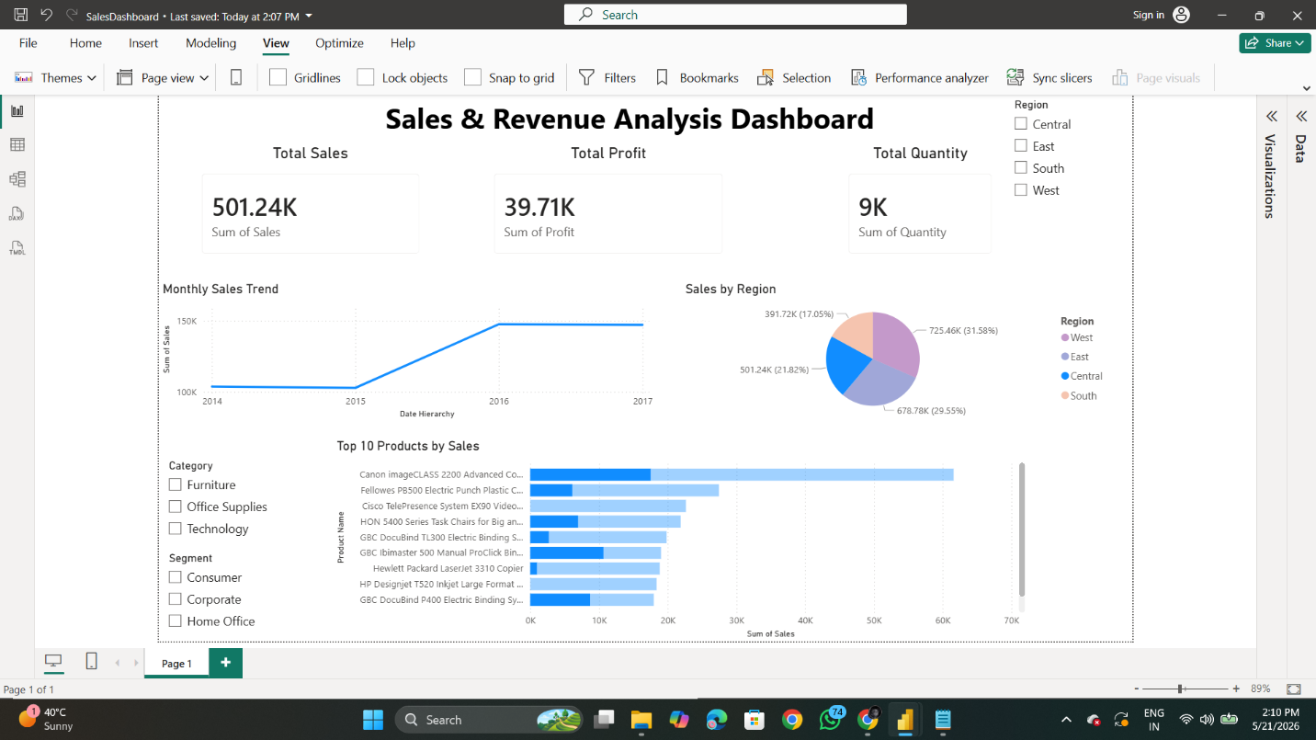

8. Explanation of Each Visualisation

8.1 KPI Cards — Total Sales, Profit & Quantity
KPI (Key Performance Indicator) Cards are large-format single-number displays placed at the top of the dashboard. They provide at-a-glance visibility into the most important business metrics.

Three KPI Cards were implemented in this dashboard:
- Total Sales Card: Displays the cumulative sum of all sales revenue across all orders in the dataset. Powered by the DAX measure: Total Sales = SUM('Orders'[Sales]).
- Total Profit Card: Shows the net profit earned across all transactions. Powered by the DAX measure: Total Profit = SUM('Orders'[Profit]).
- Total Quantity Card: Reflects the total number of product units sold. Powered by the DAX measure: Total Quantity = SUM('Orders'[Quantity]).

When a Slicer filter is applied (e.g., filtering by a specific Region), all three KPI Cards dynamically update to reflect the filtered values, enabling contextualised metric tracking.



8.2 Monthly Sales Trend — Line Chart
The Monthly Sales Trend Line Chart is a time-series visualisation that plots Total Sales values against each month over the entire dataset period. The X-axis represents the Order Date (grouped by Year and Month), while the Y-axis represents the Total Sales value.

This chart serves multiple analytical purposes:
- Identifying peak sales months and seasonal trends
- Detecting months with unusually low sales that may require investigation
- Comparing year-over-year performance for the same calendar months
- Supporting inventory and staffing planning based on anticipated demand cycles

The line chart clearly reveals that sales volumes tend to increase significantly in the final quarter of the year (October–December), particularly in November and December, which aligns with year-end shopping trends and holiday seasons.

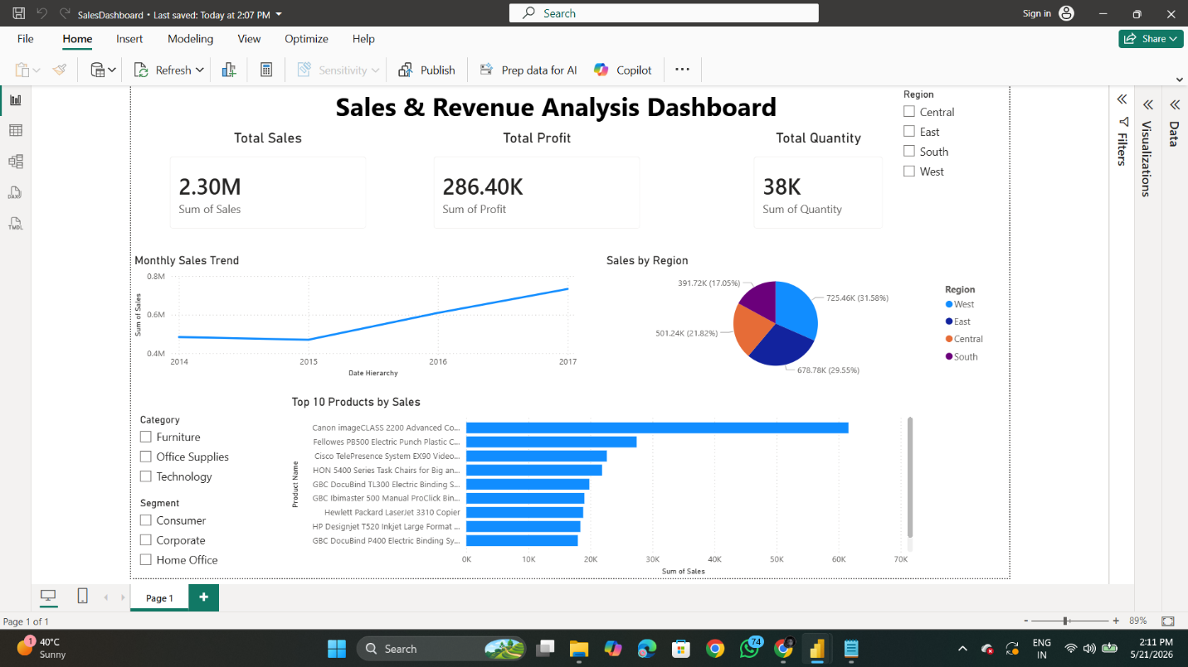

8.3 Sales by Region — Pie Chart
The Sales by Region Pie Chart provides a proportional view of how total sales revenue is distributed across the four geographic regions in the dataset: East, West, Central, and South.

Each slice of the pie represents one region, with the slice size proportional to its share of total sales revenue. Data labels display both the region name and percentage contribution, making it easy to compare regional performance at a glance.

Business value of this chart:
- Quickly identifies the highest and lowest revenue-generating regions
- Enables regional managers to benchmark their performance against other regions
- Supports geographic resource allocation and marketing budget decisions


8.4 Top 10 Products by Sales — Bar Chart
The Top 10 Products by Sales Bar Chart is a horizontal bar chart that ranks the ten highest revenue-generating products in the dataset. The Product Name is displayed on the Y-axis, and Total Sales is plotted on the X-axis. Bars are sorted in descending order of sales value, ensuring the top performer is always displayed at the top.

A Top N Visual-Level Filter (N = 10) is applied in the Filters pane to restrict the display to only the top 10 products. Data labels on each bar display the exact sales figure for precision.

Analytical use cases:
- Identifying the star products in the portfolio that drive the majority of revenue
- Informing product promotion and inventory prioritisation decisions
- Benchmarking product performance relative to other items in the same category



8.5 Interactive Slicers — Region, Category & Segment
Three interactive Slicer visuals are included on the dashboard, each acting as a dynamic filter that controls what data is displayed across all other visuals simultaneously:
- Region Slicer: Allows the user to filter all dashboard visuals by one or more of the four geographic regions (East, West, Central, South).
- Category Slicer: Enables filtering by the three main product categories — Furniture, Technology, and Office Supplies.
- Segment Slicer: Filters data by customer segment — Consumer, Corporate, or Home Office.

The cross-filter behaviour of Power BI ensures that all visuals — KPI Cards, Line Chart, Pie Chart, and Bar Chart — respond simultaneously to any slicer selection, enabling multi-dimensional data exploration without page navigation.



9. Dashboard Features
The completed dashboard incorporates the following key features that enhance its usability and analytical value:

- Interactive Cross-Filtering: All visuals dynamically update when any Slicer filter is changed, ensuring consistent and contextual data display.
- Drill-Through Capability: Users can right-click on any data point to explore underlying details and drill into granular data.
- Tooltips: Hovering over any data point on any visual reveals a detailed tooltip showing exact metric values for that data point.
- Dynamic Titles: Chart titles automatically update to reflect the currently applied filter context.
- Responsive Layout: The dashboard layout is optimised for standard widescreen monitors and is also viewable on the Power BI Mobile app.
- Professional Colour Theme: A consistent blue-white colour palette is applied across all visuals for a clean, professional appearance.
- Data Labels: All charts display data labels for precision reading without the need to estimate from axes.

10. Business Insights Generated
The following actionable business insights were derived from the analysis conducted through the dashboard:

Insight | Finding | Recommendation
Top Region | West region leads in total sales revenue | Prioritize inventory & marketing in West
Most Profitable Category | Technology yields highest profit margins | Increase product range in Technology
Weakest Segment | Home Office segment shows lowest volume | Launch targeted Home Office campaigns
Sales Seasonality | Sales peak in November–December | Plan Q4 inventory and staffing early
Loss-Making Products | Some discounted items yield negative profit | Review discount policies on key SKUs
Top Product Performer | Canon imageCLASS leads in total revenue | Ensure stock availability year-round

These insights demonstrate that the dashboard is not merely a data visualisation tool but a strategic business intelligence asset that directly supports data-driven decision-making at the operational and management levels.

11. Advantages of Power BI
Microsoft Power BI offers several significant advantages that make it the preferred BI tool for this project and for enterprise use cases broadly:

- Ease of Use: Power BI features a drag-and-drop interface that requires minimal programming knowledge, making it accessible to business analysts and non-technical users.
- Wide Data Connectivity: Power BI can connect to over 200 data sources — including Excel, CSV, SQL databases, Azure, Google Analytics, Salesforce, and more.
- Real-Time Dashboards: Power BI supports live data connections and near real-time dashboard refreshes when connected to streaming data sources.
- DAX for Custom Analytics: The DAX formula language enables complex custom calculations and business logic that go beyond basic aggregations.
- Power Query for Data Preparation: The built-in ETL (Extract, Transform, Load) tool eliminates the need for separate data preparation software.
- Cloud Publishing: Reports can be published to the Power BI Service cloud platform and shared across the organisation, enabling collaborative analytics.
- Mobile App Support: Power BI provides native mobile apps for iOS, Android, and Windows, allowing dashboards to be viewed on any device.
- Cost-Effective: Power BI Desktop is available free of charge. The Power BI Pro licence is competitively priced compared to alternatives like Tableau.
- Regular Feature Updates: Microsoft releases monthly updates to Power BI, continuously adding new visual types, AI capabilities, and connectors.
- Integration with Microsoft Ecosystem: Seamless integration with Excel, Teams, SharePoint, and Azure makes Power BI a natural choice for organisations already using Microsoft products.

12. Challenges Faced During Development
Despite Power BI's user-friendly nature, several challenges were encountered during the development of this dashboard:

- Data Type Errors: Some numeric columns such as Sales and Profit were initially imported as text data types, causing aggregation functions to fail. This was resolved by manually setting the correct data types in Power Query.
- Date Hierarchy Issues: The Order Date column initially caused issues with the line chart's X-axis grouping. The date field had to be converted to a proper Date data type and a custom Date Hierarchy (Year > Month Number > Month Name) had to be configured.
- Top N Filter for Bar Chart: Applying the Top 10 filter for the Products Bar Chart required navigating to the Visual-Level Filters section in the Filters pane, which was initially unclear. Understanding the distinction between Page-Level and Visual-Level filters took some time.
- Slicer Cross-Filter Behaviour: Managing the cross-filter direction between the Slicers and the Pie Chart required accessing the Edit Interactions menu to customise which visuals are affected by each Slicer.
- Dashboard Layout Alignment: Precisely aligning KPI Cards, charts, and Slicers on the report canvas was time-consuming and required careful use of the Align and Distribute tools in the Format tab.
- Performance Optimisation: With close to 10,000 rows and multiple calculated measures, the dashboard initially loaded slowly. Removing unused columns from the data model significantly improved performance.

13. Learning Outcomes
This internship project provided rich learning experiences across both technical and professional domains:

Technical Skills Acquired
- Proficiency in Microsoft Power BI Desktop for end-to-end dashboard development
- Hands-on experience with Power Query Editor for data cleaning and transformation (ETL)
- Practical application of DAX formula language for creating calculated measures and KPIs
- Understanding of data modelling concepts and the role of data types in BI tools
- Ability to design and configure multiple visualisation types — KPI Cards, Line Charts, Pie Charts, Bar Charts, and Slicers
- Experience with filter management — Page-Level, Visual-Level, and Slicer filters
- Knowledge of BI best practices in dashboard layout, colour design, and user experience

Professional and Analytical Skills Developed
- Structured problem-solving approach to BI project development
- Business acumen — understanding how data insights translate into strategic recommendations
- Time management and project planning across a multi-week internship engagement
- Technical documentation and report writing skills
- Presentation and communication skills for conveying data insights to non-technical stakeholders

14. Conclusion
This internship project successfully achieved its primary objective of developing a comprehensive, interactive Sales & Revenue Analysis Dashboard using Microsoft Power BI and the Superstore Sales Dataset. The dashboard provides a unified, dynamic reporting platform through which business stakeholders can monitor key performance indicators, analyse revenue trends, assess regional and product-level performance, and explore data interactively across multiple dimensions.

The project demonstrated the immense value that Business Intelligence tools bring to data-driven organisations. By transforming raw, unstructured CSV data into a structured, visually engaging dashboard, this project illustrated how BI can bridge the gap between raw data and strategic decision-making — making complex information accessible to all levels of an organisation without requiring technical expertise.

From a personal development perspective, this internship provided invaluable hands-on experience in the end-to-end BI development lifecycle — encompassing data sourcing, cleaning, modelling, visualisation, and insight generation. The technical skills and professional competencies gained during this project form a strong foundation for a career in Data Analytics, Business Intelligence, or Data Science.

In conclusion, this project affirms that in the age of big data, the organisations that succeed are those that can efficiently translate data into decisions. Microsoft Power BI, as demonstrated through this project, is a powerful enabler of that capability.

15. Future Improvements
While the current dashboard fulfils its core analytical objectives, several enhancements can be made in future iterations to expand its capabilities and business value:

15.1 Advanced Analytics Integration
- Predictive Analytics: Integrate Power BI's built-in Azure Machine Learning or R/Python script visuals to add sales forecasting and predictive models.
- Anomaly Detection: Utilise Power BI's AI Insights feature to automatically detect unusual spikes or drops in sales data.
- Clustering Analysis: Apply clustering algorithms to segment customers or products into behavioural groups for targeted marketing.

15.2 Data Source Expansion
- Connect the dashboard to a live SQL Server or Azure database to enable real-time or near-real-time data refresh.
- Integrate additional data sources such as marketing spend data, customer feedback scores, or inventory levels to create a more holistic analytics platform.
- Incorporate data from CRM systems such as Salesforce to link sales performance with customer relationship metrics.

15.3 Dashboard Enhancements
- Drill-Through Pages: Develop dedicated drill-through report pages for Regional Detail, Product Detail, and Customer Segment Detail analysis.
- Custom Tooltips: Design visually rich custom tooltip pages that appear on hover for enhanced data storytelling.
- Bookmarks and Navigation: Implement Bookmarks and page navigation buttons to create a guided, story-driven dashboard experience.
- Mobile Layout: Design a dedicated mobile-optimised layout for the Power BI Mobile app.

15.4 Governance and Sharing
- Publish the dashboard to the Power BI Service for organisation-wide sharing and collaboration.
- Implement Row-Level Security (RLS) to restrict data access based on user roles — e.g., Regional Managers can only view data for their assigned region.
- Schedule automated data refreshes in the Power BI Service to keep the dashboard updated without manual intervention.

16. References
The following references, documentation, and learning resources were consulted during the development of this project:

- Microsoft Corporation. (2024). Power BI Documentation. Microsoft Learn. https://learn.microsoft.com/en-us/power-bi/
- Microsoft Corporation. (2024). Data Analysis Expressions (DAX) Reference. Microsoft Learn. https://learn.microsoft.com/en-us/dax/
- Microsoft Corporation. (2024). Power Query M Language Reference. Microsoft Learn. https://learn.microsoft.com/en-us/powerquery-m/
- Superstore Sales Dataset. (n.d.). Sample Retail Dataset. Retrieved from Tableau / Kaggle Public Dataset Repository. https://www.kaggle.com/datasets/vivek468/superstore-dataset-final
- Russo, M., & Ferrari, A. (2019). The Definitive Guide to DAX: Business Intelligence for Microsoft Power BI, SQL Server Analysis Services, and Excel. Microsoft Press.
- Raviv, R. (2021). Mastering Microsoft Power BI: Expert Techniques for Powerful Data Analytics and Business Intelligence. Packt Publishing.
- Tableau Public. (2024). Superstore Sample Data Reference. Tableau Software. https://public.tableau.com/app/resources/sample-data
- Guy in a Cube. (2024). Power BI Tutorial Videos [YouTube Channel]. https://www.youtube.com/@GuyInACube
- SQLBI. (2024). DAX Patterns: Practical Solutions for Real-World Power BI Projects. https://www.daxpatterns.com/
- Gartner Inc. (2024). Magic Quadrant for Analytics and Business Intelligence Platforms. Gartner Research.

───── End of Report ─────

