PERSONAL FINANCE ADVISOR
Project Report – An AI-Powered Fintech Web Application for Income & Expense Tracking, Budgeting, Savings Goals and Intelligent Financial Guidance
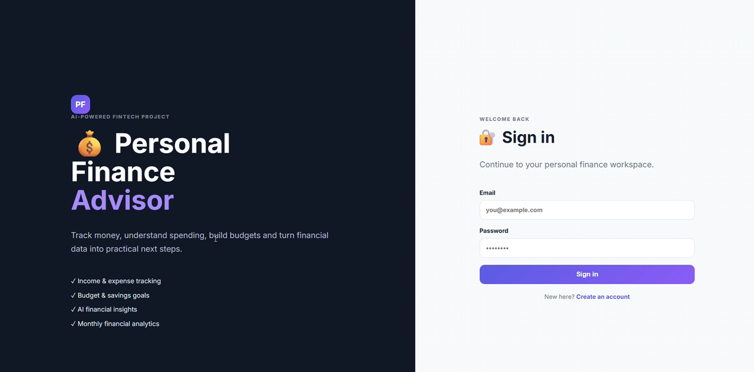

ABSTRACT
Managing personal money is a skill that most students and young professionals learn only through trial and error. Spending is scattered across cash, UPI and cards, budgets are made mentally and forgotten, and savings goals rarely get tracked. Personal Finance Advisor is a web-based, AI-powered fintech application that brings income tracking, expense tracking, category budgets, savings goals and an AI assistant into a single, easy-to-use workspace.
After signing in, the user lands on an Overview dashboard that shows four key indicators – monthly income, monthly expenses, available balance and savings rate – together with a live income-versus-expenses chart and a category-wise spending breakdown. Users can record income and expenses, set a spending limit for each category, create savings goals and add money towards them. Progress bars show how much of each budget or goal has been used. All data is stored locally in the application database.
The distinguishing feature of the system is the AI Advisor. The user types a natural-language question such as "How can I reduce my expenses this month?" and the system sends the question, together with the user's recorded income, expenses, budgets and goals, to a language model. The model returns three actionable, data-grounded suggestions and a clear disclaimer that it is an educational assistant and not a licensed financial advisor. In the test scenario documented in this report, the advisor correctly identified Healthcare as the largest expense (₹3,000 against a ₹2,000 limit), highlighted Education as the second-largest category, and encouraged the user to keep Food and Transport spending low to protect the remaining balance of ₹1,850.
Keywords: Personal finance, budgeting, expense tracking, savings goals, AI advisor, fintech, dashboard, large language model.

1 INTRODUCTION

1.1 Background
Digital payments have made spending effortless. A single tap on a phone can move money in a second, yet the same convenience makes it difficult to remember where the money went at the end of the month. Surveys of college students and early-career professionals repeatedly show that most do not maintain a budget and discover their overspending only when the balance runs low. At the same time, existing personal finance tools are often built for experienced investors, are cluttered with features, or require linking bank accounts – something many users are not comfortable with.
Recent progress in Artificial Intelligence, and in particular in large language models (LLMs), makes it possible to go beyond simple charts. An AI assistant can read the user's own numbers and explain them in plain language, point out risky categories and suggest realistic next steps. Personal Finance Advisor combines a clean tracking dashboard with such an AI assistant to give users both visibility and guidance.

1.2 Motivation
The project was motivated by three observations. First, young users need a simple tool that works in rupees and matches the way they actually spend – food, travel, stationery, healthcare and rent. Second, budgets are only useful if they are visible; a progress bar that turns full when a limit is crossed is far more effective than a number in a notebook. Third, generic financial advice found online is rarely personalised, whereas an AI advisor that is grounded in the user's own records can give specific and actionable suggestions.

1.3 Problem Statement
To design and develop a web-based personal finance management system that allows an individual to record income and expenses, define category-wise budgets and savings goals, visualise the current-month financial position through an interactive dashboard, and obtain personalised, data-grounded financial suggestions from an AI assistant – while keeping the user's data stored locally within the application.

1.4 Objectives
- To provide secure registration and sign-in so that every user has a private financial workspace.
- To allow quick recording of income (source, amount, date) and expenses (title, category, amount, date).
- To compute and display monthly income, monthly expenses, available balance and savings rate automatically.
- To visualise cash flow and category-wise spending with live charts.
- To let users set category budgets and monitor consumption with progress indicators.
- To let users create savings goals and add savings towards them over time.
- To integrate an AI Advisor that answers natural-language questions using the user's own financial data and always carries a responsible-use disclaimer.

2 LITERATURE SURVEY AND SYSTEM ANALYSIS
Existing ways of managing money – notebooks, spreadsheets, bank/UPI statements and full budgeting apps – either only record data, give generic advice, require bank access, or are too complex for students and first-time budgeters.

2.1 Proposed System
Personal Finance Advisor is proposed as a focused, privacy-friendly alternative. It keeps the interface minimal – a left navigation bar with Overview, Transactions, Budget, Savings goals and AI Advisor, and a single dashboard with cards and charts. The application stores data locally in its own database, so no bank credentials are required. The AI Advisor receives only the user's recorded income, expenses, budgets and goals, and replies with short, numbered suggestions grounded in those numbers.

3 SYSTEM REQUIREMENTS

3.1 Functional Requirements
Table 3.1: Functional requirements
ID | Requirement | Description
FR-1 | User registration | A new user can create an account with name, email and password.
FR-2 | User sign-in | A registered user can sign in with email and password and is taken to a personal workspace.
FR-3 | Record income | The user enters a source (e.g. Salary, Internship), an amount in ₹ and a date.
FR-4 | Record expense | The user enters a title, selects a category, enters an amount in ₹ and a date.
FR-5 | Delete record | Any income or expense entry can be removed using the cross icon beside it.
FR-6 | Dashboard analytics | The system shows monthly income, monthly expenses, available balance and savings rate.
FR-7 | Charts | An income / expenses / balance bar chart and a category-wise doughnut chart are displayed live.
FR-8 | Category budgets | The user sets a limit for a category and sees spent-versus-limit with a progress bar.
FR-9 | Savings goals | The user creates goals with a target and adds savings; progress is shown as a bar.
FR-10 | AI Advisor | The user asks a question and receives suggestions based on their recorded data.

3.2 Non-Functional Requirements
- Usability: a clean, responsive interface with clear labels, placeholders and date pickers.
- Performance: dashboard values and charts refresh immediately after each add or delete operation.
- Privacy: financial data is stored in the local application database; no bank credentials are collected.
- Reliability: input validation prevents empty or invalid amounts from being saved.
- Maintainability: modules for authentication, transactions, budgets, goals and AI are kept separate so that each can be improved independently.
- Responsible AI: every AI response begins with a disclaimer that it is educational and not professional financial advice.

4 SYSTEM DESIGN

4.1 System Architecture
The application follows a layered architecture, shown in Figure 4.1. The Presentation Layer contains the sign-in page and the dashboard screens. The Application Layer holds the business logic for authentication, transactions, budgets, goals and analytics. The AI & Intelligence Layer prepares the user's data as context, adds safety rules, calls the LLM and formats the answer. Finally, the Data Layer stores users, income, expenses, budgets and goals.
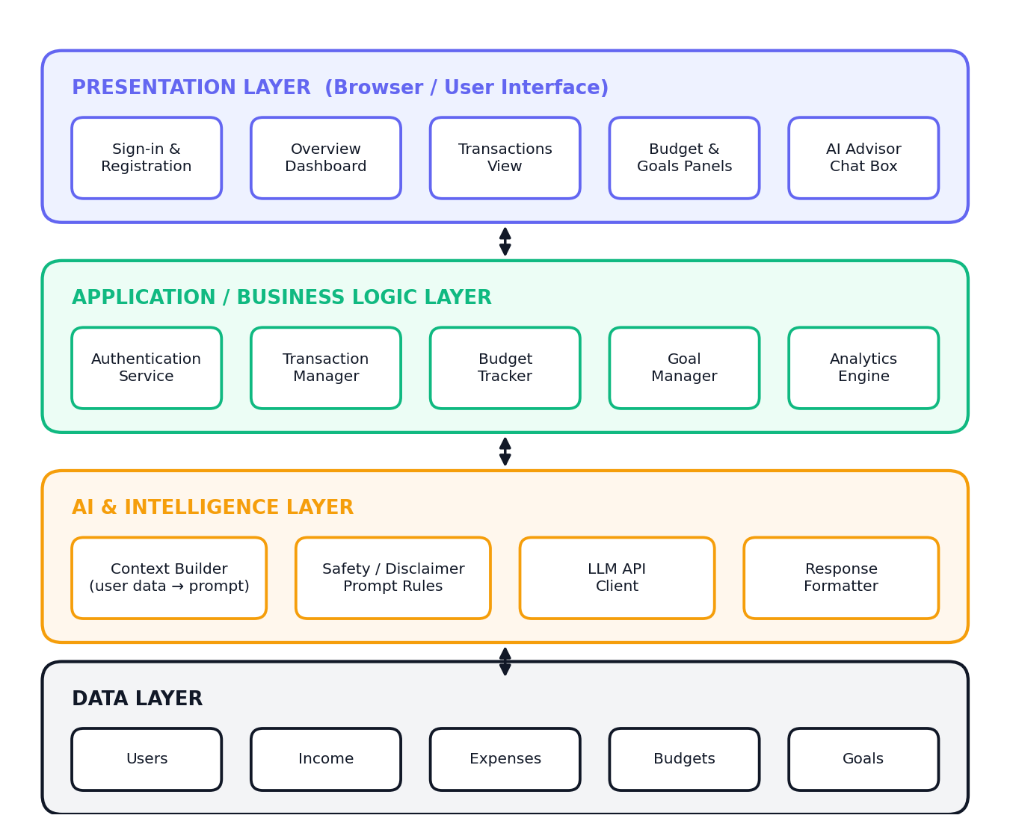
Figure 4.1: Layered system architecture of Personal Finance Advisor

4.2 System Flowchart
Figure 4.2 shows the overall control flow. A new visitor first creates an account and then signs in. When the credentials are valid, the personal dashboard is loaded and the user may choose any action – recording income or expenses, setting budgets or goals, or asking the AI Advisor. After each action the data is validated and saved, and the dashboard totals, charts and progress bars are recalculated before control returns to the action menu.
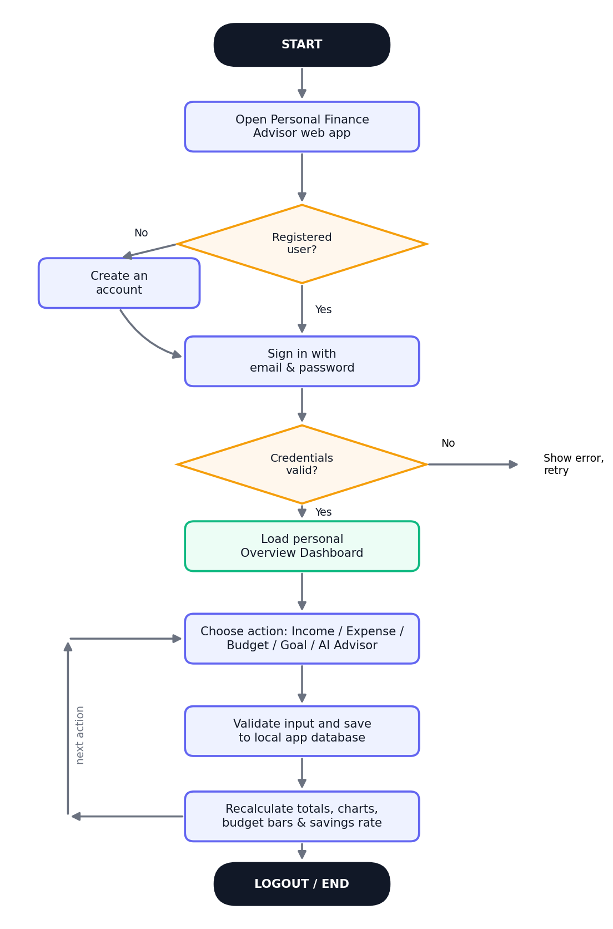
Figure 4.2: Overall system flowchart

4.3 Use-Case Diagram
The primary actor is the User. The use cases in Figure 4.3 describe everything the user can do inside the system boundary: registration and sign-in, viewing the dashboard, recording income and expenses, setting budgets, creating goals, adding savings and consulting the AI Advisor.
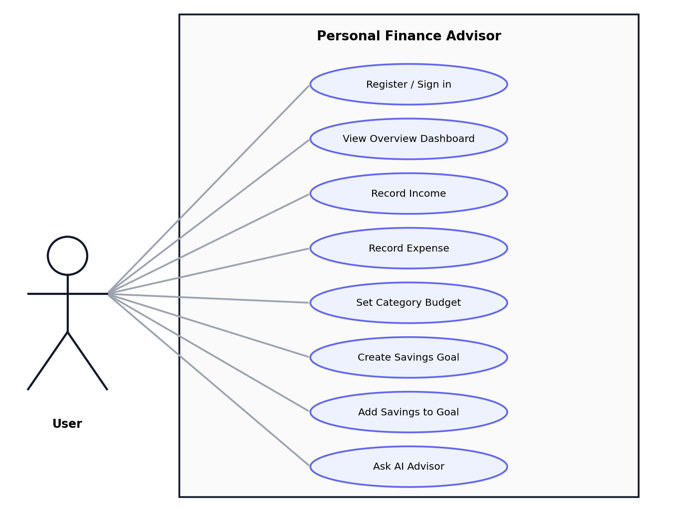
Figure 4.3: Use-case diagram

4.4 Data Flow Diagrams

Level 0 DFD (Context diagram)
At the highest level, the whole application is a single process that exchanges data with three external entities: the user, the local database and the AI service (Figure 4.4). The user supplies credentials, transactions, budgets, goals and questions, and receives dashboards, charts, alerts and insights.
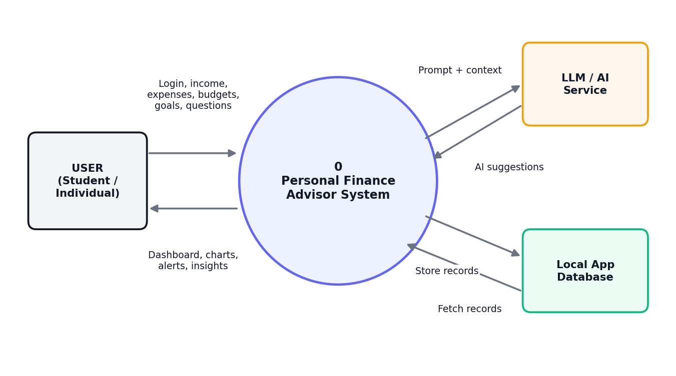
Figure 4.4: Level 0 data flow diagram

Level 1 DFD
Figure 4.5 decomposes the system into five processes: authentication, income and expense management, budget and goal management, analytics generation and AI advisor insights. Data stores D1, D2 and D3 hold the users, the transactions and the budgets/goals respectively. Process 5.0 communicates with the external LLM API.
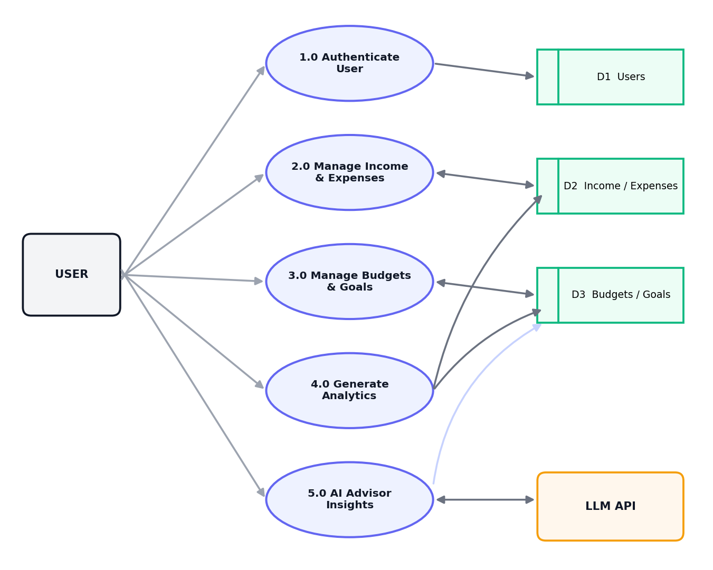
Figure 4.5: Level 1 data flow diagram

4.5 Database Design
The database contains five related tables. The Users table is the parent; every other table carries a user_id foreign key so that each person sees only their own records (Figure 4.6).
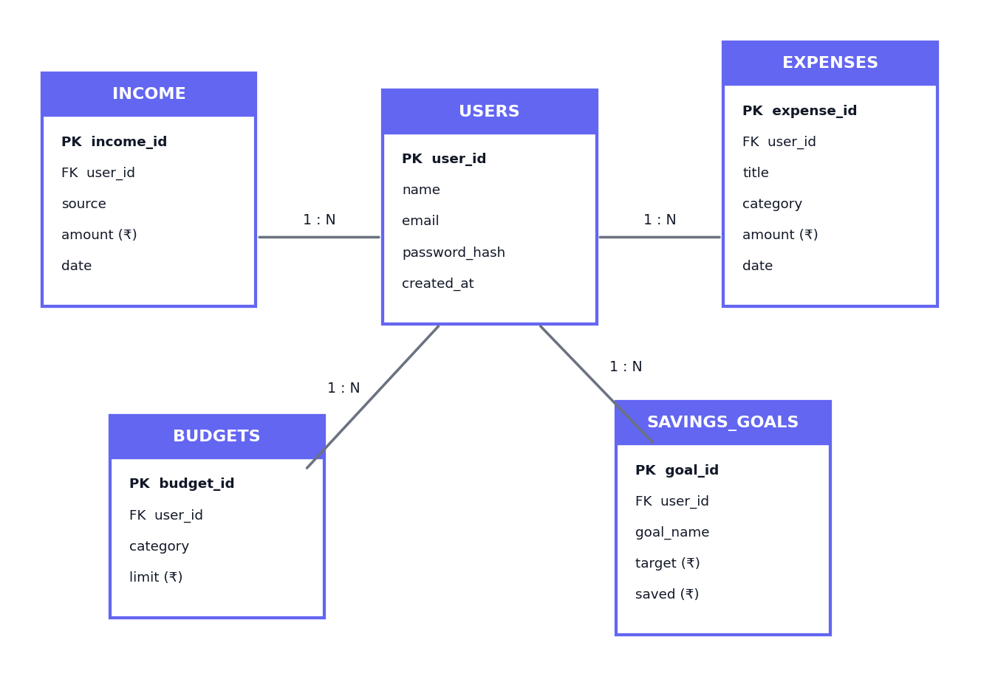
Figure 4.6: Entity-relationship diagram

4.6 Sequence Diagram – AI Advisor Request
Figure 4.7 traces what happens when the user asks the AI Advisor a question. The web interface sends the question to the back end, which fetches the user's income, expenses, budgets and goals from the database, builds a prompt that includes safety rules, and forwards it to the LLM. The generated advice is formatted and returned to the interface for display.
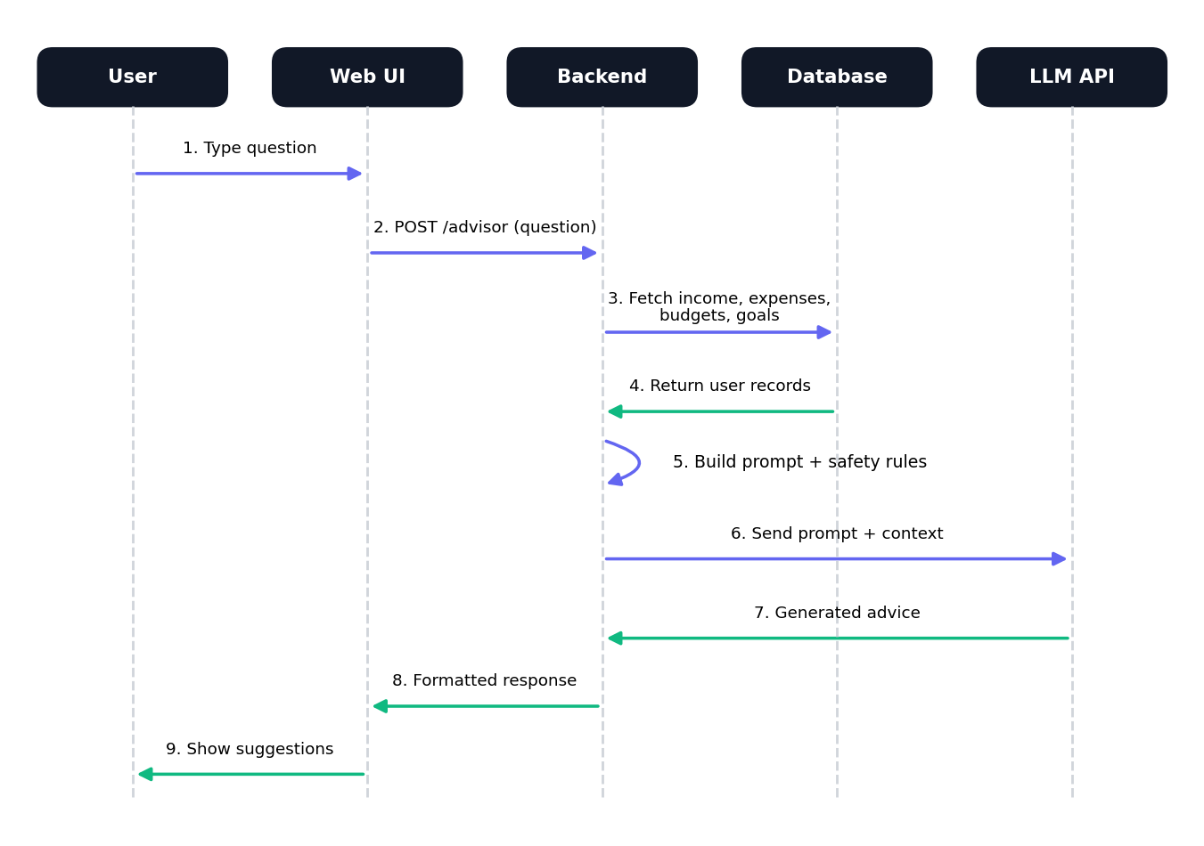
Figure 4.7: Sequence diagram of an AI Advisor request

5 IMPLEMENTATION
This chapter describes the implemented modules together with screenshots of the working application captured during the project demonstration.

5.1 Authentication Module
The landing page is split into two halves. The left half introduces the product – "Personal Finance Advisor, an AI-powered fintech project" – and lists its four main promises: income and expense tracking, budget and savings goals, AI financial insights and monthly financial analytics. The right half contains the Sign in form with email and password fields, a gradient Sign in button and a "Create an account" link for new users (Figure 5.1). After successful authentication the user is redirected to the Overview dashboard.
Figure 5.1: Welcome / Sign-in screen

5.2 Overview Dashboard
The dashboard is the home of the application. The dark sidebar on the left provides navigation to Overview, Transactions, Budget, Savings goals and AI Advisor, and a note at the bottom reassures the user that data is stored locally in the app database. The top bar greets the user by name and shows the profile card with email. Below the greeting, four summary cards display Monthly Income, Monthly Expenses, Available Balance and Savings Rate.
For a new user with no records every card shows ₹0 and the charts are empty, as shown in Figure 5.2. This empty state confirms that the application starts clean for each account.
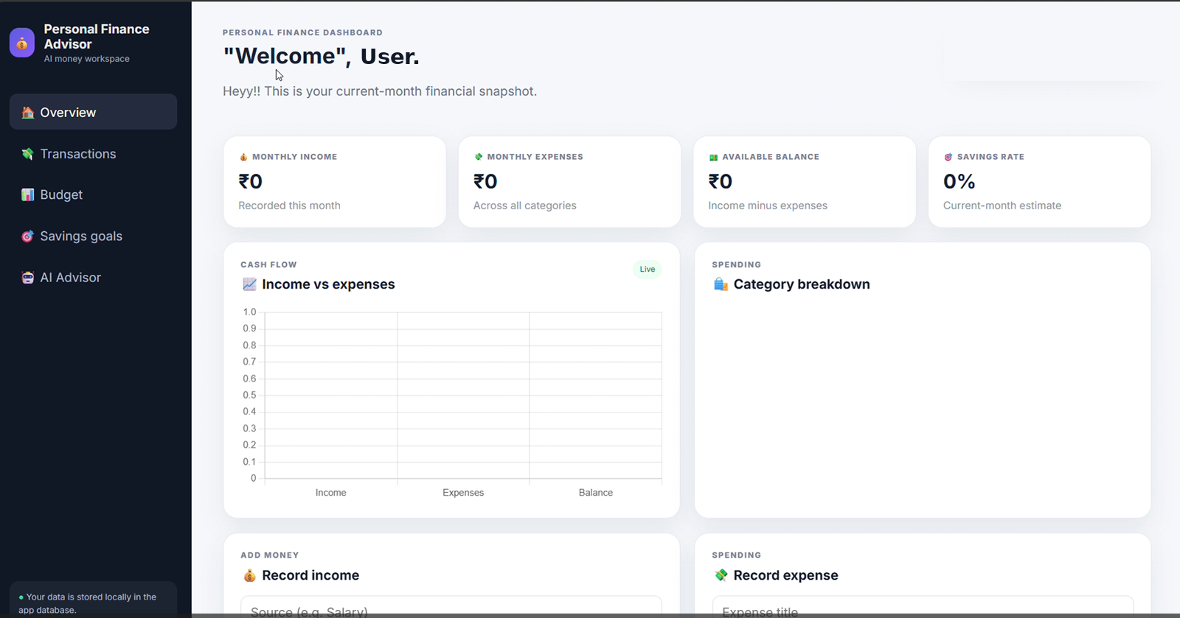
Figure 5.2: Overview dashboard for a new account (empty state)
Once transactions are recorded, the dashboard updates immediately (Figure 5.3). In the test scenario the user had recorded ₹5,500 of income and ₹200 of expenses, so the available balance became ₹5,300 and the savings rate 96.4 %. The Income vs expenses bar chart compares income, expenses and balance, while the Category breakdown doughnut chart shows that the entire expense so far belongs to the Food category.
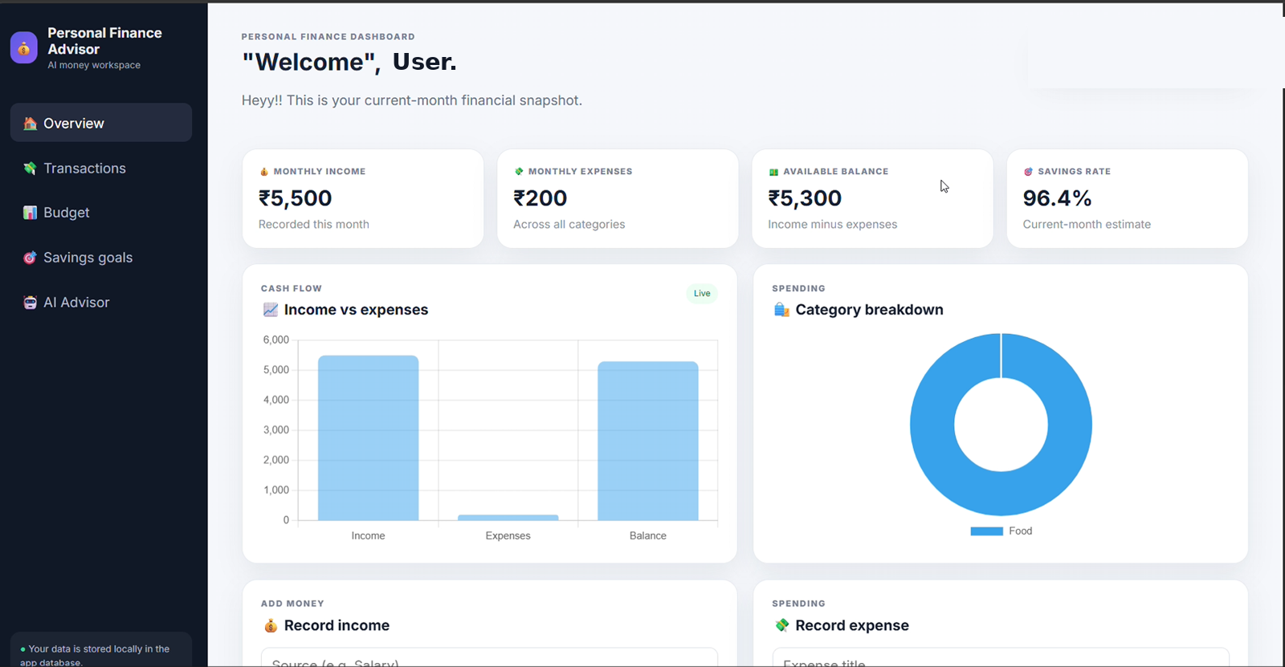
Figure 5.3: Overview dashboard with recorded data and live charts

5.3 Income and Expense Recording Module
Below the charts, two cards allow data entry (Figure 5.4). The Record income card has fields for the source (for example Salary), the amount in ₹ and a date picker, followed by an Add income button. The Record expense card has an expense title, a Category drop-down, the amount and the date. Recently added entries appear beneath each form – for example, an "Internship" income of ₹2,000 dated 2026-09-09 – and each can be removed with the small cross icon. When no entry exists the card shows a friendly message such as "No expense records yet."
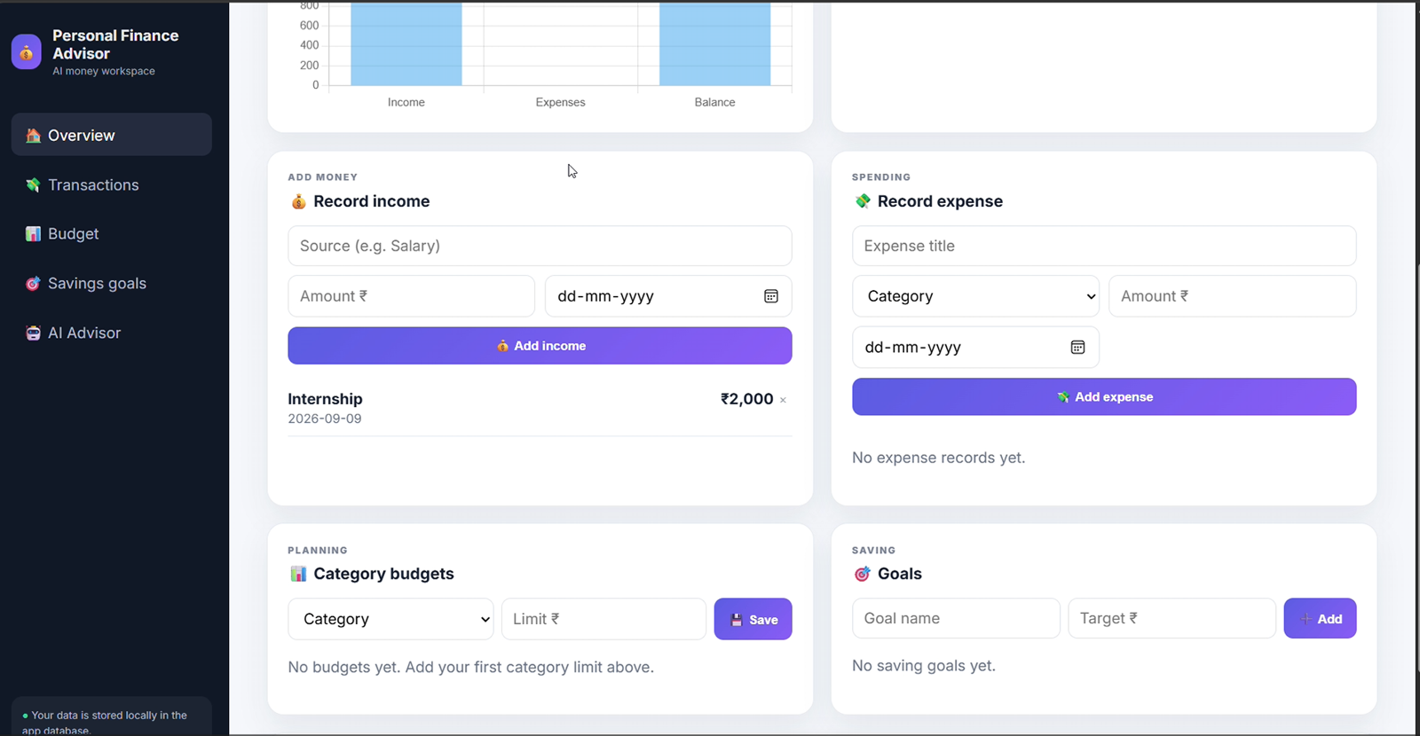
Figure 5.4: Record income and record expense forms

5.4 Budget and Savings Goal Module
The Category budgets card lets the user choose a category and set a limit in ₹. Each saved budget is listed with the amount spent and the limit and a progress bar, for example Food ₹200 / ₹2,000, Transport ₹100 / ₹500 and Rent ₹0 / ₹8,000. When a category exceeds its limit, as with Healthcare at ₹3,000 / ₹2,000, the bar is shown completely filled so that the problem is visible at a glance.
The Goals card under the heading "Saving" lets the user create a goal by entering a name and target (for instance "Trip to Goa" with a target of ₹5,000). Existing goals such as "New Laptop" (₹5,000 saved of ₹60,000) show progress bars, and the + Add savings button on each goal increases the saved amount (Figure 5.5). After adding ₹1,000 to the Goa goal, its progress reads ₹1,000 / ₹5,000.
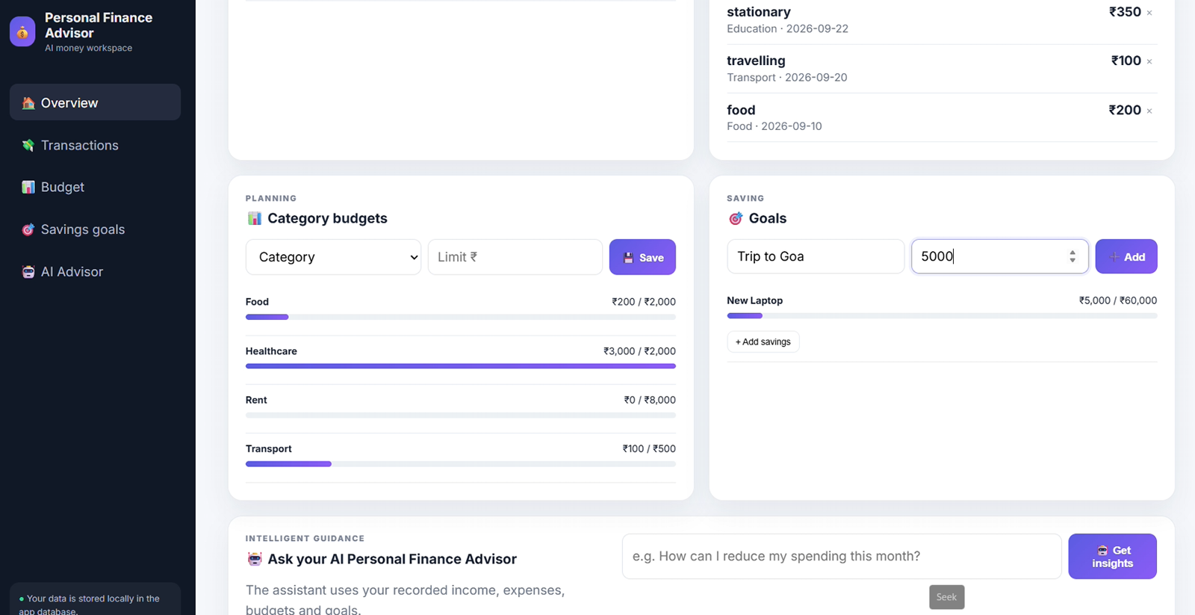
Figure 5.5: Category budgets and savings goals with progress indicators

5.5 AI Advisor Module
The AI Advisor card, titled "Ask your AI Personal Finance Advisor", contains a text box and a Get insights button. The helper text explains that the assistant uses the user's recorded income, expenses, budgets and goals. When the user submits a question, the back end assembles this data into a prompt, adds instructions that the answer must be based strictly on the provided data and must carry a disclaimer, and calls the language model.
Figure 5.6 shows the question "How can I reduce my expenses this month?" and the response. The advisor begins with the disclaimer that it is an educational assistant for a student project and not a licensed financial advisor, and then gives three numbered suggestions: (1) address Healthcare spending, the largest expense at 3,000 and 1,000 above its budget; (2) review Education expenses of 350, the second-highest category; and (3) maintain low spending in Food and Transport, which are well under their budgets, to protect the current balance of 1,850 for the New Laptop and Trip to Goa goals.
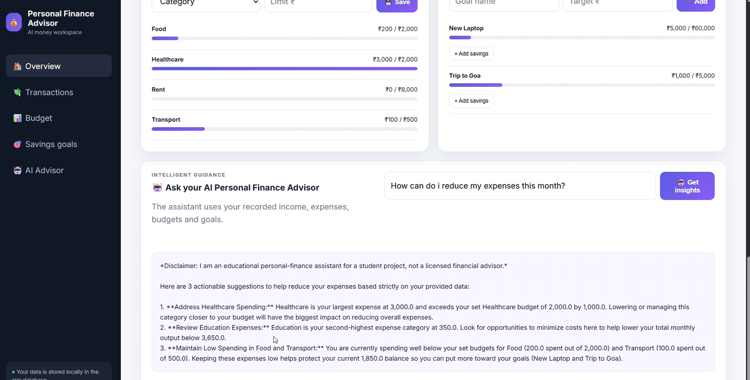
Figure 5.6: AI Advisor answering a question using the user's own data

6 TESTING AND RESULTS

6.1 Testing Approach
Functional (black-box) testing was performed manually by exercising every screen with typical and boundary inputs and comparing the observed result with the expected result. The tests were run using a demonstration account with realistic student data such as an internship income, food and travel expenses and a laptop-saving goal.

6.2 Test Cases
Table 6.1: Functional test cases and outcomes
No. | Test case | Expected result | Observed result | Status
T1 | Open sign-in page | Form with email and password shown | Page displayed as designed | Pass
T2 | Sign in with valid account | Dashboard opens with user name | Welcome message and profile card shown | Pass
T3 | New account dashboard | All indicators show ₹0 | Cards ₹0, 0 %; empty charts | Pass
T4 | Add income ₹2,000 (Internship) | Entry listed, income total increases | Entry listed with date; total updated | Pass
T5 | Add expense ₹200 (Food) | Expenses ₹200; balance reduced | Balance ₹5,300; donut shows Food | Pass
T6 | Savings rate calculation | 5,300 ÷ 5,500 = 96.4 % | 96.4 % displayed | Pass
T7 | Set budget Food ₹2,000 | Bar shows 10 % usage | Food ₹200 / ₹2,000 shown | Pass
T8 | Overspend Healthcare ₹3,000 | Bar full for limit ₹2,000 | Bar completely filled | Pass
T9 | Create goal Trip to Goa ₹5,000 | Goal listed at ₹0 progress | Goal listed with Add savings button | Pass
T10 | Add savings ₹1,000 to goal | Progress 20 % | ₹1,000 / ₹5,000 displayed | Pass
T11 | Ask AI "How can I reduce my expenses?" | Disclaimer + 3 data-based suggestions | Disclaimer and three suggestions shown | Pass

6.3 Results and Analysis
After the full set of test transactions was entered, total expenses reached ₹3,650: Healthcare ₹3,000, Education ₹350 (stationery), Food ₹200 and Transport ₹100 (travelling). With an income of ₹5,500, the remaining balance was ₹1,850, which is the same figure quoted by the AI Advisor in its answer. This agreement between the dashboard and the AI response shows that the advisor reads the same underlying data as the analytics module.
Figure 6.1 compares the budget limits with actual spending. Food, Transport and Rent are well within limits, while Healthcare exceeds its limit by ₹1,000. The AI Advisor correctly picked Healthcare as the first category to address, which is exactly the priority a human reviewer would choose.
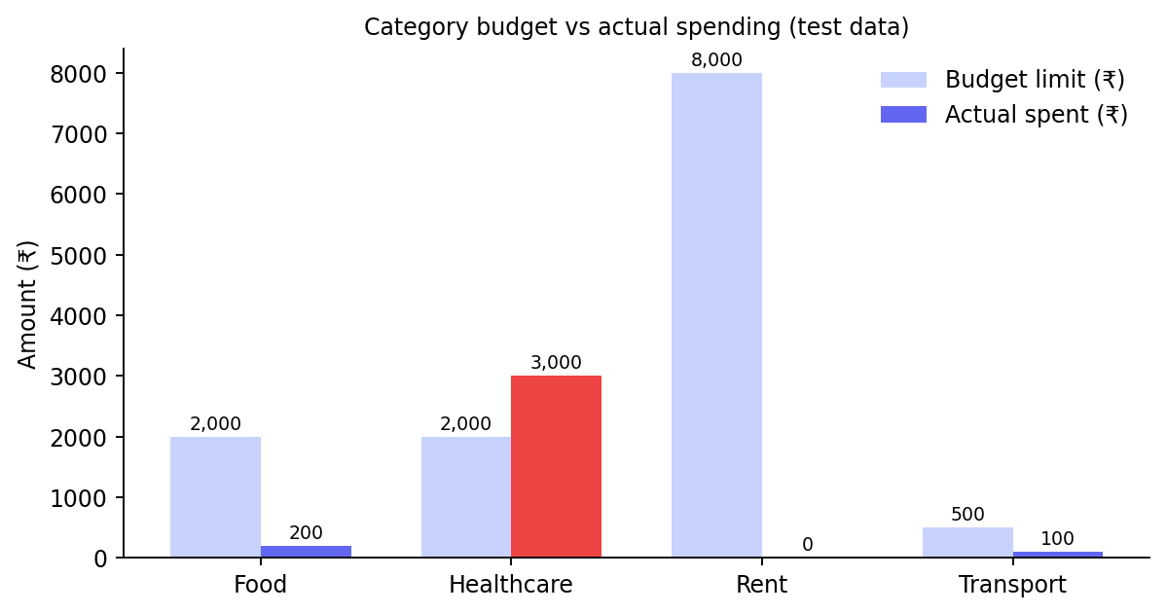
Figure 6.1: Budget limits versus actual spending

7 ADVANTAGES, LIMITATIONS AND FUTURE SCOPE

7.1 Advantages
- Personalised guidance: AI suggestions are tied to the user's own numbers rather than generic tips.
- Single workspace: tracking, budgeting, goals and advice are available on one screen.
- Immediate visual feedback: live charts and progress bars make overspending obvious.
- Privacy-friendly: no bank linking; data remains in the local application database.
- Low learning curve: a simple, modern interface that students can use without training.
- Responsible AI: every answer is accompanied by a disclaimer.

7.2 Limitations
- Transactions must be entered manually; there is no automatic import from bank statements or UPI.
- The AI Advisor depends on an internet connection and on the availability of the external language model.
- The AI response is currently shown as plain text, so formatting symbols such as asterisks for bold text appear as typed.
- Analytics are limited to the current month; long-term trend reports are not yet available.
- The system is designed for a single user per account and does not support shared household budgets.

7.3 Future Scope
- Automatic import of transactions from CSV, bank statements and SMS alerts.
- Month-by-month and yearly trend analysis with downloadable PDF / Excel reports.
- Smart notifications when a category reaches 80 % of its budget.
- Rendering of AI answers with rich formatting, and voice-based questions.
- Predictive models for expected month-end balance and personalised savings plans.
- Mobile application and optional cloud synchronisation with encrypted backup.

8 CONCLUSION
Personal Finance Advisor successfully demonstrates how a simple tracking application can be upgraded into an intelligent money companion by integrating an AI assistant. The system allows users to register, sign in, record income and expenses, set category budgets, create and fund savings goals, and view their current-month position through meaningful charts. The AI Advisor turns the recorded data into clear, numbered suggestions with a responsible-use disclaimer.
Testing with a realistic student scenario showed that all eleven functional test cases passed and that the advice generated by the AI matched the figures shown on the dashboard. The project therefore meets its stated objectives and provides a solid foundation for future enhancements such as automatic transaction import, trend analytics and predictive savings planning. Beyond the technical outcome, the project reinforced the value of combining data visualisation with natural-language explanations to improve financial awareness among young users.

REFERENCES
- Chart.js Contributors, "Chart.js Documentation – Bar and Doughnut Charts," https://www.chartjs.org/docs.
- Mozilla Developer Network, "Web Technology for Developers," https://developer.mozilla.org.
- SQLite Consortium, "SQLite Documentation," https://www.sqlite.org/docs.html.

