Overview
An integrated logistics management platform designed to streamline cargo transport and delivery, connecting businesses, drivers, and customers.

Users of the System

Businesses:

Manage Cargo: Businesses have the ability to add, update, and track the details of cargo, including its size, type. This management is crucial for maintaining an accurate inventory and planning logistics.
Create Shipments: They can create new shipment orders, specifying details like cargo content, status. This process involves coordinating with drivers for efficient delivery.
Drivers:

Accept Cargo Assignments: Drivers can view available cargo assignments posted by businesses and choose to accept them based on factors like location, cargo type, and their schedule.
Manage Deliveries: After accepting assignments, drivers are responsible for the transportation and timely delivery of cargo. They need to manage routes, schedules, and communicate any delays or issues.
Customers:

Receive Cargo Status Updates: Customers can track the status of their cargo, receiving updates on shipment progress. This feature enhances transparency and customer satisfaction.

Functional Requirements
User Registration & Profile Management: This feature allows for the creation of user accounts, enabling login and profile editing. It includes mechanisms for validating user input and securely managing personal information.
Cargo Creation & Management: Businesses can add, view information. This function includes authorization checks to ensure only permitted modifications.
Assignment of Cargo to Drivers: The system allows for assigning specific cargoes to drivers. It ensures that drivers receive detailed information about their assignments and maintains accurate records.
User Role-Based Authentication: The application distinguishes between different user roles, providing tailored interfaces and functionalities for businesses, drivers, and customers.
JWT Authorization: This component manages user sessions and secures API calls using JSON Web Tokens, with comprehensive token creation, validation, and management.
RESTful API & Angular Service Layer: Develops Angular services for seamless communication with backend RESTful APIs, ensuring efficient data exchange and system integration.

Your task is to complete the following backend files:

server/src/main/java/com/edutech/logisticsmanagementandtrackingsystem/entity/Business.java
server/src/main/java/com/edutech/logisticsmanagementandtrackingsystem/entity/Cargo.java
server/src/main/java/com/edutech/logisticsmanagementandtrackingsystem/entity/Customer.java
server/src/main/java/com/edutech/logisticsmanagementandtrackingsystem/entity/Driver.java
server/src/main/java/com/edutech/logisticsmanagementandtrackingsystem/entity/User.java
server/src/main/java/com/edutech/logisticsmanagementandtrackingsystem/config/SecurityConfig.java
server/src/main/java/com/edutech/logisticsmanagementandtrackingsystem/Controller/BusinessController.java
server/src/main/java/com/edutech/logisticsmanagementandtrackingsystem/Controller/CustomerController.java
server/src/main/java/com/edutech/logisticsmanagementandtrackingsystem/Controller/DriverController.java
server/src/main/java/com/edutech/logisticsmanagementandtrackingsystem/Controller/RegisterAndLoginController.java
server/src/main/java/com/edutech/logisticsmanagementandtrackingsystem/jwt/JwtRequestFilter.java
server/src/main/java/com/edutech/logisticsmanagementandtrackingsystem/jwt/JwtUtil.java
server/src/main/java/com/edutech/logisticsmanagementandtrackingsystem/repository/BusinessRepository.java
server/src/main/java/com/edutech/logisticsmanagementandtrackingsystem/repository/CargoRepository.java
server/src/main/java/com/edutech/logisticsmanagementandtrackingsystem/repository/CustomerRepository.java
server/src/main/java/com/edutech/logisticsmanagementandtrackingsystem/repository/DriverRepository.java
server/src/main/java/com/edutech/logisticsmanagementandtrackingsystem/repository/UserRepository.java
server/src/main/java/com/edutech/logisticsmanagementandtrackingsystem/service/BusinessService.java
server/src/main/java/com/edutech/logisticsmanagementandtrackingsystem/service/CargoService.java
server/src/main/java/com/edutech/logisticsmanagementandtrackingsystem/service/CustomerService.java
server/src/main/java/com/edutech/logisticsmanagementandtrackingsystem/service/DriverService.java
server/src/main/java/com/edutech/logisticsmanagementandtrackingsystem/service/UserService.java

Technology Stack
Backend: Spring Boot, JPA, MySQL
Frontend: Angular
Security: Spring Security, JWT

Key Points to Note
Security: Implement strong security protocols, especially for user data and API access. Use encryption for sensitive data and HTTPS for secure communication.
Scalability: Design the system to handle increasing amounts of data and users. Optimize database queries and use efficient data structures.
User Interface Consistency: Ensure a consistent look and feel across different modules. Maintain responsiveness for various devices.
Best Practices: Adhere to coding best practices such as DRY (Don't Repeat Yourself), modular design, and comprehensive documentation. Ensure code readability and maintainability.
Backend Functionalities to be Built
User Management: Develop endpoints for user registration, login, and profile management. Implement validation checks, secure password storage, and error handling.
Cargo Management: Create CRUD operations for cargo, ensuring data integrity and proper authentication. Implement business logic for cargo status updates and notifications.
Cargo-Driver Assignment: Develop functionalities for assigning cargo to drivers, managing the logistics of assignments, and tracking cargo status.
Role-Based Authentication: Set up role-based access control. Define different access levels and permissions for businesses, drivers, and customers.
JWT Token Management: Implement token generation, validation, and expiration mechanisms. Ensure secure token storage and transmission.

API Endpoints

For Businesses (Admin Side):
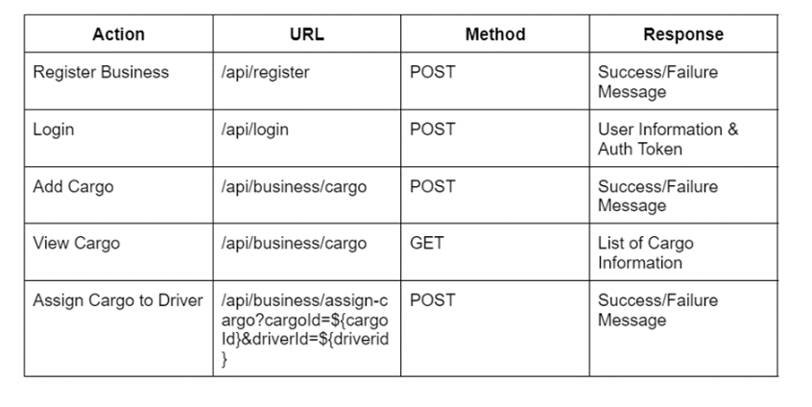

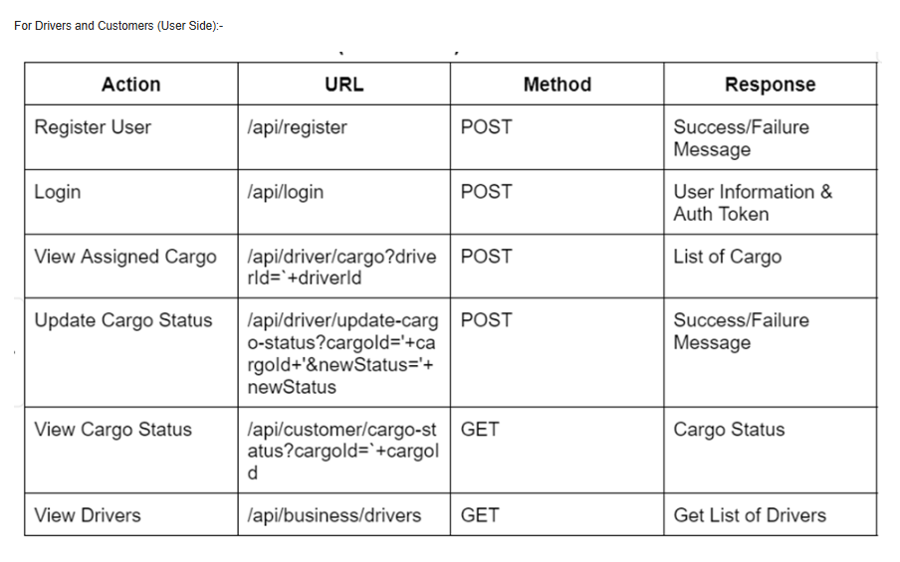
Frontend Functionalities to be Built
User Interface for Registration and Profile Management: Design intuitive forms and dashboards for user registration and profile management, with input validation and user feedback.
Cargo Management Dashboard: Develop interfaces for businesses to manage cargo, with features for adding, viewing, updating, and deleting cargo entries.
Cargo Assignment Interface: Create a user-friendly interface for businesses to assign cargo to drivers, and for drivers to view their assignments.
Role-Specific UI Elements: Tailor the UI based on the user's role, displaying relevant information and options for businesses, drivers, and customers.
Session Management with JWT: Implement client-side handling of JWT for session management, including token storage, retrieval, and automatic renewal.

Backend Test Cases:
User Registration: Ensure the user registration process correctly stores user data in the database and handles duplicate email addresses.
Cargo Addition: Verify that cargo is added to the database with the correct attributes and linked to the right business account.
Driver Assignment: Test that a cargo item is correctly assigned to a driver and that this change is reflected in the database.
Login Authentication: Ensure that the login process authenticates user credentials correctly and rejects invalid login attempts.
JWT Token: Validate that a JWT token is correctly generated upon login and that it expires as per the specified duration.

Frontend Test Cases:
Registration Form Validation: Check if the registration form correctly validates input data and displays appropriate error messages for invalid inputs.
Cargo Management Interface: Test the cargo addition interface to ensure that it correctly sends data to the backend and updates the UI upon successful addition.
Driver Assignment UI: Verify that the interface correctly displays available drivers for cargo assignment and updates upon a successful assignment.
Role-Based UI Display: Ensure that the UI elements displayed to the user are appropriate for their role (business, driver, customer).
Session Management: Test if the application correctly manages user sessions using JWT tokens, including handling token expiration and renewal.

Your task is to complete the following frontend files:

client/src/app/addcargo/addcargo.component.ts
client/src/app/addcargo/addcargo.component.html
client/src/app/assgin-cargo/assgin-cargo.component.ts
client/src/app/assgin-cargo/assgin-cargo.component.html
client/src/app/viewcargostatus/viewcargostatus.component.ts
client/src/app/viewcargostatus/viewcargostatus.component.html
client/src/app/login/login.component.ts
client/src/app/login/login.component.html
client/src/services/http.service.ts
client/src/services/auth.service.ts
client/src/app/app.component.html
client/src/app/registration/registration.component.ts
client/src/app/registration/registration.component.html

The below testcases need to be passed :-

testAssignCargoToDriver Passed
testViewCargoStatus Passed
testPermissionForDriverEndpoints Passed
testUpdateCargoStatus Passed
testLoginUser Passed
testPermissionForBusinessEndpoints Passed
testRegisterCustomer Passed
testAddCargo Passed
testPermissionForCustomerEndpoints Passed
testLoginWithWrongUsernameOrPassword Passed
testViewAllCargos Passed
testViewAssignedCargos Passed
testRegisterBusiness Passed
testRegisterDriver Passed
AddcargoComponent should have invalid form if any field is empty Passed
AddcargoComponent should have valid form if all fields are filled Passed
HttpService should be created Passed
HttpService should fetch order status Passed
HttpService should update cargo status Passed
HttpService should assign driver to cargo Passed
HttpService should get assigned orders for driver Passed
HttpService should assign driver to cargo Passed
HttpService should fetch cargo Passed
24 HttpService should fetch driver Passed
25
26
27
28
29

1

3

5

2

4

6
7

8

10

9

11
12
13
14
15
16
17
18
19
20
21
22
23

HttpService should add cargo Passed
HttpService should login Passed
HttpService should register user Passed
LoginComponent should have invalid form if username and password are empty Passed
LoginComponent should have invalid form if username or password is empty Passed

