Death Analysis
ADHOC NETWORKS
Under The Guidance of :
Mr. Ashutoshh Singh
Mr. Mukesh Nagar
Mentor:
Mr. Tushar Goyal
Mr. Anand Shukla
Made by:
Tanishka Singhal (Team Leader)
Shreya Goyal
Yasheesh Gupta
Diyvansh Goyal
Nupur Surana

Introduction
Nowadays in today’s modern world especially where India is progressing so well, where medical facilities are growing with a big number still some deaths are being noticed. India, while having such good medical facilities, such good doctors, making it approachable to the majority of population the reason to find the cause of death becomes so important issue. In order to take action on it the visualization of data for example graphs between certain quantities is a big task.
Here comes the role of Data Analytics which helps to analysis such a big amount of data and visualize it into various types of graphs. So, we made this project to solve this problem with a easier approach in order to facilitate user.
This project deals with analysis of deaths in some districts of Rajasthan. Basically it’s main motive is to visualize the data which deals with various factors related to death as to how death has occurred, region of death, deceased sex, date of death, marital status, drinking water, toilet being used, highest qualification.
We tried to provide user various types of graph between various values. Using this project we can find the target value of number of deaths with the time being provided.
This project is mainly helpful for doing analysis, studying about these issues, concluding various problems and then their solutions, predicting various values like number of death going to happen in coming years, at what age it’s going to happen, due to what all issues.

Gathering Material
“ As the world became more and more dependent on technology with each passing day, software automatically became an important organ for development. Since software is needed almost everywhere today, its development is a highly intelligent and precise process, involving various steps. Known as software development life cycle, these steps include planning, analysis, design, development & implementation, testing and maintenance. These steps go on to create the perfect software for clients. ”

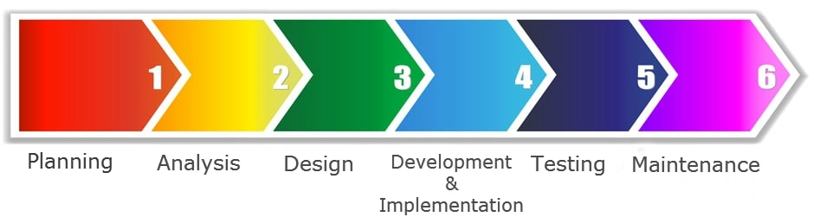

- Planning:
While having a random discussion with faculty members we got the idea about this project. The moment we got this idea, we had a small discussion and decided to perform the initial step of finding the dataset regarding the topic death analysis. We contacted various hospitals, various friends, internet and somehow managed to find a huge dataset regarding death analysis. Similarly we went on planning and executing things one by one and this way managed to complete the project.
- Analysis:
We analysed the need of project and how much is going to help people keeping in mind present day’s requirements and scenario. We all analysed the dataset and filtered . Analysing present day’s scenario with project is an important task in order to get the idea about the utility of project which we did by doing a small survey. In that survey we basically had interaction with people regarding the same.
3. Design:
This project is basically divided into two parts i.e. frontend and backend. Frontend part dealt with html page and using various tags in order to prepare an interface of the project. Backend part dealt with generating graphs between certain attributes, using various algorithms and finally linking both the two parts together.
4. Development & Implementation:
The actual task of developing the software starts here with data recording going on in the background. Once the software is developed, we did it’s pilot study where the project’s functionality was checked again ad again to make sure it is properly working or not and linking process took place.
5. Testing:
In this stage we tested the project to make sure it is properly working and meeting all the requirements we aimed to solve through this project. During this stage many errors took place but somehow by taking help from internet and various mentors we managed to solve it.
6. Maintenance: Once the software passes through all the stages without any issues, it is to undergo a maintenance process wherein it will be maintained and upgraded from time to time to adapt to changes. This stage is for future use. From the very starting we made our project in such a way that in future at any point of time changes can be made and it can be upgraded time to time.

Specification & Design
This project is made using various platforms and various computer languages in which specifically we used certain libraries.
Python is the computer language which we mainly used in the backend part. The libraries which we mainly used in python are Pandas , Matplotlib and Pyspark.
- Pandas: Pandas has so many uses that it might make sense to list the things it can't do instead of what it can do.
This tool is essentially your data’s home. Through pandas, you get acquainted with your data by cleaning, transforming, and analyzing it.
For example, say you want to explore a dataset stored in a CSV on your computer. Pandas will extract the data from that CSV into a DataFrame — a table, basically — then let you do things like:
- Calculate statistics and answer questions about the data, like
  - What's the average, median, max, or min of each column?
  - Does column A correlate with column B?
  - What does the distribution of data in column C look like?
- Clean the data by doing things like removing missing values and filtering rows or columns by some criteria
- Visualize the data with help from Matplotlib. Plot bars, lines, histograms, bubbles, and more.
- Store the cleaned, transformed data back into a CSV, other file or database.
Matplotlib: When you’re working with the Python plotting library Matplotlib, the first step to answering the above questions is by building up knowledge on topics like:
- The anatomy of a Matplotlib plot: what is a subplot? What are the Axes? What exactly is a figure?
- Plot creation, which could raise questions about what module you exactly need to import (pylab or pyplot?), how you exactly should go about initializing the figure and the Axes of your plot, how to use matplotlib in Jupyter notebooks, etc.
- Plotting routines, from simple ways to plot your data to more advanced ways of visualizing your data.
- Basic plot customizations, with a focus on plot legends and text, titles, axes labels and plot layout.
- Saving, showing, clearing, … your plots: show the plot, save one or more figures to, for example, pdf files, clear the axes, clear the figure or close the plot, etc.
- Lastly, you’ll briefly cover two ways in which you can customize Matplotlib: with style sheets and the rc settings.

What Does A Matplotlib Python Plot Look Like?
At first sight, it will seem that there are quite some components to consider when you start plotting with this Python data visualization library. You’ll probably agree with me that it’s confusing and sometimes even discouraging seeing the amount of code that is necessary for some plots, not knowing where to start yourself and which components you should use.
Luckily, this library is very flexible and has a lot of handy, built-in defaults that will help you out tremendously. As such, you don’t need much to get started: you need to make the necessary imports, prepare some data, and you can start plotting with the help of the plot() function! When you’re ready, don’t forget to show your plot using the show() function.

Pyspark: Apache Spark is one the most widely used frameworks when it comes to handling and working with Big Data and Python is one of the most widely used programming languages for Data Analysis, Machine Learning, and much more. So, why not use them together? This is where Spark with Python also known as PySpark comes into the picture.
With an average salary of $110,000 per annum for an Apache Spark Developer, there's no doubt that Spark is used in the industry a lot. Because of its rich library set, Python is used by the majority of Data Scientists and Analytics experts today. Integrating Python with Spark was a major gift to the community. Spark was developed in the Scala language, which is very much similar to Java. It compiles the program code into bytecode for the JVM for Spark big data processing. To support Spark with Python, the Apache Spark community released PySpark. In this Spark with Python blog, I'll discuss the following topics.
- Introduction to Apache Spark and its features
- Why go for Python?
- Setting up Spark with Python (PySpark)
- Spark in Industry
- PySpark SparkContext and Data Flow
- PySpark KDD Use Case
Apache Spark is an open-source cluster-computing framework for real-time processing developed by the Apache Software Foundation. Spark provides an interface for programming entire clusters with implicit data parallelism and fault-tolerance.
- Speed: It is 100x faster than traditional large-scale data processing frameworks.
- Powerful Caching: Simple programming layer provides powerful caching and disk persistence capabilities.
- Deployment: Can be deployed through Mesos, Hadoop via Yarn, or Spark's own cluster manager.
- Real Time: Real-time computation and low latency because of in-memory computation.
- Polyglot: It is one of the most important features of this framework as it can be programmed in Scala, Java, Python, and R.
We used various portals or platforms like HTML, CSS, BOOTSTRAP, JavaScript for backend as well as frontend. Mainly frontend part is done using HTML and backend part is done using CSS, JavaScript, BOOTSTRAP. We used HTML for making the interface part using its various tags to get started with our projector software in order to avail it.
We used certain part of machine learning also. The main algorithm which we mainly used in order to predict the target value that is year of death is Decision Tree Algorithm.
Decision Tree Algorithm
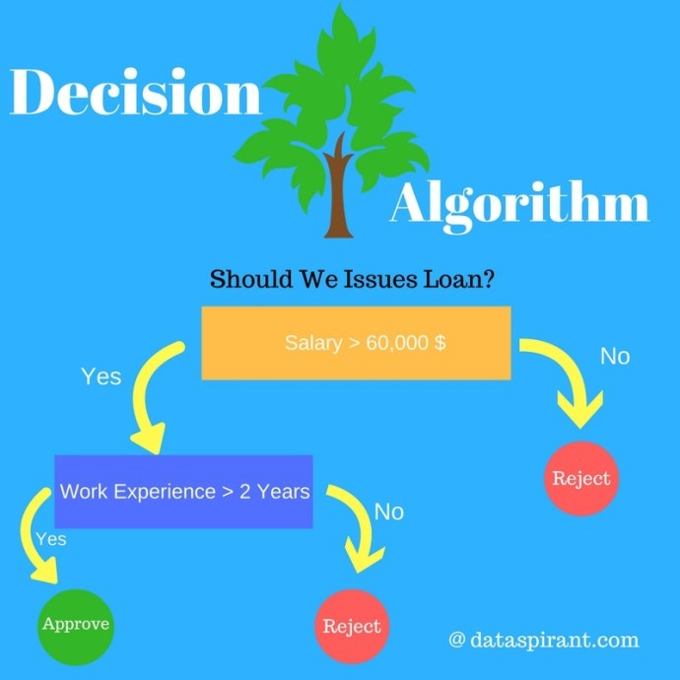
Decision Tree algorithm belongs to the family of supervised learning algorithms. Unlike other supervised learning algorithms, decision tree algorithm can be used for solving regression and classification problems too.
The general motive of using Decision Tree is to create a training model which can use to predict class or value of target variables by learning decision rules inferred from prior data (training data).
The understanding level of Decision Trees algorithm is so easy compared with other classification algorithms. The decision tree algorithm tries to solve the problem, by using tree representation. Each internal node of the tree corresponds to an attribute, and each leaf node corresponds to a class label.

Decision Tree Algorithm Pseudocode
- Place the best attribute of the dataset at the root of the tree.
- Split the training set into subsets. Subsets should be made in such a way that each subset contains data with the same value for an attribute.
- Repeat step 1 and step 2 on each subset until you find leaf nodes in all the branches of the tree.

In decision trees, for predicting a class label for a record we start from the root of the tree. We compare the values of the root attribute with record’s attribute. On the basis of comparison, we follow the branch corresponding to that value and jump to the next node.
We continue comparing our record’s attribute values with other internal nodes of the tree until we reach a leaf node with predicted class value. As we know how the modeled decision tree can be used to predict the target class or the value. Now let’s understanding how we can create the decision tree model.
Results And Evaluation
Finally , after a lot of hard work and dedication the project dealing with Death Analysis is ready. We tested it numerous times in order to ensure what we planned and made is similar and meets all the requirements. Our project is successful in visualizing the data related to deaths in Jaipur, Rajasthan in the form of various types of graphs and predicting the year of death.

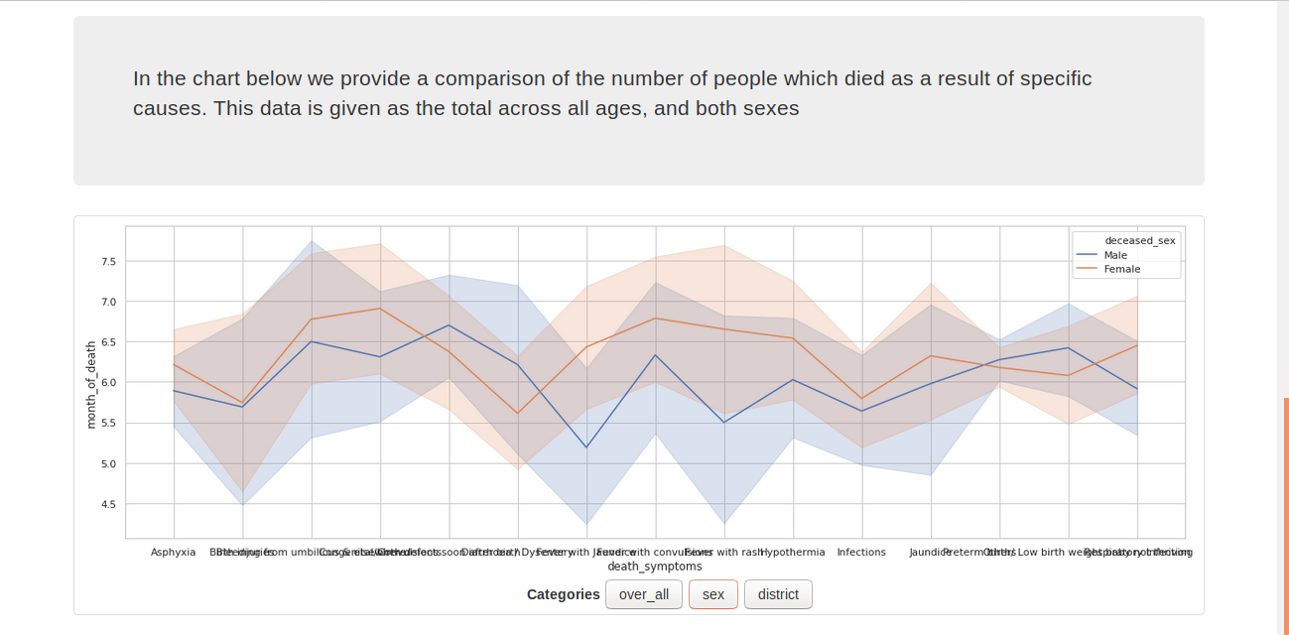

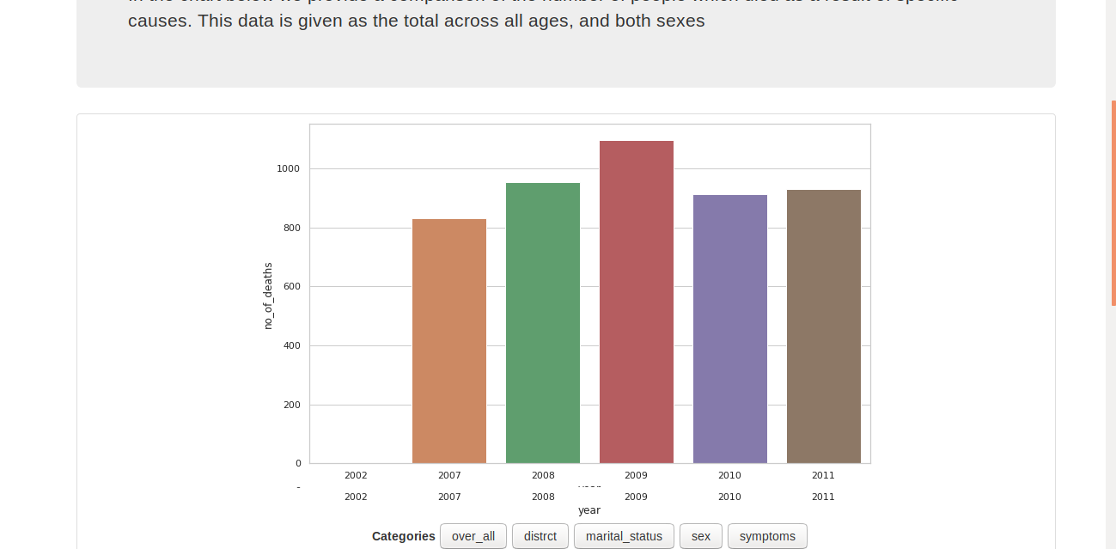

These are some photos of the our project how it visualizes data in the form of graphs.
Future Work
This project can be modified in future and can be used for analyzing death happening and cause of it in all over India and further all over the world. Main thing for extending it to that extent is requirement of dataset. Then various more algorithms can be used for predicting more target values. In these all possible ways work can be done in the coming future.
References
- http://dataaspirant.com/2017/01/30/how-decision-tree-algorithm-works/
- https://www.udemy.com/course/spark-and-python-for-big-data-with-pyspark/?utm_source=adwords-learn&utm_medium=udemyads&utm_campaign=NEW-AW-PROS-TECH-India-DSA-1-EN-ENG_._ci__._sl_ENG_._vi_TECH_._sd_All_._la_EN_._&utm_content=deal4584&utm_term=_._ag_71318360778_._ad_346561141829_._de_c_._dm__._pl__._ti_dsa-761862820772_._li_9061782_._pd__._&gclid=CjwKCAjwr8zoBRA0EiwANmvpYEkvVhCro4IlYqfxk_lJCtyCMGVQQmGOGISaZ5nBTmGk1MZdfPKI8xoCcZ8QAvD_BwE
- https://www.learnpython.org/en/Pandas_Basics
- https://www.datacamp.com/community/tutorials/matplotlib-tutorial-python?utm_source=adwords_ppc&utm_campaignid=1455363063&utm_adgroupid=65083631748&utm_device=c&utm_keyword=&utm_matchtype=b&utm_network=g&utm_adpostion=1t1&utm_creative=332602034364&utm_targetid=aud-299261629574:dsa-473406587955&utm_loc_interest_ms=&utm_loc_physical_ms=9061782&gclid=CjwKCAjwr8zoBRA0EiwANmvpYBEwxscfII4VzSX_g4vP_E7erMpoovNr7u_m3ZQ9uX4exrxeDYD-ixoCxi0QAvD_BwE
- https://data.gov.in/

