Lab 1: Requirements Engineering & UML Use-Case Modelling
Problem Statement #01 — Campus & Academic Operations: Smart Lab Equipment & Slot Reservation Portal

Deliverable 1 — Requirements Table
Exactly five Functional Requirements (FR-001–FR-005) and two Non-Functional Requirements (NFR-001, NFR-002). FR-001 and NFR-001 were provided in the problem statement; the remaining requirements were elicited from the scenario context.
Req ID | Type | Description | Priority | Acceptance Criteria | Rationale
FR-001 | Functional | The system shall allow authenticated students to view real-time availability and reserve a maximum 2-hour slot for any calibrated equipment up to 7 days in advance. (given) | High | Pass: Slot is successfully locked and a reservation token is generated. Fail: Double-booking is allowed or the reservation exceeds the 2-hour limit. | Core booking functionality; prevents double-booking of high-value hardware.
FR-002 | Functional | The system shall allow an authenticated student to cancel an active reservation up to 60 minutes before the slot start time, immediately releasing the equipment for other bookings. | Medium | Pass: The cancelled slot reappears as “Available” within 5 seconds when cancelled more than 60 minutes before start. Fail: The slot remains locked, or cancellation is permitted after the 60-minute cutoff. | Prevents equipment sitting idle while blocked by a reservation no longer needed, improving utilisation for other students.
FR-003 | Functional | The system shall verify that the requested equipment’s calibration status is “Valid” before confirming any reservation, and shall block reservation of equipment flagged “Calibration Overdue”. | High | Pass: A reservation attempt on overdue equipment is rejected with an explanatory message and no token is generated. Fail: A reservation is confirmed for equipment with an expired calibration record. | Ensures students only use instruments that are verified safe and accurate, as required by the lab’s calibration policy.
FR-004 | Functional | The system shall allow a lab technician to record equipment return by entering the reservation token, capturing the actual return timestamp against the scheduled slot end time. | High | Pass: The return is logged with a timestamp and equipment status changes to “Available” (or “Under Maintenance” if flagged). Fail: The return cannot be recorded, or no timestamp is captured. | Creates the auditable record needed to detect and act on late returns.
FR-005 | Functional | The system shall automatically place a 7-day reservation hold on a student account after the student accrues 3 or more late equipment returns within a rolling 30-day window. | Medium | Pass: On the 3rd late return within 30 days, the account is blocked from new reservations for 7 days and the student is notified. Fail: A student with 3 or more late returns in 30 days can still reserve equipment. | Enforces the late-return disciplinary rules and discourages equipment hoarding during peak demand.
NFR-001 | Non-functional | The system shall ensure that concurrent slot reservation requests are processed within 200 ms with strict database-level lock isolation to prevent race conditions. (given) | High | Pass: Benchmarking tests confirm target latency and security standards under simulated peak load. | Prevents two students from simultaneously locking the same equipment slot.
NFR-002 | Non-functional | The system shall maintain 99.5% uptime during semester operating hours (08:00–20:00, Monday–Saturday), excluding scheduled maintenance windows announced at least 24 hours in advance. | High | Pass: Monthly uptime monitoring logs show ≥ 99.5% availability during operating hours. Fail: Unplanned downtime exceeds the 0.5% threshold in any calendar month. | Students depend on the portal for time-critical lab bookings; unplanned outages directly block coursework deadlines.

Deliverable 2 — UML Use-Case Diagram
Actors: Student, Lab Technician. The diagram includes an « include » relationship (Reserve Equipment Slot always invokes Verify Calibration Status and Generate Reservation Token) and an « extend » relationship (Apply Late-Return Disciplinary Hold optionally extends Mark Equipment Returned, only when the return is late).
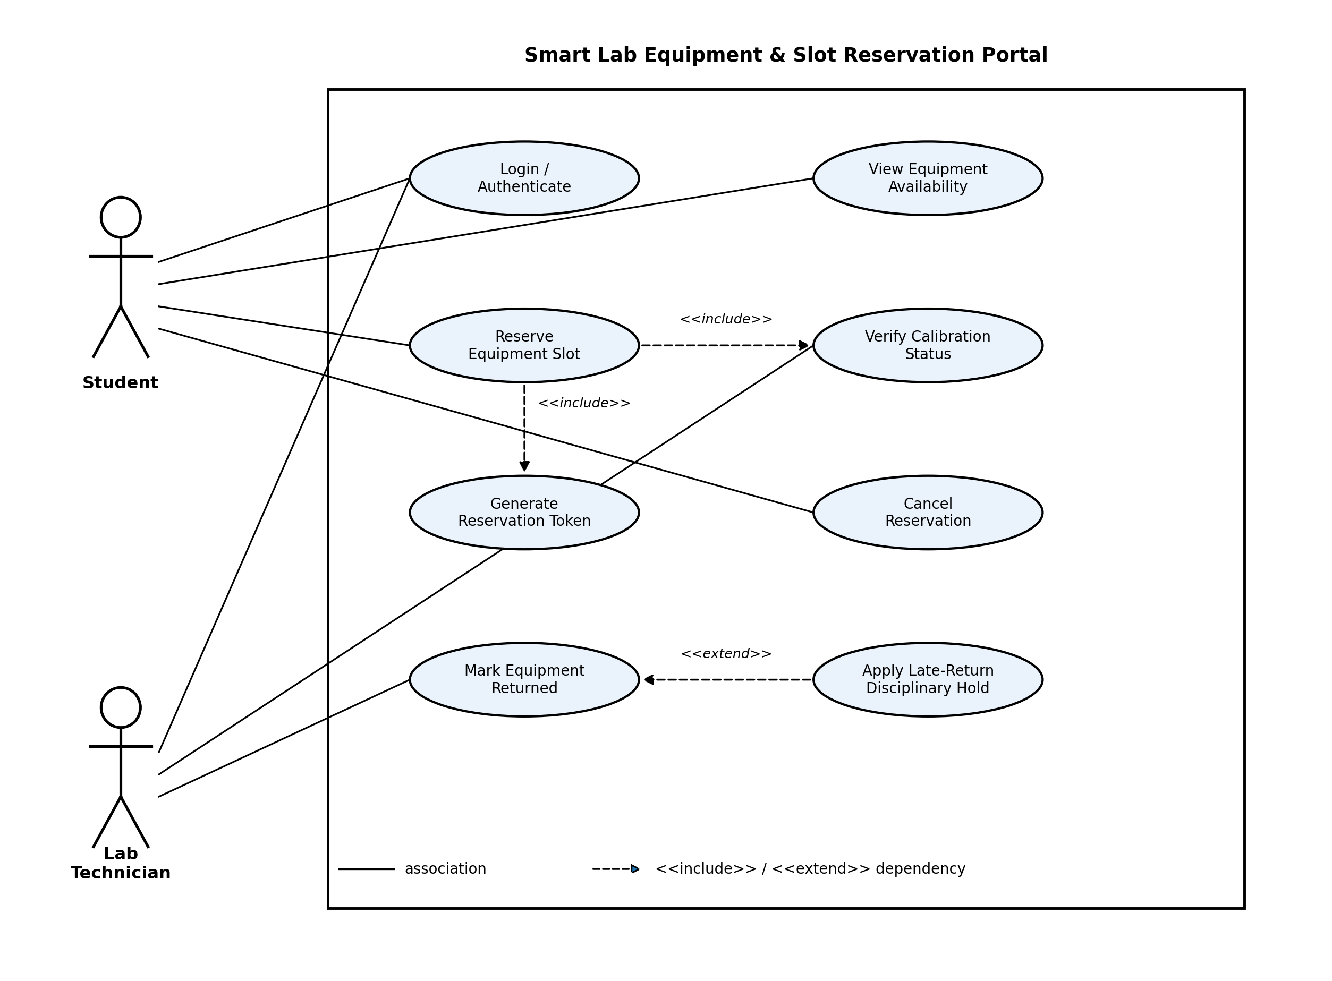

Use Cases Summary
- Login / Authenticate — base use case required before any student or technician action.
- View Equipment Availability — student browses the real-time equipment calendar.
- Reserve Equipment Slot — student books a calibrated instrument for ≤ 2 hours, ≤ 7 days ahead. « include » Verify Calibration Status, « include » Generate Reservation Token.
- Verify Calibration Status — included use case; checks the instrument’s calibration record before a reservation is confirmed.
- Generate Reservation Token — included use case; issues the unique token that locks the slot.
- Cancel Reservation — student releases a slot they no longer need, ≥ 60 minutes before start.
- Mark Equipment Returned — lab technician logs the actual return timestamp against the reserved slot.
- Apply Late-Return Disciplinary Hold — « extend » of Mark Equipment Returned; triggered only when the return is late and the student’s 30-day late count reaches the threshold.

Deliverable 3 — Use-Case Flow Specification

Preconditions
- The student is authenticated in the portal (Login / Authenticate use case has completed successfully).
- The equipment inventory and calibration records are current.

Postconditions
- On success: the requested slot is locked for the selected equipment, a unique reservation token exists, and the equipment availability calendar reflects the new booking in real time.
- On failure: no slot is locked and no reservation token is generated; equipment availability is unchanged.

Main Success Scenario
1. Student selects “Reserve Equipment” from the portal dashboard.
2. System displays the real-time availability calendar for calibrated equipment (oscilloscopes, logic analyzers, FPGA development boards).
3. Student selects an equipment item, a start time, and a duration of at most 2 hours, within the next 7 days.
4. System invokes « include » Verify Calibration Status for the selected equipment.
5. System confirms the equipment’s calibration status is “Valid” and the slot is free.
6. System locks the slot using a database-level lock to prevent concurrent double-booking.
7. System invokes « include » Generate Reservation Token and creates a unique token for the booking.
8. System displays a confirmation screen showing the reservation token, equipment ID, and the date/time window.
9. System sends a confirmation notification (email / in-app) to the student.
10. Use case ends successfully.

Alternate Flow — 4a. Equipment Fails Calibration Check
4 a1. System detects that the selected equipment’s calibration status is “Calibration Overdue”.
4 a2. System rejects the reservation attempt and displays: “Equipment not available — calibration overdue.”
4 a3. System suggests an alternative calibrated instrument of the same type, if one is available in the requested window.
4 a4. Student either selects the alternative equipment (resume Main Success Scenario at step 3) or exits; if the student exits, the use case ends without a reservation being created.

