Ride Sharing & Matching Platform
A Project Based Learning Report Submitted in partial fulfilment of the requirements for the award of the degree

of

Bachelor of Technology
in The Department of Computer Science and Engineering
DATA STRUCTURES AND ALGORITHMS - 3 (25CS2103E)

Submitted by
2510030257: E. Sai Teja
2510030335: K. Sai Charan
2510030398: T. Sai Praneeth
2510030288: M. Harshith
2510030361: Tanishk Joshi

Under the guidance of
Malgireddy Saidireddy



Department of Computer Science and Engineering
Koneru Lakshmaiah Education Foundation, Aziz Nagar
Aziz Nagar – 500075
OCT - 2026.

Abstract
Ride-sharing services must assign every incoming pickup request to a suitable driver quickly and accurately. A simple approach that compares straight-line distances ignores the real road network and can select a driver who is close on the map but far away by road. This project presents a Ride Sharing & Matching Platform that models city roads as a weighted graph and matches each rider to the nearest available driver using Dijkstra's shortest-path algorithm implemented with a min-heap. Rider requests are served in first-in-first-out order from a queue, driver locations and availability are kept in a hash map for O(1) lookup, and the graph is stored as an adjacency list that needs O(V + E) space. The matcher follows a greedy rule, always assign the closest driver, and stops the search as soon as the first available driver is reached, so the whole map is not explored. Ties between equally distant drivers are broken deterministically by the lowest driver ID. The system also handles edge cases such as no driver being available, a disconnected map, and a rider and driver sharing the same node. Compared with a linear scan that costs O(n) per request but uses only straight-line distance, the proposed method runs in O((V + E) log V) and bases every match on real road distance. Results were verified against hand-computed shortest paths on sample inputs. The work shows how graphs, heaps, hash maps and greedy design can be combined to solve a real-world optimisation problem, and it can be extended with live traffic, A* search, demand prediction, dynamic pricing and ride pooling.
Keywords: Ride sharing, Dijkstra's algorithm, Min-heap, Greedy algorithm, Weighted graph, Nearest-driver matching

List of Figures
Fig. 1. Final system workflow of the Ride Sharing & Matching Platform, from pickup request to ride completion. 7
Fig. 2. Sample road network with the rider at A and drivers at B, D and E. The first match follows the highlighted path. 8

List of Tables
Table I. Modules implemented in the platform 7
Table II. Algorithms and data structures summary 7
Table III. Shortest road distances from rider node A 8
Table IV. Edge cases tested and the behaviour of the system 9
Table V. Comparison of the linear scan with Dijkstra and a min-heap 9
Table VI. Challenges faced and the solutions adopted 9

Table of Contents
1. Introduction 6
a. Problem Statement 6
b. Objectives 6
c. Project Overview 6
2. Methodology 7
a. Final System Workflow 7
b. Modules Implemented 7
c. Algorithms and Data Structures 7
d. Novelty of the Developed Methodology 8
e. Adaptability of the Methodology 8
3. Experiments 8
a. Sample Input and Output 8
b. Testing and Edge Cases 9
c. Methodology Evaluation 9
4. Results 9
a. Complexity Comparison 9
b. Challenges and Solutions 9
c. Results and Learning Outcomes 10
d. Dissemination and Accessibility 10
5. Conclusion and Future Work 10
References 10

Introduction
Ride-sharing platforms have changed the way people travel in cities. A rider opens an application, requests a pickup, and expects a nearby driver to be assigned within moments. Behind this simple experience is a matching problem: among all drivers who are currently free, the platform must decide which one should serve the rider. The quality of this decision directly affects how long the rider waits, how far the driver travels without a passenger, and how efficiently the fleet is used.
A common first solution is to compute the straight-line distance between the rider and every driver and pick the smallest value. This is easy to implement, but it has a serious weakness. Vehicles cannot travel through buildings, rivers or one-way streets, so a driver who looks close on the map may need a long detour to reach the rider. A driver who is slightly farther away in a straight line may actually be the better choice because a direct road connects the two points. Matching should therefore be based on the distance travelled along the road network and not on the distance measured in a straight line.
This project addresses that weakness with the tools of Data Structures and Algorithms. The city road network is modelled as a weighted graph in which intersections are vertices and roads are edges whose weights represent distance. Dijkstra's shortest-path algorithm, implemented with a min-heap (priority queue), is run from the rider's location to find the closest available driver by road distance. A greedy strategy is used: the closest driver is always the one assigned. Rider requests are held in a first-in-first-out queue so that they are served fairly in the order of arrival, and driver information is stored in a hash map so that location and availability can be read and updated in constant time.
The report describes the final system in detail. It presents the workflow of a request from arrival to completion, the modules implemented, the algorithms and data structures used, a worked example with sample input and output, the testing and edge cases considered, a complexity comparison with a simple linear-scan approach, the challenges faced and the solutions adopted, and the possible future improvements. The novelty, adaptability, evaluation and accessibility of the methodology are also discussed.

Problem Statement
Given a road network, a set of drivers with known locations and availability, and a stream of rider pickup requests, assign each request to the available driver who is closest to the rider by road distance. The assignment must be fast, must be deterministic when two drivers are equally distant, and must handle special situations such as no free driver, a rider who cannot be reached, and a driver who is already at the rider's location.

Objectives
- To model city roads as a weighted graph stored efficiently as an adjacency list.
- To find the nearest available driver using Dijkstra's algorithm with a min-heap and a greedy selection rule.
- To serve rider requests fairly using a first-in-first-out queue.
- To keep driver locations and availability up to date using a hash map with O(1) lookup.
- To handle edge cases such as ties, unavailable drivers and disconnected maps correctly.
- To compare the proposed method with a linear-scan approach in terms of time complexity and quality of matches.

Project Overview
The Ride Sharing & Matching Platform is a ride-sharing system that matches riders to the nearest available driver. City roads are modelled as a weighted graph. Dijkstra's algorithm with a min-heap finds the closest driver, and the greedy choice of always assigning the closest driver keeps the matching rule simple and predictable. The project was developed as the final review of the Data Structures and Algorithms (DSA) course by a team of five students of the Computer Science and Engineering branch.

Methodology

Final System Workflow
Every ride request passes through the same sequence of steps, shown in Fig. 1. The rider first sends a pickup request, which joins the request queue in first-in-first-out order. When the request reaches the front of the queue, Dijkstra's algorithm is run from the rider's node. The first available driver reached by the search is assigned to the rider. The driver is then marked as busy and the ride starts. After the ride, the driver becomes free again at the drop-off location, so the next search uses the driver's updated position.
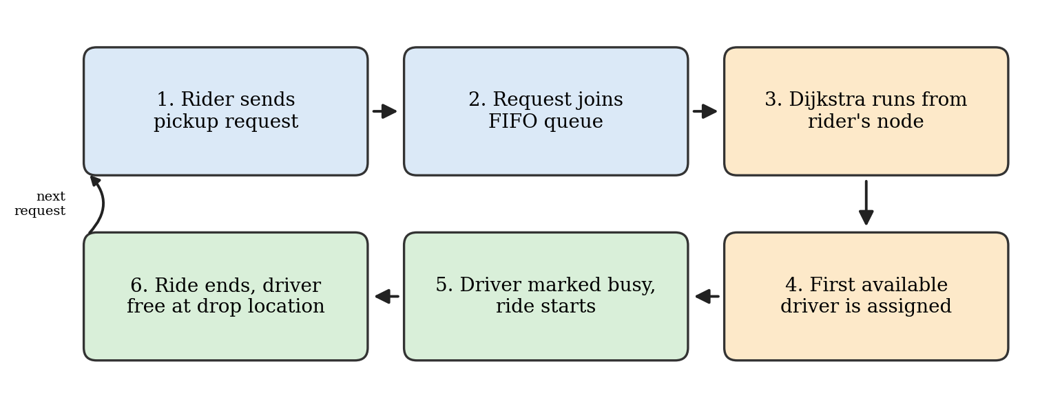
- Final system workflow of the Ride Sharing & Matching Platform, from pickup request to ride completion.

Modules Implemented
The system is divided into five modules, each with a single responsibility. Their roles and the data structures they rely on are listed in Table I.
- Modules implemented in the platform
Module | Responsibility | Data structure
Graph | Adds roads and stores the road network | Adjacency list
Driver manager | Keeps each driver's location and availability | Hash map
Rider queue | Serves pickup requests in the order of arrival | FIFO queue
Matcher | Finds the nearest available driver with Dijkstra and tie-breaking | Min-heap
Ride manager | Starts and finishes rides and updates driver status | Hash map updates

Algorithms and Data Structures
Table II summarises the algorithms and data structures used and the cost of each. Dijkstra's algorithm gives the shortest road distance from the rider to every vertex it explores. The greedy strategy turns this into a matching rule by choosing the nearest driver first. The min-heap always yields the vertex with the smallest tentative distance in O(log V) time. The adjacency list stores only the roads that exist, so it needs O(V + E) space, and the hash map gives O(1) driver lookup.
- Algorithms and data structures summary
Component | Purpose | Cost
Dijkstra's algorithm | Shortest road distance from the rider | O((V + E) log V)
Greedy strategy | Assign the nearest available driver first | One decision per request
Min-heap | Extract the closest unvisited vertex | O(log V) per operation
Adjacency list | Store the road network | O(V + E) space
Hash map | Driver location and availability lookup | O(1) per lookup

Novelty of the Developed Methodology
- Moves from straight-line distance to road-aware matching, so the matched driver is the closest by road.
- Combines a road graph and a min-heap in a single matching step.
- Uses an early-stop Dijkstra: the search ends at the first available driver instead of covering the whole map.
- Applies deterministic tie-breaking, so drivers at an equal distance are always chosen in the same, predictable way.

Adaptability of the Methodology
The methodology does not depend on a particular city. It works on any map because only the graph input changes. Edge weights can represent distance, travel time or live traffic without changing the algorithm. Extra rules such as driver rating or vehicle type can be added through the priority used in the heap. The same approach also fits other dispatch problems such as food delivery, courier services and ambulance dispatch, where the nearest available resource must be found on a road network.

Experiments

Sample Input and Output
The behaviour of the system was examined on a small road network with five locations, A to E. The roads and their lengths are A-B 4, A-C 2, C-B 1, C-D 3, D-E 2 and B-E 5. Drivers are located at B, D and E, and a rider requests a pickup from A. The network is shown in Fig. 2.
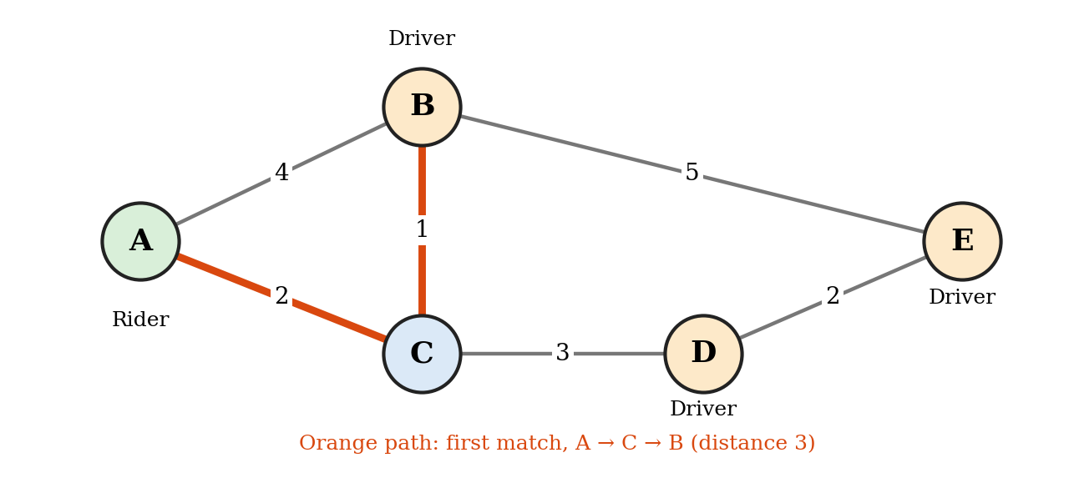
- Sample road network with the rider at A and drivers at B, D and E. The first match follows the highlighted path.
Running Dijkstra's algorithm from A gives the shortest road distances listed in Table III. Although B is joined to A by a road of length 4, the route through C is shorter and costs only 3. The first available driver reached by the search is the one at B, so the first output is: driver at B, path A > C > B, distance 3.
- Shortest road distances from rider node A
Node | Distance from A | Shortest path | Driver present
C | 2 | A > C | No
B | 3 | A > C > B | Yes
D | 5 | A > C > D | Yes
E | 7 | A > C > D > E | Yes

The driver at B is now marked busy. When the next request arrives from A, the search skips B and reaches D first, so the second output is: driver at D, path A > C > D, distance 5. This confirms that busy drivers are skipped in later searches and that the assigned driver is always the nearest free one.

Testing and Edge Cases
Besides the normal case, the system was tested on situations that commonly cause errors in matching. They are listed in Table IV together with the behaviour of the system.
- Edge cases tested and the behaviour of the system
Situation | Behaviour
Two drivers at equal distance | Tie is broken by the lowest driver ID
No driver available | The rider waits in the queue
Rider cannot be reached (disconnected map) | The request is rejected
Rider and driver on the same node | Distance is 0 and the driver is matched
Nearest driver is busy | Busy drivers are skipped in the next search

Methodology Evaluation
The methodology was evaluated on four aspects. For correctness, the results were checked against hand-computed shortest paths, as in the worked example above. For efficiency, the linear scan costing O(n) per request was compared with Dijkstra and a min-heap costing O((V + E) log V) with an early stop. The edge cases of ties, no driver available and a disconnected map were tested as described above. The metrics used to judge the matching are the pickup distance and the matching time per request.

Results

Complexity Comparison
Table V compares the simple linear-scan approach with the proposed Dijkstra and min-heap approach. The linear scan is cheap for each request but looks only at straight-line distance. The proposed method does a little more work per request but uses real road distances, which gives more accurate matches. For both methods, the graph needs O(V + E) space and the driver data needs O(n) space.
- Comparison of the linear scan with Dijkstra and a min-heap
Aspect | Linear scan | Dijkstra + min-heap
Time per request | O(n) | O((V + E) log V)
Distance used | Straight-line distance only | Real road distance
Space | O(n) for drivers | O(V + E) graph and O(n) drivers
Accuracy of match | Can pick a driver who is far by road | Picks the nearest driver by road

The trade-off is a small amount of extra computation per request in exchange for accurate matches. Because the search stops at the first available driver, the work done in practice is often much less than the worst case.

Challenges and Solutions
Several problems appeared during development. They and the solutions adopted are given in Table VI.
- Challenges faced and the solutions adopted
Challenge | Solution
Distance ties between drivers | A deterministic tie-break rule: the lowest driver ID wins
Slow full scan of the map | Dijkstra stops early at the first available driver
Outdated driver locations | Location is updated when a ride ends
Large maps | An adjacency list is used instead of a matrix

Results and Learning Outcomes
- Matching is based on road distance, not only on straight-line distance.
- The search stops at the first driver found, so it runs faster than a full search.
- Graphs, heaps, hash maps and greedy design were applied to a real problem and combined into one working system.

Dissemination and Accessibility
The project is easy to reproduce. The input format is simple: it consists of the roads, the drivers and the rider requests. The code is commented and a README explains how to run it, so the results can be reproduced by others. The source code is shared through a GitHub repository, and no special hardware or software is needed to run it.

Conclusion and Future Work
This project built a ride-sharing matching platform that assigns each rider to the nearest available driver. The graph model together with Dijkstra's algorithm gives accurate nearest-driver matching based on real road distance. The right data structures keep the matching efficient: a min-heap for the search, an adjacency list for the map, a hash map for drivers and a queue for requests. The project shows that Data Structures and Algorithms can be used to optimise real-world problems.
Several improvements are possible in the future:
- Live traffic: use time-based edge weights so that matching reflects current road conditions.
- A* search: use a heuristic to speed up routing on large maps.
- Machine learning: predict demand so that drivers can be positioned in advance.
- Dynamic pricing: adjust fares according to demand and supply.
- Ride pooling: allow multiple riders to share a single ride.

References
- E. W. Dijkstra, "A note on two problems in connexion with graphs," Numerische Mathematik, 1, 269-271 (1959).
- Thomas H. Cormen, Charles E. Leiserson, Ronald L. Rivest, and Clifford Stein, Introduction to Algorithms, MIT Press, (2009, (third edition)).
- Michael L. Fredman, and Robert E. Tarjan, "Fibonacci heaps and their uses in improved network optimization algorithms," Journal of the ACM, 34, 596-615 (1987).
- Peter E. Hart, Nils J. Nilsson, and Bertram Raphael, "A formal basis for the heuristic determination of minimum cost paths," IEEE Transactions on Systems Science and Cybernetics, 4, 100-107 (1968).
- Robert Sedgewick, and Kevin Wayne, Algorithms, Addison-Wesley, (2011, (fourth edition)).

