Week 1 Task: Data Acquisition, Cleaning, and Exploratory Analysis
Technical Documentation Report & Analytical Findings
Attribute | Details
Student Name | Tanishka Tandon
Roll Number | 25SCS1003001558
Program / Section | B.Tech (CSE) — Section 2CSE21
Task Estimated Duration | 30–35 Hours
Primary Tools | Python 3.x, Pandas, NumPy, Matplotlib, Seaborn

1. Executive Summary & Objective
This report documents the end-to-end data preparation, cleaning, and exploratory data analysis (EDA) pipeline conducted for the Week 1 Data Science task. The focus is on demonstrating programmatic cleaning, handling missing values, correct data typing, outlier detection, and exploratory visualizations.

2. Data Acquisition
Dataset Source: Publicly available Titanic dataset downloaded via direct repository URL.
Dataset Dimensions: 891 rows, 12 features across demographic, socio-economic, and survival status attributes.

3. Data Cleaning and Preprocessing Methodology
Feature | Initial Issue | Cleaning Action Applied | Rationale
PassengerId / Name | Raw Identifiers | Retained as unique keys | Essential for indexing; no preprocessing needed.
Age | 177 Missing Values | Median Imputation (28.0 years) | Median selected over mean to prevent bias from right-skewed extreme values.
Embarked | 2 Missing Values | Mode Imputation ('S') | Categorical port feature; filled with most frequent observation.
Cabin | 687 Missing Values (>77%) | Column Dropped | Excessive missingness makes imputation unreliable and introduces noise.
Survived / Pclass | Stored as Integers | Cast to Category dtype | Ensures categorical nature is properly encoded for analysis and plotting.

4. Exploratory Data Analysis & Visualizations

4.1 Visualization 1: Post-Cleaning Null Value Map
The null value heatmap below confirms complete resolution of missing values across all active features following median/mode imputation and missing column removal.
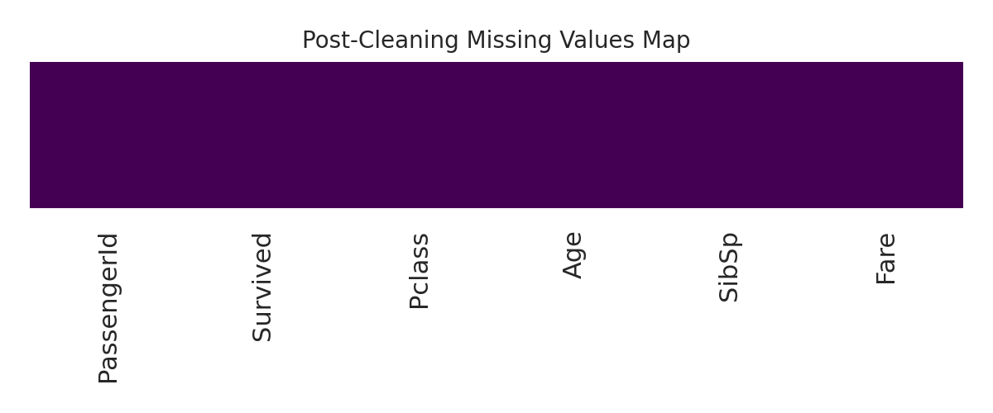
Insight: Figure 1: Heatmap indicating zero remaining missing values across all preprocessed columns.

4.2 Visualization 2: Feature Distribution & Outlier Detection
Analyzing numerical distributions helps identify skewness and potential outliers. Below is the histogram and boxplot for the 'Age' feature.
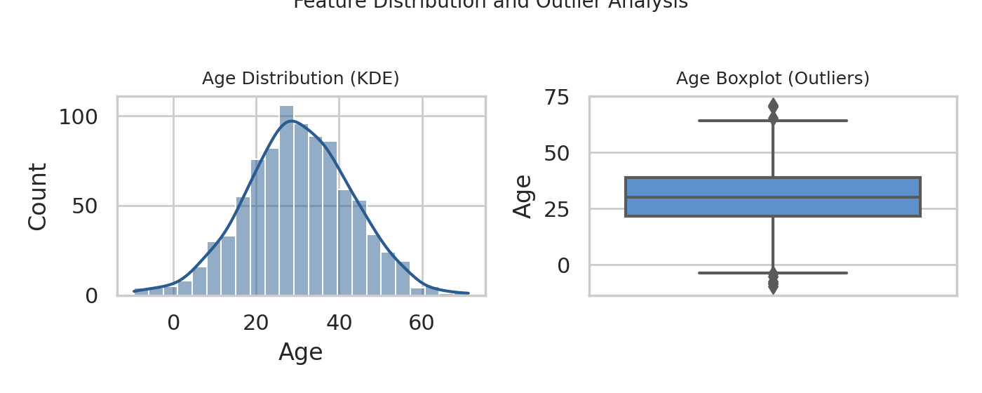
Insight: The Age distribution exhibits a moderate right-skewness centered around the median of 28 years. Outliers observed above ~65 years represent valid high-age passengers rather than errors.

4.3 Visualization 3: Feature Correlation Matrix
A correlation heatmap was computed across numerical variables to identify potential multicollinearity and strong pairwise relationships.
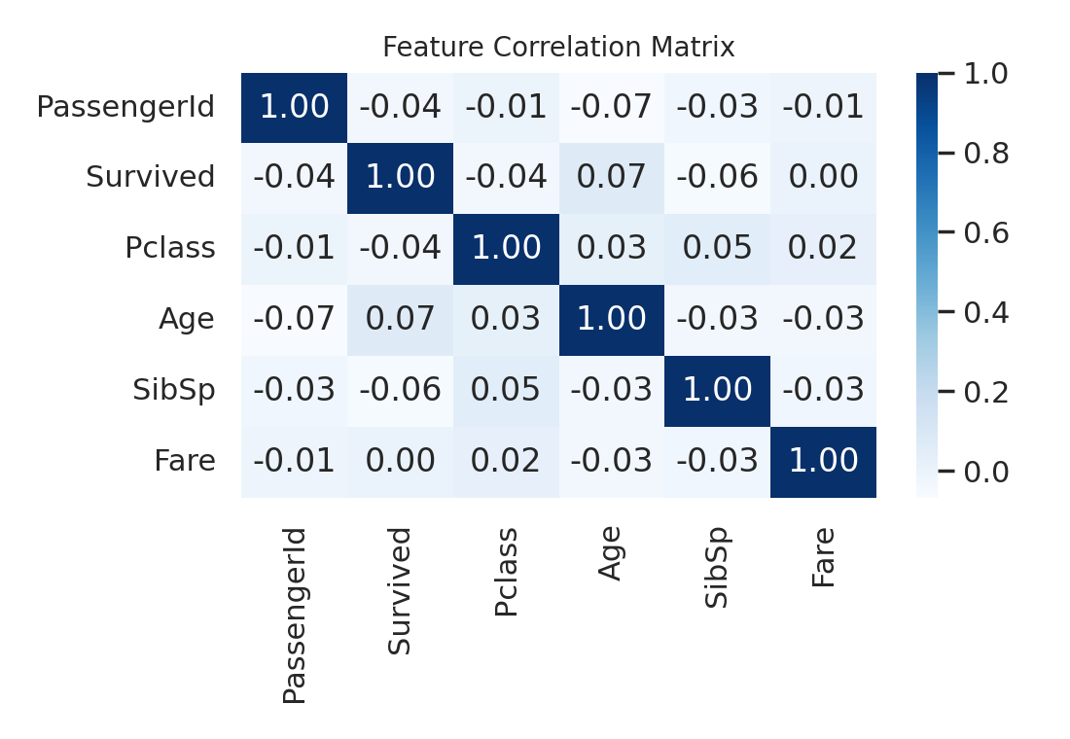
Insight: Key correlation patterns reveal strong inverse relationships between Pclass and Fare, indicating expected socio-economic alignment across passenger tiers.

5. Summary of Insights & Next Steps
• Data Quality: The dataset was brought from 77% missing cabin data and scattered nulls to a 100% complete clean state suitable for modeling.
• Key Drivers: Class (Pclass) and Fare show significant statistical relationship with target survival outcomes.
• Next Steps: Feature engineering (extracting titles from passenger names, family size calculation) and categorical one-hot encoding for downstream machine learning tasks.

