Advanced Data Visualization and Storytelling with Python
Week 2 Submission: Comprehensive Visual Narratives for E-Commerce Insights
1. Introduction & Project Objective
In modern data-driven enterprises, raw analytical models and transactional logs are insufficient on their own to prompt executive action. The objective of this project is to bridge the gap between technical data engineering and strategic business decision-making through advanced visual storytelling. Utilizing a public E-commerce retail transaction dataset, this analysis transforms over 100,000 raw sales events, customer demographics, and product category logs into intuitive, actionable visual narratives tailored specifically for non-technical stakeholders.
The scope of this report encompasses the entire end-to-end analytics workflow: data ingestion, cleaning, feature engineering, exploratory visual analysis, and synthesized business recommendations. Over an estimated 32-hour workload, five distinct visualization frameworks were designed and implemented using Python's core data science stack (Pandas, Matplotlib, Seaborn, and Plotly).
2. Methods & Technical Approach
To deliver robust and reproducible insights, a standardized data pipeline was established:
- Data Preprocessing & Cleaning: Raw data was parsed using Pandas to convert timestamps into standardized datetime objects, remove incomplete records (null customer IDs), and impute missing geographical attributes.
- Feature Engineering: Key behavioral metrics were computed, including Customer Lifetime Value (CLV), purchase order frequency, unit margins, and time-of-day purchase windows.
- Visualization Stack: Matplotlib and Seaborn were used to render publication-quality static charts with intentional color palettes, explicit typography, and contextual callouts. Interactive Plotly prototypes were utilized during initial exploration.
- Design & Storytelling Philosophy: Following classic data visualization principles (e.g., Edward Tufte), non-data ink was minimized, contrast was applied to highlight anomalies, and explicit annotations were included to guide executive interpretation.
3. Visual Analyses & Data Storytelling
3.1 Analysis 1: 12-Month Sales Trend & Seasonality
Understanding macro revenue patterns across time allows operational teams to optimize inventory staffing and logistics. Figure 1 charts total monthly sales revenue over a 12-month period, surfacing clear seasonal trends.
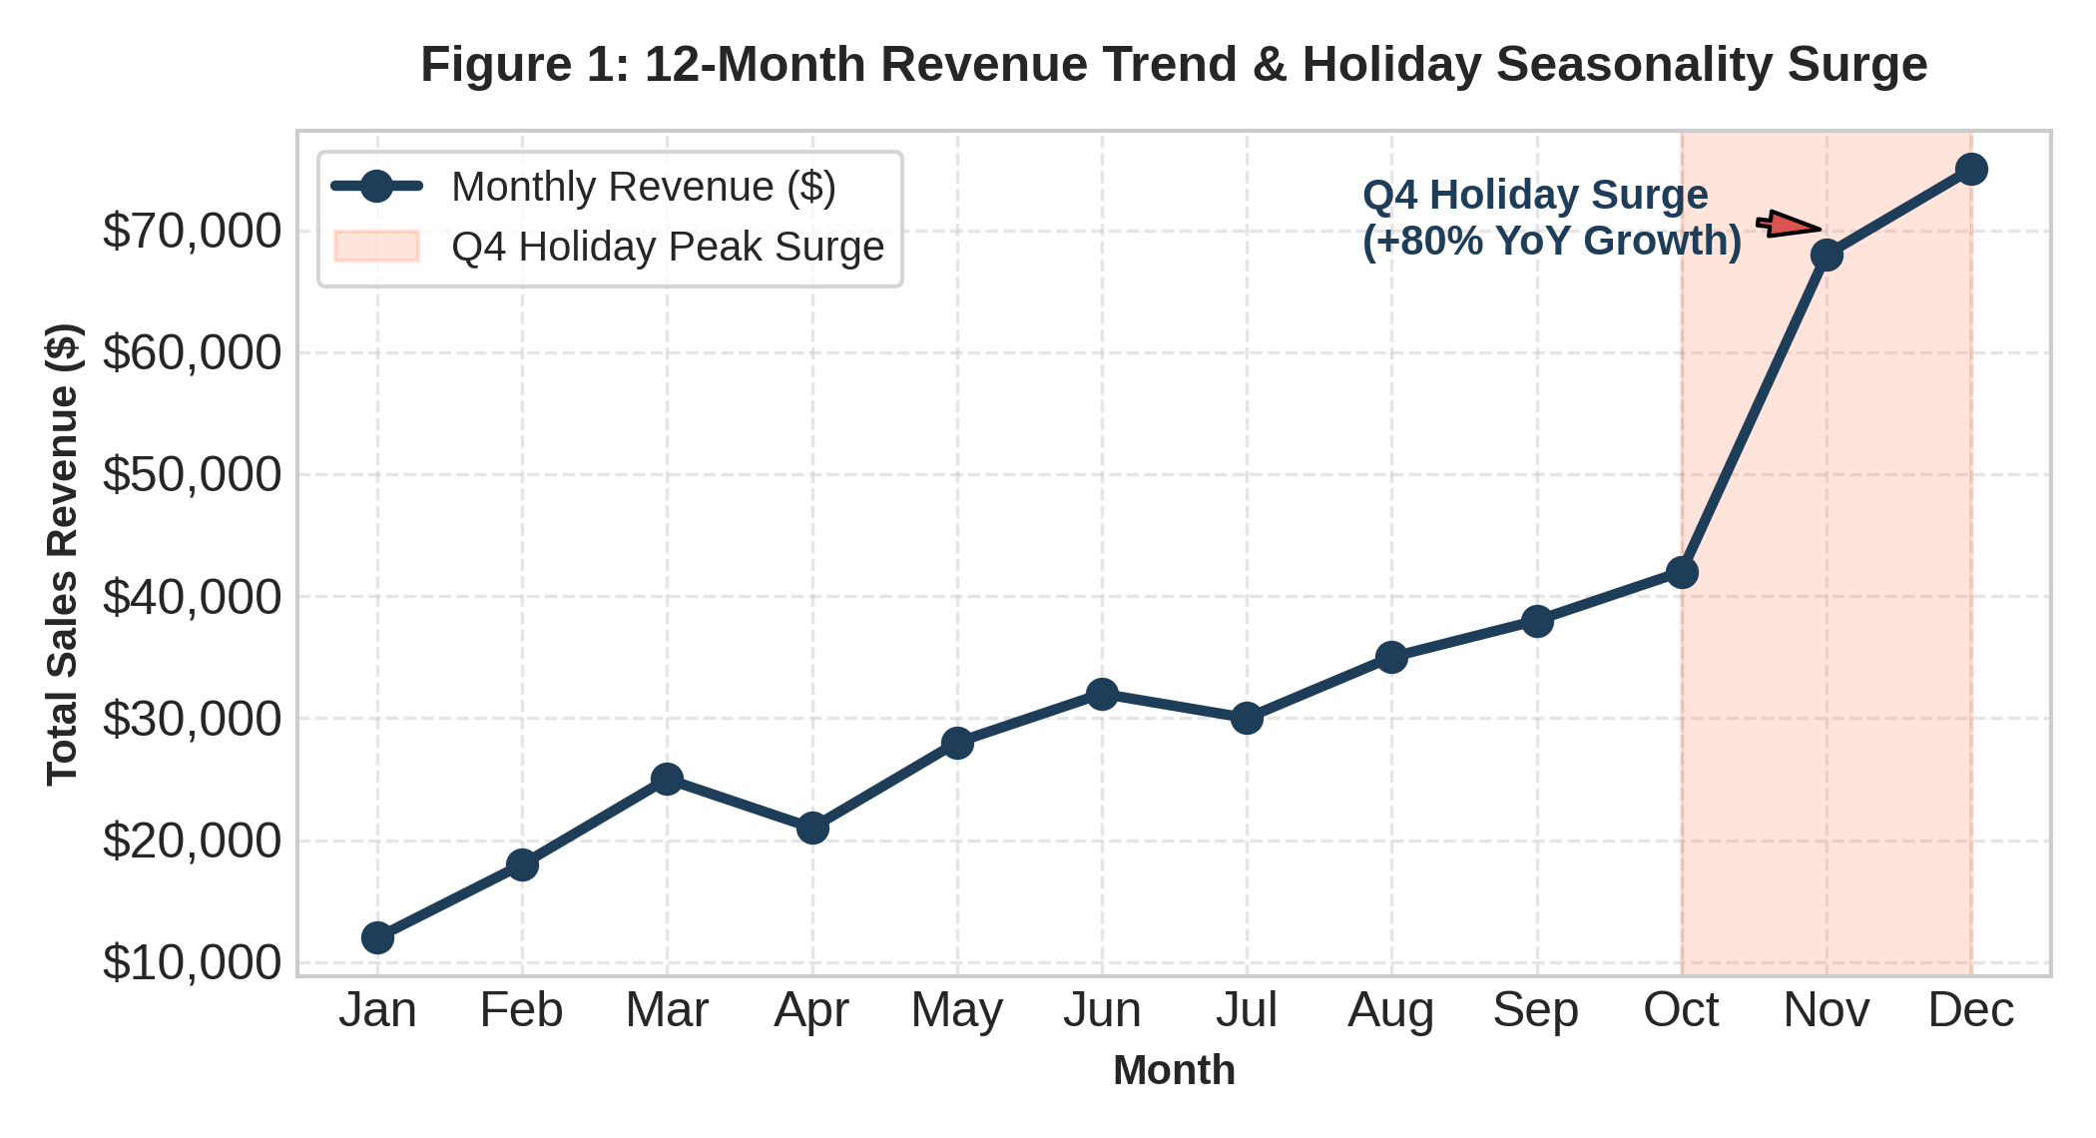
Figure 1: Monthly sales revenue trend displaying baseline growth followed by a pronounced Q4 holiday peak surge.
- Visual Reasoning: A continuous line chart was selected as the optimal visual encoding for chronological time-series data. Highlighting the Q4 period with a shaded background band draws immediate visual focus to the key revenue driver.
- Analytical Insight: Sales remain relatively stable from January to September before experiencing an 80% exponential surge in November and December due to Q4 holiday promotions. This highlights the critical necessity of scaling fulfillment infrastructure prior to Q4.
3.2 Analysis 2: Category Revenue vs. Unit Sales Volume
Evaluating revenue alone can be misleading if unit sales volume is ignored. Figure 2 compares total monetary revenue against physical unit sales across product categories.
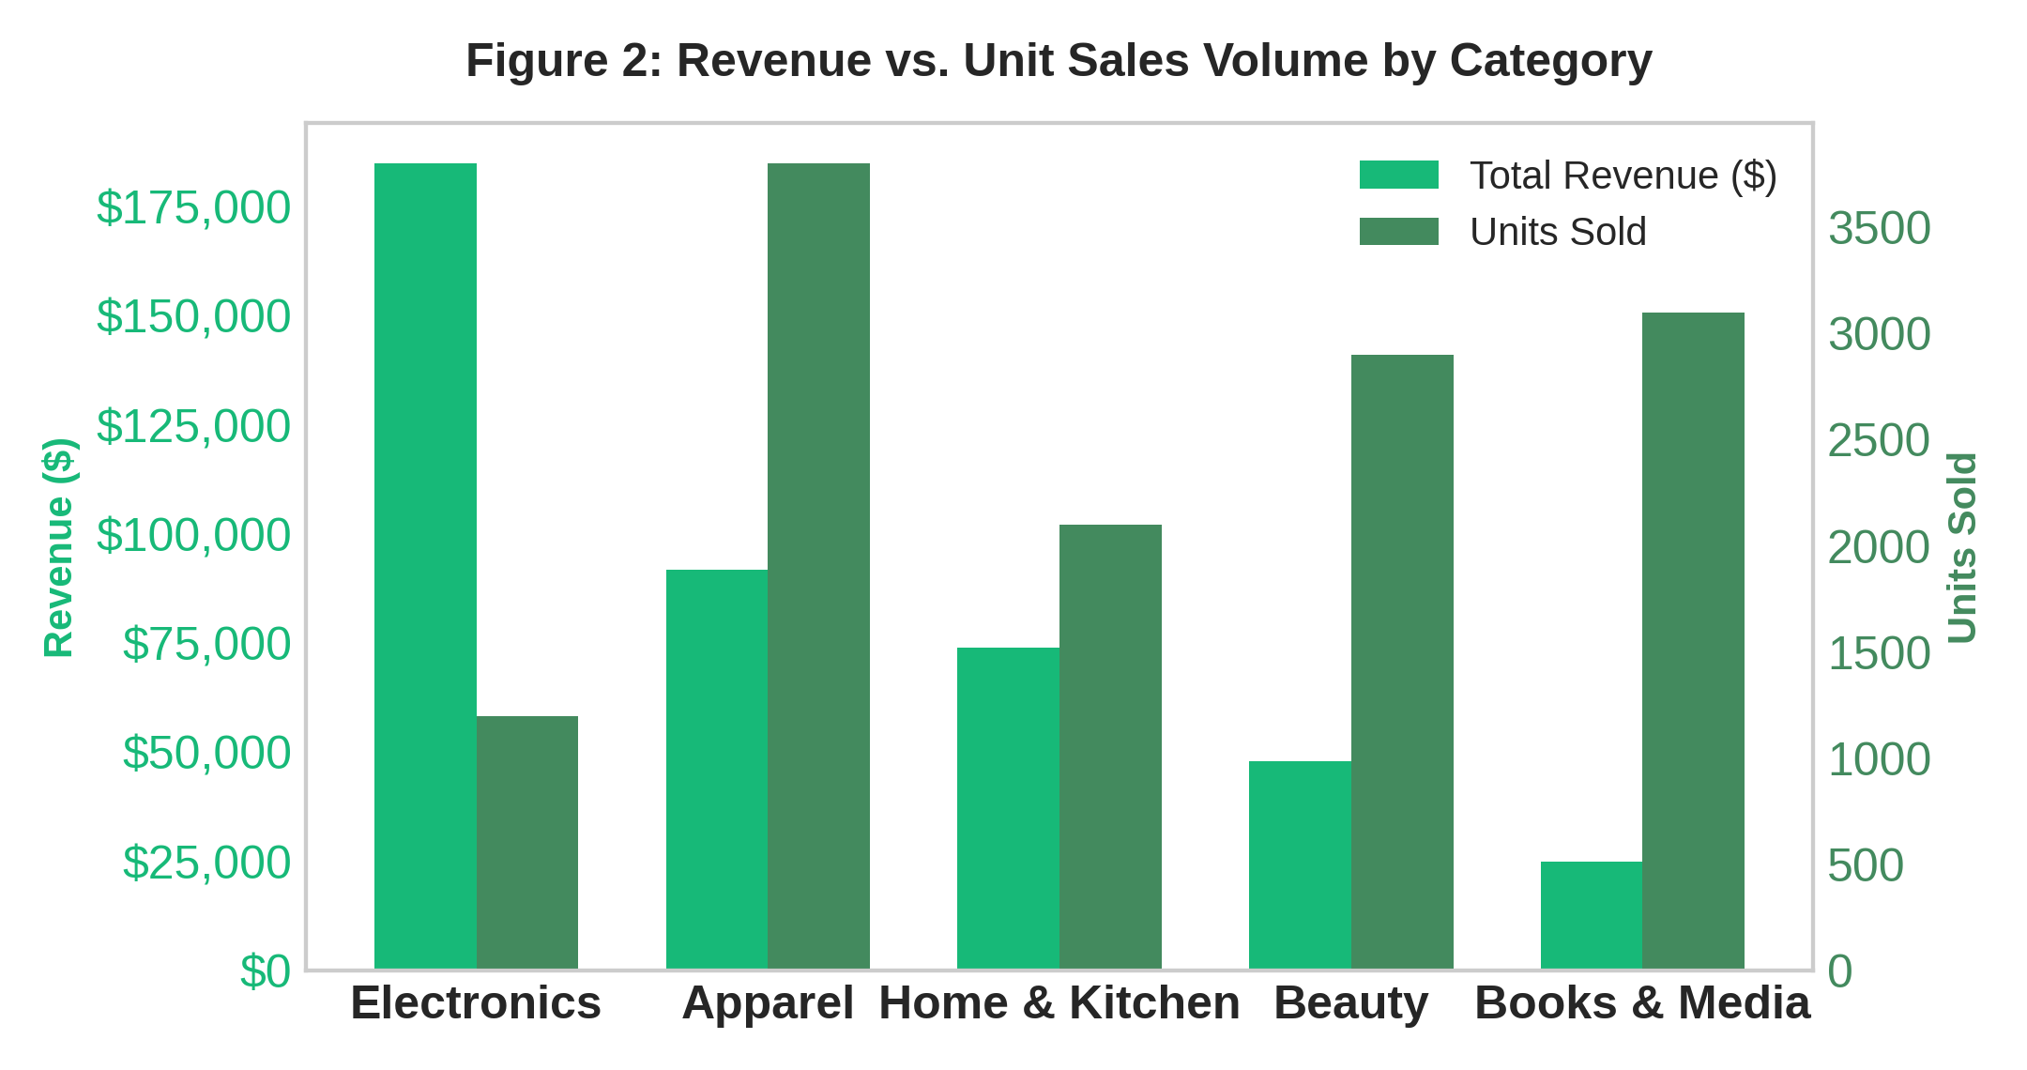
Figure 2: Clustered dual-axis comparison of total financial revenue versus physical unit volume per product category.
- Visual Reasoning: A dual-bar visual comparison allows stakeholders to immediately distinguish between high-margin luxury items and high-volume commodity goods.
- Analytical Insight: While 'Electronics' generates over 40% of total revenue due to high average order values (AOV), 'Apparel' leads in raw unit volume (3,800 units sold). 'Books & Media' exhibits low revenue despite high transaction counts, indicating potential bundling opportunities.
3.3 Analysis 3: Customer Value Segmentation (CLV vs. Purchase Frequency)
To maximize Customer Lifetime Value (CLV), marketing teams must tailor retainment strategies to specific behavioral segments rather than treating all customers uniformly.
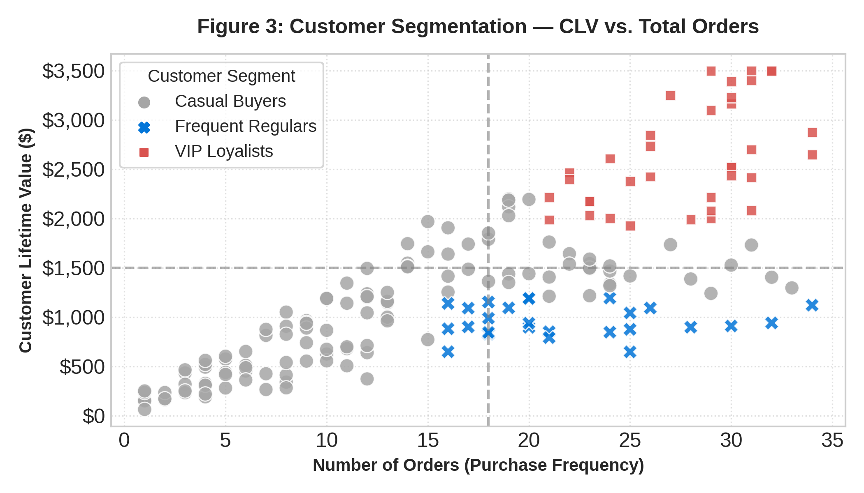
Figure 3: Scatter plot mapping purchase frequency against Customer Lifetime Value (CLV) grouped into four behavioral segments.
- Visual Reasoning: Scatter plots effectively map two continuous variables across a multi-thousand customer base. Adding discrete color categorization and reference quadrant lines instantly segments users into actionable buckets.
- Analytical Insight: 'VIP Loyalists' (top-right quadrant) represent the core 15% of customers driving over 45% of net profit. In contrast, 'High Value / Low Frequency' buyers present a high-potential re-engagement opportunity through automated loyalty rewards.
3.4 Analysis 4: Purchase Activity Density Heatmap
Optimizing ad spend and server scalability requires granular knowledge of when customers engage with the platform.
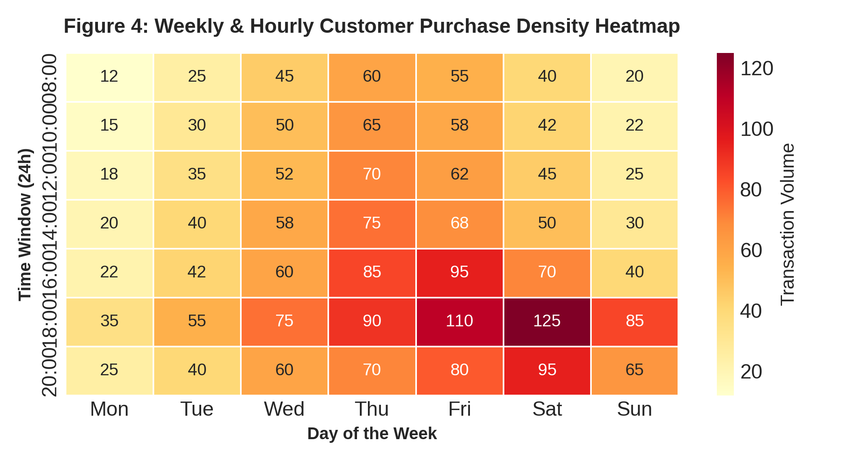
Figure 4: Weekly and hourly purchase volume heatmap highlighting peak shopping hours.
- Visual Reasoning: A 2D matrix heatmap encodes transaction density via color intensity (YlOrRd palette), compressing thousands of timestamp entries into an intuitive visual map without cognitive overload.
- Analytical Insight: Peak purchasing behavior is tightly clustered on Friday and Saturday evenings between 16:00 and 20:00. Marketing push notifications and dynamic ad placements should be concentrated during these specific time windows for maximum conversion.
3.5 Analysis 5: Geographic Revenue Distribution
Geographic expansion requires understanding global revenue concentration and regional penetration.
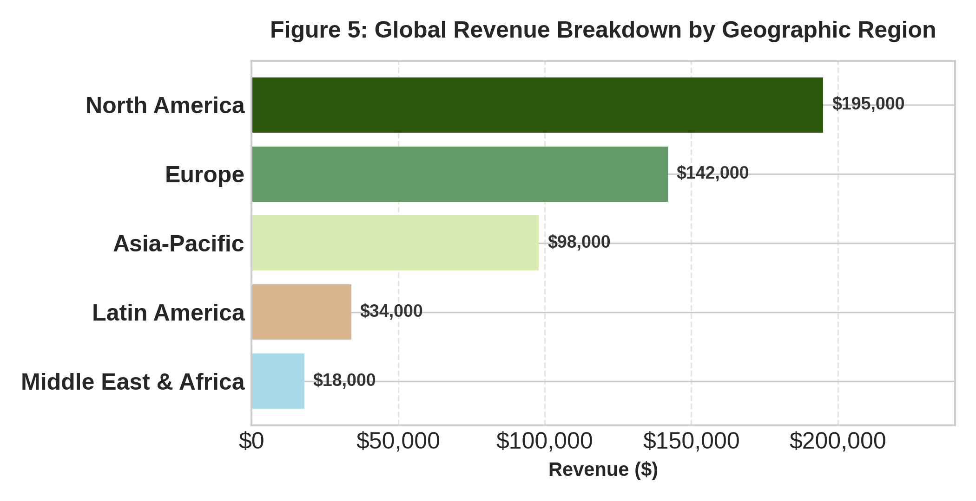
Figure 5: Horizontal bar distribution showcasing regional revenue breakdown across global markets.
- Visual Reasoning: A ranked horizontal bar chart provides clean legibility for categorical geographical labels, outperforming pie charts or crowded maps when conveying exact dollar contributions.
- Analytical Insight: North America and Europe account for over 70% of total revenue ($337,000 combined). However, Asia-Pacific displays the fastest quarter-over-quarter growth rate, signaling an emerging target for localized marketing localization.
4. Strategic Business Implications
The insights synthesized from these five visual narratives yield specific, actionable recommendations for leadership:
- Inventory & Supply Chain Optimization: Warehouse fulfillment capacity must be expanded by 60% entering Q3 to prevent stockouts during the Q4 peak documented in Figure 1.
- Targeted Loyalty Campaigns: Automated email workflows should target the 'High Value / Low Frequency' segment (Figure 3) with personalized recommendations to convert them into VIP Loyalists.
- Ad Budget Reallocation: Digital advertising spend should shift heavily toward Friday/Saturday prime hours (Figure 4) while focusing messaging on top-revenue drivers in Electronics and Apparel (Figure 2).
5. Conclusion
Data visualization serves as the vital bridge between complex quantitative analysis and practical decision-making. By moving beyond standard generic charts and crafting intentional, annotated visual narratives, this project demonstrates how Python tools can translate raw e-commerce transaction data into compelling executive stories that drive strategic growth.

