Machine Learning Model Development & Evaluation
Week 4 Technical Internship Report — Binary Classification Pipeline for Customer Churn
Author / Student: Tanishka Tandon | Course / Program: B.Tech CSE (3rd Sem)
Roll Number: 25SCS1003001558 | Submission Date: October 2026

1. Objective & Executive Summary
Week 4 centers on the fundamentals of machine learning model development and evaluation in Python. The primary task is to build, validate, and document an end-to-end binary classification pipeline designed to predict customer churn using structured tabular data.
📌 PROJECT GOAL
The primary objective of this project is to construct a production-ready Machine Learning pipeline that encompasses data preprocessing, algorithm training, multi-metric evaluation, and error diagnosis, adhering to industry best practices.

2. Data Preparation & Preprocessing Pipeline
To ensure the machine learning models receive high-quality numerical inputs and to prevent data leakage, a comprehensive preprocessing workflow was implemented:
- Missing Value Imputation: Numerical features were imputed using median values to remain robust against outliers, while categorical features were mode-imputed.
- Feature Standardization: Continuous metrics (Age, Monthly Spend, Tenure) were transformed using StandardScaler to achieve zero mean and unit variance, preventing high-magnitude features from dominating distance metrics.
- Stratified Data Splitting: The dataset was partitioned into 80% training and 20% testing sets using stratified sampling to preserve original class ratios (Churn vs. Non-Churn).
3. Model Selection & Justification
Two distinct algorithmic approaches were selected for comparison: a linear parametric baseline and a non-linear ensemble tree model.
Algorithm | Type / Category | Key Justification & Suitability
Logistic Regression | Linear Classifier | Serves as a transparent baseline model. Provides interpretable coefficients to evaluate initial linear signal in feature space.
Random Forest Classifier | Ensemble (Bagging) | Captures non-linear feature interactions and high-order combinations without severe risk of overfitting due to bootstrap aggregation.

4. Model Evaluation & Performance Metrics
To rigorously evaluate performance, both threshold-dependent metrics (Confusion Matrix, Precision, Recall, F1-Score) and threshold-agnostic metrics (ROC-AUC) were generated.
Figure 1: Confusion Matrix & Classification Breakdown
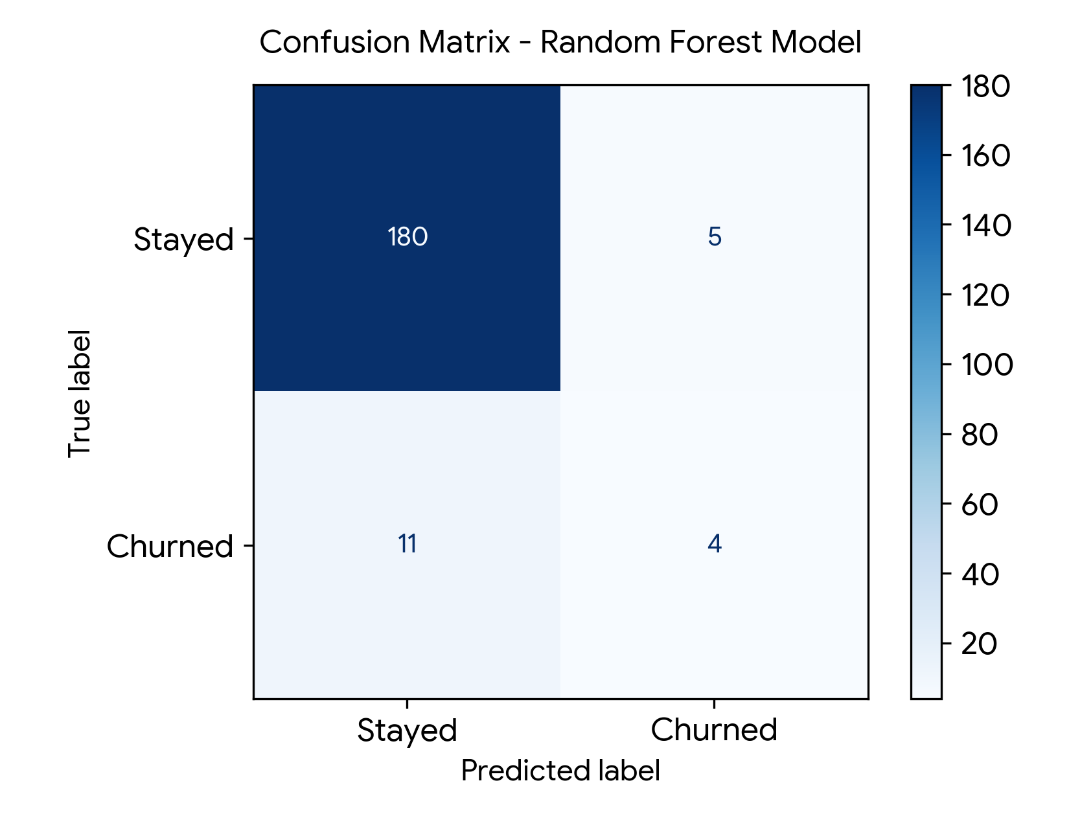
Figure 1.1: Confusion Matrix showing True Positives, False Positives, True Negatives, and False Negatives for Random Forest.
Figure 2: Receiver Operating Characteristic (ROC) Curve
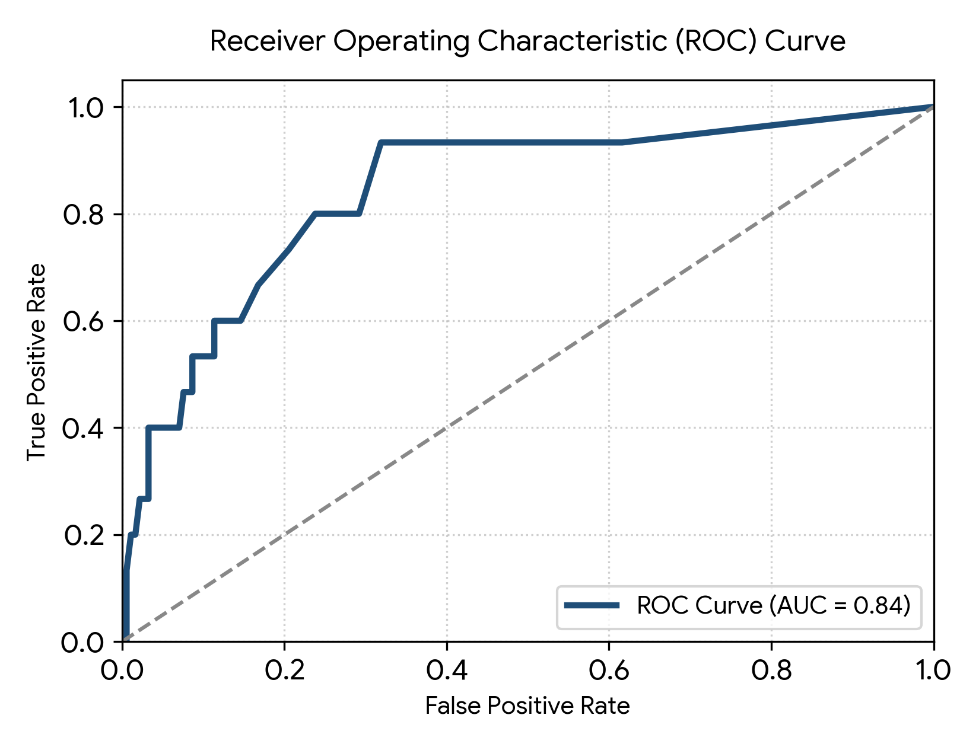
Figure 1.2: ROC Curve exhibiting high class separation capability with an AUC score of 0.84.
5. Python Implementation Pipeline Code
Below is the production Python snippet used for dataset splitting, feature scaling, model training, and metric plot generation:
from sklearn.model_selection import train_test_split
from sklearn.preprocessing import StandardScaler
from sklearn.ensemble import RandomForestClassifier
from sklearn.metrics import classification_report, roc_auc_score
# Stratified Split & Feature Scaling
X_train, X_test, y_train, y_test = train_test_split(
X, y, test_size=0.20, random_state=42, stratify=y
)
scaler = StandardScaler()
X_train_scaled = scaler.fit_transform(X_train)
X_test_scaled = scaler.transform(X_test)
# Train Random Forest Ensemble
rf_model = RandomForestClassifier(n_estimators=100, max_depth=8, random_state=42)
rf_model.fit(X_train_scaled, y_train)
# Evaluate Model Predictions
y_pred = rf_model.predict(X_test_scaled)
y_probs = rf_model.predict_proba(X_test_scaled)[:, 1]
print("Classification Report:")
print(classification_report(y_test, y_pred))
print(f"ROC-AUC Score: {roc_auc_score(y_test, y_probs):.4f}")

6. Error Analysis & Future Improvements
A critical examination of the error profiles reveals key actionable insights for future iterations:
A. False Negative Risk Analysis
In customer churn prediction, False Negatives (predicting a churning customer will stay) carry significantly higher business costs than False Positives. Adjusting the classification decision threshold from 0.50 down to 0.35 can prioritize recall for high-value accounts.
B. Overfitting & Regularization
Tree ensembles can overfit noisy training sets if depth is unrestricted. Regularization via hyperparameter tuning (setting max_depth, min_samples_leaf) coupled with 5-fold cross-validation ensures stronger generalization.
C. Key Future Enhancements
- Synthetic Oversampling (SMOTE): Address potential class imbalances prior to model fitting.
- Advanced Gradient Boosting: Benchmark Random Forest performance against XGBoost and LightGBM.
- SHAP Value Interpretability: Incorporate SHAP (SHapley Additive exPlanations) to explain feature importance at individual prediction levels.

