LSDE Week 5
Illustrated Practical Guide
  - Amazon S3 EC2 and RDS on macOS
Use this guide to upload files to S3, connect to an Amazon Linux instance from a Mac, copy files with the AWS CLI, and import two CSV datasets into MySQL on Amazon RDS. Each screenshot is placed beside the activity it supports.

Before you begin
You need an AWS Academy sandbox, a Mac with Terminal, and the Blackboard files bristol.txt, AMZN.csv and Water.csv. Keep their exact spelling and capitalisation. Work in one AWS region throughout; the screenshots use US East N Virginia, us-east-1.

Where commands run
Location | What you do
AWS Console | Create and configure S3, EC2 and RDS resources.
Mac Terminal | Use the .pem key file to connect to EC2 with SSH.
EC2 shell | Run aws, dnf, curl, ls and the MySQL connection command.
MySQL prompt | Run CREATE, LOAD DATA, SELECT and UPDATE statements.

Replace these values
Placeholder | Use your own value
YOUR_BUCKET_NAME | The S3 bucket you create for this practical.
YOUR_EC2_HOST | The current EC2 public IPv4 address or public DNS name.
YOUR_RDS_ENDPOINT | The RDS endpoint hostname, without https:// or a port.
lab-key.pem | The actual .pem filename saved on your Mac.

Values written in capitals are placeholders. Do not enter a password into a command or document; type it only at the password prompt. Screenshot redactions are solid pixels in the image files.

1 Start the sandbox
1. Open AWS Academy, enter your course and open the Sandbox activity.
2. Select Start Lab and wait for the AWS indicator to turn green.
3. Open the AWS Console and select your lab region. Download the three data files from Blackboard.

2 Create the S3 bucket
1. Search for S3, open Buckets and select Create bucket.
2. Choose General purpose and Global namespace, if the namespace setting is shown.
3. Enter a unique bucket name using lowercase letters, numbers and hyphens. Do not include personal information in a name intended for demonstrations.
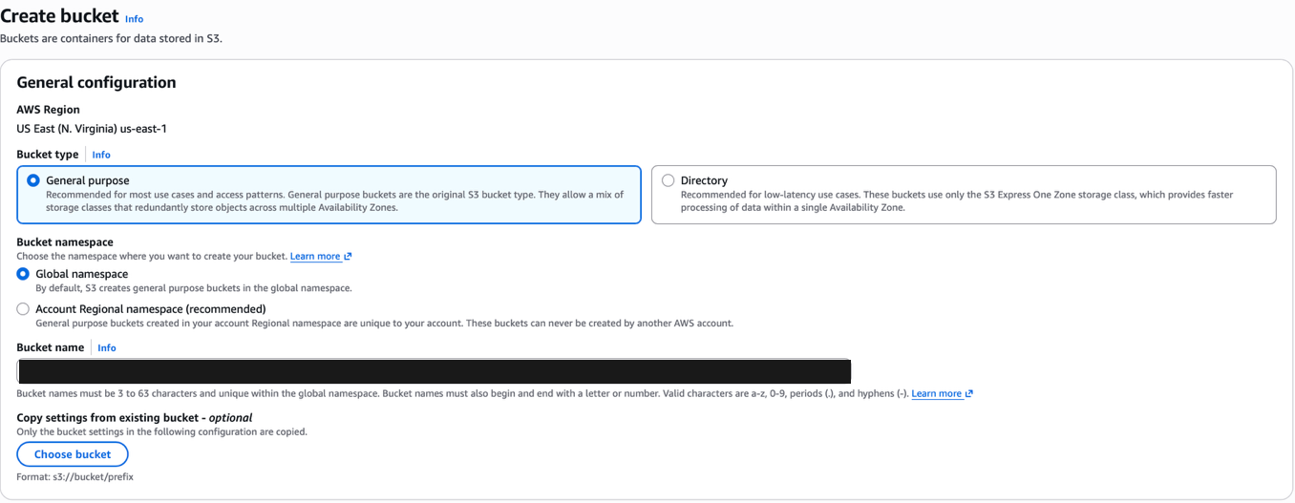
Figure 1 General purpose bucket and unique bucket name
1. Scroll to Object Ownership. Select ACLs enabled, then Bucket owner preferred.
2. Keep these settings for the workshop exercise that makes one text object public.
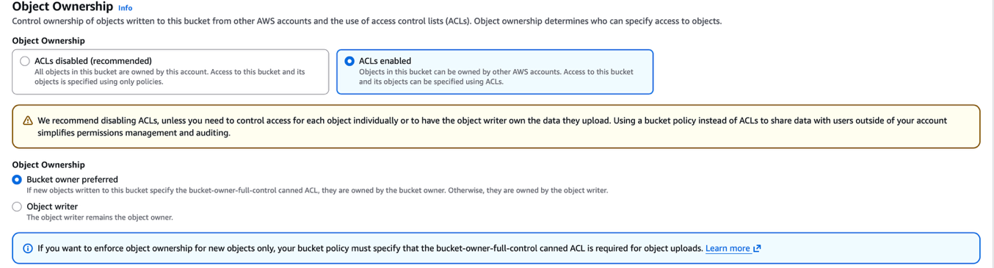
Figure 2 ACLs enabled and Bucket owner preferred
Checkpoint: a unique bucket name is entered and the ownership options match the screenshots.

3 Configure public access and upload files
1. For the public text-file demonstration, untick Block all public access.
2. Tick the acknowledgement, leave bucket versioning disabled for this short exercise, and select Create bucket.
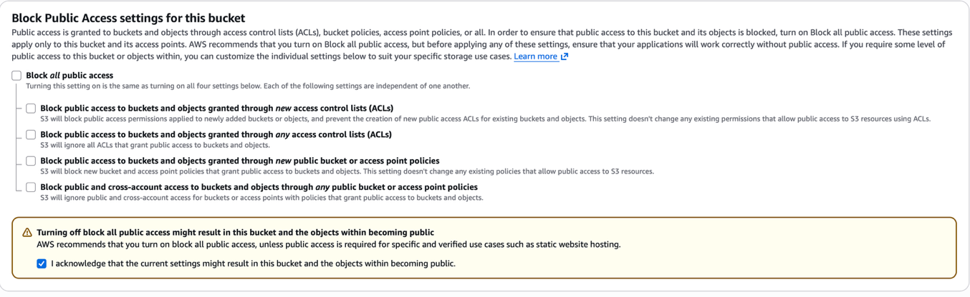
Figure 3 Public access settings for the text-file demonstration
1. Open the new bucket and select Upload, then Add files.
2. Select bristol.txt, AMZN.csv and Water.csv, and select Upload.
3. Return to Objects and confirm all three files are listed.
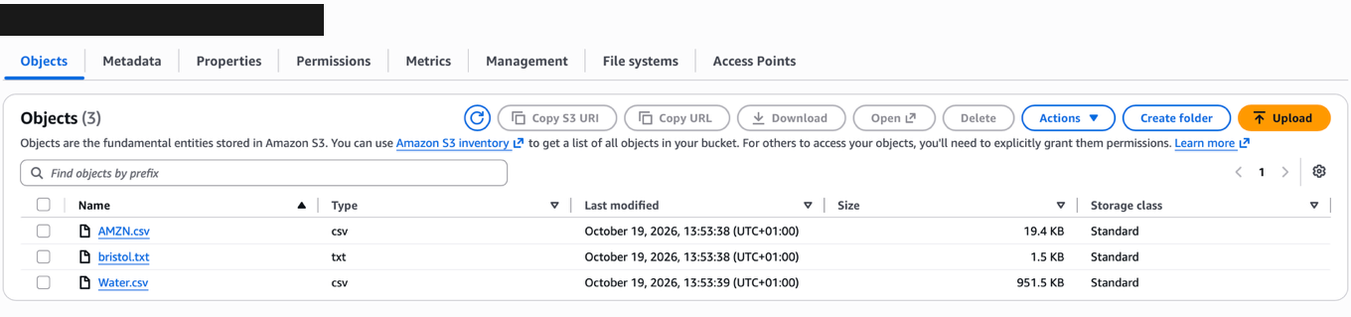
Figure 4 The three workshop files uploaded to S3
Only bristol.txt needs public access for this exercise. Keep the CSV files private; EC2 will read them using its IAM role. Account-level restrictions may still block public access. If the lab prevents the public demonstration, continue with the private CLI activity and ask the tutor about the restriction.

4 Make the text object public
1. Open bristol.txt and copy its Object URL. Try the URL in a separate browser tab; a private object returns Access Denied.
2. Return to the Objects list, select only bristol.txt, open Actions and select Make public using ACL. Confirm the change.
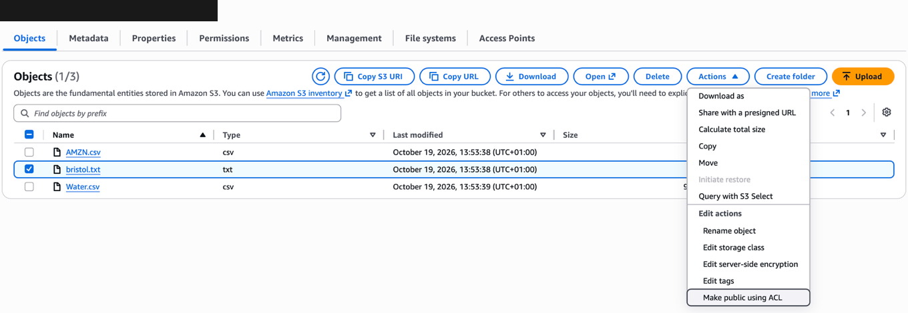
Figure 5 Make public using ACL for the selected text file
1. Open bristol.txt again and locate the Object URL under Properties.
2. Refresh the URL in the other tab. The text should now display.
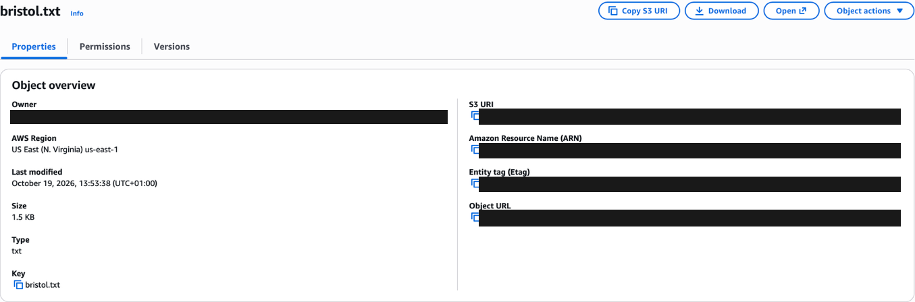
Figure 6 Object details with identifying values removed
This exercise serves a public text object. It does not configure the separate S3 static website endpoint. Copy S3 URI is used later for CLI transfers; Object URL is used in the browser.

5 Launch an Amazon Linux instance
1. Open EC2, choose Instances and select Launch instances.
2. Enter a generic name such as LSDE-Week5-EC2.
3. Under Application and OS Images, choose Amazon Linux 2023 with 64-bit x86 architecture.
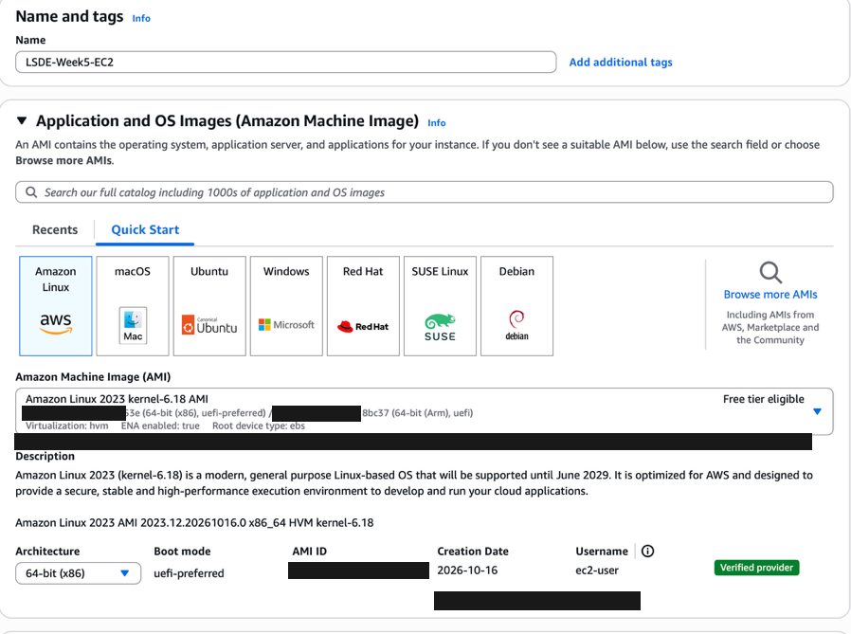
Figure 7 Amazon Linux 2023 image selection
Use the operating system shown above for the dnf and mariadb105 commands in this guide. A public AMI identifier can change over time; select the current lab-supported Amazon Linux 2023 image.

6 Set the instance and SSH options
1. Choose t3.micro if the sandbox permits it.
2. Create a key pair, choose RSA and .pem, and save the file in Downloads. The example commands use lab-key.pem; replace this with your actual filename.
3. Choose the lab or default VPC, a public subnet and Auto-assign public IP enabled.
4. Allow SSH on TCP port 22 from My IP. Leave the default storage and select Launch instance.
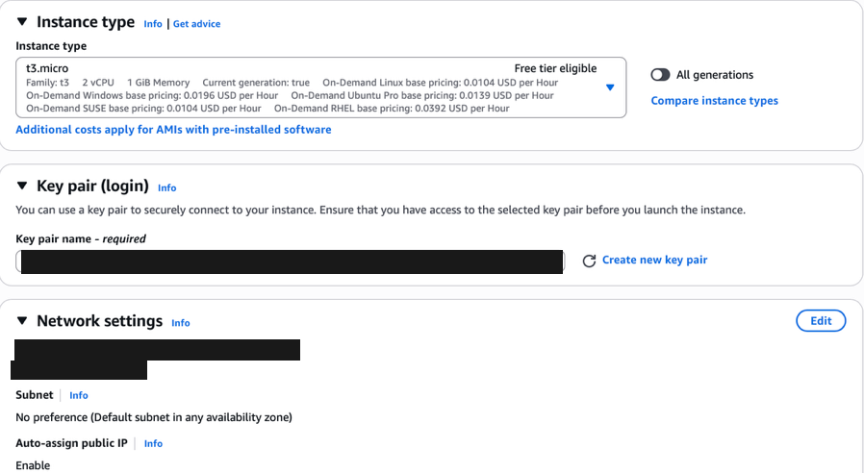
Figure 8 Instance type key pair and network settings
Checkpoint: wait for the instance to be Running and its status checks to pass. Select it and find the current Public IPv4 address or Public DNS. If your public IP changes, update the SSH rule to your current My IP value.

7 Attach the S3 IAM role
1. Select the EC2 instance created for this practical.
2. Choose Actions, then Security, then Modify IAM role.
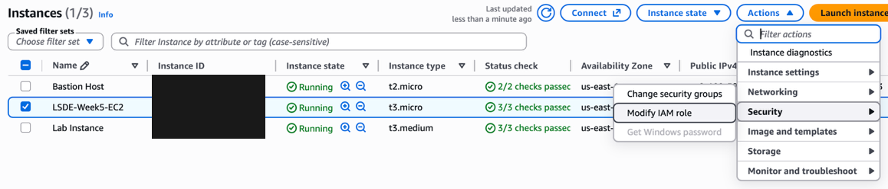
Figure 9 The menu path to Modify IAM role
1. Select EMR_EC2_DefaultRole, as specified in the workshop. If it is absent, use the S3-enabled instance role provided by your sandbox.
2. Select Update IAM role.
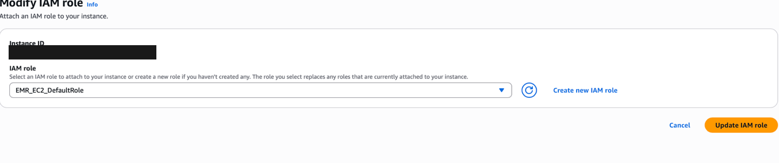
Figure 10 The workshop IAM role selected for the instance
The role provides credentials to software running on EC2. If aws s3 ls reports Unable to locate credentials, check that the role is attached to this instance, allow a short time for it to appear, and retry. If it reports AccessDenied, the role may lack the required S3 permissions.
Checkpoint: the instance shows an IAM role. Select the instance you created, rather than a pre-provisioned Bastion Host or Lab Instance.

8 Connect to EC2 from your Mac
1. Press Command and Space, type Terminal, and press Enter.
2. Move to the folder containing your downloaded key file.
3. Restrict the key file permissions and connect using the current EC2 address.

Run in Mac Terminal
cd ~/Downloads
chmod 400 lab-key.pem
ssh -i "lab-key.pem" ec2-user@YOUR_EC2_HOST
Replace both lab-key.pem occurrences with your actual downloaded filename. Replace YOUR_EC2_HOST with the current public IPv4 address or public DNS from the instance details. Type yes if asked to trust the host.

Recognise the EC2 shell
After login, the prompt begins with ec2-user and ends with $. Commands entered here run on EC2. The .pem file remains on your Mac.
whoami
pwd
aws s3 ls
Expected: whoami returns ec2-user, pwd normally shows /home/ec2-user, and aws s3 ls lists the buckets your role can access.

If the connection fails
No such file or directory: check the .pem filename and its folder. Permission denied publickey: use the key associated with this instance and the ec2-user login. Connection timed out: check the instance is running, has a public address, and permits SSH from your current public IP.
Use the SSH client command shown under EC2 Connect if you need to confirm the hostname and key filename. You can keep the AWS Console open while working in Terminal.

9 Copy files from S3 to EC2
Run these commands in the EC2 shell. Set BUCKET_NAME to the actual bucket created in Step 2, keeping the quotes.
BUCKET_NAME='YOUR_BUCKET_NAME'
aws s3 ls
aws s3 ls "s3://$BUCKET_NAME/"
aws s3 cp "s3://$BUCKET_NAME/bristol.txt" .
aws s3 cp "s3://$BUCKET_NAME/AMZN.csv" .
aws s3 cp "s3://$BUCKET_NAME/Water.csv" .
ls -lh
Keep the final dot in every download command: it means the current directory. The object key is case-sensitive. If a filename has spaces, keep its full S3 path inside quotes.
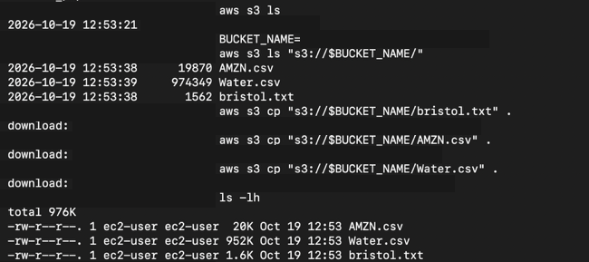
Figure 11 CLI downloads and the three files present on EC2
cat bristol.txt
head -n 3 AMZN.csv
head -n 3 Water.csv
Checkpoint: all three files are listed locally. The CSV headers should match the positional import mappings later in this guide, with dates in YYYY-MM-DD format.

10 Copy an EC2 file back to S3
Create a copy of the downloaded text file and upload that copy to the same bucket.
cp bristol.txt bristol_copy.txt
aws s3 cp bristol_copy.txt "s3://$BUCKET_NAME/"
aws s3 ls "s3://$BUCKET_NAME/"
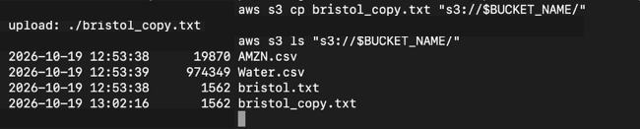
Figure 12 The uploaded text copy appears in the S3 listing
1. Refresh the S3 Objects list in the AWS Console.
2. Confirm bristol_copy.txt is present alongside the original three files.

What the two copies mean
cp creates a local copy inside EC2. aws s3 cp uploads or downloads between EC2 and S3. The contents of the original text file are unchanged by creating and uploading the copy.

Workshop challenge
The command below removes all current objects from the named bucket. Save it for the end of the practical, after both CSV imports and after you have recorded your results.
aws s3 rm "s3://$BUCKET_NAME/" --recursive
For a versioned bucket, this command does not remove every historical version. Use the console Empty action when a complete bucket cleanup is needed.

11 Create the RDS MySQL instance
Keep the EC2 Terminal session open. In the AWS Console, open Aurora and RDS, choose Databases and select Create database.
Setting | Choose
Creation method | Standard create
Engine | MySQL
Engine version | A version supported by the sandbox
Template | Free tier if shown otherwise Dev/Test
Availability | Single-AZ DB instance
DB identifier | lsde-week5-db or another generic lab name
Credentials | Self managed with master username admin
Master password | Create your own and keep it private
Instance class | Burstable classes then db.t3.micro if permitted
Storage | General Purpose SSD with 20 GiB if supported
Compute resource | Connect to an EC2 compute resource
EC2 selection | The instance created for this practical
VPC | The same VPC as EC2
Public access | No
Port | 3306
Authentication | Password authentication
Enhanced monitoring | Off for this short lab
Encryption | Leave enabled
Initial database name | Leave blank; create it with SQL later

Select Create database. Wait for Available. The EC2 connection option sets up the connection security groups. If you configure them manually, allow TCP 3306 on the RDS security group from the EC2 security group.
Use the Academy sandbox and its allowed instance types and budget.

12 Find the endpoint and prepare the client
1. Open the new RDS instance and confirm its status is Available.
2. Choose Connectivity and security. Use Endpoints or the connection snippet to locate the instance endpoint.
3. Copy only the hostname, without https:// or :3306. Keep the database private and use EC2 for the client connection.
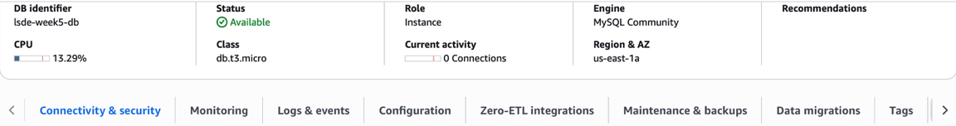
Figure 13 RDS available with MySQL and a micro instance class
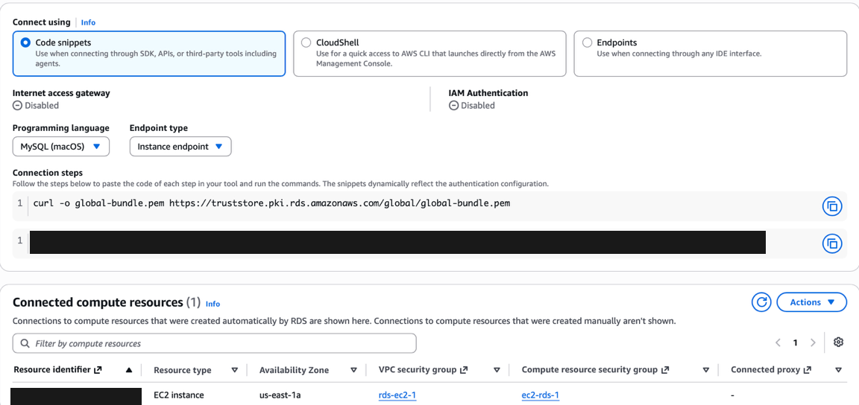
Figure 14 Endpoint connection area and linked EC2 resource

Run in the EC2 shell
sudo dnf update -y
sudo dnf install mariadb105 -y
mysql --version
cd /home/ec2-user
ls -lh AMZN.csv Water.csv
mariadb105 supplies the MySQL-compatible client on Amazon Linux 2023. If either CSV is missing, repeat the relevant S3 download from Step 9.

13 Connect EC2 to RDS
Run the following in the EC2 shell. Replace YOUR_RDS_ENDPOINT with the endpoint copied from your current RDS instance.
cd /home/ec2-user
curl -o global-bundle.pem \
https://truststore.pki.rds.amazonaws.com/global/global-bundle.pem
RDS_ENDPOINT='YOUR_RDS_ENDPOINT'
mysql --local-infile=1 -h "$RDS_ENDPOINT" -P 3306 \
-u admin -p \
--ssl-ca=/home/ec2-user/global-bundle.pem \
--ssl-verify-server-cert
Enter the RDS master password when prompted. It is normal for no characters to appear while typing. The certificate flags above are for the MariaDB client installed in Step 12.

Run at the MySQL prompt
SELECT CURRENT_TIMESTAMP;
SHOW GLOBAL VARIABLES LIKE 'local_infile';
The timestamp confirms a working connection. local_infile should be ON before you import CSV files. If it is OFF, follow Appendix A. The client option --local-infile=1 and the server setting must both allow local imports.

Confirm the data before importing
\! head -n 3 /home/ec2-user/AMZN.csv
\! head -n 3 /home/ec2-user/Water.csv
The backslash exclamation command runs a shell command from the MySQL client. Do not add a SQL semicolon to these two commands. The files are local to EC2 because that is where the client runs.
These steps connect the MySQL client running on EC2 directly to RDS. Appendix B shows the separate optional SSH-tunnel route for a client running on your Mac.

14 Create and import the finance table
CREATE DATABASE IF NOT EXISTS finance_db;
USE finance_db;
CREATE TABLE IF NOT EXISTS amazon_prices (
`date` DATE PRIMARY KEY,
`open` DECIMAL(12,4) NOT NULL,
`high` DECIMAL(12,4) NOT NULL,
`low` DECIMAL(12,4) NOT NULL,
`close` DECIMAL(12,4) NOT NULL,
adj DECIMAL(12,4) NOT NULL,
volume BIGINT UNSIGNED NOT NULL
);
DESCRIBE amazon_prices;
SELECT COUNT(*) AS existing_rows FROM amazon_prices;
If the table already contains a completed import, inspect it and skip the LOAD DATA command. IF NOT EXISTS preserves an existing table; it does not check or repair its structure.

Import into an empty table
LOAD DATA LOCAL INFILE '/home/ec2-user/AMZN.csv'
INTO TABLE amazon_prices
FIELDS TERMINATED BY ','
OPTIONALLY ENCLOSED BY '"'
LINES TERMINATED BY '\n'
IGNORE 1 LINES
(`date`, `open`, `high`, `low`, `close`, adj, volume);
SHOW WARNINGS LIMIT 10;
SELECT COUNT(*) AS amazon_rows FROM amazon_prices;
SELECT * FROM amazon_prices ORDER BY `date` LIMIT 10;
The CSV order is date, open, high, low, close, adj_close, volume. The sixth input column maps to adj. IGNORE 1 LINES skips the header. Prices are stored to four decimal places; volume uses BIGINT for large whole-number counts.
Checkpoint: the supplied AMZN.csv produced 251 rows in the recorded run. Review warnings immediately after LOAD DATA; later statements can replace the warning list.

15 Query finance data and create the Water table

Query and update the finance record
USE finance_db;
SELECT * FROM amazon_prices
WHERE `date` = '2021-10-15';
UPDATE amazon_prices
SET `open` = 1000.00, `close` = 1100.00
WHERE `date` = '2021-10-15';
SELECT * FROM amazon_prices
WHERE `date` = '2021-10-15';
The update changes one example record. Check that the query finds the date first, and keep the WHERE clause so that other dates are not updated. If the original values were already changed in a previous run, MySQL can report zero changed rows.

Create the Water database and table
CREATE DATABASE IF NOT EXISTS water_db;
USE water_db;
CREATE TABLE IF NOT EXISTS water_data (
`date` DATE PRIMARY KEY,
precipitation DECIMAL(12,4) NOT NULL,
pet DECIMAL(12,4) NOT NULL,
temperature DECIMAL(12,4) NOT NULL,
disch_spec DECIMAL(12,4) NULL,
disch_vol DECIMAL(12,4) NULL,
peti DECIMAL(12,4) NOT NULL,
humidity DECIMAL(12,4) NOT NULL,
short_rad DECIMAL(12,4) NOT NULL,
long_rad DECIMAL(12,4) NOT NULL,
windspeed DECIMAL(12,4) NOT NULL
);
DESCRIBE water_data;
SELECT COUNT(*) AS existing_rows FROM water_data;
The two discharge fields allow NULL because the CSV contains missing discharge values. If this table already contains the completed import, skip its LOAD DATA command.

16 Import and inspect the Water data
Run the following only when water_data is empty and its structure matches Step 15.
USE water_db;
LOAD DATA LOCAL INFILE '/home/ec2-user/Water.csv'
INTO TABLE water_data
FIELDS TERMINATED BY ','
OPTIONALLY ENCLOSED BY '"'
LINES TERMINATED BY '\n'
IGNORE 1 LINES
(
`date`, precipitation, pet, temperature,
@disch_spec, @disch_vol, peti, humidity,
short_rad, long_rad, windspeed
)
SET
disch_spec = NULLIF(@disch_spec, ''),
disch_vol = NULLIF(@disch_vol, '');
SHOW WARNINGS LIMIT 10;
SELECT COUNT(*) AS water_rows FROM water_data;
SELECT * FROM water_data ORDER BY `date` LIMIT 10;

How the input columns map
The CSV header uses discharge_spec and discharge_vol; these input positions are mapped to the SQL columns disch_spec and disch_vol. Likewise, shortwave_rad and longwave_rad map to short_rad and long_rad. Mapping is positional, so keep the order shown above.
The @ variables temporarily hold the raw discharge fields. NULLIF converts empty strings into SQL NULL. Missing measurements stay missing instead of becoming zero.

Expected checks
The supplied Water.csv produced 16,436 rows in the recorded run. The first dates begin in October 1970, and some discharge fields are NULL. If the import reports invalid dates, incorrect numeric values or skipped rows, inspect the warnings before continuing.
If the file has different columns, date formatting, or missing-value markers, adjust the import to the file rather than forcing it into this mapping.

17 Query and update the Water data
USE water_db;
SELECT * FROM water_data
WHERE `date` = '1970-10-01';
UPDATE water_data
SET disch_spec = 10.00, disch_vol = -10.00
WHERE `date` = '1970-10-01';
SELECT * FROM water_data
WHERE `date` = '1970-10-01';
These are artificial values from the workshop exercise. The negative discharge value demonstrates an UPDATE; it is not a validated environmental measurement.
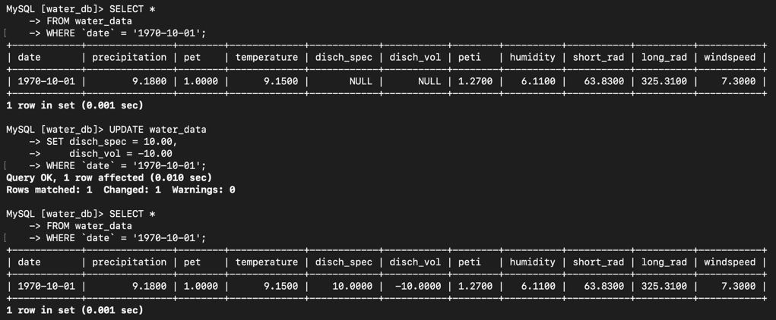
Figure 15 The selected Water record before and after the example update
Expected values are 10.0000 for disch_spec and -10.0000 for disch_vol on 1970-10-01. The recorded update matched and changed one row, with zero update warnings.

18 Verify the completed practical
SELECT COUNT(*) AS amazon_rows
FROM finance_db.amazon_prices;
SELECT COUNT(*) AS water_rows
FROM water_db.water_data;
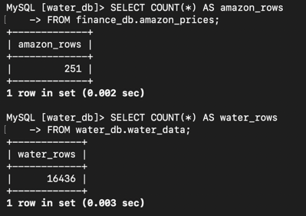
Figure 16 Recorded counts for both imported datasets
Table | Recorded rows
finance_db.amazon_prices | 251
water_db.water_data | 16,436

Save the row counts and the before-and-after queries as evidence of the exercise. Row counts confirm that records are present; review import warnings and sample values as well.

Exit each session
At the MySQL prompt, leave the database client:
EXIT;
At the EC2 shell prompt, disconnect SSH:
exit
Exiting Terminal does not delete the AWS resources. Clean them up in Step 19 when you have finished practising.

19 Clean up your lab resources
Complete this step after saving your results and when you no longer need this disposable setup. Delete only the resources you created for this practical.

Delete the RDS database
1. Open RDS, then Databases, and select the workshop DB instance.
2. Choose Actions, then Delete. If deletion protection blocks the action, use Modify to disable it for this disposable lab database.
3. For this temporary exercise, clear Create final snapshot and Retain automated backups if you do not need a saved copy. Complete the acknowledgement and confirm deletion.

Terminate the EC2 instance
1. Open EC2, select your workshop instance and choose Instance state.
2. Select Terminate instance and confirm. Do not terminate pre-provisioned sandbox resources such as a lab instance or bastion host.

Empty and delete the S3 bucket
1. Open S3 and select your workshop bucket.
2. Choose Empty and complete the confirmation. This removes the stored objects.
3. Return to the bucket list, select the empty bucket and choose Delete. Complete the confirmation.
The workshop CLI challenge can remove the current objects before you disconnect from EC2:
aws s3 rm "s3://$BUCKET_NAME/" --recursive
Use the console Empty action for a versioned bucket. Do not run either action until you have finished using the CSV files.

End the Academy session
Return to AWS Academy and select End Lab according to your sandbox instructions. Check the console for leftover resources you created, such as manually retained snapshots or unattached storage. EC2 and RDS are separate resources and need separate cleanup.

Appendix A Enable local CSV imports
Use these steps only if SHOW GLOBAL VARIABLES LIKE local_infile reports OFF. The default parameter group cannot be edited directly.
1. In RDS, open your database Configuration tab and note the MySQL engine version and current DB parameter group.
2. Open Parameter groups and select Create parameter group. Choose the family matching your engine version, for example mysql8.4 for MySQL 8.4.
3. Choose DB Parameter Group if a type is requested. Enter a generic name such as lsde-local-infile and create it.
4. Open the new group, choose Edit parameters, search for local_infile and set its value to 1. Save changes.
5. Open your database and choose Modify. Under Additional configuration, select the new DB parameter group.
6. Choose Continue, then Apply immediately, and confirm the modification.
7. If the database or parameter group shows Pending reboot, choose Actions and Reboot. Wait for Available.
8. Exit the old MySQL client and reconnect using the command in Step 13, including --local-infile=1.

Check again at the MySQL prompt
SHOW GLOBAL VARIABLES LIKE 'local_infile';
Expected value: ON. If the Academy sandbox does not permit creating or attaching parameter groups, ask the tutor to enable local imports using the lab-supported method.

Do not repeat completed imports
If an import has already completed, check its table count before running LOAD DATA again. The date primary key prevents duplicate dates, but repeated imports can create warnings and obscure the original result.

Appendix B SSH tunnel and troubleshooting

Optional SSH tunnel for a client on your Mac
The main guide runs the MySQL client on EC2 and does not need port forwarding. If your tutor asks you to demonstrate a tunnel from your Mac, run the following in Mac Terminal after replacing the key, endpoint and EC2 hostname:
ssh -i "lab-key.pem" \
-L 127.0.0.1:13306:YOUR_RDS_ENDPOINT:3306 \
ec2-user@YOUR_EC2_HOST
Keep this SSH session open. In a local database client, the forwarded host is 127.0.0.1 and the port is 13306. This tunnel does not install a local client or automatically configure TLS certificate hostname verification. For the CSV imports in this guide, continue using the client on EC2.

Common problems
Symptom | Action
Unable to locate credentials | Attach the course S3-enabled IAM role to the EC2 instance.
S3 AccessDenied | Check the role permissions, bucket name and exact object key.
MySQL command not found | On Amazon Linux 2023, install mariadb105 with dnf.
RDS connection times out | Check Available status, the endpoint, the same VPC, and TCP 3306 from the EC2 security group.
Access denied for admin | Check the master username and password. Reset through RDS Modify if necessary.
Local loading is disabled | Enable both the client option and the server setting; see Appendix A.
File not found | Check /home/ec2-user, filename spelling and case. Download again from S3 if missing.
Unknown ssl-mode option | Use the MariaDB certificate options from Step 13.
Invalid values or duplicate keys | Read SHOW WARNINGS immediately. Check the CSV mapping and whether data was already imported.

Reference material
LSDE Workshop Week 5 slides and the supplied workshop screenshots. AWS documentation: Creating and connecting to a MySQL DB instance; Importing data from any source to RDS for MySQL; Granting public access to S3 data. MariaDB documentation: Securing connections for client and server.
AWS and MariaDB documentation are available at docs.aws.amazon.com and mariadb.com/docs. Console labels can vary; use the matching setting in your sandbox.

