STUDENT PROJECT - PARTNER ENGAGEMENT AGREEMENT
(UNDERGRADUATE AND MASTERS LEVEL)

[This template is used to capture and formalise the involvement of Partners in UG and Masters level student projects where:
- the work to be performed by the student(s) will form part of their academic programme;
- no funding is to be provided to or by the Partner;
- there will be no formal supervision by the Partner and no paid placement is involved (though there may be some site visits); and
- there will be no sharing of confidential information (including commercially sensitive information and personal data subject to data protection legislation including UK GDPR), equipment, hazardous materials or human tissue. Where Confidential Information will be shared the Confidentiality Agreement will need to be entered into in addition – see separate agreement.

The details will be agreed by the Student(s), the Partner and UoB before the project starts. If any unforeseen circumstances arise, a reasonable way forward should be agreed.]

Student(s) and University of Bristol

Name of student(s) and email address(es) (“Student” or “Students”) | Tanishk Shinde - ac25643@bristol.ac.uk  Sanskar Gade - km25788@bristol.ac.uk  Megh Kashilkar - jw25316@bristol.ac.uk  Jitendra Suwalka - rn25015@bristol.ac.uk
University registered name and address | The University of Bristol, Beacon House, Queens Road, Bristol BS8 1QU, UK.
Academic programme and unit the project forms part of | MSc Data Science, Data Science Project
Faculty and School/Department | Faculty of Science and Engineering, School of Engineering Maths and Technology, MSc Data Science
Unit Director(s) | Dr Ayush Joshi ayush.joshi@bristol.ac.uk
Project Supervisor/Mentor(s) | Felipe Campelo - f.campelo@bristol.ac.uk  Jason Mclaren - qu21443@bristol.ac.uk

Partner

Full registered name and address of partner organisation | Dalhousie University  Department of Engineering, Agricultural Campus  PO Box 550, Truro, NS B2N 5E3, Canada
Lead contact for the project | Ahmad Al-Mallahi, Industry Research Chair and Associate Professor  ahmad.almallahi@dal.ca

Project

Description of project to be undertaken by the student(s) | Project title: Robotic Rock Picking - Computer Vision for Potato Fields  The students will develop and evaluate a lightweight computer-vision pipeline to detect rocks in potato-field RGB images and classify each detected rock as completely exposed or half buried. The work includes dataset preparation and annotation validation, training and comparison of object-detection and classification models, evaluation of accuracy, latency and model size, and export of a selected model for edge deployment. The results are intended to support a wider Dalhousie system in which rock detections are combined with GPS information and passed to an automated robotic rock-removal system.  Confidential information: Yes. Camera and mount specifications will be shared with the students in an MS Word document. A separate Confidentiality Agreement is required in addition to this Partner Engagement Agreement.
Duration of project | 1 June 2026 - 31 August 2026
Place project will be carried out | University of Bristol, with partner engagement conducted remotely with Dalhousie University.
Expected project outcomes and outputs:  - Outcomes:  - Outputs: | Outcomes  • A validated and reproducible dataset and annotation workflow for field-rock detection.  • A comparative evaluation of lightweight models for rock detection and burial-status classification.  • An evidence-based model and edge-deployment recommendation considering accuracy, latency, memory and model size.  • Documented limitations and recommendations for future integration with GPS mapping and robotic rock removal.  Outputs  • University of Bristol dissertation/report (up to 30 pages) and a 10-minute presentation to the wider cohort and academic staff.  • A partner-facing technical report and presentation summarising the method, results, limitations and recommendations.  • Reproducible code/notebook, trained model artefacts and edge-export files where applicable, subject to confidentiality and agreed sharing permissions.  • Final presentation date, time, venue and attendees are not yet determined and will be agreed by the parties.
Contributions:  - Required from Partner:  - Required from UoB: | Required from the Partner  • Provide the project brief, source image data, relevant contextual information, and the confidential camera and mount specifications.  • Clarify technical requirements and provide progress feedback at least monthly, including an initial briefing, a mid-project review and a final review.  • Confirm any restrictions on data use, publication and the Partner's intended use of the project results and intellectual property.  Required from the University of Bristol / Students  • The students will commit approximately 600 hours to the 60-credit project during June-August 2026.  • The University will provide academic supervision through Felipe Campelo and Jason Mclaren, together with access to suitable facilities, software and computing resources.  • The University will provide assessment guidance and support for appropriate confidentiality, data-management and academic-integrity requirements.
Communication | Primary communication will be via email and Microsoft Teams. Students will arrange meetings, send progress summaries or questions in advance, and keep a written record of agreed actions. Confidential material must be shared and stored only through approved University systems.

Intellectual Property and Liability
- Any intellectual property owned by (or licenced to) a party prior to the commencement of, or developed independently of, this agreement (“Background IP”) will remain vested on the party introducing it (or on its licensors, as the case may be) and each party to this agreement hereby grants to the other parties a non-exclusive, royalty-free, non-transferable licence to use such Background IP solely for the purpose of the performance of the Project and use of the Arising IP in accordance with clause 3 below.
- Each party to this agreement shall own the Intellectual Property it generates under or in connection with the Project (“Arising IP”) and shall be responsible for securing ownership of such Arising IP (if applicable). For avoidance of doubt, the Student(s) will own the Arising IP on the dissertation, presentation, report or any other deliverables produced by the Student(s) under or in connection with the Project.
- Each party to this agreement hereby grants to the other parties (as applicable) a non-exclusive, royalty-free, non-transferable licence over any Arising IP generated by that party for:
  - the purpose of the performance of the Project;
  - educational purposes by the Student(s) and/or the University; and
  - the Partner’s:
    - learnings from promising results identified by the Student(s) in order to improve or refocus existing approaches within the Partner’s business; and
    - identification and invitation of high potential student talent who demonstrate an interest in and aptitude for the Project for consideration as prospective hires upon graduation.
- The Partner acknowledges and agrees that neither the University nor the Student(s) will have any liability for any use which may be made of any work carried out or results reached under the Project or data or other materials supplied, nor for any reliance which may be placed on these. The Partner acknowledges that any Project outputs are shared without any express or implied warranties, representations, or undertakings.
- To the extent permitted by applicable law, the liability of both the University and the Partner under this Agreement shall be limited to £1,000 each and the maximum liability of each Student(s) under this Agreement shall not exceed £250.

Each of the following parties enters into this agreement on the date set out below.

SIGNED on behalf of the SIGNED on behalf of the
University of Bristol by ......................................... Partner by .........................................
Name: .......................................... Name: Ahmad Al-Mallahi
Position: Head of School of Engineering Maths and Technology Position: Industry Research Chair and Associate Professor
Date: ........................................... Date: .........................................

The Partner wishes to use the Project results and the IP Rights therein for the following purpose:
Purpose [TO BE COMPLETED BY PARTNER before signing]: ................................................................................................

Each Student(s) by signing below gives the Partner an irrevocable, worldwide, perpetual, royalty free non-exclusive licence to use the Project results and the IP Rights for the above purpose.
Name: Tanishk Shinde Signed 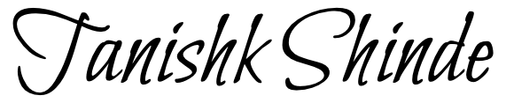 Date 16 July 2026
Name: Sanskar Gade Signed  Date 16 July 2026
Name: Megh Kashilkar Signed 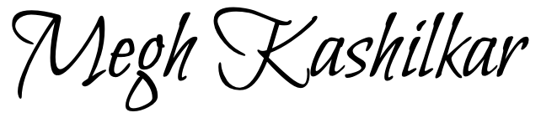 Date 16 July 2026
Name: Jitendra Suwalka Signed 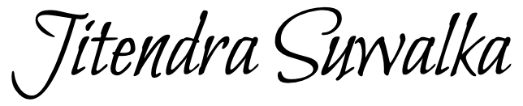 Date 16 July 2026

