**Introduction**

Can we decide using some location Data to find an ideal place to start a restaurant?

Well, the answer is yes, using location data we can definitely figure out whether we need to open our restaurant in an open place or a place with more restaurant traffic. Whether the restaurant should be in a place which has restaurants with good ratings, as more foot traffic would be noticed. Imagine if your mind changes from a restaurant to a street food chain, well my fellow peers this same technique can be used to spot the areas where we would finally land our plans.

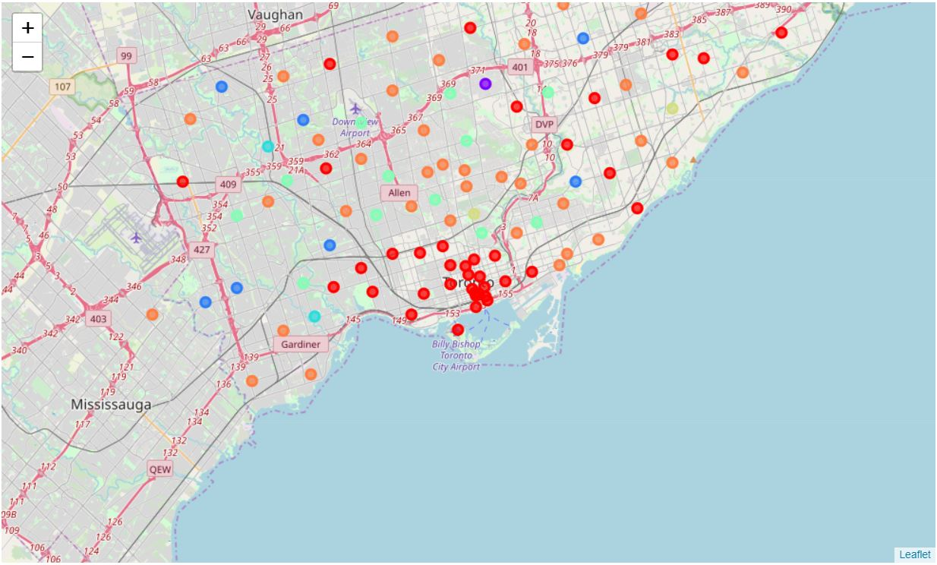

__This is a Clustered Map showing all the neighbourhoods in Toronto.__

**Data and it’s preparation**

The data i am using is the location data to Mumbai and its eating joints within a radius of 5 kilometres, this awesome data was made available by Foursquare API (Really powerful API).

I extracted the raw data in the form of Json text which was then converted to a Pandas Dataframe and Finally the Name, Latitudes and Longitudes of the food joint was taken to plot the amazing map.

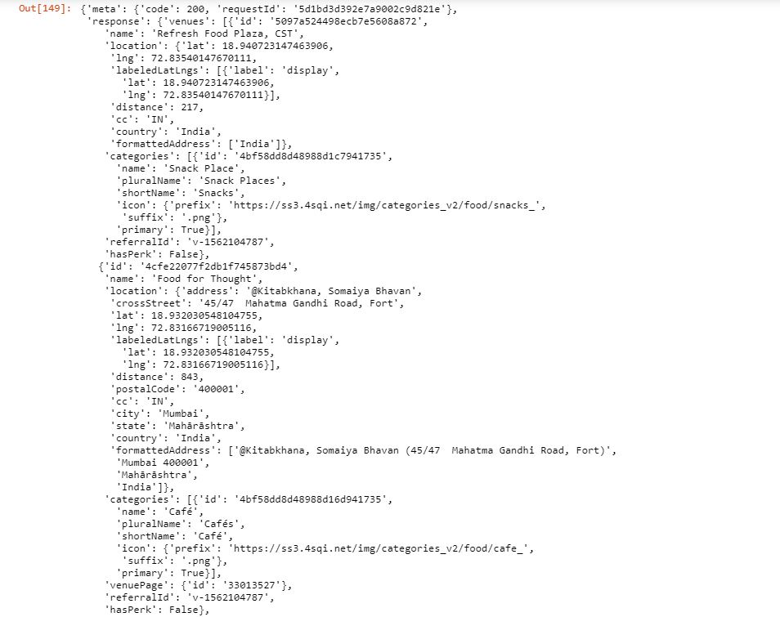

__This data was tramsformed to a pandas dataframe(below).__

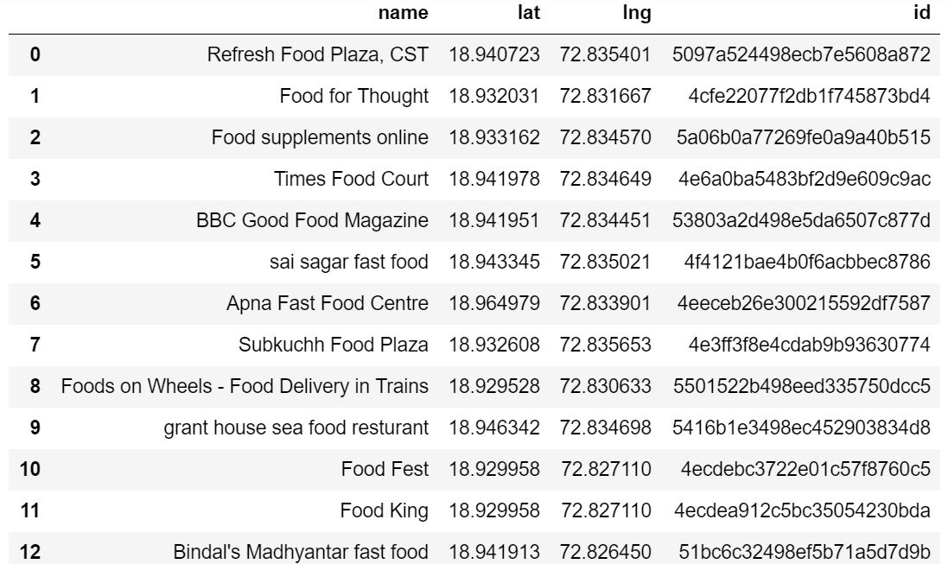

**Methodology**

No such Machine Learning algorithms were used in the solving of this problem.

So, essential steps for machine learning and data analysis such as Business understanding, analytical approach,etc. are not shown here.

**Results**

Well the Folium Library was used to visualize the result.

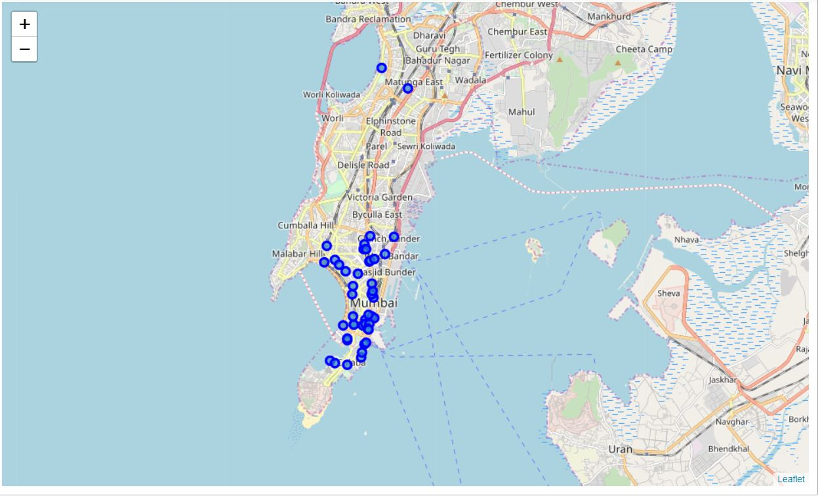

Discussion

From the above map of Mumbai we can clearly make out that Areas near Coulaba are really crowdy and have high foot traffic so a street food shop would definitely work in that are but area in the interior are not that crowded, so, these places are more suitable for a Restaurant.

Similarly, we can do so for many other situations, like if a person wants to setup his office, another wants to put up a shop, etc. One way or the other this analysis will be important for a person to find a place of his/her choice.

Conclusion

Concluding, I would like to thank Alex Aklson for a thorough Course Material and obviously my dear PEERS for helping in the discussion Forums.

Going through the course has really build up concepts in my mind and I believe that I will definitely benefit from it,

Thank You.