Problem Link: https://www.hackerrank.com/challenges/fizzbuzz/problem
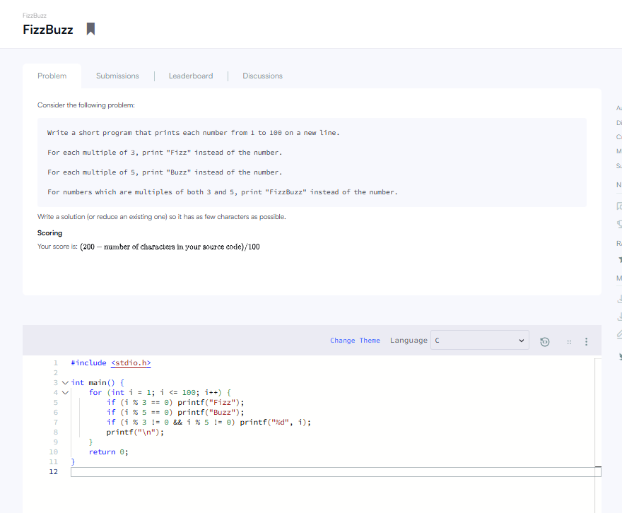
Result:


