Problem Link: https://leetcode.com/problems/smallest-even-multiple/description/
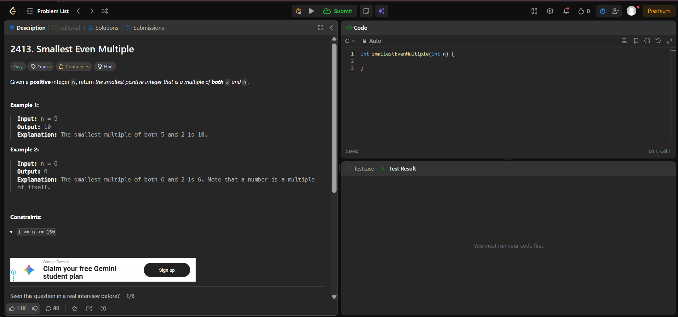
Result:


