Problem Link: https://leetcode.com/problems/number-of-steps-to-reduce-a-number-to-zero/description/
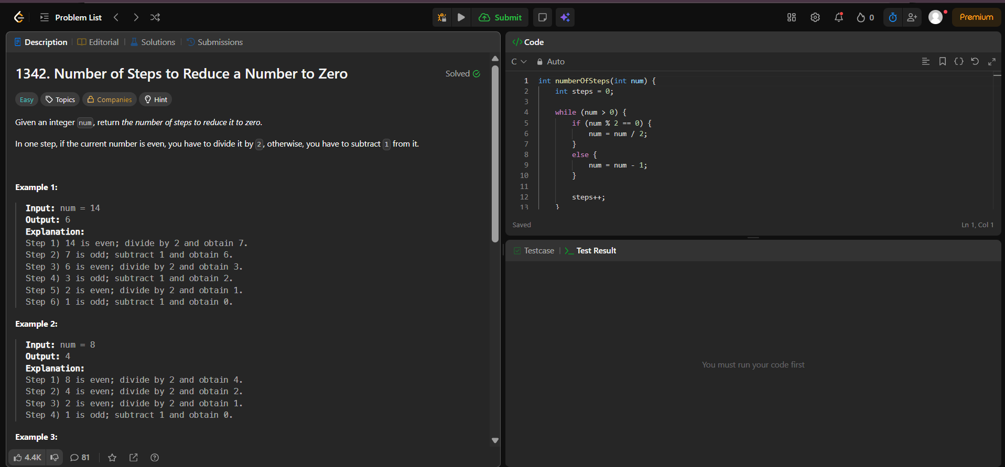
Result:


