Problem Link: https://leetcode.com/problems/count-odd-numbers-in-an-interval-range/description/
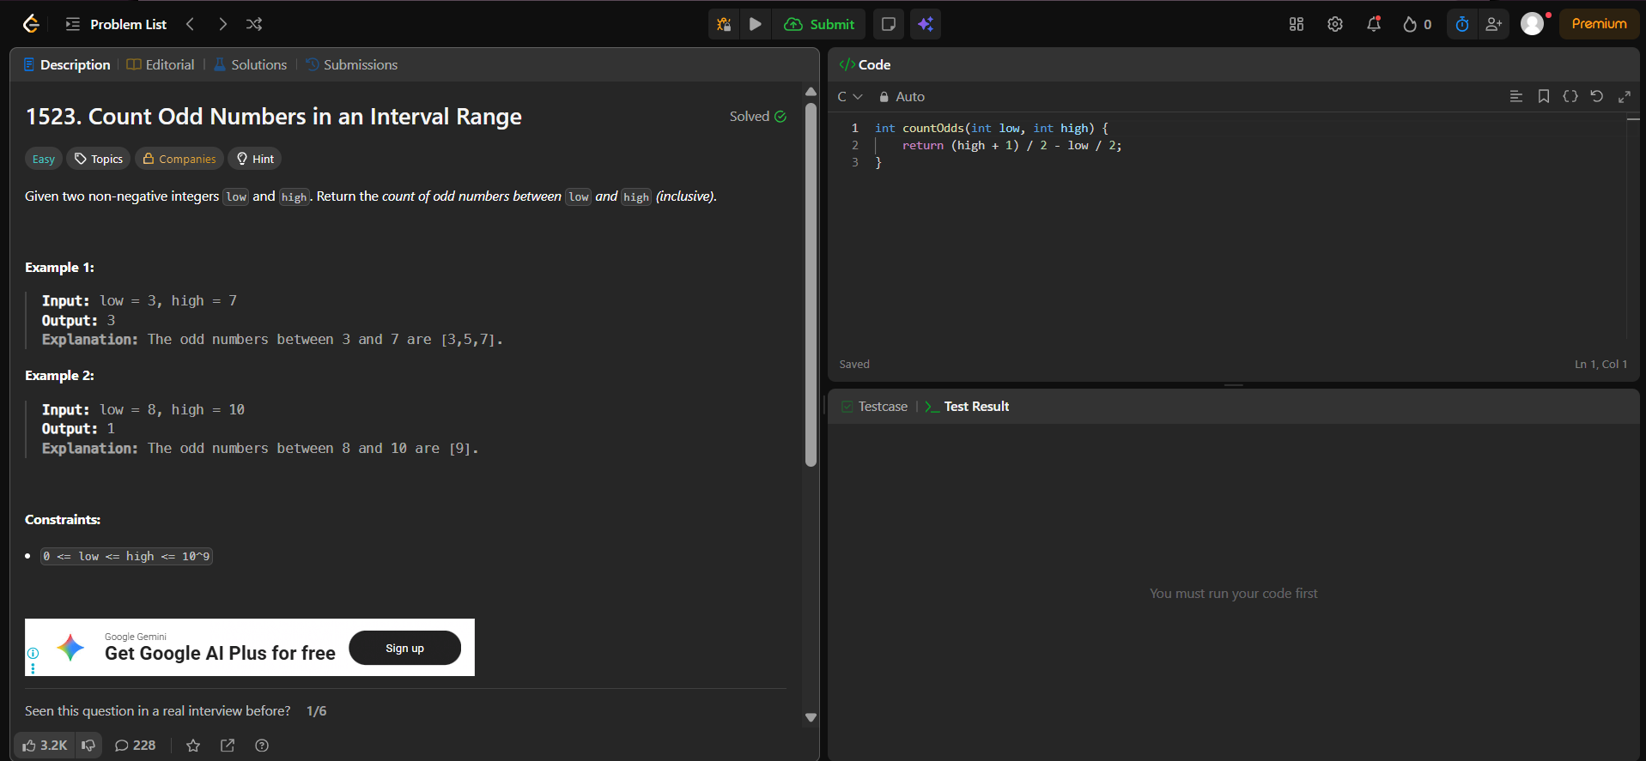
Result:


