Problem Link: https://leetcode.com/problems/count-operations-to-obtain-zero/description/
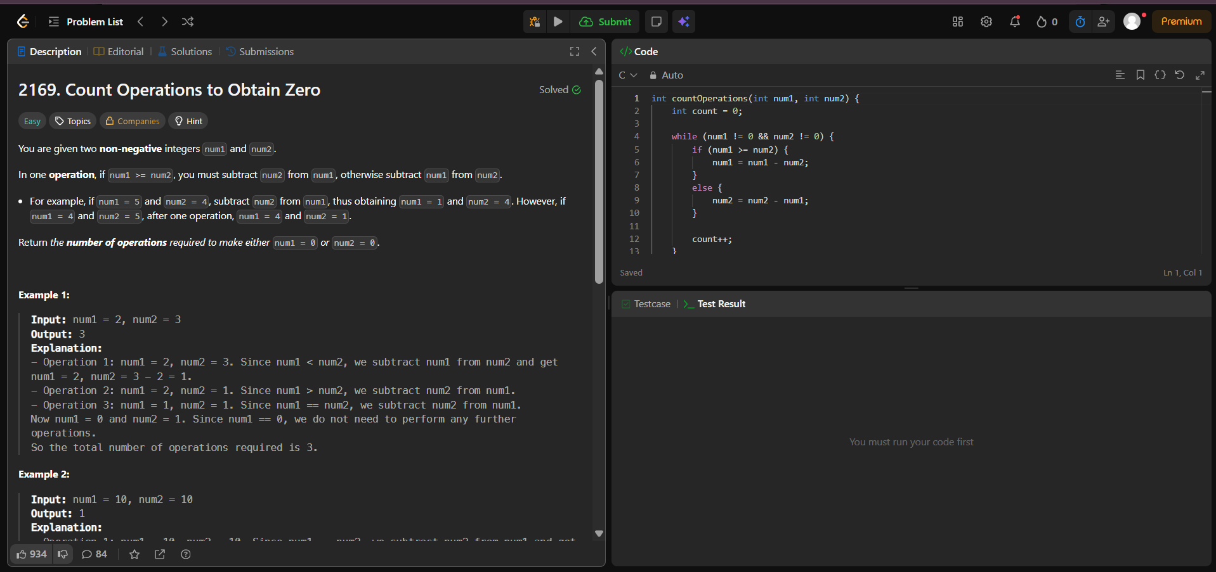
Result:


