Problem Link: https://leetcode.com/problems/sum-multiples/description/
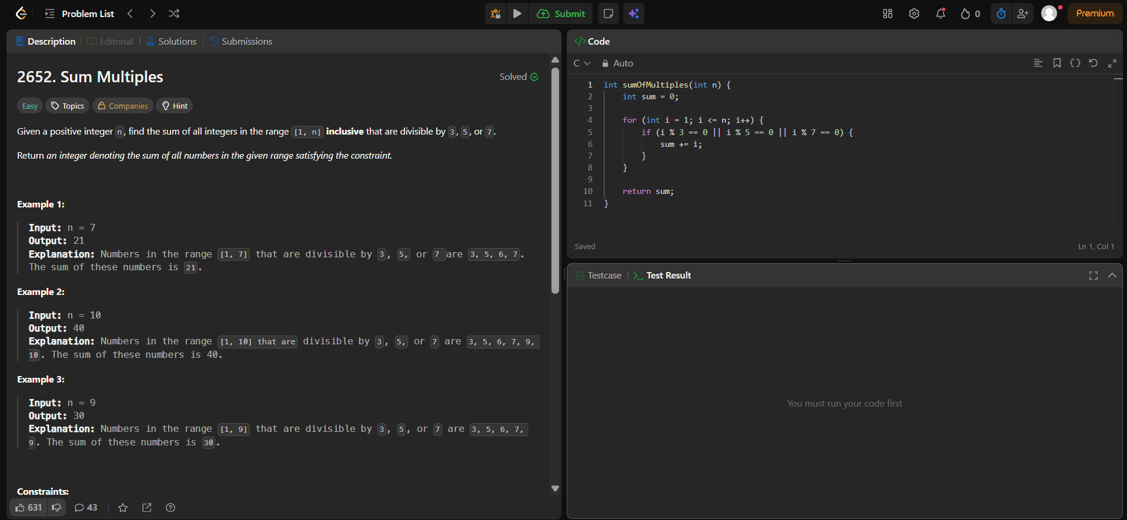
Result:


