Problem Link: https://www.hackerearth.com/problem/algorithm/digit-sum-4/
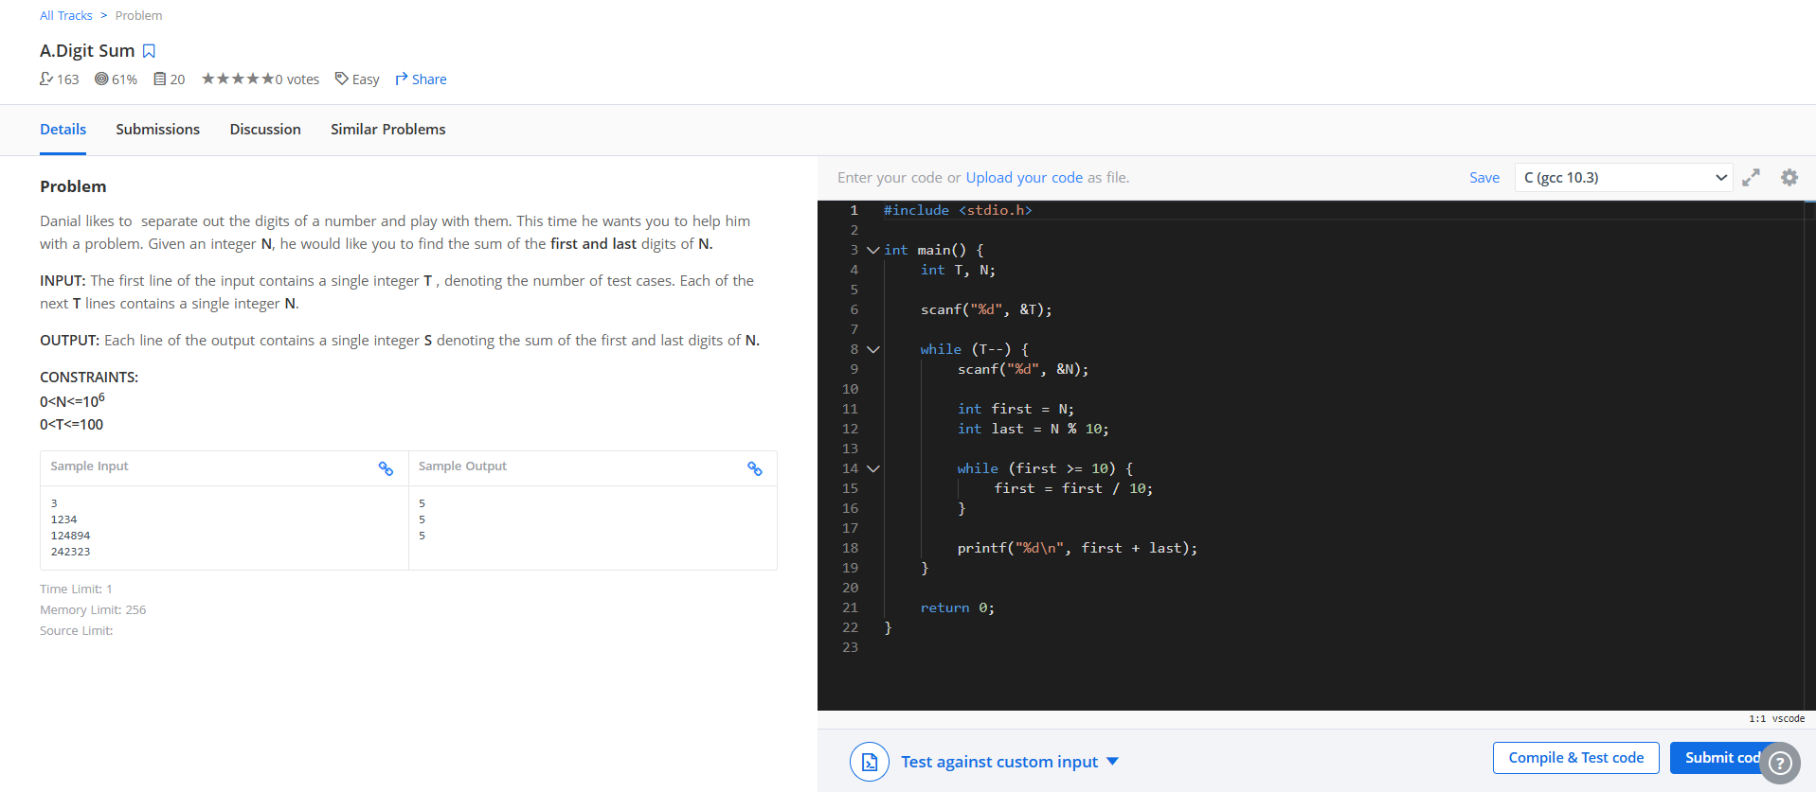
Result:


