Problem Link: https://leetcode.com/problems/subtract-the-product-and-sum-of-digits-of-an-integer/description/
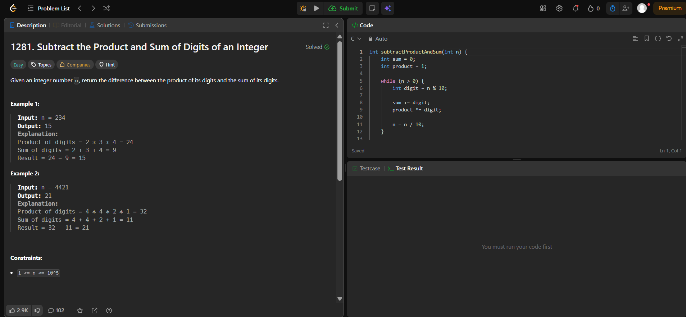
Result:


