Problem Link: https://leetcode.com/problems/count-the-digits-that-divide-a-number/description/
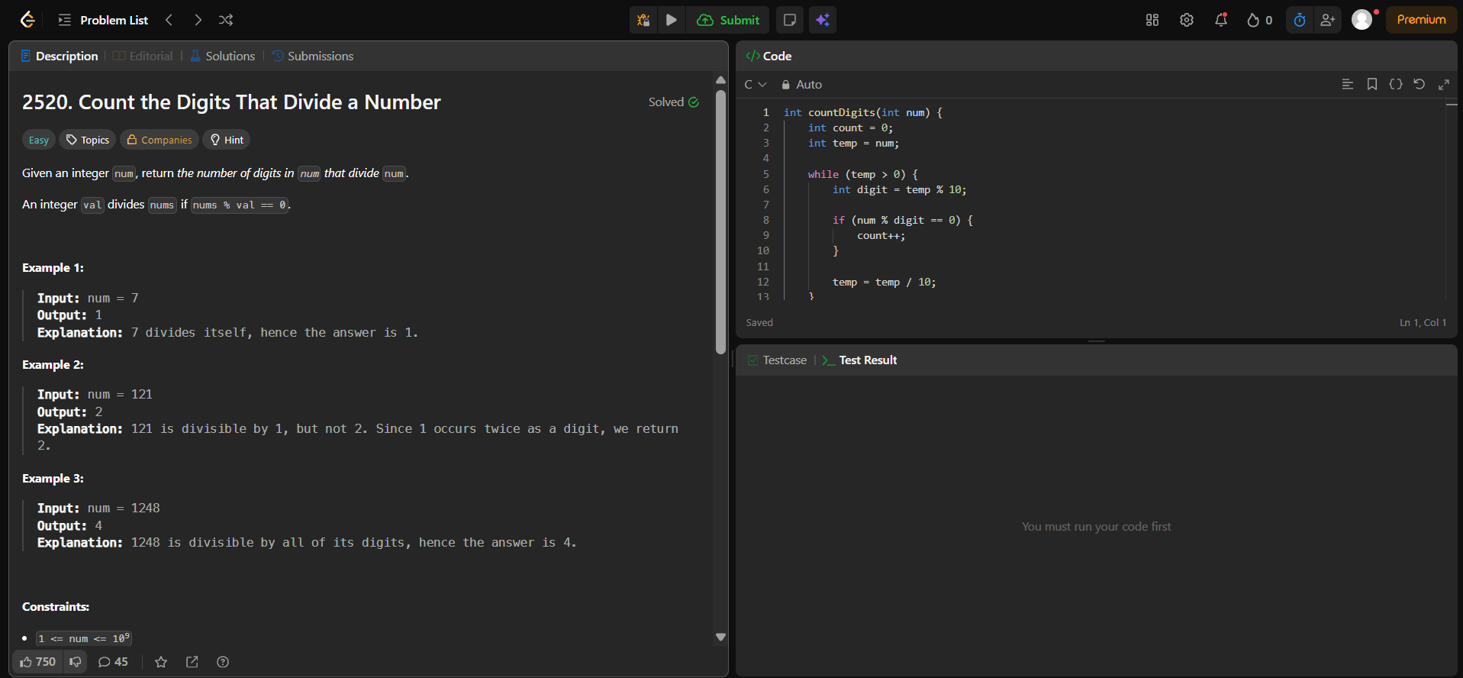
Result:


