Problem Link: https://leetcode.com/problems/reverse-integer/description/
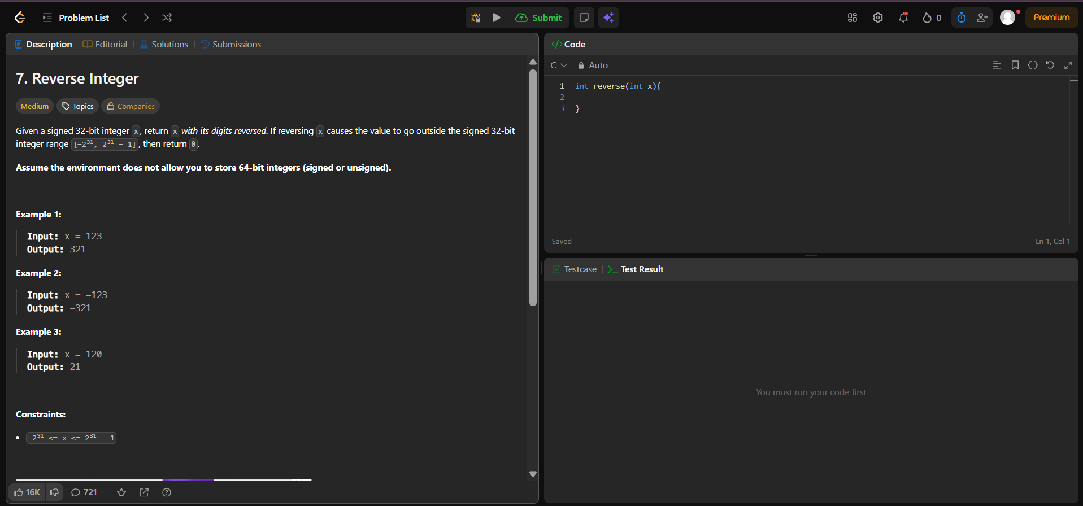
Result:


