Problem Link: https://leetcode.com/problems/palindrome-number/description/
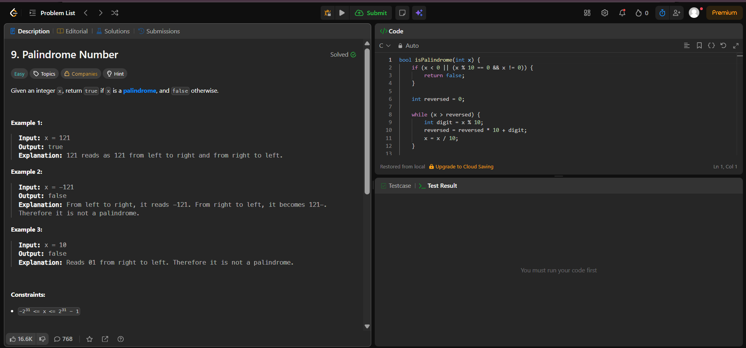
Result:


