Problem Link: https://www.hackerearth.com/problem/algorithm/prime-numbers/
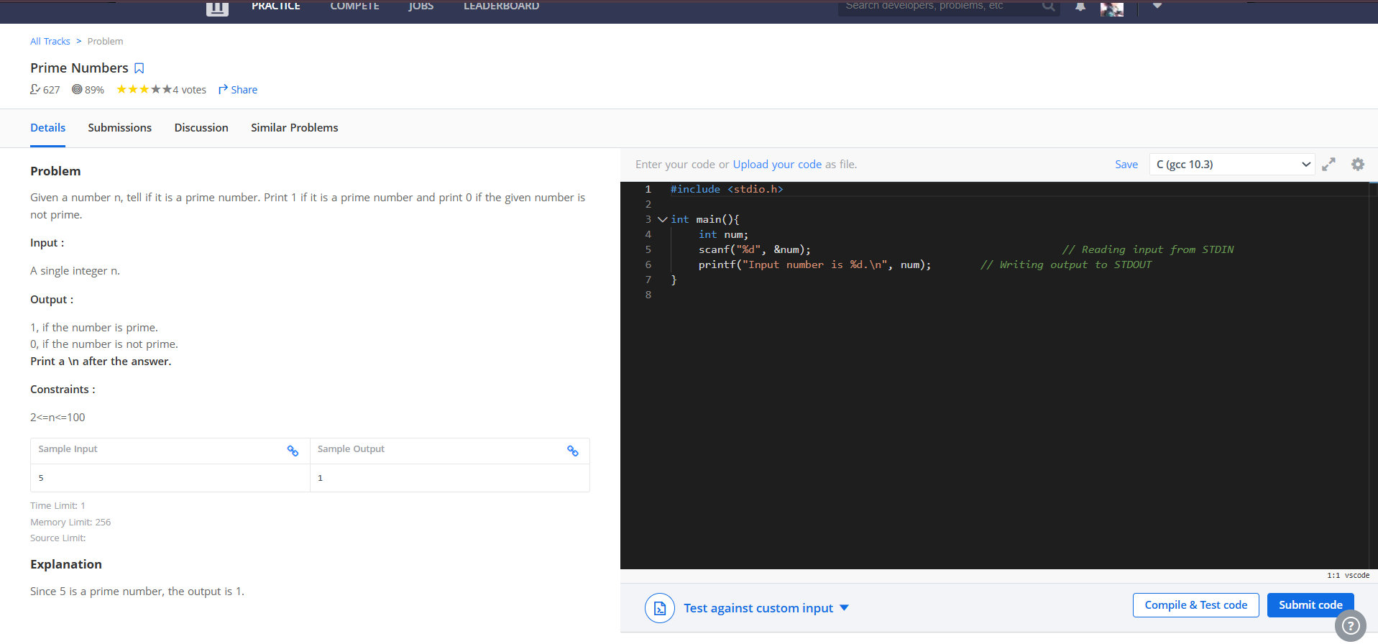
Result:


