Problem Link: https://leetcode.com/problems/power-of-two/description/
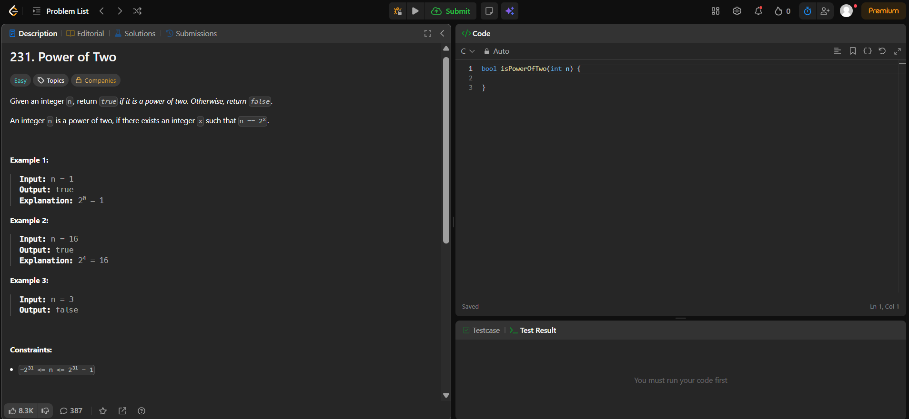
Result:


