Problem Link: https://leetcode.com/problems/power-of-three/description/
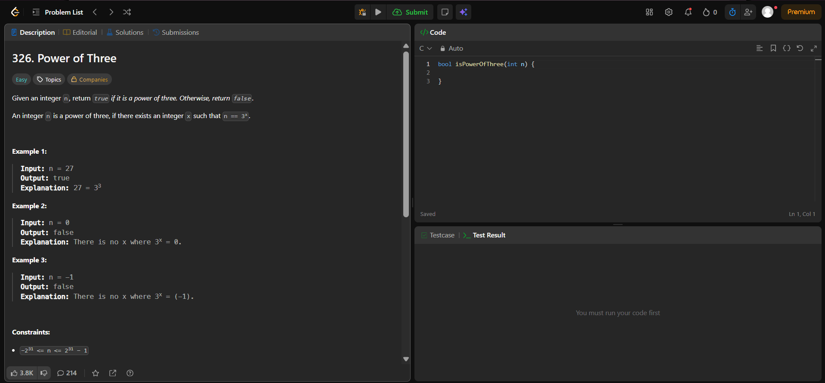
Result:


