Problem Link: https://leetcode.com/problems/perfect-number/description/
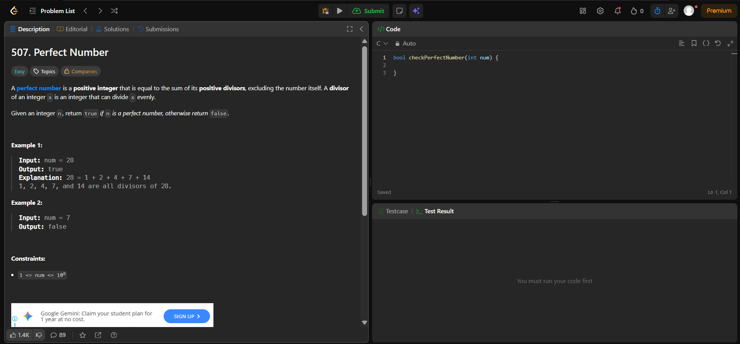
Result:


