PES University — Dept. of CSE
Lab 1: Requirements Engineering & UML Use-Case Modelling
Problem Statement #13 — Patient Health Record Consent Management System

1. Complete Requirements Table
Five Functional Requirements (FR-001 – FR-005) and two Non-Functional Requirements (NFR-001 – NFR-002), covering the patient-consent lifecycle: grant, revoke, notify, enforce, and audit.
ID | Type | Description | Priority | Acceptance Criteria | Rationale
FR-001 | Functional | The system shall allow patients to grant time-bounded (e.g., 24-hour) access permissions for specific diagnostic records to verified clinic doctors. | High | Pass: Clinic access automatically revokes upon expiry timestamp.  Fail: Clinic accesses records after consent expiration. | Gives patients granular, time-limited control over their data and enforces least-privilege access for external providers.
FR-002 | Functional | The system shall allow patients to revoke an active consent grant immediately, regardless of its originally specified expiry time. | High | Pass: Access is denied and any active session is terminated within 5 seconds of revocation.  Fail: Clinic retains access after revocation. | Patients must be able to withdraw consent at will, independent of any pre-set expiry, per health-data privacy norms.
FR-003 | Functional | The system shall notify the patient before an active consent grant expires (e.g., 1 hour prior), and shall notify the clinic administrator when access is about to lapse. | Medium | Pass: Notification delivered within 60 seconds of the trigger threshold.  Fail: No notification sent, or sent after expiry. | Timely alerts let clinicians complete access-dependent tasks and let patients reconfirm or extend consent before revocation.
FR-004 | Functional | The system shall restrict a Clinic Administrator's / verified doctor's access strictly to the record categories and patient(s) named in an active consent grant, enforcing read-only access by default. | High | Pass: An attempt to open a record outside the granted scope is blocked and logged.  Fail: A clinic user views/edits records outside consented scope. | Enforces data-minimization and scope-limitation even for authenticated, verified healthcare staff.
FR-005 | Functional | The system shall allow patients to view a real-time, filterable history of all consent grants, revocations, expirations, and access events on their account. | Medium | Pass: History reflects a new grant/revoke/access event within 2 seconds of occurrence.  Fail: History is missing entries or not updated within acceptable latency. | Transparency into data access builds patient trust and satisfies regulatory right-to-access obligations.
NFR-001 | Performance & Security | All consent grant, revoke, and access events shall be permanently written to an append-only audit trail. | High | Pass: Benchmarking confirms target write latency and tamper-evident security under simulated peak load.  Fail: Audit entries can be modified/deleted, or latency breaches SLA under load. | An immutable, performant audit trail is required for compliance, breach forensics, and dispute resolution.
NFR-002 | Security & Data Privacy | All health records and consent metadata shall be encrypted (AES-256 at rest, TLS 1.3 in transit); Clinic Administrator accounts shall require multi-factor authentication. | High | Pass: Security scan confirms no unencrypted PHI storage/transmission and MFA enforced on all clinic-admin logins.  Fail: Any PHI found unencrypted, or single-factor access succeeds. | Health records are highly sensitive PHI; encryption and strong authentication are baseline compliance requirements (e.g., HIPAA / India's DPDP Act).

2. UML Use-Case Diagram
Actors: Patient (primary) and Clinic Administrator (primary), with the Audit Log shown as a supporting system actor. The diagram includes two «include» relationships (Access Diagnostic Records / Request Emergency Override Access → Verify Consent Validity; Grant Time-Bound Consent Access and Revoke Consent → Record Audit Trail Entry) and two «extend» relationships (Receive Consent Expiry Notification extends Grant Time-Bound Consent Access; Request Emergency Override Access extends Access Diagnostic Records).
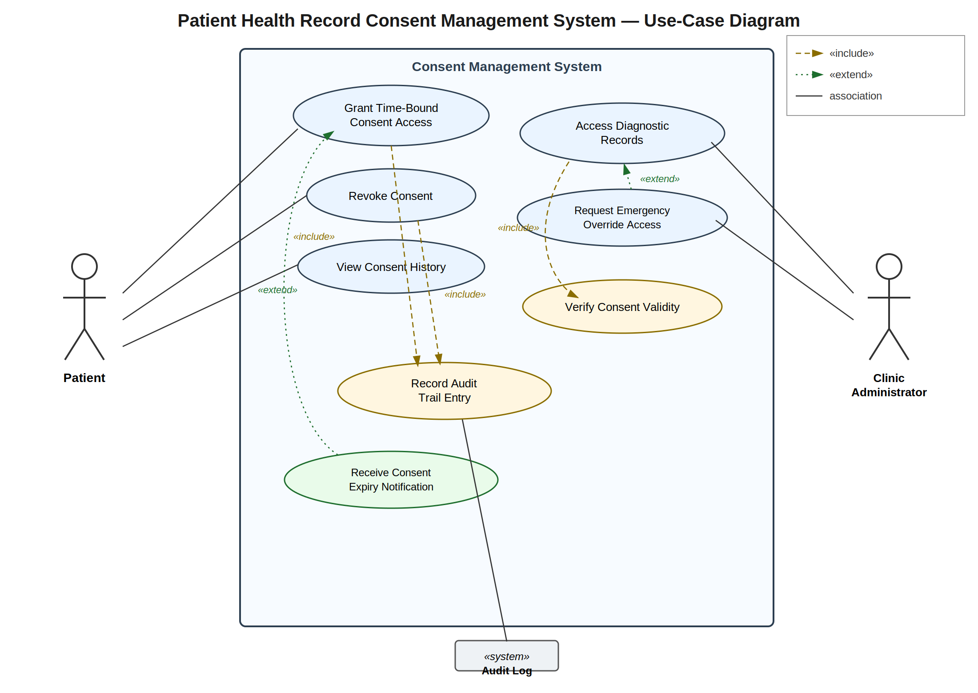
Use-case summary:
- Grant Time-Bound Consent Access (Patient) — create a scoped, expiring consent grant. Includes Record Audit Trail Entry; extended by Receive Consent Expiry Notification.
- Revoke Consent (Patient) — immediately withdraw an active grant. Includes Record Audit Trail Entry.
- View Consent History (Patient) — browse past and active consent events.
- Access Diagnostic Records (Clinic Administrator) — open records within an active grant's scope. Includes Verify Consent Validity; extended by Request Emergency Override Access.
- Request Emergency Override Access (Clinic Administrator) — request exceptional access outside a standing grant; also includes Verify Consent Validity.
- Verify Consent Validity — shared sub-behaviour that checks grant scope and expiry (included use case).
- Record Audit Trail Entry — shared sub-behaviour that appends an immutable log entry (included use case).
- Receive Consent Expiry Notification — optional alert sent before a grant lapses (extension).

3. Use-Case Flow Specification
Use Case: Grant Time-Bound Consent Access
Related Requirement | FR-001
Primary Actor | Patient
Secondary Actors | Clinic Administrator (grantee, notified on success); Audit Log (receives the logged event)
Preconditions | 1. The patient is authenticated and logged into the system.  2. The target clinic / diagnostic lab and the specific doctor are already verified and active in the system.  3. At least one diagnostic or medical record exists in the patient's account that is eligible for sharing.
Postconditions (Success) | 1. A time-bound consent record exists, storing the grantee's ID, the record scope, and a computed expiry timestamp.  2. An immutable "Consent Granted" entry has been appended to the Audit Trail.  3. The grantee can subsequently pass Verify Consent Validity until the grant expires or is revoked.
Main Success Scenario | 1. Patient opens "Manage Consent" and selects "Grant New Consent."  2. System displays the patient's shareable records and the list of verified clinics/doctors.  3. Patient selects the specific record(s) and the verified doctor/clinic to grant access to.  4. Patient sets the access duration (default 24 hours; may customize within allowed bounds).  5. Patient reviews the summary and confirms the grant.  6. System re-validates that the selected grantee is currently verified and active.  7. System creates the consent entry with the computed expiry timestamp.  8. System executes Record Audit Trail Entry «include», logging a "Consent Granted" event.  9. System sends a confirmation to the patient and an access-granted notification to the clinic administrator.  10. Use case ends successfully.
Alternate Flow A1 — Grantee Not Verified | Trigger: at step 6, the selected clinic/doctor's verification is invalid, expired, or revoked.  6a. System rejects the request and displays: "Selected provider is not currently verified."  6b. System logs a "Consent Grant Denied" event to the Audit Trail.  6c. Flow returns to step 3 so the patient can choose a different, verified grantee, or the patient cancels and the use case ends without postconditions being met.
Note: a second alternate flow — patient cancellation prior to confirmation (steps 2–5) — simply discards the in-progress request with no consent record created and no compliance audit entry logged.

