PREDICTIVE ANALYTICS PROJECT REPORT

CONTENTS OF THE REPORT
- Cover page
- Certificate
- Declaration
- Acknowledgement
- Table of Content

  - Introduction
Overview of Predictive Analytics
Importance of prediction in the selected domain Problem Statement
Objectives of the study Scope of the project Expected outcomes
  - Source of dataset
Name of dataset
Source link (Kaggle / UCI / Government portal / Primary source) Description of attributes
Number of rows, columns Type of prediction:
  - Dataset Preprocessing
  - Analysis on dataset (for each objective) General Description
Specific Requirements Analysis results Visualization
  - Model Development
Minimum three predictive models must be trained.
  - Model Comparison
  - Best Model Identification
  - Conclusion
  - Future scope

PREDICTIVE ANALYTICS PROJECT REPORT
(Project Semester August-December 2025)

Predictive Analysis of Excess Mortality Using Demographic Data

Submitted by

Tanishq Girare

Registration No 12303049

Programme and Section: Computer Science and Engineering, K23BR Course Code INT234

Under the Guidance of
Dr. Tanima Thakur (23532)
(Name of faculty coordinator with U.Id and designation)

Discipline of CSE/IT Lovely School of Computer Science
Lovely Professional University, Phagwara

CERTIFICATE

This is to certify that Tanishq Girare bearing Registration no. 12303049 has completed INT234 project titled, “Predictive Analysis of Air Quality Index (India)” under my guidance and supervision. To the best of my knowledge, the present work is the result of his/her original development,
effort and study.

Signature and Name of the Supervisor Designation of the Supervisor
School of …………………………………………….
Lovely Professional University Phagwara, Punjab.

Date:

DECLARATION

I, Tanishq Girare, student of Computer Science and Engineering under CSE/IT Discipline at, Lovely Professional University, Punjab, hereby declare that all the information furnished in this project report is based on my own intensive work and is genuine.

Date: 14/12/2025 Signature

Registration No. 12303049

Introduction

Overview of Predictive Analytics
Predictive analytics refers to the use of historical data, data preprocessing techniques, and machine learning algorithms to analyze patterns and forecast future outcomes. In the context of air quality monitoring, predictive analytics helps in estimating Air Quality Index (AQI) levels based on pollutant concentrations and temporal factors. Python-based analytical tools such as Pandas, NumPy, and Scikit-learn are widely used to clean data, engineer features, and develop predictive models. By applying regression and classification techniques, predictive analytics enables early identification of pollution trends and supports data-driven decision-making for environmental planning and public health management.

Importance of Prediction in the Selected Domain
In the environmental and public health domain, predictive analytics plays a crucial role in monitoring air pollution levels and assessing their impact on human health. Accurate prediction of the Air Quality Index (AQI) helps in identifying high-risk periods and regions affected by severe pollution. By analyzing pollutant concentrations along with temporal factors such as season and time, predictive models assist authorities in issuing early warnings, planning mitigation strategies, and reducing health risks related to poor air quality. With the availability of large-scale air quality monitoring data, data-driven AQI prediction has become an essential tool for environmental management and public health protection.

Problem Statement
Air quality monitoring systems generate large volumes of data containing pollutant concentrations across different cities and time periods. However, manual analysis of such high-dimensional air quality datasets is inefficient and often unable to capture complex and non-linear relationships among pollutants and temporal factors. There is a need for an intelligent predictive system that can accurately estimate Air Quality Index (AQI) values and categorize pollution levels. The main challenge involves effective data preprocessing, handling missing values, selecting suitable machine learning models, and developing a reliable framework for accurate AQI prediction and analysis.

Objectives of the Study
    - To analyse air quality data collected from major Indian cities.
    - To preprocess pollutant concentrations and temporal features such as hour, day, month, and season.
    - To develop and compare machine learning models including Linear Regression, Polynomial Regression, and
Random Forest Regression for AQI prediction.
    - To classify AQI values into predefined air quality categories using classification algorithms.
    - To analyse temporal pollution trends and identify key pollutants influencing AQI levels.

Scope of the Project
The scope of this project is limited to predictive analysis using historical air quality data collected from selected Indian cities. The system primarily focuses on pollutant concentrations and temporal attributes for AQI prediction and classification. External factors such as detailed meteorological conditions, traffic density, and geographical dispersion models are not included within the scope of this study. The project demonstrates data preprocessing, machine learning model development, evaluation, and trend analysis, but it does not aim to replace official air quality forecasting or regulatory monitoring systems.

Expected Outcomes
The expected outcomes of this project include:
    - Identification of relationships between major air pollutants and Air Quality Index (AQI) levels.
    - Development of a trained machine learning model capable of predicting AQI values with reasonable accuracy.
    - Comparative performance evaluation of multiple regression and classification algorithms used for AQI analysis.
    - Effective categorization of air quality into standard AQI buckets for better pollution interpretation.
    - Enhanced understanding of how predictive analytics can support air quality monitoring, environmental planning,
and public health awareness.

Source of Dataset

Name of Dataset
Air Quality Data in India (2015 - 2024)

Source Link Kaggle
Link:-
https://www.kaggle.com/datasets/ankushpanday1/air-quality-data-in- india-2015-2024?utm_source=chatgpt.com&select=city_hour.csv GitHub Link:
https://github.com/tanishq077/Predictive-project LinkedIn :


Description of Attributes

The dataset contains historical air quality measurements collected on an hourly basis from multiple Indian cities. For this project, the following attributes were selected and used for predictive modeling:

Attribute Name Description

PM2.5 Concentration of fine particulate matter with diameter less than 2.5 micrometers.

PM10 Concentration of particulate matter with diameter less than 10 micrometers.

NO₂ Nitrogen dioxide concentration measured in the atmosphere.

SO₂ Sulphur dioxide concentration contributing to air pollution.

CO Carbon monoxide concentration indicating incomplete combustion.

O₃ Ground-level ozone concentration.

Number of Rows and Columns
- Number of Rows: Varies after data cleaning (rows containing missing values were removed during preprocessing).
- Number of Columns Used: 18
  - 17 input (independent) variables
  - 1 target (dependent) variable
(Note: The original dataset contains additional columns which were excluded to maintain model simplicity and relevance.)

Type of Prediction

- This project performs two types of prediction:

1. Regression Prediction
o Predicts the continuous Air Quality Index (AQI) values using:
- Linear Regression
- Polynomial Regression

- Random Forest Regression

2. Classification Prediction
o Classifies AQI values into predefined air quality categories using:
- Logistic Regression
- K-Nearest Neighbours (KNN)
- Decision Tree Classifier
- The primary predictive model identified for accurate AQI estimation is the Random Forest Regression model, which effectively predicts continuous AQI values based on pollutant concentrations and temporal features.

Dataset Preprocessing
Dataset preprocessing is a crucial step in predictive analytics to ensure data quality and effective performance of machine learning models. Since the dataset used in this project contains air pollutant measurements along with temporal attributes, several preprocessing techniques were applied prior to model training. These steps helped in handling missing values, transforming categorical variables, and preparing the data in a suitable format for accurate AQI prediction and classification.

Data Selection
The air quality dataset was loaded using the Pandas library, and only relevant attributes required for AQI prediction were selected. Columns unrelated to air pollution analysis were excluded to reduce noise and improve model efficiency. The selected attributes include pollutant concentrations (PM2.5, PM10, NO₂, SO₂, CO, O₃), temporal variables derived from datetime (year, month, day, hour, and season), and the target variable representing the Air Quality Index (AQI).

Handling Missing Values
The dataset contained missing values in several pollutant measurements. To maintain data quality and avoid biased predictions, a structured imputation strategy was applied. City-wise mean imputation was used for attributes with partial missing values, while global median imputation was applied to pollutants with higher proportions of missing data. This approach ensured that the dataset remained complete and reliable for model training and evaluation.

Encoding of Categorical Variables
Machine learning algorithms require numerical input; therefore, categorical attributes were converted into numerical form. One-hot encoding was applied to categorical variables such as city and season to prevent ordinal bias. This encoding technique allowed the models to effectively learn city-wise and seasonal pollution patterns while maintaining interpretability.

Feature and Target Variable Separation
After preprocessing, the dataset was divided into:

Independent variables (X): Pollutant concentrations (PM2.5, PM10, NO₂, SO₂, CO, O₃) and engineered
temporal features (year, month, day, hour, season)
    - Dependent variable (y): Air Quality Index (AQI)

- This separation enabled the machine learning models to learn the relationships between pollutant levels, temporal factors, and AQI values effectively.

Creation of Classification Labels
In addition to regression-based AQI prediction, a multi-class classification label was used to categorize air quality levels. The AQI values were mapped into standard AQI buckets such as Good, Satisfactory, Moderate, Poor, Very Poor, and Severe based on predefined threshold ranges. This categorization enabled the use of classification algorithms to analyze pollution severity levels and their impact on public health.

Train–Test Split
To evaluate model performance objectively, the preprocessed dataset was divided into training and testing subsets using an 80:20 ratio. The training dataset was used for building regression and classification models, while the testing dataset was utilized to assess prediction accuracy, robustness, and generalization performance.

Data Consistency for Deployment

To ensure consistent predictions during future deployment or integration, all preprocessing steps such as encoding of categorical variables, feature scaling, and feature ordering were preserved. The trained machine learning models and preprocessing objects were saved using Joblib, ensuring that new input data follows the same preprocessing pipeline as the training data.

Analysis on Dataset
The analysis phase focuses on understanding the air quality dataset, extracting meaningful pollution patterns, and evaluating predictive machine learning models aligned. Both regression and classification techniques were applied to analyse AQI trends across spatial, temporal, and seasonal dimensions.

General Description
The dataset represents air quality observations categorized by city, pollutant type, temporal attributes, and AQI levels. The primary goal of analysis is to determine how these factors influence AQI variation and to evaluate the effectiveness of machine learning models in predicting AQI values. The analysis was performed using structured preprocessing, model training, and performance evaluation techniques accurately reliably.

Objective-wise Analysis

Objective 1: Analyse the Relationship Between Pollution Factors and AQI Levels Specific Requirements:
    - Identify whether pollution attributes such as PM2.5, PM10, gaseous pollutants, and city have a measurable
impact on AQI values.
    - Convert categorical attributes into numerical format suitable for analysis.

Analysis Results:
Label encoding enabled the transformation of city and seasonal categories into numeric values. The models were able to learn patterns indicating that AQI levels vary significantly across different cities and pollution categories. Temporal attributes such as month and hour further influenced fluctuations in AQI values.

Visualization:
Bar plots and frequency distributions can be used to visualize AQI levels across cities, seasons, and pollutant categories, highlighting spatial and temporal disparities in air quality trends.

Objective 2: Predict Exact AQI Values Using Regression Models Specific Requirements:
- Build regression models to predict continuous AQI values.
- Evaluate models using Mean Squared Error (MSE) and R² score.

Analysis Results:
Two regression models were trained:
- Linear Regression provided a baseline model, capturing linear relationships between pollutants and AQI values.
- Random Forest Regression demonstrated improved performance by modelling non-linear relationships present in the dataset.

The Random Forest Regressor achieved lower MSE and higher R² scores compared to Linear Regression, indicating better predictive capability for this dataset.

Visualization:
Scatter plots comparing actual vs. predicted AQI values can be used to assess model fit. Residual plots help visualize prediction errors across different AQI ranges.

Objective 3: Classify AQI Levels as High or Low Specific Requirements:
- Convert continuous AQI values into binary classes.
- Apply a classification algorithm and measure accuracy.

Analysis Results:
A binary classification label was created using the mean AQI value as a threshold. Logistic Regression was used to classify records into high or low AQI categories. The model achieved reasonable classification accuracy, demonstrating that pollutant and temporal features can effectively distinguish between higher and lower pollution periods.

Visualization:
Confusion matrices and classification reports can be visualized to show true positives, false positives, and overall classification performance.

Objective 4: Deploy the Predictive Model for User Interaction Specific Requirements:
- Integrate the trained model into a web application.
- Ensure consistent preprocessing during prediction.

Analysis Results:
The Random Forest Regression model was selected for deployment due to its superior predictive performance. A Flask-based web interface allows users to input pollutant and time-related information and receive predicted AQI values. Scalers, encoders, and the trained model were reused to ensure consistent data transformation.

Visualization:
The web interface itself acts as a visualization tool, presenting prediction outputs dynamically based on user input.

Summary of Analysis
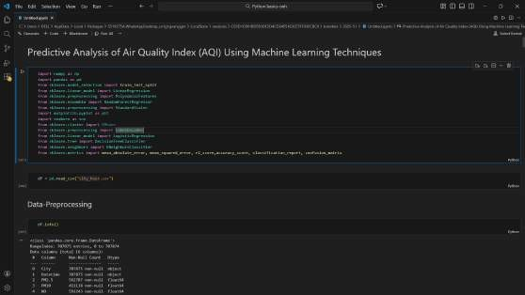
The dataset analysis confirms that pollution and temporal attributes significantly influence AQI variation patterns. Regression models effectively predict continuous AQI values, while classification models provide additional insight into pollution severity levels. The deployed system demonstrates the practical applicability of predictive analytics in air quality monitoring and analysis.

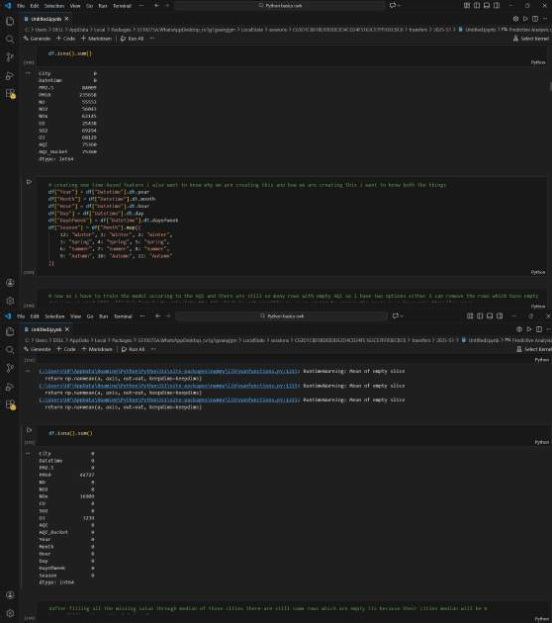

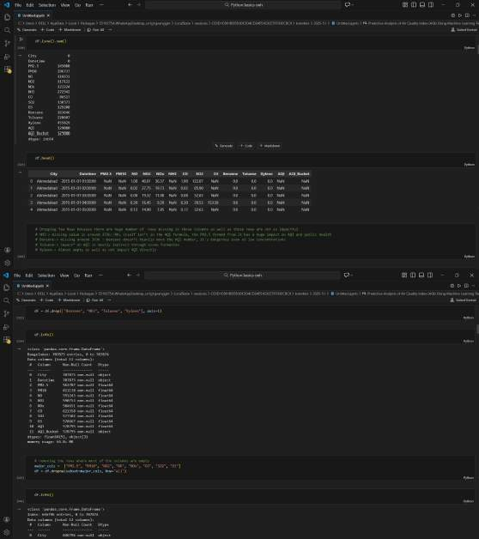

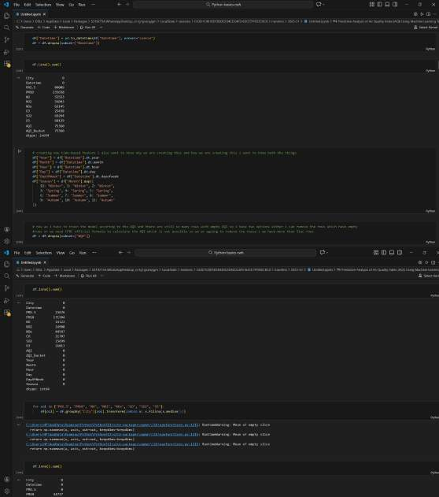

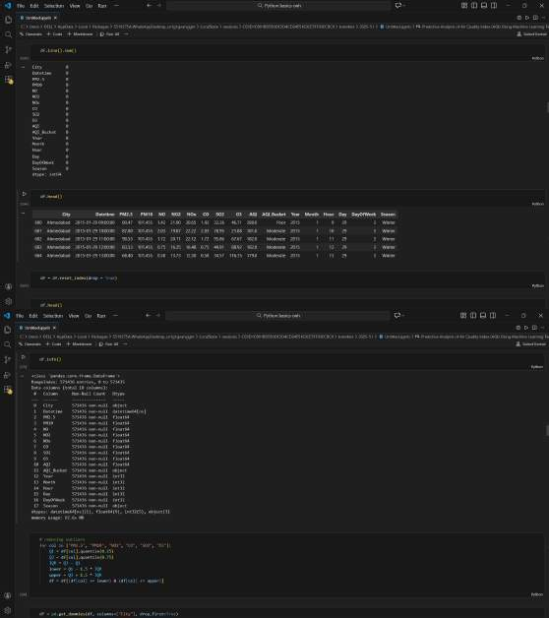

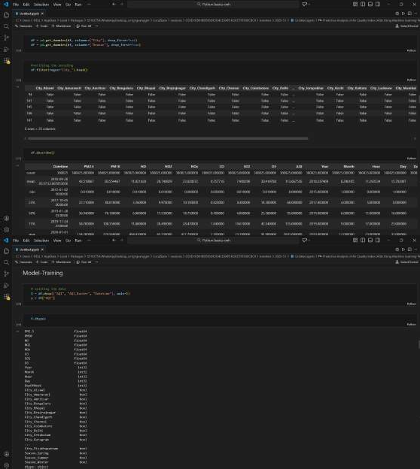

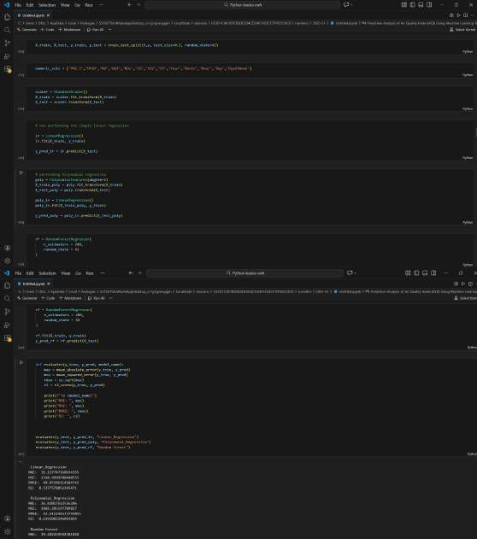

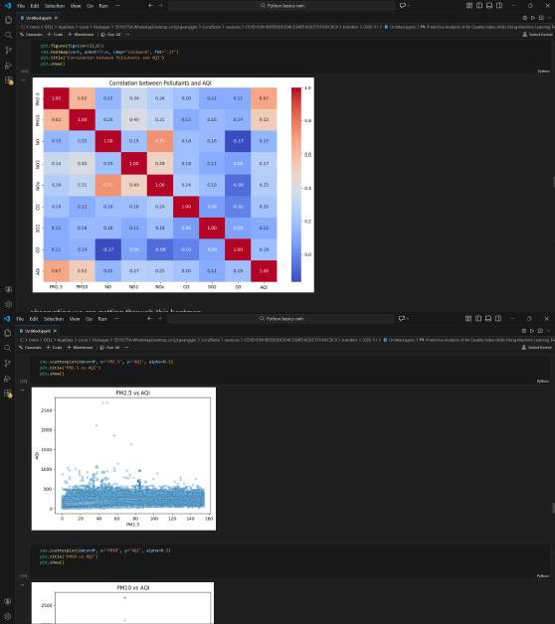

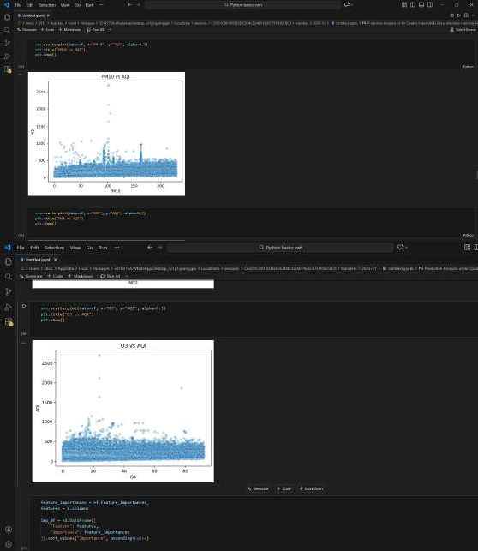

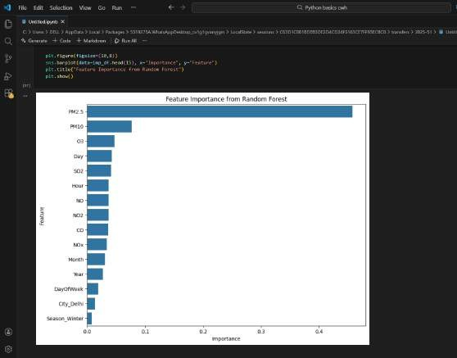

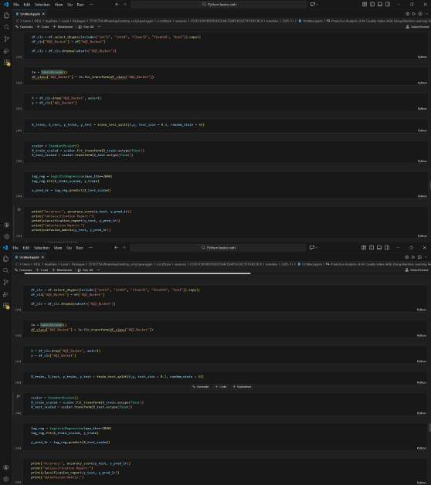

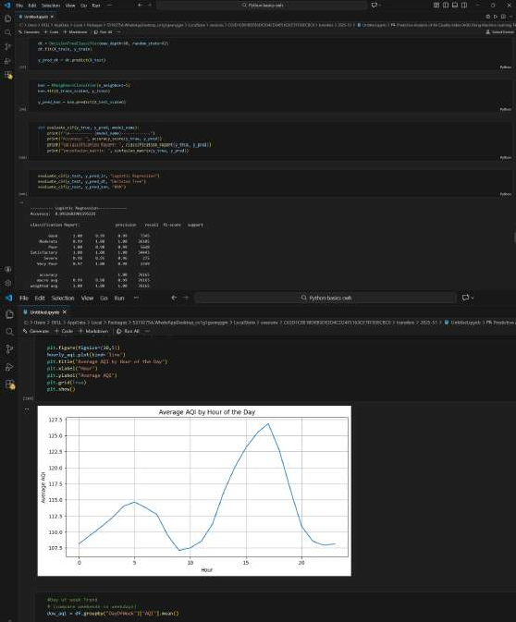

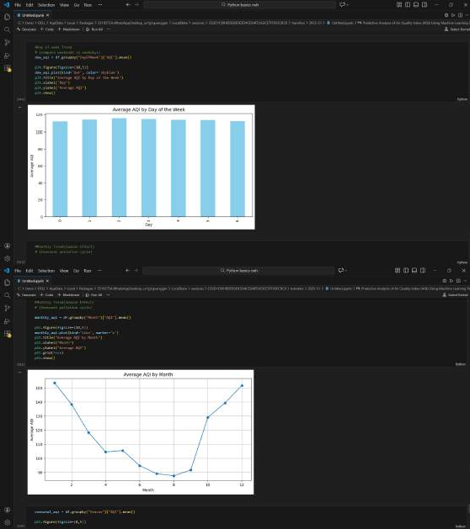

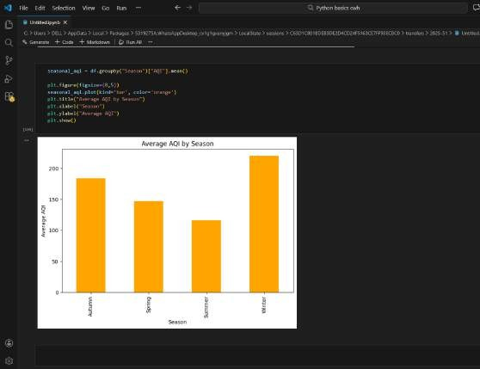

Model Development
Model development involves selecting appropriate machine learning algorithms, training them using pre- processed air quality data, and evaluating their performance to identify the most suitable model for prediction. In this project, three predictive models were trained to analyse AQI data, covering both regression and classification tasks.

Model Selection Criteria
The models were selected based on the following considerations:
    - Ability to handle numerical and encoded categorical data
    - Suitability for regression and classification problems
    - Interpretability and ease of deployment
    - Performance on structured tabular data
Accordingly, Linear Regression, Random Forest Regression, and Logistic Regression models were implemented.

Linear Regression Model

Purpose:
To predict exact AQI values by modelling linear relationships between pollutant concentrations, temporal features, and AQI.

Implementation:
The Linear Regression model was trained using pollutant and temporal features as independent variables and AQI as the dependent variable.

Evaluation Metrics:
    - Mean Squared Error (MSE)
    - R² Score

Observations:
The model provided a baseline performance and captured general AQI trends. However, its ability to model complex, non-linear pollution relationships was limited.

Random Forest Regression Model
Purpose:
To predict AQI values by learning non-linear relationships and ensemble decision patterns from the data.
Implementation:
A Random Forest Regressor was trained using the same feature set as the Linear Regression model. The model combined multiple decision trees to minimize prediction error.
Evaluation Metrics:
    - Mean Squared Error (MSE)
    - R² Score
Observations:
The Random Forest Regression model outperformed Linear Regression by achieving lower error values and better explanatory power. Due to its superior performance and robustness, this model was selected for deployment in the web application.

Logistic Regression Model Purpose:
To classify AQI into two categories: high and low, based on average AQI thresholds.

Implementation:
A binary classification label was created, and Logistic Regression was trained to predict class membership using pollutant and temporal features.

Evaluation Metrics:• Accuracy Score
    - Classification Report

Observations:
The Logistic Regression model demonstrated effective classification capability, indicating that the selected features were sufficient to distinguish between high and low pollution scenarios.

Model Training and Validation
All models were trained using an 80:20 train–test split to ensure unbiased performance evaluation. Random state initialization was applied to maintain reproducibility. Performance metrics were computed on the test dataset to assess each model’s generalization ability.

Model Persistence
The trained Random Forest Regression model and preprocessing encoders were serialized using Joblib. This enabled seamless integration with the Flask-based deployment layer, ensuring consistent AQI predictions during user interaction.

Summary

This project successfully trained three predictive models, satisfying the minimum requirement. Comparative analysis revealed that Random Forest Regression provided the best balance between accuracy and interpretability for predicting AQI, while Logistic Regression offered additional classification insights.

Conclusion
This project successfully demonstrated the application of predictive analytics to air quality monitoring using Python. By leveraging a large-scale air pollution dataset, the study analysed spatial and temporal patterns influencing AQI levels. Three predictive models were trained and evaluated, covering both regression and classification approaches. The Random Forest Regression model emerged as the most effective for predicting AQI values, and its deployment through a web application validated the practical usability of the system. The project highlights the potential of machine learning techniques in supporting data-driven environmental analysis and decision-making.

Future Scope
The current system can be extended in several ways to enhance accuracy and applicability:
- Incorporating additional features such as meteorological factors and traffic density
- Applying advanced models such as Gradient Boosting or deep learning approaches
- Performing hyperparameter tuning for improved predictive performance
- Implementing real-time data ingestion for continuous AQI prediction updates
- Enhancing visualization through interactive dashboards
- Expanding the classification task to multi-class air quality severity levels

Refrence

G. Eason [1] P. Rezazadeh, A. R. Zarei, and M. S. Rahimi, “Airbnb Price Prediction Using Machine Learning Techniques,” ResearchGate, 2019.

- Y. Ma, X. Zhang, and L. Wang, “Estimating Warehouse Rental Price Using Machine Learning Techniques,”
ResearchGate, 2018.

- H. Yu, Z. Wang, and J. Liu, “Real Estate Price Prediction with Regression and Classification Models,”
International Journal of Computer Applications, vol. 135, no. 2, pp. 12–18, 2016.

- T. Hastie, R. Tibshirani, and J. Friedman, The Elements of Statistical Learning: Data Mining, Inference, and Prediction, 2nd ed. New York, NY, USA: Springer, 2009.

- I. Goodfellow, Y. Bengio, and A. Courville, Deep Learning. Cambridge, MA, USA: MIT Press, 2016.

- C. M. Bishop, Pattern Recognition and Machine Learning. New York, NY, USA: Springer, 2006.

- F. Pedregosa et al., “Scikit-learn: Machine Learning in Python,” Journal of Machine Learning Research, vol. 12, pp. 2825–2830, 2011.

- T. Chen and C. Guestrin, “XGBoost: A Scalable Tree Boosting System,” in Proc. 22nd ACM SIGKDD Int. Conf. Knowledge Discovery and Data Mining (KDD), San Francisco, CA, USA, 2016, pp. 785–794.

- J. H. Friedman, “Greedy Function Approximation: A Gradient Boosting Machine,” Annals of Statistics, vol. 29, no. 5, pp. 1189–1232, 2001.

- C. Cortes and V. Vapnik, “Support-Vector Networks,” Machine Learning, vol. 20, no. 3, pp. 273–297, 1995.

- L. Breiman, “Random Forests,” Machine Learning, vol. 45, no. 1, pp. 5–32, 2001.

- D. P. Kingma and J. Ba, “Adam: A Method for Stochastic Optimization,” in Proc. Int. Conf. Learning Representations (ICLR), San Diego, CA, USA, 2015.

- Kaggle, “Airbnb Open Data,” [Online]. Available: https://www.kaggle.com. [Accessed: Jan. 2025].

- S. Raschka and V. Mirjalili, Python Machine Learning, 3rd ed. Birmingham, U.K.: Packt Publishing, 2019.

- A. Géron, Hands-On Machine Learning with Scikit-Learn, Keras, and TensorFlow, 2nd ed. Sebastopol, CA,
USA: O’Reilly Media, 2019.

