**INTRODUCTION**

* **SonicFund** is designed to transform learning with an innovative online platform offering:
  + High-quality educational resources.
  + Personalized learning experiences tailored to individual needs.
* The platform addresses the challenges of traditional education by providing:
  + Flexible and accessible learning solutions.
  + Interactive tools to meet the needs of diverse learners.
* **Key Features:**
  + Combines advanced technologies and modern teaching methods to make education accessible for everyone.
  + Promotes collaboration and knowledge sharing between learners, educators, and experts.
  + Fosters a vibrant community to spark curiosity and encourage intellectual growth.
* With features like curated content, personalized learning pathways, and interactive tools, SonicFund ensures:
  + An engaging and user-friendly experience.
  + Improved learning retention and academic success.
  + Positive social impact by transforming education for people from all backgrounds.

***TECHNOLOGY USED***

* **MongoDB** serves as the flexible and scalable database solution, accommodating the diverse needs of a dynamic educational platform.
* **Express.js** simplifies server-side development, streamlining the creation of robust backend systems to handle user interactions and data management.
* **React.js** powers the dynamic and interactive user interface, offering a rich learning experience with its component-based architecture.
* **Node.js** enables high-performance server-side execution, facilitating real-time interactions and fast data processing for an optimal user experience.

**OBJECTIVES**

* **Facilitate Access to Financial Services**
* Make financial transactions accessible to users worldwide.
* Offer secure and efficient financial tools regardless of:
  + Geographical location.
  + Socioeconomic status.
  + Financial background.
* **Personalize Transaction Experiences**
* Tailor financial services to each user’s unique needs and preferences.
* Use advanced algorithms to:
  + Provide customized financial recommendations.
  + Track transaction histories.
  + Offer targeted support for achieving financial goals.
* **Foster Collaboration and Engagement**
* Build a vibrant financial community with interactive features:
  + Forums for discussion.
  + Community-driven advice.
  + Tools for collaboration among users, experts, and businesses.
* Enable users to share insights, exchange ideas, and learn from others.
* **Promote Financial Literacy**
* Provide diverse resources for users of all ages and backgrounds.
* Empower individuals to:
  + Confidently manage their finances.
  + Adapt to changing financial needs.
  + Achieve long-term financial goals.
* **Drive Innovation in Financial Services**
* Continuously improve the platform by:
  + Adopting the latest technologies and industry best practices.
  + Incorporating user feedback.

**RELATED STUDIES**

* **Existing Digital Wallets**: Paytm, Google Pay, PhonePe, and similar payment platforms are widely used.
* **Issues in Current Solutions**:
  + **Security Gaps**: Weak authentication, inadequate encryption, and vulnerabilities to phishing.
  + **Limited User Control**: Users have little control over their data and payment flow.
  + **Research Insight**: Users prefer apps that offer strong security, privacy, multi-platform support, and fast payments. This insight forms the foundation for **SonicFund's development**.
  + **Privacy Flaws**: Platforms collect and track user data for marketing purposes.

***Numbers of studies related to each payment technologies***

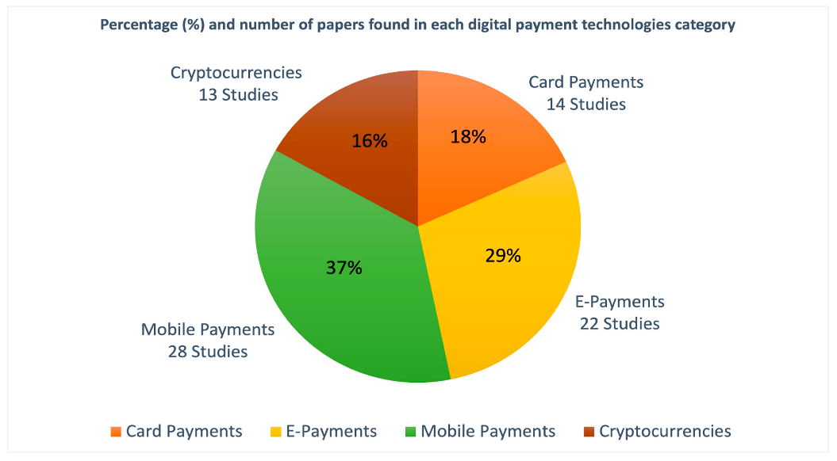

**FEASIBILITY STUDY**

**1**. **Technical Feasibility**

* **Resource Availability:**
  + Ensure access to essential resources like hardware, software, and skilled personnel for development and maintenance.
* **Technology Stack:**
  + Evaluate the MERN stack for:
    - Scalability and security.
    - Compatibility with financial systems.
* **Infrastructure Requirements:**
  + Identify the needed infrastructure, including:
    - Web servers and secure payment gateways.
    - Databases and sufficient network bandwidth.

**2. Economic Feasibility**

* **Cost Analysis:**
  + Assess all costs involved:
    - Development and hosting.
    - Maintenance and potential revenue sources (e.g., transaction fees, premium features, partnerships).

**3. Operational Feasibility**

* **Organizational Capabilities:**
  + Review organizational strengths in:
    - Project management and technical expertise.
    - Operational readiness to develop and maintain the platform.
* **Performance Optimization:**
  + Continuously improve platform performance by:
    - Streamlining payment processing.
    - Enhancing API endpoints and frontend responsiveness.
* **Training and Support:**
  + Implement effective onboarding programs for:
    - Staff, partners, and users.

**METHODOLOGY**

**Agile Methodology Steps for SonicFund**

**1. Plan**

* Define project objectives, scope, and requirements based on:
  + Stakeholder feedback.
  + Project guidelines.
* Break down the project into tasks such as:
  + Market research.
  + Designing transaction workflows.
  + Coding assignments.
* Set timelines and milestones aligned with the financial roadmap.

**2. Design**

* Visualize the platform structure with:
  + Wireframes, flowcharts, or diagrams.
* Create prototypes using tools like Sketch or Figma, incorporating stakeholder feedback.
* Ensure designs prioritize:
  + User needs.
  + Security and usability standards.

**3. Develop**

* Begin coding tasks based on the design specifications.
* Use version control systems (e.g., Git) for collaboration and managing code changes.
* Break down development into smaller modules such as:
  + Payment gateways.
  + User authentication.
  + Transaction dashboards.
* Track progress for each module.

**4. Test**

* Conduct:
  + **Unit testing** for individual components.
  + **Integration testing** to ensure seamless module interactions (e.g., payments, accounts, notifications).
* Perform code reviews and demo sessions to gather feedback.

**5. Deploy**

* Prepare for platform launch by:
  + Ensuring code is documented, secure, and formatted.
  + Packaging project files and dependencies for deployment.
* Double-check deployment requirements, such as:
  + Security certifications.

**6. Review**

* Reflect on project outcomes by:
  + Identifying challenges faced and lessons learned.
  + Collecting feedback via platform demos and user testing.
* Document insights for future iterations and continuous improvement.

***FLOW DIAGRAM***

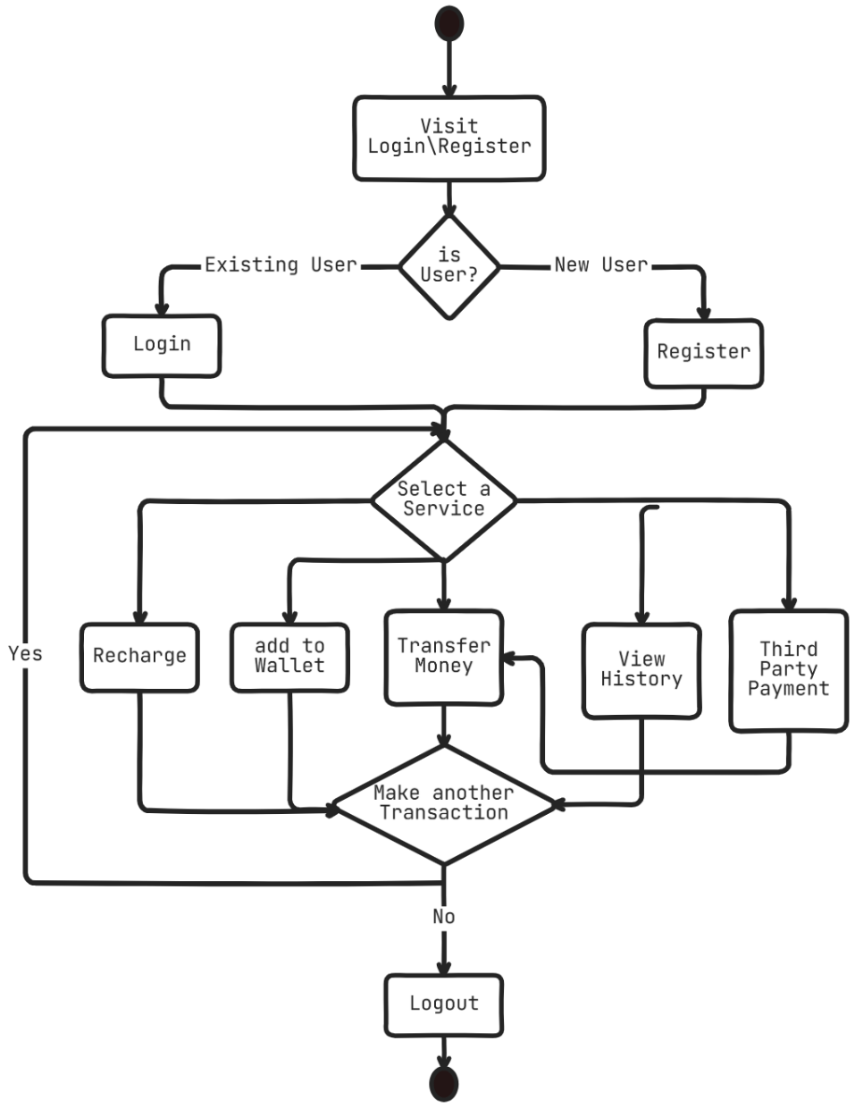

***E- R DIAGRAM***

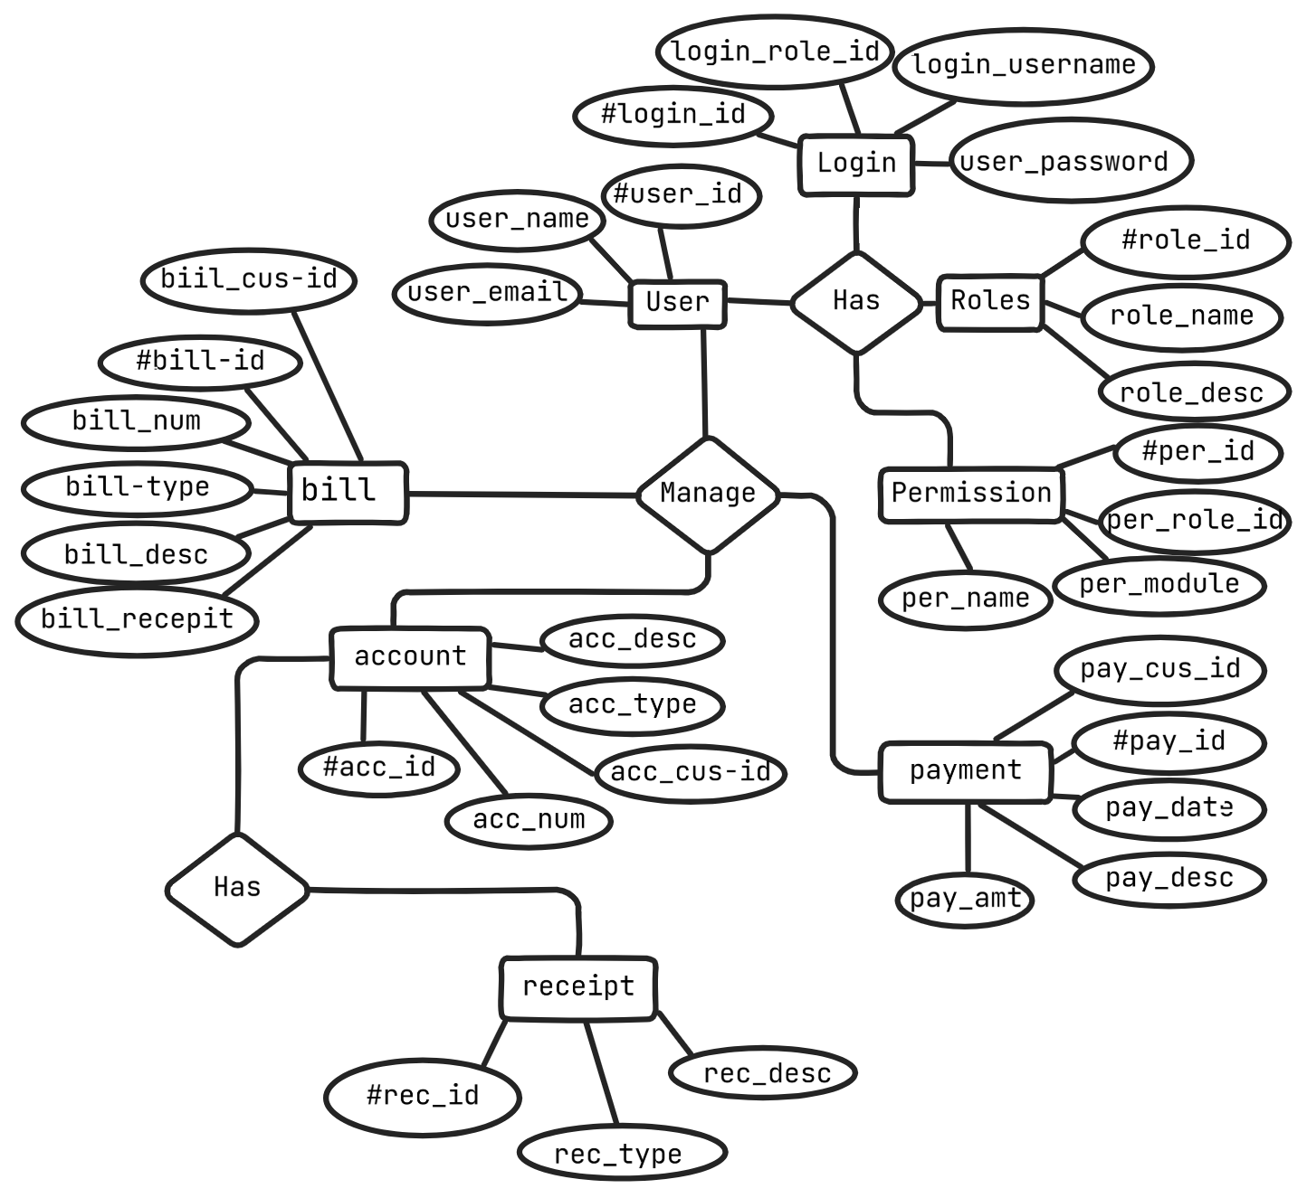

**SOFTWARE AND HARDWARE REQUIREMENTS**

**a) Software Requirements:**

**1. Operating System:** Windows 10/11 or Linux distribution (e.g., Ubuntu)

**2. Development tools:**

* Text editor or IDEs like VS-CODE, Notepad
* Web Browser: Google chrome, Brave
* Command line interface: Terminal (Linux), Command prompt

**3. Version Control system:** Git, Git Client (e.g. GitHub Desktop)

**4. Database Management System:** MongoDB, MongoDB Compass

**5. Development Framework and libraries:**

MERN Stack:

* MongoDB: NoSQL Database
* Express.js: Web application framework
* React.js: JavaScript library for building user interfaces
* Node.js: JavaScript runtime environment

Additional libraries and frameworks as needed:

* Tailwind-CSS, Material-UI, or similar for frontend UI components
* Axios or similar for making HTTP requests
* Redux or similar for state management in React.js applications

**b) Hardware requirements:**

* Desktop or Laptop computer with adequate processing power and memory.
* **Minimum requirements:**
* Intel Core i5 processor or equivalent
* 8GB RAM
* 250GB SSD or 1TB HDD storage

**Recommended:**

* External monitor(s) for multi-tasking and improved productivity (optional)
* Mouse and keyboard for ergonomic use (optional)

**Expected Outcome(s)**

* **Enhanced Security**: Multi-factor authentication and encryption for safer transactions.
* **Better User Experience**: Intuitive, easy-to-use interface.
* **Faster Payments**: Quick and seamless transaction processing.
* **Privacy**: Minimal data collection, ensuring user privacy.
* **Multiple Payment Methods**: Supports UPI, cards, and net banking.
* **Scalability**: Can handle growing transaction volumes.

**REFERENCES**

* **Reference Books**
* "MERN Quick Start Guide: Build web applications with MongoDB, Express.js, React, and Node" by Eddy Wilson Iriarte Koroliova
* "Node.js Web Development: Server-side web development made easy with Node 14 using practical examples" by David Herron
* **Reference Websites**
* What is Agile methodology? (A beginner’s guide) by Sarah Loyan

<https://asana.com/resources/agile-methodology>

* MongoDB Documentation

<https://docs.mongodb.com/>

* Express.js Documentation

<https://expressjs.com/en/resources/glossary.html>

* React.js Documentation

<https://legacy.reactjs.org/docs/>

* Node.js Documentation

<https://nodejs.org/docs/>

* Inspired by

https://100xdevs.com/