PROJECT REPORT

HR MANAGEMENT SYSTEM
USING SPRING BOOT

A Web-Based Employee Management REST Application
Student Name: [STUDENT NAME]
Roll Number: [ROLL NUMBER]
Course/Program: [COURSE NAME]
College/University: [COLLEGE NAME]
Guide/Supervisor: [GUIDE NAME]
Academic Year: [ACADEMIC YEAR]

Certificate
This is to certify that the project entitled "HR Management System Using Spring Boot" has been developed and documented as part of the academic requirements by [STUDENT NAME], Roll Number [ROLL NUMBER], under the guidance of [GUIDE NAME]. The work is based on the Spring Boot project files supplied for this report.
The project implements an employee-management REST backend using Spring Boot, Spring Data JPA and MySQL. This certificate is provided as a report template and should be completed and signed by the appropriate academic authorities.

Guide/Supervisor: ____________________ Head of Department: ____________________

Date: ____________________ Seal/Signature: ____________________

Declaration
I, [STUDENT NAME], declare that the project report entitled "HR Management System Using Spring Boot" is prepared as part of my academic project work. The technical descriptions in this report are derived from the provided project source files and configuration. Any information not available in the supplied project is explicitly identified as a placeholder or as not specified.

Student Signature: ____________________
Date: ____________________

Acknowledgement
I would like to express my sincere gratitude to my project guide, faculty members, department and institution for their guidance and support during the development of this project. I also acknowledge the assistance of everyone who contributed to the learning and testing process.
The project provided practical experience with Spring Boot application structure, REST API development, Spring Data JPA, MySQL database connectivity and layered backend design.

Abstract
The HR Management System is a backend web application developed using Spring Boot for managing employee records through RESTful APIs. The supplied implementation focuses on a single Employee domain entity and provides operations to retrieve all employees, retrieve an employee by identifier, create an employee and delete an employee. The application uses Spring Web for HTTP/REST handling, Spring Data JPA for persistence, Hibernate through JPA for object-relational mapping, and MySQL as the relational database.
The system follows a simple layered structure. The EmployeeController exposes the REST endpoints under the /employees path. EmployeeService contains the application-level operations and delegates persistence to EmployeeRepository, which extends JpaRepository<Employee, Long>. The Employee model is a JPA entity with an auto-generated Long primary key and fields for name, email, department, designation and salary. The database connection is configured in application.properties for a MySQL database named hr_management_db, with Hibernate configured to update the schema automatically.
The project demonstrates the fundamental workflow of a Spring Boot CRUD-style backend: an HTTP request is received by a controller, passed to a service, persisted or retrieved through a repository, and returned as an HTTP response. The supplied project also includes a Spring Boot context-loading test. No separate frontend, authentication system, JWT implementation, payroll module, attendance module, leave module, or multiple-entity relational model is present in the provided source.
Keywords: Spring Boot, REST API, Spring Data JPA, Hibernate, MySQL, Employee Management, Java 17.

Table of Contents
Click any entry to jump to that section.
Certificate 1
Declaration 2
Acknowledgement 3
Abstract 4
1. Introduction 8
1.1 Background 8
1.2 Problem Statement 8
1.3 Proposed Solution 8
1.4 Objectives 8
1.5 Scope 8
1.6 Significance of the Project 9
2. Existing System 9
2.1 Drawbacks of Manual / Spreadsheet Processes 9
3. Proposed System 9
3.1 Layers and Responsibilities 9
3.2 Design Principles Applied 10
4. Feasibility Study 10
5. Requirement Analysis 10
5.1 Functional Requirements 10
5.2 Non-Functional Requirements 11
6. Main Features 11
6.1 Employee Listing 11
6.2 Get Employee by ID 11
6.3 Create Employee 11
6.4 Delete Employee 11
6.5 Cross-Origin Configuration 11
7. Technologies Used 11
8. System Requirements 12
8.1 Hardware Requirements 12
8.2 Software Requirements 12
9. System Architecture 13
9.1 Controller Layer 13
9.2 Service Layer 13
9.3 Repository Layer 13
9.4 Persistence Layer 13
10. Project Package Structure 14
11. Database Design 14
11.1 Database Configuration 14
11.2 Employee Entity 15
11.3 Illustrative Entity Structure 15
12. Entity Relationship Diagram 16
13. API Documentation 16
13.1 Endpoint Details 16
14. Request and Response Examples 17
14.1 Create Employee — POST /employees 17
14.2 Get All Employees — GET /employees 17
14.3 Delete Employee — DELETE /employees/{id} 17
15. CRUD Operations 17
16. Data Flow 18
16.1 Data Flow Diagram 18
16.2 Request/Response Flow Explained 19
16.3 Data Flow per Operation 19
17. Key Spring Boot Annotations Used 19
18. Validation and Exception Handling 20
19. Security 20
20. Testing 20
21. Running and Testing the Application 21
21.1 Setup Steps 21
21.2 API Testing Using Postman 21
22. Screenshots 21
23. Advantages 22
24. Limitations 22
25. Future Enhancements 22
26. Conclusion 23
27. References 23
28. Appendix 24
28.1 Actual API Mapping 24
28.2 Employee Model Summary 24
28.3 Project Configuration Summary 24
28.4 Source Scope Note 24

List of Figures
Figure 1: Layered architecture represented by the supplied source code 13
Figure 2: Entity Relationship Diagram of the supplied HR Management System 16
Figure 3: HR Management System (Spring Boot) – Data Flow 18

1. Introduction

1.1 Background
Human Resource Management involves maintaining employee information and supporting organizational processes related to people. Even a small organization benefits from structured digital records because employee details need to be stored, retrieved and maintained consistently. A backend application can provide a centralized interface through which authorized clients or development/testing tools can work with employee records.
Modern enterprise software is commonly built as layered web services that communicate over HTTP using JSON. Spring Boot has become one of the most widely used Java frameworks for such services because it removes most of the boilerplate configuration required by the traditional Spring Framework and offers production-ready defaults. This project applies these ideas to a focused HR use case: storing and managing employee records.

1.2 Problem Statement
Manual or spreadsheet-based employee management can make record retrieval and maintenance repetitive and difficult to standardize. Data may be duplicated across files, difficult to search, and prone to inconsistent formats. A backend service can reduce this operational friction by exposing defined endpoints and storing employee information in a relational database.

1.3 Proposed Solution
The supplied project proposes a Spring Boot REST backend centered on an Employee entity. The application exposes /employees endpoints for reading, creating and deleting employee records. Spring Data JPA handles repository operations and MySQL provides persistent storage.

1.4 Objectives
- Maintain structured employee records.
- Provide REST endpoints for employee retrieval, creation and deletion.
- Persist employee information in MySQL using JPA.
- Separate HTTP handling, service logic and persistence using controller, service and repository components.
- Provide a simple backend that can be tested using an API client such as Postman.

1.5 Scope
The implemented scope is employee record management. The supplied code does not define separate Department, Attendance, Leave, Payroll, User or Role entities. It also does not include an application frontend in the supplied project files.

1.6 Significance of the Project
Although compact, the project demonstrates the complete path of a typical enterprise backend request: HTTP handling, application logic, object-relational mapping and relational storage. It therefore serves as a practical learning foundation and as a starting point that can be extended into a fuller HR platform.

2. Existing System
A conventional manual HR process may rely on paper records, spreadsheets or disconnected files. Such approaches can require repeated data entry and manual searching. The project addresses the record-management portion of this problem by providing a persistent database-backed API.

2.1 Drawbacks of Manual / Spreadsheet Processes
Area | Limitation of the existing approach | How the project responds
Data storage | Records scattered across files and folders. | Central MySQL database (hr_management_db).
Retrieval | Manual searching and filtering. | GET /employees and GET /employees/{id} endpoints.
Consistency | Fields and formats vary between users. | A single Employee entity defines the fields.
Integration | Hard to connect with other software. | Standard REST/JSON interface usable by any client.
Maintenance | Repeated edits and duplicate copies. | Create and delete operations act on one shared data source.

3. Proposed System
The proposed system is a Spring Boot backend application. The controller receives HTTP requests, the service performs the corresponding application operation, and the repository communicates with the database. The Employee entity provides the persistence model.

3.1 Layers and Responsibilities
Layer | Actual component | Responsibility
Controller | EmployeeController | Exposes /employees REST endpoints and maps requests to service operations.
Service | EmployeeService | Provides get-all, get-by-ID, save and delete operations.
Repository | EmployeeRepository | Extends JpaRepository<Employee, Long> for persistence operations.
Model/Entity | Employee | Defines the employee data persisted by JPA.
Configuration | application.properties | Defines MySQL datasource and JPA/Hibernate settings.

3.2 Design Principles Applied
- Separation of concerns: each layer has one responsibility, which keeps the code easy to read and to change.
- Dependency injection: Spring supplies the service and repository objects, avoiding manual object creation and tight coupling.
- Convention over configuration: Spring Boot auto-configuration and Spring Data JPA derive most behaviour from dependencies and interfaces.
- Statelessness: each REST call is independent, which suits API clients and simplifies future scaling.

4. Feasibility Study
A feasibility study checks whether the proposed system can be built and used in practice. The points below are based on the technologies visible in the supplied project.
Type | Assessment
Technical | The stack (Java 17, Spring Boot, Spring Data JPA, MySQL, Maven) is mature, widely documented and fully supported by common IDEs and build tools.
Economic | The frameworks and database used are available under open-source or community licensing, so the software cost of the prototype is low. Exact cost figures are not specified in the project.
Operational | The REST interface can be used from Postman today and from a web or mobile frontend in the future without changing the backend design.
Schedule | The single-entity design keeps the implementation small and quick to test; further modules can be added incrementally.

5. Requirement Analysis

5.1 Functional Requirements
ID | Requirement | Supported in supplied code
FR-01 | Store employee name, email, department, designation and salary. | Yes
FR-02 | Retrieve the list of all employees. | Yes
FR-03 | Retrieve a single employee by ID. | Yes
FR-04 | Create a new employee record. | Yes
FR-05 | Delete an employee record by ID. | Yes
FR-06 | Update an existing employee record. | No (not implemented)

5.2 Non-Functional Requirements
Quality | Description | Current status
Maintainability | Layered structure with small, focused classes. | Met by design
Portability | Runs on any platform supporting Java 17 and MySQL. | Met by technology choice
Interoperability | JSON over HTTP, consumable by any client. | Met
Security | Authentication, authorization and encryption. | Not implemented
Reliability | Input validation and structured error handling. | Not implemented
Performance | Not measured; no performance test results were supplied. | Not specified

6. Main Features

6.1 Employee Listing
GET /employees retrieves all employee records by calling EmployeeService.getAllEmployees(), which delegates to EmployeeRepository.findAll().

6.2 Get Employee by ID
GET /employees/{id} retrieves an employee by Long identifier. EmployeeService uses findById(id) and returns the entity when present; if the record is not found, the supplied implementation returns null.

6.3 Create Employee
POST /employees accepts an Employee object in the request body and saves it through EmployeeService.saveEmployee(), which delegates to EmployeeRepository.save().

6.4 Delete Employee
DELETE /employees/{id} deletes the record using EmployeeRepository.deleteById(id). The controller returns the text response "Employee deleted successfully".

6.5 Cross-Origin Configuration
EmployeeController is annotated with @CrossOrigin, so cross-origin requests are enabled at the controller level. No more specific CORS policy is defined in the supplied source.

7. Technologies Used
Technology | Version / evidence | Purpose
Java | 17 (pom.xml) | Programming language and runtime target.
Spring Boot | 4.1.1 (parent in pom.xml) | Application framework and auto-configuration.
Spring Web | spring-boot-starter-web | REST controller and HTTP endpoint support.
Spring Data JPA | spring-boot-starter-data-jpa | Repository abstraction and persistence.
Hibernate | Configured through JPA; MySQLDialect specified | ORM provider used by the JPA stack.
MySQL Connector/J | Runtime dependency | JDBC connectivity to MySQL.
MySQL | Database configured as hr_management_db | Persistent relational data store.
Maven | Maven wrapper and pom.xml | Build and dependency management.
Spring Boot DevTools | Runtime/optional dependency | Development-time support.
JUnit/Spring Boot Test | Test dependency | Application context-loading test.

8. System Requirements

8.1 Hardware Requirements
The supplied project does not specify minimum CPU, RAM, storage or network requirements. A development machine capable of running Java 17, Maven and MySQL is required; exact minimum hardware specifications are not specified in the project.

8.2 Software Requirements
Requirement | Project evidence
Java | 17
Spring Boot | 4.1.1
Database | MySQL
Build tool | Maven / Maven Wrapper
IDE | Not specified in project
API testing tool | Not specified in project; Postman can be used for manual API testing.
Operating system | Not specified in project

9. System Architecture
The application follows a classic three-tier layered architecture: a presentation (web) layer, an application (service) layer and a data-access layer, backed by a relational database. Requests travel downward through the layers and responses travel back up.
Client / API Testing Tool
Postman or any HTTP client
▼
EmployeeController
@RestController | REST API: /employees
▼
EmployeeService
@Service | application operations
▼
EmployeeRepository
JpaRepository<Employee, Long>
▼
MySQL Database
hr_management_db
Figure 1: Layered architecture represented by the supplied source code

9.1 Controller Layer
EmployeeController is annotated with @RestController and @RequestMapping("/employees"). It exposes GET, POST and DELETE operations. It does not contain a PUT or PATCH mapping.

9.2 Service Layer
EmployeeService is annotated with @Service. It contains methods for retrieving all employees, retrieving one employee, saving an employee and deleting an employee.

9.3 Repository Layer
EmployeeRepository extends JpaRepository<Employee, Long>. This provides standard persistence methods such as findAll(), findById(), save() and deleteById().

9.4 Persistence Layer
The Employee class is annotated with @Entity. JPA/Hibernate maps the entity to a database table. Because no @Table annotation is present, an explicit table name is not defined in the source.

10. Project Package Structure
com.hcl.HRmanagementproject
├── HRmanagementprojectApplication.java
├── controller
│ └── EmployeeController.java
├── model
│ └── Employee.java
├── repository
│ └── EmployeeRepository.java
└── service
└── EmployeeService.java

The supplied project also contains a test package with HRmanagementprojectApplicationTests.java.
Package | Class | Purpose
com.hcl.HRmanagementproject | HRmanagementprojectApplication | Spring Boot application entry point.
controller | EmployeeController | REST API endpoints for employees.
model | Employee | JPA entity representing employee records.
repository | EmployeeRepository | JPA repository for Employee persistence.
service | EmployeeService | Business/application operations for Employee.

11. Database Design
The project defines one JPA entity: Employee. No other entity classes or relationship annotations are present. Therefore, the supplied implementation represents a single-entity database model with no foreign keys and no inter-entity cardinality.

11.1 Database Configuration
Property | Configured value / description
JDBC URL | jdbc:mysql://localhost:3306/hr_management_db
Username | root
Password | Configured in the project but intentionally not reproduced in this report for security.
Driver | com.mysql.cj.jdbc.Driver
DDL mode | update
Show SQL | true
Hibernate dialect | org.hibernate.dialect.MySQLDialect

The application.properties file contains a database password. It is deliberately redacted from this report because credentials should not be distributed in project documentation.

11.2 Employee Entity
Field | Java type | Database role/type | Key | Description
id | Long | BIGINT-compatible numeric identifier | PK | Auto-generated using GenerationType.IDENTITY.
name | String | VARCHAR-like text | — | Employee name.
email | String | VARCHAR-like text | — | Employee email address.
department | String | VARCHAR-like text | — | Department value stored directly as text.
designation | String | VARCHAR-like text | — | Employee designation/job title.
salary | Double | DOUBLE-compatible numeric value | — | Employee salary.

No @Column annotations, nullable constraints, unique constraints, validation annotations, foreign keys or relationship annotations are present on Employee.

11.3 Illustrative Entity Structure
The following sketch shows the structure described above. It is a simplified illustration of the entity’s fields and annotations, not a verbatim copy of the source file.
@Entity
public class Employee {

@Id
@GeneratedValue(strategy = GenerationType.IDENTITY)
private Long id;

private String name;
private String email;
private String department;
private String designation;
private Double salary;

// constructors, getters and setters
}

12. Entity Relationship Diagram
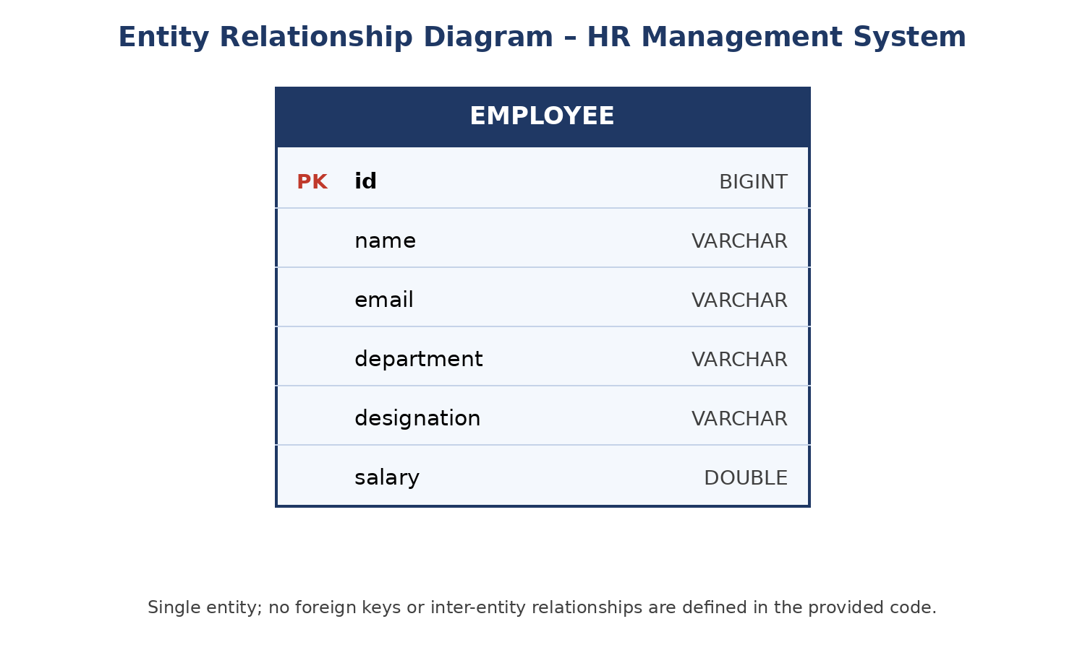
Figure 2: Entity Relationship Diagram of the supplied HR Management System
The ER diagram contains the only entity defined in the supplied project, Employee. The id field is the primary key and is generated by the database identity strategy. The project does not define foreign keys or relationships to other entities, so no one-to-one, one-to-many, many-to-one or many-to-many relationship is shown.

13. API Documentation
Method | Endpoint | Description | Request body | Response
GET | /employees | Retrieve all employees | None | List of Employee objects
GET | /employees/{id} | Retrieve employee by ID | None | Employee object or null if not found in current implementation
POST | /employees | Create/save an employee | Employee JSON | Saved Employee object
DELETE | /employees/{id} | Delete employee by ID | None | String confirmation

13.1 Endpoint Details
The controller uses @RequestMapping("/employees") as the base path. @GetMapping, @PostMapping and @DeleteMapping are used. No @PutMapping or @PatchMapping is implemented.

14. Request and Response Examples

14.1 Create Employee — POST /employees
{
"name": "John Doe",
"email": "john@example.com",
"department": "IT",
"designation": "Software Engineer",
"salary": 60000.0
}

The example uses the exact fields defined by Employee; the sample values are illustrative and are not claimed to be stored in the supplied database.

14.2 Get All Employees — GET /employees
[
{
"id": 1,
"name": "John Doe",
"email": "john@example.com",
"department": "IT",
"designation": "Software Engineer",
"salary": 60000.0
}
]

14.3 Delete Employee — DELETE /employees/{id}
Employee deleted successfully

15. CRUD Operations
Operation | HTTP endpoint | Implementation
Create | POST /employees | employeeService.saveEmployee() → employeeRepository.save()
Read all | GET /employees | employeeService.getAllEmployees() → employeeRepository.findAll()
Read one | GET /employees/{id} | employeeService.getEmployeeById() → employeeRepository.findById()
Delete | DELETE /employees/{id} | employeeService.deleteEmployee() → employeeRepository.deleteById()
Update | Not implemented | No PUT/PATCH endpoint or update-specific service method is present.

16. Data Flow
The data flow of the HR Management System describes how a request from a client travels through the Spring Boot layers to the MySQL database and how the result returns to the client. Figure 3 shows the complete flow, from the client sending an HTTP request to the controller returning a JSON response.

16.1 Data Flow Diagram
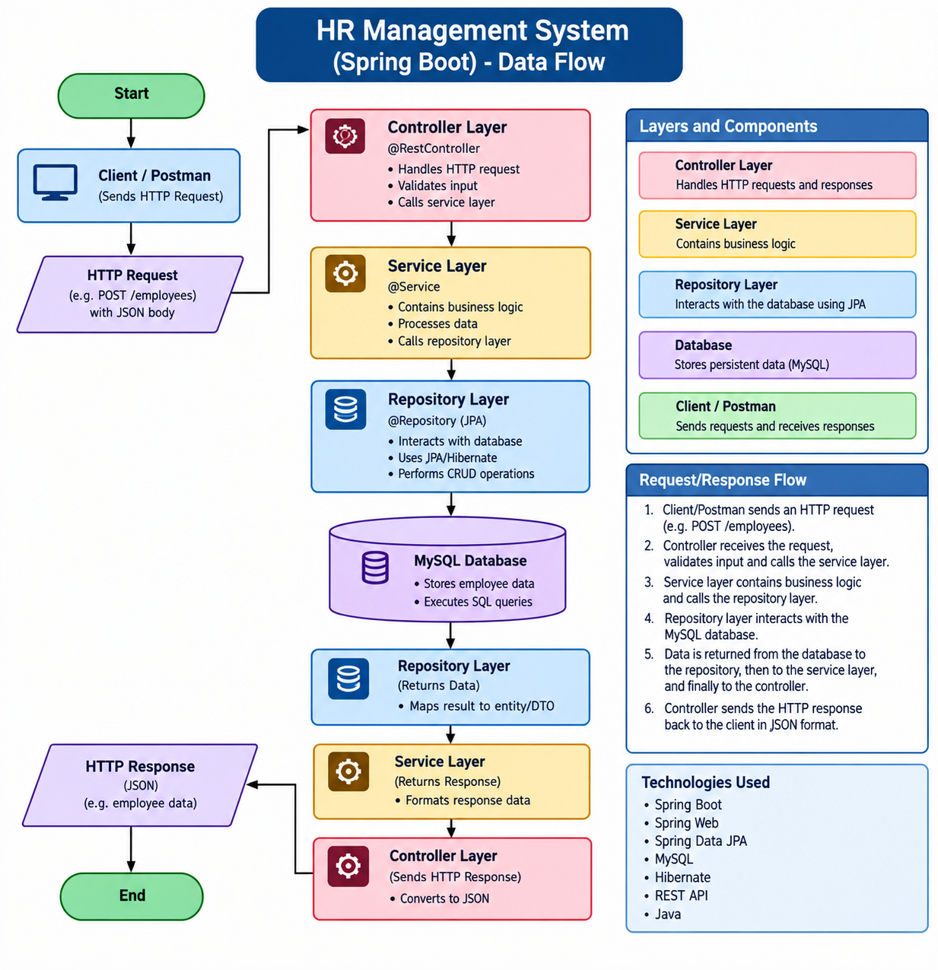
Figure 3: HR Management System (Spring Boot) – Data Flow

16.2 Request/Response Flow Explained
- Client sends a request. The client (Postman or any HTTP client) sends an HTTP request, for example POST /employees with a JSON body.
- Controller receives it. EmployeeController, annotated with @RestController, receives the request, converts the JSON body into an Employee object and calls the service layer.
- Service processes it. EmployeeService carries out the application operation and calls the repository layer.
- Repository accesses the database. EmployeeRepository uses Spring Data JPA and Hibernate to execute the required CRUD operation against MySQL.
- Data returns upward. The result is mapped to an Employee entity and passed back through the repository, service and controller.
- Controller sends the response. The controller returns the result to the client as an HTTP response, converted to JSON.

Note: The diagram shows the general layered flow. In the supplied source, the controller does not perform explicit input validation, and the repository returns Employee entities directly rather than separate DTO classes. These are noted as possible enhancements in Section 25.

16.3 Data Flow per Operation
Operation | Request | Data passed down | Data returned up
Create | POST /employees + JSON | Employee object → save() | Saved Employee (with generated id) as JSON
List | GET /employees | findAll() | List of Employee objects as JSON
Get by ID | GET /employees/{id} | findById(id) | Employee as JSON, or null if not found
Delete | DELETE /employees/{id} | deleteById(id) | Text: "Employee deleted successfully"

17. Key Spring Boot Annotations Used
The table below summarises the main annotations referred to in the project and their role.
Annotation | Where used | Purpose
@SpringBootApplication | Application class | Marks the entry point and enables auto-configuration and component scanning.
@RestController | EmployeeController | Combines controller behaviour with automatic JSON response conversion.
@RequestMapping("/employees") | EmployeeController | Defines the base URL path for all employee endpoints.
@GetMapping / @PostMapping / @DeleteMapping | EmployeeController | Map HTTP GET, POST and DELETE requests to controller methods.
@CrossOrigin | EmployeeController | Allows cross-origin requests to the controller endpoints.
@Service | EmployeeService | Registers the class as a Spring service bean.
@Entity | Employee | Marks the class as a JPA entity mapped to a table.
@Id / @GeneratedValue | Employee.id | Declare the primary key and its auto-generation strategy.

18. Validation and Exception Handling
No Jakarta Bean Validation annotations such as @NotNull, @Email or @Size are present in Employee. The project also does not define custom exception classes or a global exception handler in the supplied source.
For GET by ID, EmployeeService uses Optional.orElse(null), meaning a missing employee is represented by a null return value in the current implementation. DELETE delegates directly to deleteById(id); explicit application-level error handling for a missing ID is not implemented.

19. Security
No Spring Security dependency, authentication mechanism, authorization rules, JWT implementation, password encryption or role-based access control is present in the supplied project. The application should therefore be considered an unsecured development backend unless security is added separately.
The datasource password exists in application.properties and should be moved to a protected environment variable or secret configuration before deployment.

20. Testing
The supplied project contains HRmanagementprojectApplicationTests.java with a single Spring Boot test method named contextLoads(). This test checks that the application context can load.
Test ID | Operation | Expected result | Evidence in source
TC-01 | Application context | Spring context loads successfully when dependencies/configuration are available. | contextLoads() test exists.
TC-02 | GET /employees | Returns employee list. | Implementation present; runtime result not supplied.
TC-03 | GET /employees/{id} | Returns employee or null if absent. | Implementation present; runtime result not supplied.
TC-04 | POST /employees | Persists and returns Employee. | Implementation present; runtime result not supplied.
TC-05 | DELETE /employees/{id} | Deletes record and returns confirmation text. | Implementation present; runtime result not supplied.

No executed test output, Postman collection or screenshots were included in the supplied ZIP, so runtime pass/fail results are not claimed.

21. Running and Testing the Application

21.1 Setup Steps
- Install Java 17, MySQL and (optionally) Maven; the Maven wrapper included in the project can be used instead of a local Maven installation.
- Create an empty MySQL database named hr_management_db, since the configured JDBC URL points to it.
- Set the MySQL username and password in application.properties (or, preferably, in environment variables).
- Start the application from the project root, for example with the Maven wrapper command: ./mvnw spring-boot:run (mvnw.cmd on Windows).
- On startup, Hibernate creates or updates the employee table automatically because the DDL mode is set to update.

21.2 API Testing Using Postman
The project can be tested with an API client such as Postman. The exact server port is not specified in application.properties, so the default Spring Boot port should not be assumed as a project-specific configuration.
Test | Method | URL pattern | Body
Create | POST | http://localhost:<port>/employees | Employee JSON
List | GET | http://localhost:<port>/employees | None
Get by ID | GET | http://localhost:<port>/employees/{id} | None
Delete | DELETE | http://localhost:<port>/employees/{id} | None

Replace <port> with the port on which the Spring Boot application is actually running.

22. Screenshots
No application, Postman or database screenshots were included in the supplied ZIP. Therefore, no fabricated screenshots are inserted into this report. Recommended screenshots for a final academic submission are:
- [Insert screenshot] Project package structure in the IDE.
- [Insert screenshot] Successful Spring Boot application startup.
- [Insert screenshot] POST /employees request and JSON response.
- [Insert screenshot] GET /employees response.
- [Insert screenshot] GET /employees/{id} response.
- [Insert screenshot] DELETE /employees/{id} response.
- [Insert screenshot] Employee table in MySQL.

23. Advantages
- Simple layered backend structure.
- Persistent employee storage using MySQL and JPA.
- RESTful endpoints for basic employee record operations.
- Standard Spring Data JPA repository abstraction reduces persistence boilerplate.
- Clear separation between controller, service, repository and entity components.
- Easy to extend with additional employee-related functionality.

24. Limitations
- Only one entity is currently modeled: Employee.
- Update operation is not implemented.
- No authentication or authorization is implemented.
- No input validation annotations are present.
- No custom exception handling is present.
- No separate frontend is included in the supplied project.
- No attendance, leave, payroll or performance modules are present.
- Database credentials are stored directly in application.properties, which is unsuitable for secure production deployment.

25. Future Enhancements
- Add PUT/PATCH support for employee updates.
- Introduce validation using Jakarta Bean Validation.
- Add structured exception handling and meaningful HTTP status codes.
- Add authentication and role-based authorization using Spring Security/JWT.
- Introduce DTOs to separate the API model from the database entity.
- Normalize related concepts such as Department into separate entities if required by project scope.
- Add attendance, leave, payroll and performance modules.
- Add a web frontend/dashboard.
- Move database credentials to environment variables or a secret-management solution.
- Add unit and integration tests for controllers, services and repositories.
- Add API documentation using OpenAPI/Swagger.

26. Conclusion
The supplied HR Management System is a Spring Boot-based REST backend focused on employee record management. Its implementation uses Java 17, Spring Boot 4.1.1, Spring Web, Spring Data JPA, Hibernate/JPA and MySQL. The code follows a straightforward controller-service-repository structure and defines a single Employee JPA entity.
The application currently supports employee creation, retrieval of all employees, retrieval by ID and deletion. Its simple architecture makes the project suitable as a foundation for a broader HR management application. At the same time, the current source has clear boundaries: there is no update endpoint, separate related entities, authentication, validation framework, custom exception handling or frontend in the supplied project.
The project demonstrates core skills in Spring Boot REST development, dependency management, JPA-based persistence and relational database connectivity. Future work can extend the current employee-management foundation with stronger validation and error handling, security, richer HR modules, a frontend and automated tests.

27. References
- Spring Boot Documentation – Spring Framework / Spring Boot reference documentation.
- Spring Data JPA Documentation – Repository and JPA persistence concepts.
- Hibernate ORM Documentation – Object-relational mapping concepts.
- MySQL Documentation – MySQL database and JDBC connectivity.
- Java Documentation – Java platform and language documentation.
- Maven Documentation – Build and dependency management.

The exact documentation URLs were not included in the supplied project files; references are listed by technology rather than as externally verified URLs.

28. Appendix

28.1 Actual API Mapping
@RequestMapping("/employees")
@GetMapping
@GetMapping("/{id}")
@PostMapping
@DeleteMapping("/{id}")

28.2 Employee Model Summary
Employee
- Long id
- String name
- String email
- String department
- String designation
- Double salary

28.3 Project Configuration Summary
Database: MySQL database named hr_management_db. JPA DDL mode: update. SQL logging: enabled. Hibernate dialect: MySQLDialect. Java target: 17. Spring Boot parent: 4.1.1.

28.4 Source Scope Note
This report was generated from the source and configuration files contained in the uploaded project ZIP. The report intentionally does not claim runtime behavior, screenshots, database contents or test outcomes that were not present in the supplied files.

