Code for solving a sudoku invloves a lot of steps.

Step 1:
finding the missing elements in each row, column and block .
Step 2:
taking each node and finding the intersection of the missing elements of the row, column and block corresponding to that node.

Step 3:
involves a series of logic implementation steps.
We have three logics and all of them work parallely, and each logic serves as the backup if any other logic fails.

Explanatinon of these logics:

logic 1: Single Postition
here, we will find the nodes which have only one possible number which can be inserted in its face value.
Steps being-
- find the node having only one possible number that can be added to that node
- make that number the face value of that node
- make that number inactive for that node
- find the nodes having this number as one of the possibilities in the row, column and block corresponding to that node and making the number inactive for those nodes.
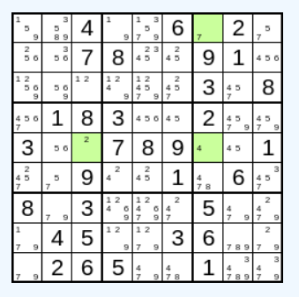
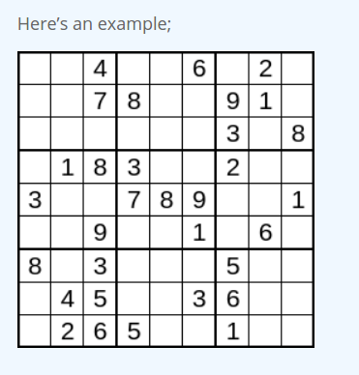

it shows the possibe numbers for each node and
highlighted nodes shows the nodes having only
one element as the possiblitity

Logic 2:
if first logic fails and their is no node which has only one possiblity but all empty nodes have number of numbers as possiblities greater than 1, then second logic comes in which will scan the sudoku for numbers which are occuring only once in all the possibilities of a nodes in a row, column or a block and thus will assign the node having such a number and assign this numnber to that node and then removing that number from the nodes having that number as a possibilty from the row, column and block corresponding to that node.

Steps involved are:
- assume a number
- check how many times that number occur as a possiblity in each row
- if the count =1
- assign that element to that node
- remove that number from the nodes having that number as a possibilty from the row, column and block corresponding to that node
- repeat the same for each column and then for each block

Logic 3: Lines
This is the first technique which doesn’t actually tell you where to place a number, but instead helps you to determine places where you can’t a number! If you’re using pencilmarks, then this will help you to remove candidates, and from there you should be able to make placements.
If you look within a box, and find that all of the places where you can put a particular number lie along a single line, then you can be sure that wherever you put the number in that box, it has to be on the line.
Even if you don’t know exactly where to put the number yet, you can use this knowledge! You know that none of the other positions on that line (in the other two boxes) could contain that number, so you can remove those as candidates!

An example-
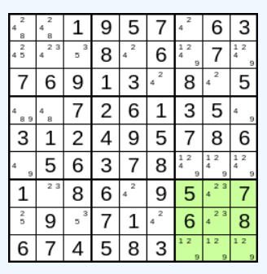

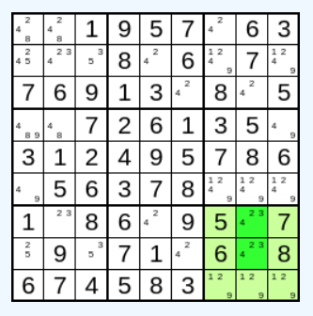
There’s only two places where the 4s can be – and they’re in a line (a column).

What this means is that the 4s on that line must be in that box – and can’t be anywhere else on the line.
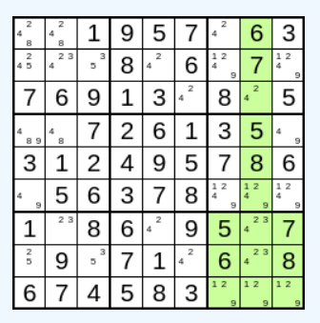

Look for the other candidates for 4 in that column…
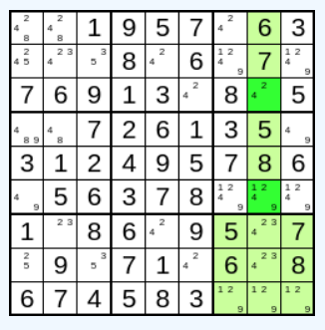

The result is that you can remove those two candidates for 4, leaving a 2 on its own – so straight away you can fill in another value!
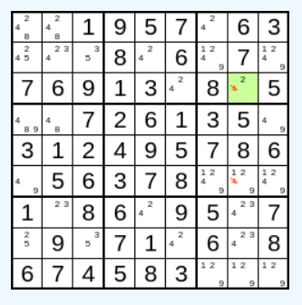

Future Improvements

some limitations of our code is that it can’t solve all sudokus which have more than one answers. It can be improved to form a code that gives all the possible answers of a sudoku with multiple answers.

More efficient codes can also be written for the sudoku involving hit and trial.

Sudoku can be expanded from 9x9 to 10x10 or more .

Input method for the sudoku can be improved and made more user friendly.

Graphics can be added to the sudoku with numbers initially with some other color and number being filled with some other color.

Programme can be changed from sudoku solver to sudoku hint giver while a user solves it and also a code which tell how close you were to the correct anwer.

