**ASSIGNMENT: 2**

**TASK: 1**

1. **docker pull <filename>:** This is used to pull from docker hub and you can use it. 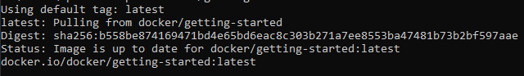
2. **docker images:** This returns all the images in the container. 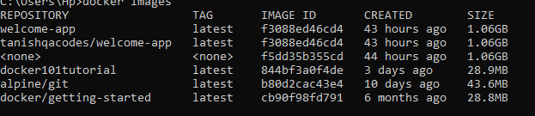
3. **docker run -d -p 80:80 docker/getting-started: This is used the run the images.** 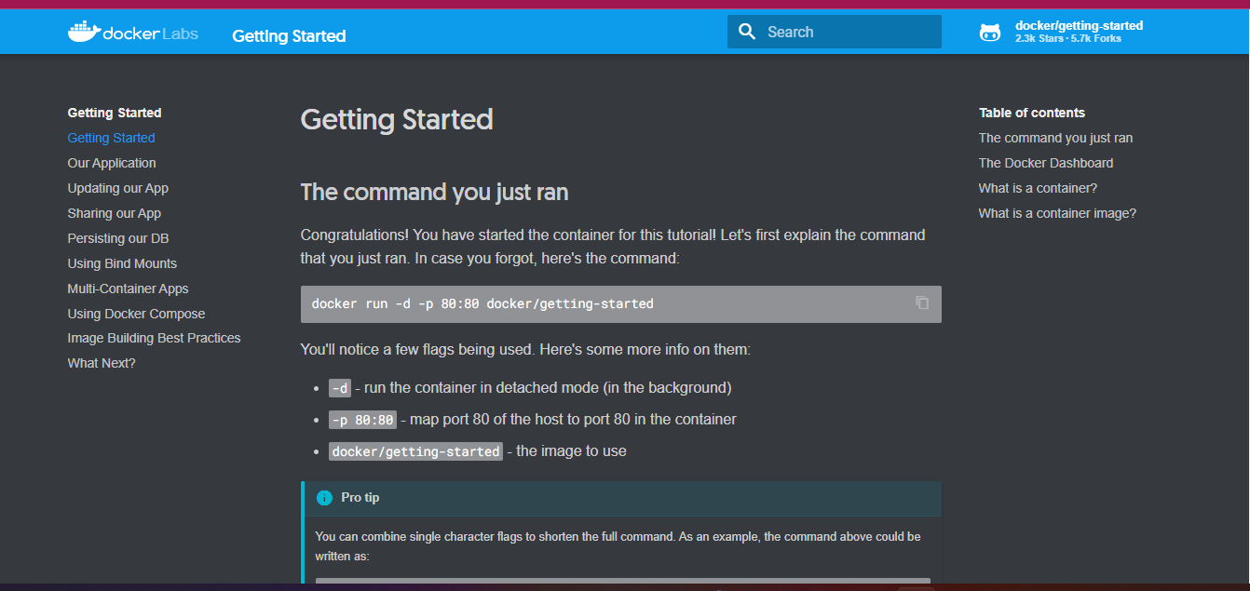
4. **docker create image []:** Create images command.
5. **docker run image []:** runs your image.
6. **Docker start container:** It starts the docker container.
7. **docker stop container:** It stops the docker container.
8. **docker build -t <docker-image-name>:** builds a docker image.
9. **docker kill container:** kill the container.
10. **docker pause container:** it pauses the container**.**
11. **docker resume container:** it resumes the container.
12. **Docker ps:** to see running container
13. **docker create <<image>>:** The docker container create (or shorthand: docker create) command creates a new container from the specified image, without starting it**.**
14. **Docker history <<images id>>:** Show the history of an image