DEPARTMENT OF ARTIFICIAL INTELLIGENCE AND MACHINE LEARNING

PROBLEM SOLVING -I GROUP 3
(USN ending with 2,4,9)

Name - Tanishq Agarwal. Section- 3 “E” USN- 1NH25AI159-T

1. Develop a Python program to perform signed binary arithmetic using the 8-bit 2’s complement representation. Use the program to verify the results of the following arithmetic expressions:
- (45 - (+19))
- ((-35) - (-12))

For each expression, display the operands in 8-bit 2’s complement binary format, perform the binary arithmetic operation, and display the final result in both binary and decimal formats. Verify the program output against the results obtained through manual binary calculations and identify any arithmetic overflow.
Sol- a) Python program:
def to_8bit(n):
return format(n & 0xFF, "08b")

def from_8bit(b):
n = int(b, 2)
return n - 256 if n >= 128 else n

a = 45
b = 19

bin_a = to_8bit(a)
bin_b = to_8bit(b)
neg_b = to_8bit(-b)

total = int(bin_a, 2) + int(neg_b, 2)
result = format(total & 0xFF, "08b")
decimal_result = from_8bit(result)

overflow = (
bin_a[0] == neg_b[0]
and result[0] != bin_a[0]
)

print("A =", a, ":", bin_a)
print("B =", b, ":", bin_b)
print("-B =", neg_b)
print("Result in binary =", result)
print("Result in decimal =", decimal_result)
print("Overflow =", overflow)

Output-
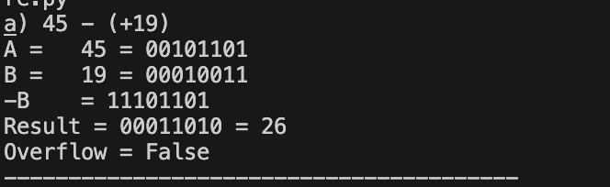

Manual Binary Calculation-

(45-(+19))
Step 1: Convert the operands to 8-bit binary.
- (+45 = 00101101 )
- (+19 = 00010011 )
Step 2: Find the 2’s complement of (+19 ).
Invert the bits:
- 00010011 (+19)
- 11101100 (1's complement)
- 11101101 (2's complement = -19)
Step 3: Add (45+(-19) ).

00101101 (+45)
+ 11101101 (-19)
-----------
1 00011010

Discard the carry beyond the 8th bit.
- Result in binary: 00011010
- Result in decimal: (+26 )
- Overflow: No
b) ((-35) - (-12))
Python program:
def to_8bit(n):
return format(n & 0xFF, "08b")
def from_8bit(b):
n = int(b, 2)
return n - 256 if n >= 128 else n
a = -35
b = -12
bin_a = to_8bit(a)
bin_b = to_8bit(b)
neg_b = to_8bit(-b)
total = int(bin_a, 2) + int(neg_b, 2)
result = format(total & 0xFF, "08b")
decimal_result = from_8bit(result)
overflow = (
bin_a[0] == neg_b[0]
and result[0] != bin_a[0]
)
print("A =", a, ":", bin_a)
print("B =", b, ":", bin_b)
print("-B =", neg_b)
print("Result in binary =", result)
print("Result in decimal =", decimal_result)
print("Overflow =", overflow)
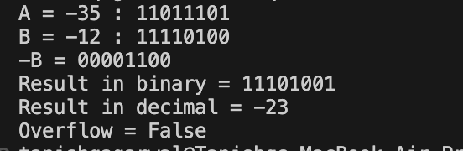
Output-

Manual Binary Calculation-

((-35)-(-12))
Step 1: Convert the operands to 8-bit binary.
For (-35 ):
+35 = 00100011
Invert = 11011100
Add 1 = 11011101
Therefore, (-35 = 11011101).
For (-12):
+12 = 00001100
Invert = 11110011
Add 1 = 11110100
Therefore, (-12 = 11110100 ).
Step 2: Convert subtraction into addition.
[ (-35)-(-12)=(-35)+(+12) ]
The 8-bit representation of (+12 ) is 00001100.
Step 3: Perform binary addition.
11011101 (-35)
+ 00001100 (+12)
-----------
11101001
The result begins with 1, so it represents a negative number.
To find its decimal value:
11101001
Invert: 00010110
Add 1: 00010111 = 23
Therefore, the result is (-23 ).
- Result in binary: 11101001
- Result in decimal: (-23 )
- Overflow: No
—————————————————————————————————————
2. Write a Python program to perform and verify the results of the following rotate operations on 8-bit binary numbers:
a) Rotate left without carry (ROL) on 10110110 by 2 positions.
b) Rotate left with carry (RCL) on 10110110 by 2 positions.
For each operation, display the original 8-bit binary number, demonstrate the rotation process step by step, and display the final 8-bit binary result. For rotate operations with carry, consider the carry flag as an additional bit and clearly indicate its initial and final values. Verify the program output against the results obtained through manual calculations.

Sol- a) Rotate Left Without Carry (ROL)

Python Program:

binary = "10110110"
print("Original:", binary)
for i in range(2):
binary = binary[1:] + binary[0]
print("Step", i + 1, ":", binary)
print("Final result:", binary)

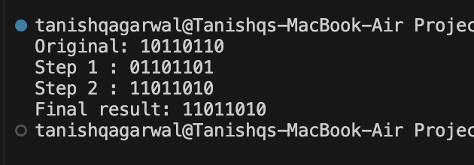
Output-

In ROL, the leftmost bit moves to the rightmost position. The carry flag is not used in the rotation.
Original 8-bit number: 10110110
Manual calculation for 2 positions:
Step 0: 10110110
Step 1: 01101101
Step 2: 11011010
Final result: 11011010

b) Rotate Left With Carry (RCL)
Python Program:

binary = "10110110"
carry = 0
print("Original:", binary)
print("Initial Carry Flag:", carry)
for i in range(2):
new_carry = int(binary[0])
binary = binary[1:] + str(carry)
carry = new_carry
print("Step", i + 1, ":", binary, "| Carry Flag:", carry)
print("Final result:", binary)
print("Final Carry Flag:", carry)

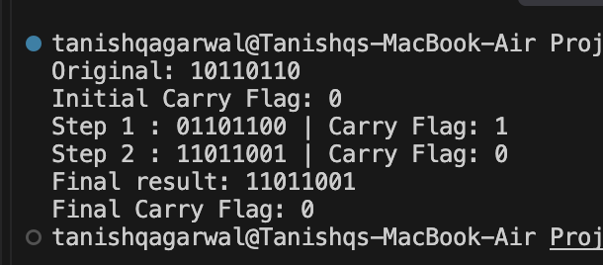
Output-

In RCL, the carry flag acts as an additional bit. The bits rotate through the carry flag, so the carry flag's initial value matters.
Assume the initial carry flag is CF = 0.
Manual calculation:
Initial: CF = 0, 10110110

Step 1: CF = 1, 01101100
Step 2: CF = 0, 11011001
Final result: 11011001

——————————————————————————END———————————————————————————————

