**2.1. For this data, construct the following contingency tables (Keep Gender as row variable)**

**2.1.1. Gender and Major**

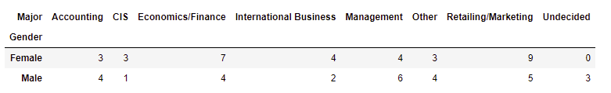

**2.1.2. Gender and Grad Intention**

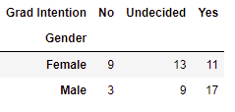

**2.1.3. Gender and Employment**

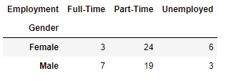

**2.1.4. Gender and Computer**

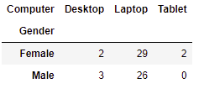

**2.2. Assume that the sample is representative of the population of CMSU. Based on the data, answer the following question:**

**2.2.1. What is the probability that a randomly selected CMSU student will be male?**

**Total male / total students = 29/62 = 0.47**

**2.2.2. What is the probability that a randomly selected CMSU student will be female?**

**Total female / total students = 33/62 = 0.53**

**2.3. Assume that the sample is representative of the population of CMSU. Based on the data, answer the following question:**

**2.3.1. Find the conditional probability of different majors among the male students in CMSU.**

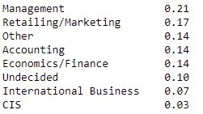

**2.3.2 Find the conditional probability of different majors among the female students of CMSU.**

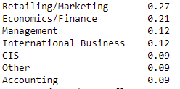

**2.4. Assume that the sample is a representative of the population of CMSU. Based on the data, answer the following question:**

**2.4.1. Find the probability That a randomly chosen student is a male and intends to graduate.**

**prob of random student being male = 29/62**

**prob of male intending to graduate = 17/29**

**answer = 29/62 * 17/29 = 0.27**

**2.4.2 Find the probability that a randomly selected student is a female and does NOT have a laptop.**

**prob of random student being female = 33/62**

**prob of female not having laptop = 4/33**

**answer = 4/33 * 33/62 = 0.06**

**2.5. Assume that the sample is representative of the population of CMSU. Based on the data, answer the following question:**

**2.5.1. Find the probability that a randomly chosen student is either a male or has full-time employment?**

**Prob of male = 29/62**

**Prob of full-time employment = 10/62**

Prob of male with full time employment = 7/62

Answer = 29/62 + 10/62 – 7/62 = 32/62 = 0.52

**2.5.2. Find the conditional probability that given a female student is randomly chosen, she is majoring in international business or management.**

**We know that given is female**

**So, no of female pursuing international business or management = 8**

**Ans = 8/33 = 0.24**

**2.6.  Construct a contingency table of Gender and Intent to Graduate at 2 levels (Yes/No). The Undecided students are not considered now and the table is a 2x2 table. Do you think the graduate intention and being female are independent events?**

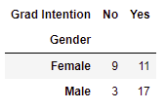

No both are not independent events.

**2.7. Note that there are four numerical (continuous) variables in the data set, GPA, Salary, Spending, and Text Messages.**

**Answer the following questions based on the data**

**2.6.1. If a student is chosen randomly, what is the probability that his/her GPA is less than 3?**

**Just apply a filter count no of students with GPA < 3 and divide by 62.**

**0.27**

**2.6.2. Find the conditional probability that a randomly selected male earns 50 or more. Find the conditional probability that a randomly selected female earns 50 or more.**

**Apply crosstab with filter**

**Male > 50 = 14/29 = 0.48**

**Female > 50 = 18/33 = 0.55**

**2.8. Note that there are four numerical (continuous) variables in the data set, GPA, Salary, Spending, and Text Messages. For each of them comment whether they follow a normal distribution. Write a note summarizing your conclusions**.

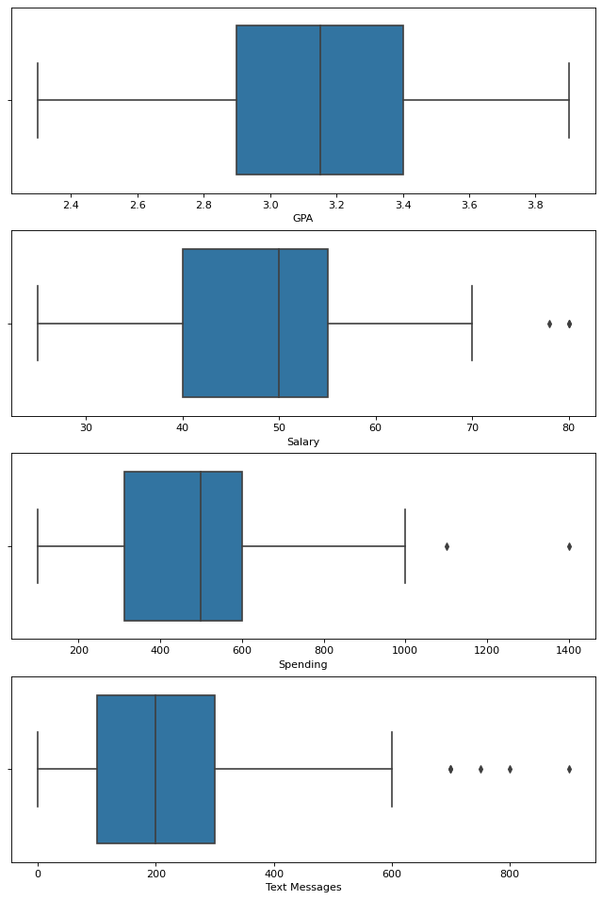

Only GPA follows a normal distribution. We can say this as mean is ten times std dev also the boxplot of GPA is very symmetrical.

Salary is skewed and does not follow normal distribution, also it has outliers.

Spending is skewed and does not follow normal distribution, also it has outliers.

Text messages is the most skewed and does not follow normal distribution, also it has multiple outliers.

