FPGA-Accelerated Quantized Neural Networks on PYNQ-Z2: ECG Arrhythmia Detection and Network Intrusion Detection via hls4ml
Vedant Nandanwar  Dept. of Electronics & Telecommunications Engg.  Vishwakarma Institute of Technology  Pune, India  nandanwar.vedant23@vit.edu | Tanishq Swami  Dept. of Electronics & Telecommunications Engg.  Vishwakarma Institute of Technology  Pune, India  tanishq.swami23@vit.edu | Arush Wangikar  Dept. of Electronics & Telecommunications Engg.  Vishwakarma Institute of Technology  Pune, India  arush.wangikar23@vit.edu | Dr. Abhay Chopde  Dept. of Electronics & Telecommunications Engg.  Vishwakarma Institute of Technology  Pune, India  abhay.chopde@vit.edu

Abstract—Neural networks are typically deployed on edge devices to allow for low-latency inferences using limited hardware resources. Two applications of interest are the classification of ECG heart rhythms from the MIT-BIH arrhythmia dataset and network intrusions from the NSL-KDD dataset. Each model was created in Keras and optimized before being deployed on an FPGA-based platform using the hls4ml and Vitis HLS tools on the Xilinx PYNQ-Z2 development platform. The deep learning models are trained in Keras and deployed on the Zynq-7020 SoC within the PYNQ-Z2 platform. The hardware elements of the network are synthesized for various fixed-point precisions ranging from ap_fixed<8,4> to ap_fixed<16,8>. The timing-clean uniform 8-bit implementations have computational latencies between 100 ns and 140 ns at a clock speed of 100 MHz. Additionally, the reported uniform 8-bit implementations do not require any DSP resources. For the 16-feature ECG model, the accuracy measured on the hardware platform (0.81) is within one percentage point of the hls4ml csim accuracy (0.80). For the ECG classification task, the 64-feature model with pruning and quantization-aware training achieves a floating-point accuracy of 0.96, an improvement over the 16-feature model (0.93) on the same task. Furthermore, the same two-hidden-layer architecture pattern (with a task-specific 41-feature input) is applied to the task of classifying network intrusions, illustrating the utility of this platform for accelerating neural networks for embedded applications.

I. Introduction
Edge deployment of neural networks is important for applications where privacy, latency or power constraints make cloud inference impractical. There are two domains of work. First being biomedical signal analysis (like ECG arrhythmia detection) which often requires classification in a wearable or implantable device where power consumption and latency need to be low [1, 2]. Second, network intrusion detection systems (NIDS) often require rapid classification of packet metadata within strict latency budget of the network fabric [3]. In both cases, FPGA-based accelerators had fully pipelined dataflow and predictable per-inference execution times, cycle counts, and the ability to scale precision to 8 bits or fewer, while avoiding the overhead of a general-purpose ALU.
Traditional FPGA development relies on RTL design in languages such as Verilog or VHDL, making rapid machine-learning iteration difficult. To address this issue hls4ml [4, 12] directly produces synthesizable C++ code for Vitis HLS from a trained Keras and PyTorch model while accurately keeping model semantics under fixed-point precision. Combined with quantization-aware training like QKeras [5] and weight pruning [6] a complete software-to-bitstream flow has been created that can be used by engineers that do not have experience designing hardware. The full pipeline is shown in Fig. 1.
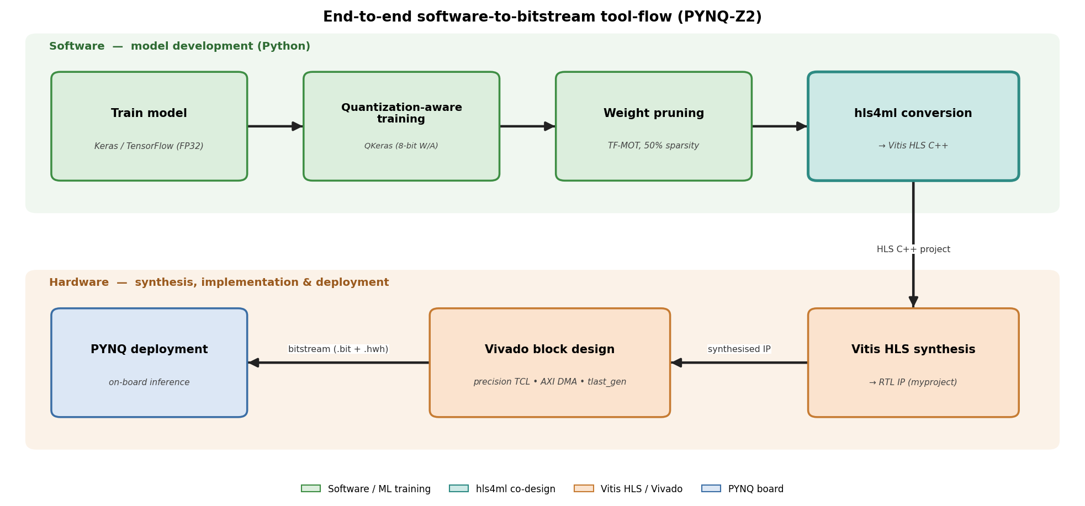
Fig. 1. End-to-end software-to-bitstream tool-flow.
This paper presents the design and implementation of two different neural network deployment pipelines onto FPGAs on the PYNQ-Z2 platform, which is comprised of the Zynq-7020 SoC and the PYNQ Python framework [7]. The central contributions of this paper are:
- The development of an end-to-end deployment workflow for the PYNQ-Z2 platform that includes training the neural network, training with quantization, pruning the network, hardware generation, synthesis of the bitstream, and performing inference on board the PYNQ-Z2 platform.
- The creation of a precision-adaptive Vivado TCL script that automatically adjusts the AXI DMA stream widths according to the neural network quantization settings.
- The implementation of a custom Verilog module responsible for generating the TLAST indicate to AXI DMA.
- An evaluation of the resource utilisation of multiple fixed- and mixed-precision configurations and the accuracy of the deployed models for classification of ECG arrhythmias from the MIT-BIH [8] and network intrusion detection from the NSL-KDD [9] data sets.
- A demonstration that re-engineering the input feature representation from 16 hand-crafted features to 64 R-peak-aligned raw signal samples, combined with QKeras quantization-aware training and 50% weight pruning, improves floating-point accuracy on the binary normal/abnormal task from 0.93 to 0.96.
II. Related Work
A. ML Inference on FPGAs
FPGA acceleration of neural networks has matured significantly over the past decade. The hls4ml project was originally developed for ultra-low-latency jet classification at the CERN Large Hadron Collider, where trigger decisions must be made in under 1 µs [4]. Earlier RTL-based approaches such as FINN [11] achieved high efficiency at the cost of model-specific design effort; HLS tools lowered this barrier substantially.
B. Quantization-Aware Training and Pruning
QAT, popularised by Jacob et al. [13], is implemented in QKeras [5] for the hls4ml flow. Empirical results indicate that QAT reportedly recovers a few percentage points relative to post-hoc fixed-point casting at 8-bit precision [5,14]; in our ECG-v1 experiments, the post-hoc-quantised baseline reached 0.80 in csim and 0.81 on hardware, while a wider QAT-trained variant (16 → 32 → 16 → 1) reached 0.92 accuracy in QKeras with quantised weights and activations. Weight pruning, introduced by Han et al. [15], is integrated into TensorFlow's Model Optimization Toolkit [6]. On hls4ml-targeted workloads, 50% weight sparsity was achievable with modest accuracy loss; we do not claim this generalises to all workloads.
C. ECG Arrhythmia and NID Datasets
Classical ECG approaches use hand-crafted features (RR-interval statistics, QRS morphology, wavelet decomposition) on the MIT-BIH dataset [8] with reported binary accuracies of 0.85–0.92 [16]. Deep learning on raw signals [10, 17] reaches 0.97+ (though [10] reports AUC on a distinct 12-rhythm ambulatory task, not directly comparable to MIT-BIH binary accuracy) but at model sizes incompatible with low-cost FPGAs without aggressive quantization. For network intrusion detection, the NSL-KDD dataset [9] is the standard binary normal-vs-attack benchmark, with reported accuracies of 0.78–0.83 due to intentional train/test attack-class divergence [18]. UNSW-NB15 [19] and CIC-IDS-2017 [20] are alternatives with looser splits.
III. System Architecture
A. Hardware Platform
All experiments target the PYNQ-Z2 development board, which carries a Xilinx Zynq-7020 SoC (xc7z020clg400-1) [21]. The Zynq-7020 combines a dual-core ARM Cortex-A9 Processing System (PS) with programmable logic (PL). Available PL resources are 53,200 LUTs, 106,400 flip-flops, 220 DSP48E1 slices, and 140 36-Kb block-RAM tiles. The board runs PYNQ Linux v3.1.1 [7], which provides a Python runtime with the Overlay class for bitstream loading and allocate for DDR-pinned buffers.
B. Block-Design Topology
The hardware-side dataflow is shown in Fig. 2. The processing_system7 IP provides FCLK_CLK0 at 100 MHz and FCLK_RESET0_N to the programmable logic. A proc_sys_reset block synchronises the reset to the clock domain. Two AXI SmartConnect [22] instances distribute AXI traffic: one for the GP0 control path to the AXI DMA's S_AXI_LITE register interface, and one for the HP0 data path through which the DMA reads input vectors and writes output predictions to DDR3.
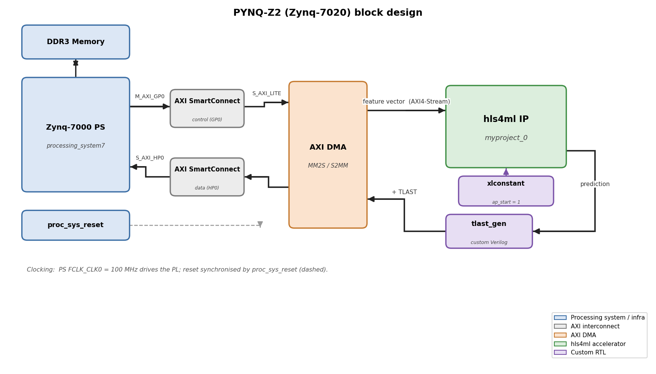
Fig. 2. PYNQ-Z2 block design with AXI DMA, SmartConnects, the hls4ml IP, and the custom tlast_gen module.
The hls4ml-generated IP (myproject_0) provides two AXI4-Stream interfaces. One interface receives the input feature vector, while the other outputs the prediction result. A custom Verilog module, tlast_gen, is inserted between the IP and the DMA interface to generate the TLAST signal required for packet termination. The signal is asserted every PACKET_SIZE beats, allowing the DMA to identify transfer boundaries correctly. An xlconstant block keeps the ap_start signal permanently enabled, allowing the IP to process incoming data automatically.
C. Stream-Width Adaptation
The width of the AXI Stream interfaces generated by hls4ml depends on the precision used by the neural network. Increasing the precision results in wider data streams, requiring corresponding changes to the AXI DMA configuration. If the DMA width is fixed to a single value, data may be truncated during transfer, leading to incorrect hardware behaviour despite successful synthesis. To prevent this issue, a TCL-based automation script reads the stream-width information generated by hls4ml and configures the DMA and tlast_gen modules accordingly during deployment.
D. Software-Side Driver
On-board inference is implemented in Python via the PYNQ Overlay class. The standard SDMA Channel wrapper intermittently raised Runtime Error during channel arming while the underlying transfer completed correctly; we overcame it by writing the DMA control/status registers directly over AXI-Lite MMIO, following [23]. The DMA state transitions are illustrated in Fig. 3.
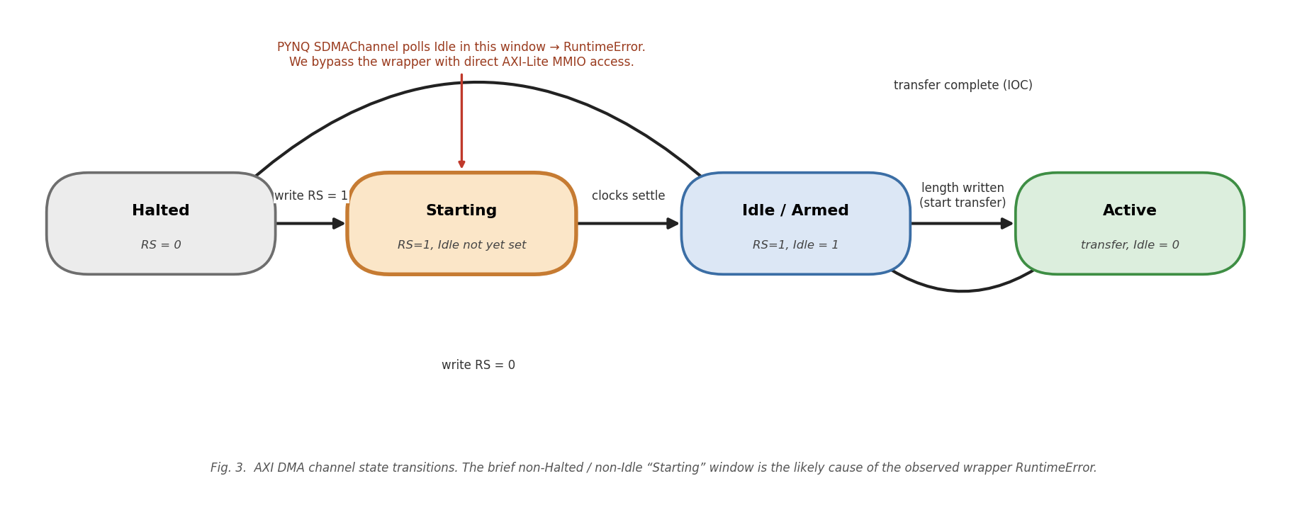
Fig. 3. AXI DMA channel state transitions. The brief non-Halted/non-Idle window after RS=1 is a likely explanation for the observed PYNQ wrapper Runtime Error.

IV. Methodology
A. ECG-v1 (16 hand-crafted features)
The baseline ECG model accepts 16 hand-crafted features per heartbeat (RR-interval statistics, QRS amplitude, frequency-domain power ratios) and predicts a binary normal/abnormal label. The architecture is a feed-forward MLP: 16 → Dense(16, ReLU) → Dense(8, ReLU) → Dense(1, sigmoid), with 417 trainable parameters. Features are standardised, the classes are balanced by undersampling normal beats, and evaluation uses a stratified random 80/20 split of the beats. Training uses the Adam optimiser, binary cross-entropy loss, batch size 32, and up to 100 epochs with early stopping (patience 10). The model is trained in floating point and quantised post hoc by hls4ml.
B. ECG-v2 (64 R-peak-aligned samples)
The improved model replaces the 16 hand-crafted characteristics with 64 raw samples of ECG signals. For every R-peak annotation in the MIT-BIH dataset, a 200-sample segment around the R-peak is extracted and down-sampled to 64 samples using the Fourier-method resampling function (scipy.signal.resample) from the SciPy library [24]. Each window is standardised using per-window z-score normalisation and clipped to ±3.9 before being converted to fixed-point values.
The model has two hidden QDense layers containing 64 and 32 neurons, respectively, followed by a sigmoid output layer. Thus, the model contains 6,273 trainable parameters, which is around 15 times the parameter count of the ECG-v1 model (417).
Beats are grouped into normal and abnormal categories using AAMI category definitions, and normal beats are randomly undersampled to balance the two classes. Evaluation uses an intra-patient stratified random 80/20 split of the extracted beats; the reported results should therefore not be interpreted as inter-patient performance. During training, quantization-aware training with QKeras quantizes the model to 8 bits for weights and activations. The model is trained for 40 epochs of QAT, followed by 15 epochs of pruning fine-tuning with the TensorFlow Model Optimization Toolkit using a polynomial decay schedule that takes the model weights from 0% to 50% sparsity.
C. Network Intrusion Detection (NSL-KDD)
The NID model accepts 41 features per network connection record and predicts binary normal/attack. Numeric features are taken directly from NSL-KDD; categorical features (protocol_type, service, flag) are integer-encoded. The architecture is 41 → QDense(64, ReLU) → QDense(32, ReLU) → QDense(1, sigmoid), trained with the same QAT recipe as ECG-v2 followed by pruning to 30% sparsity. The evaluation protocol is the canonical NSL-KDD partition: training uses KDDTrain+ only, KDDTest+ is held out for final evaluation, and all categorical mappings and standardisation parameters are fitted on KDDTrain+ only. The NID bitstream built in this work was trained on a pooled random split of KDDTrain+ and KDDTest+, which leaks test-distribution samples into training, so its accuracy is not reported as a benchmark result; evaluation under the canonical partition is left to future work. The three network architectures are summarised in Fig. 4.
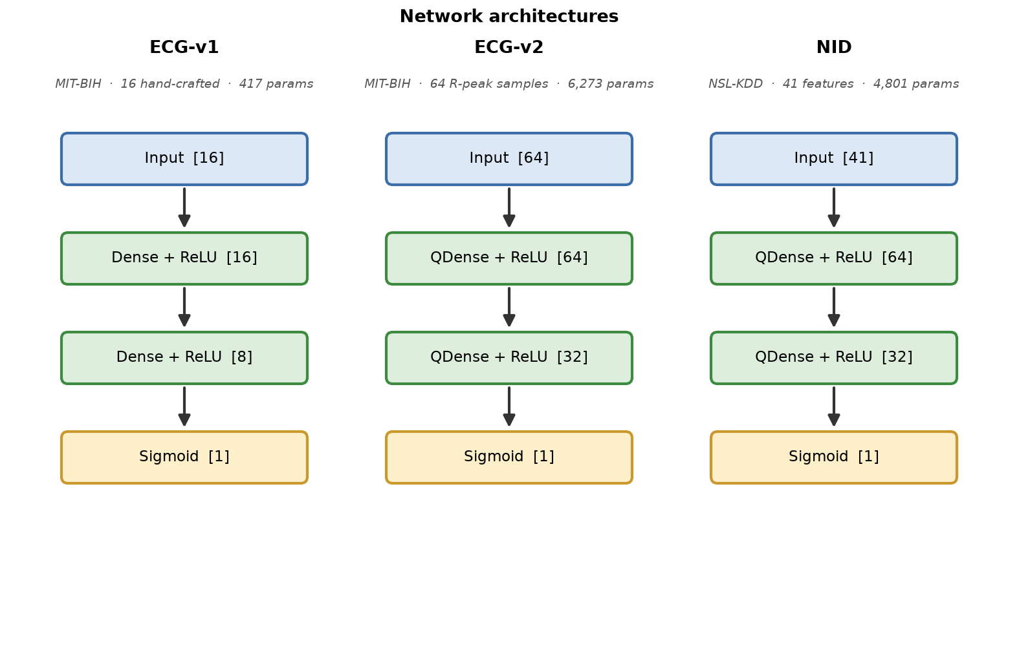
Fig. 4. Network architectures: ECG-v1 (16 features, 417 params), ECG-v2 (64 features, 6,273 params), NID (41 features, 4,801 params).
D. Mixed-Precision Configurations
Table I summarises the mixed-precision configurations considered. The uniform_8bit configuration was built and deployed for each model; low_mixed was additionally built for ECG-v1 and ECG-v2; the higher-precision high_mixed configurations were characterised in synthesis only. ECG-v2 uses a ReuseFactor of 8.
TABLE I MIXED-PRECISION CONFIGURATIONS EVALUATED
Config | Precision | RF | Tradeoff
uniform_8bit | ⟨8, 4⟩ | 1 | Max throughput
low_mixed | ⟨6, 2⟩ / ⟨12, 6⟩ | 1 | Alternative mixed precision
high_mixed_rf1 | ⟨16, 8⟩ / ⟨12, 6⟩ | 1 | Exceeds DSP budget
high_mixed_rf2 | ⟨16, 8⟩ / ⟨12, 6⟩ | 2 | Fits Zynq-7020 resources

V. Results
A. Resource Utilisation
Table II reports the Vivado post-implementation resource utilisation for all five built configurations across the three models. No configuration uses any DSP slices, as hls4ml synthesises the 8-bit (and low-mixed) MACs into LUT logic; this is confirmed by the post-implementation reports for every built configuration. ECG-v2/low_mixed is the only build that does not meet the 100 MHz timing constraint (WNS = −4.83 ns).
TABLE II POST-IMPLEMENTATION RESOURCE UTILISATION (VIVADO, xc7z020-clg400-1)
Model / Config | LUT | FF | DSP | Lat. (cyc)
ECG-v1 / uniform_8bit | 8,225 | 7,442 | 0 | 10
ECG-v1 / low_mixed | 7,654 | 7,363 | 0 | 10
ECG-v2 / uniform_8bit | 24,295 | 16,984 | 0 | 12
ECG-v2 / low_mixed | 34,793 | 21,732 | 0 | 12
NID / uniform_8bit | 26,722 | 19,545 | 0 | 14
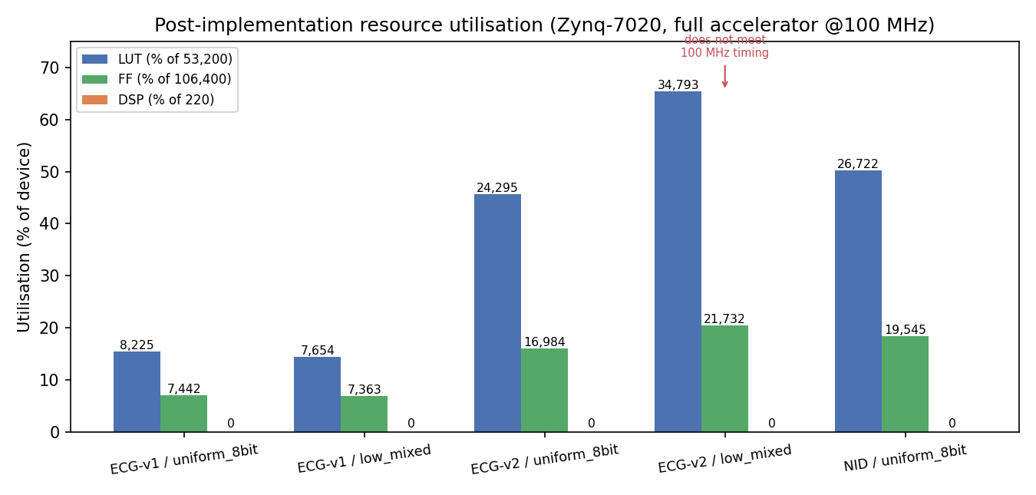
Fig. 5. Post-implementation (Vivado place-and-route) resource utilisation of the five built configurations, as a percentage of available Zynq-7020 resources.
B. Classification Accuracy
Table III and Fig. 6 report float Keras accuracy, hls4ml csim accuracy, and on-board hardware accuracy where they were measured. The ECG-v1 baseline under uniform 8-bit quantization reaches 0.80 in csim and 0.81 on hardware, against 0.93 in floating point; several of the 16 hand-crafted features exceed the representable range of ap_fixed<8,4> and saturate. The ECG-v2 model with 64 R-peak-aligned features and QAT+pruning reaches 0.96 in floating point; its csim and on-board accuracy were not recorded. NID results under the canonical KDDTrain+/KDDTest+ partition are not yet available (Section IV-C).
TABLE III ACCURACY ACROSS MODELS AND CONFIGURATIONS
Model / Config | Float | csim | HW
ECG-v1 / uniform_8bit | 0.93 | 0.80 | 0.81
ECG-v2 / uniform_8bit | 0.96 | — | —
NID / uniform_8bit | — | — | —
— = not measured. ECG-v1: post-hoc quantised baseline (417 params), stratified random split; HW measured on the PYNQ-Z2. ECG-v2: intra-patient stratified random split. NID: evaluation under the canonical KDDTrain+/KDDTest+ partition pending (Section IV-C).
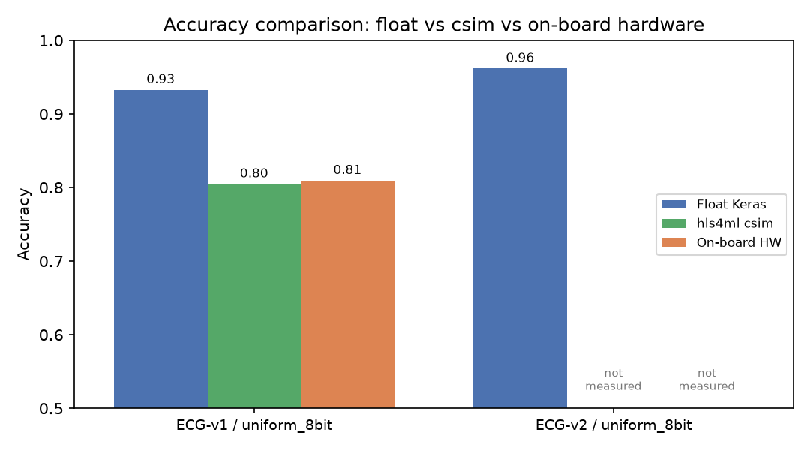
Fig. 6. Accuracy comparison: float Keras vs hls4ml csim vs on-board hardware for the uniform 8-bit configurations where they were measured.
C. Latency and Throughput
The bare HLS-IP computational latency at 100 MHz is 10 cycles = 100 ns for ECG-v1 (initiation interval II = 1), 12 cycles = 120 ns for ECG-v2 at ReuseFactor 8 (II = 3), and 14 cycles = 140 ns for NID (II = 1). End-to-end wall-clock time per inference on the PYNQ PS, which additionally includes DMA set-up and AXI-Lite control overhead, was not recorded in this study.
VI. Conclusion
In this work, we present an end-to-end FPGA acceleration solution for two binary neural network classification tasks on the PYNQ-Z2 platform. The architecture uses the hls4ml framework to convert the trained models into hardware descriptions and utilizes a custom Vivado TCL script to generate the FPGA block design according to the precision of the models. For the 16-feature ECG model, the accuracy measured on the hardware (0.81) was within one percentage point of the csim accuracy (0.80). For the ECG-v2 model with 64 data samples taken at the R-peaks of the cardiac signals and trained using the QKeras library with quantization-aware training, floating-point accuracy improved to 0.96, with a computational latency of ~120 ns and no utilization of DSP blocks at 8-bit precision. Furthermore, the same two-hidden-layer architecture pattern was applied to NSL-KDD cyber-attack detection and deployed on the board; its evaluation under the canonical KDDTrain+/KDDTest+ partition is left to future work.
Acknowledgement
The authors thank the Fast Machine Learning (FastML) collaboration for developing hls4ml, the QKeras maintainers, and the PYNQ project. We also thank the faculty of the Department of Electronics and Telecommunications Engineering at Vishwakarma Institute of Technology, Pune, for infrastructure support.
References
[1] G. D. Clifford, F. Azuaje, and P. McSharry, Advanced methods and tools for ECG data analysis. Norwood, MA: Artech House, 2006.
[2] U. R. Acharya et al., “A deep convolutional neural network model to classify heartbeats,” Comput. Biol. Med., vol. 89, pp. 389–396, 2017.
[3] M. Ring, S. Wunderlich, D. Scheuring, D. Landes, and A. Hotho, “A survey of network-based intrusion detection data sets,” Comput. Secur., vol. 86, pp. 147–167, 2019.
[4] J. Duarte et al., “Fast inference of deep neural networks in FPGAs for particle physics,” JINST, vol. 13, p. P07027, 2018.
[5] C. N. Coelho et al., “Automatic heterogeneous quantization of deep neural networks for low-latency inference on the edge for particle detectors,” Nat. Mach. Intell., vol. 3, no. 8, pp. 675–686, 2021.
[6] TensorFlow Model Optimization Toolkit, “Pruning in Keras example,” https://www.tensorflow.org/model_optimization/guide/pruning, 2024.
[7] Xilinx Inc., “PYNQ: Python productivity for Zynq,” https://www.pynq.io/, 2024.
[8] G. B. Moody and R. G. Mark, “The impact of the MIT-BIH Arrhythmia Database,” IEEE Eng. Med. Biol. Mag., vol. 20, no. 3, pp. 45–50, 2001.
[9] M. Tavallaee, E. Bagheri, W. Lu, and A. A. Ghorbani, “A detailed analysis of the KDD CUP 99 data set,” in Proc. IEEE Symp. CISDA, 2009, pp. 53–58.
[10] A. Y. Hannun et al., “Cardiologist-level arrhythmia detection and classification in ambulatory electrocardiograms using a deep neural network,” Nat. Med., vol. 25, no. 1, pp. 65–69, 2019.
[11] Y. Umuroglu et al., “FINN: A framework for fast, scalable binarised neural network inference,” in Proc. ACM/SIGDA Int. Symp. FPGA, 2017, pp. 65–74.
[12] F. Fahim et al., “hls4ml: An open-source codesign workflow to empower scientific low-power machine-learning devices,” arXiv:2103.05579, 2021.
[13] B. Jacob et al., “Quantization and training of neural networks for efficient integer-arithmetic-only inference,” in Proc. CVPR, 2018, pp. 2704–2713.
[14] T. Aarrestad et al., “Fast convolutional neural networks on FPGAs with hls4ml,” Mach. Learn.: Sci. Technol., vol. 2, no. 4, p. 045015, 2021.
[15] S. Han, J. Pool, J. Tran, and W. J. Dally, “Learning both weights and connections for efficient neural networks,” in Adv. Neural Inf. Process. Syst., 2015, pp. 1135–1143.
[16] M. Llamedo and J. P. Martínez, “Heartbeat classification using feature selection driven by database generalisation criteria,” IEEE Trans. Biomed. Eng., vol. 58, no. 3, pp. 616–625, 2011.
[17] S. Mousavi and F. Afghah, “Inter- and intra-patient ECG heartbeat classification for arrhythmia detection,” in Proc. IEEE ICASSP, 2019, pp. 1308–1312.
[18] L. Dhanabal and S. P. Shantharajah, “A study on NSL-KDD dataset for intrusion detection system based on classification algorithms,” IJARCCE, vol. 4, no. 6, pp. 446–452, 2015.
[19] N. Moustafa and J. Slay, “UNSW-NB15: a comprehensive data set for network intrusion detection systems,” in Proc. MilCIS, 2015, pp. 1–6.
[20] I. Sharafaldin, A. H. Lashkari, and A. A. Ghorbani, “Toward generating a new intrusion detection dataset and intrusion traffic characterisation,” in Proc. ICISSP, 2018, pp. 108–116.
[21] Xilinx Inc., Zynq-7000 SoC Technical Reference Manual, UG585 (v1.13), 2021.
[22] Xilinx Inc., AXI SmartConnect LogiCORE IP Product Guide, PG247, 2023.
[23] Xilinx Inc., AXI DMA LogiCORE IP Product Guide, PG021 (v7.1), 2022.
[24] P. Virtanen et al., “SciPy 1.0: fundamental algorithms for scientific computing in Python,” Nat. Methods, vol. 17, pp. 261–272, 2020.
[25] Association for the Advancement of Medical Instrumentation, “Testing and reporting performance results of cardiac rhythm and ST segment measurement algorithms,” ANSI/AAMI EC57:2012/(R)2020, 2020.

