SCHOOL OF TECHNOLOGY | 
DATABASE MANAGEMENT SYSTEMS
(Course Code: 25TU01MLM2)
PROJECT-BASED LEARNING (PBL) REPORT
Small Database Application Development using Python
PROJECT TITLE
DESIGN AND IMPLEMENTATION OF A DATABASE MANAGEMENT SYSTEM FOR SCHOOL TRANSPORT ROUTE AND STUDENT PICKUP MANAGEMENT SYSTEM
Program | B.Tech Computer Science and Engineering
Section | CSE Panthers
Faculty | Prof. Sahithi Chennamadhavuni
Date of Submission | 12 October 2026
Academic Year | 2026 – 27
Submitted by
Roll Number | Student Name | Mobile | Email ID
25WU0101142 | Tanishq Hanumanta | 9301909850 | tanishq.hanumanta@woxsen.edu.in
© School of Technology, Woxsen University, 2026. All rights reserved

ACKNOWLEDGEMENT
I would like to place on record my sincere gratitude to Woxsen University, School of Technology, and its Department of Computer Science and Engineering for giving me the platform and the academic infrastructure to take up this Project-Based Learning (PBL) activity as part of the Database Management Systems (DBMS) course.
I am especially thankful to my course faculty, Prof. Sahithi Chennamadhavuni, for the guidance, feedback and steady support I received while designing and building the “School Transport Route and Student Pickup Management System”. Her suggestions helped me turn ideas I had only read about, such as entity-relationship modelling, 3NF normalisation, integrity constraints, capacity-checking triggers, ACID transactions and analytical SQL queries, into a working database application.
Working on this project strengthened my understanding of DBMS concepts and showed me how they apply to a real-world problem.
Tanishq Hanumanta

UNDERTAKING
I hereby declare that the project entitled “School Transport Route and Student Pickup Management System”, submitted as part of the Project-Based Learning activity for the Database Management Systems (DBMS) course, is my individual work carried out under the guidance of the course faculty.
I undertake that the project report, database design, SQL scripts, application source code, results, and supporting materials submitted by me have been prepared for academic purposes. Wherever information, ideas, tools, datasets, or other resources have been referred to, appropriate acknowledgement has been provided.
I further undertake that I am responsible for the correctness and authenticity of the work submitted and that I have followed the academic and project guidelines prescribed by the University.
Date | Place | Name: | Roll Number: | Program: | Signature
12/10/2026 | Woxsen University | Tanishq Hanumanta | 25WU0101142 | B.Tech CSE | [Sign here]

TABLE OF CONTENTS
Contents Page No.
LIST OF TABLES 5
LIST OF FIGURES 6
LIST OF ACRONYMS 7
Abstract 8
1. PROBLEM STATEMENT, SOLUTION STRATEGY AND ER DIAGRAM 9
1.1 Problem Statement 9
1.2 Objectives 10
1.3 Scope and Assumptions 10
1.4 Proposed Solution Strategy 10
1.5 Functional Requirements 12
1.6 Entity-Relationship Diagram (ERD) 13
1.7 Entity and Relationship Summary 14
2. LOGICAL DATABASE DESIGN 16
2.1 Relational Schema 16
2.2 Keys and Integrity Constraints 17
2.3 Functional Dependencies 18
2.4 Normalization up to Third Normal Form (3NF) 19
2.5 Data Dictionary 20
2.6 Implementation of Logical Design: DDL and Sample Data 22
3. APPLICATION DEVELOPMENT USING LOGICAL DATABASE DESIGN 25
3.1 Application Overview 25
3.2 Development Environment and Database Connectivity 26
3.3 Application Modules and Database Mapping 27
3.4 CRUD Operations 27
3.5 Business Rules, Validation and Error Handling 28
3.6 Reports and Database Operations 29
3.7 Application Screens 32
3.8 Testing and Results 35
4. CONCLUSION 37
4.1 Limitations and Future Enhancements 37
5. REFERENCES 38
6. APPENDICES 39

LIST OF TABLES
Table No. | Table Title | Page No.
Table 1 | Scope and Assumptions | 10
Table 2 | Proposed Solution Strategy | 11
Table 3 | Functional Requirements | 12
Table 4 | Entity and Relationship Summary | 14
Table 5 | Relational Schema | 16
Table 6 | Keys and Integrity Constraints | 17
Table 7 | Normalization Status up to 3NF | 19
Table 8 | Data Dictionary | 20
Table 9 | Database Implementation Environment | 22
Table 10 | Application Development Environment | 26
Table 11 | Application Module-to-Database Mapping | 27
Table 12 | CRUD Operations | 28
Table 13 | Business Rules, Validation and Error Handling | 28
Table 14 | Reports and Database Operations | 29
Table 15 | Test Cases | 35

LIST OF FIGURES
Figure No. | Figure Title | Page No.
Figure 1 | Entity-Relationship Diagram of the Proposed System | 13
Figure 2 | Three-tier System Architecture | 25
Figure 3 | Flowchart of Student-Stop Registration and Bus Allocation | 31
Figure 4 | Flowchart of Pickup Attendance and Fee Collection | 32
Figure 5 | Route Setup and Stop Sequence Screen | 33
Figure 6 | Student Registration with Stop and Bus Assignment | 33
Figure 7 | Daily Pickup Attendance Screen | 34
Figure 8 | Fee Collection and Dues Screen | 34
Figure 9 | Maintenance Entry and Status Screen | 35
Figure 10 | Reports and Dashboard | 35

LIST OF ACRONYMS
Acronym | Expansion
3NF | Third Normal Form
ACID | Atomicity, Consistency, Isolation, Durability
API | Application Programming Interface
CRUD | Create, Read, Update, Delete
DBMS | Database Management System
DDL | Data Definition Language
DL | Driving Licence
ER | Entity-Relationship
ERD | Entity-Relationship Diagram
FD | Functional Dependency
FK | Foreign Key
FR | Functional Requirement
HTTP | HyperText Transfer Protocol
JSON | JavaScript Object Notation
PBL | Project-Based Learning
PK | Primary Key
REST | Representational State Transfer
SQL | Structured Query Language
TC | Test Case
UI | User Interface

ABSTRACT
A school bus looks like a simple service from the outside, but behind it sits a data problem. Every morning and afternoon a fixed set of buses follows ordered routes, each bus has a limited number of seats, each student must be tied to exactly one stop, one route and one bus, and the school must know who was actually picked up, who was absent, who still owes transport fees and which bus is due for servicing. When these records are scattered over registers and spreadsheets, capacity and daily pickup status become unclear. The objective of this project is to build a database-driven School Transport Route and Student Pickup Management System that handles route setup, student-stop assignment, bus allocation, pickup attendance, fee collection and maintenance tracking. I designed an Entity-Relationship model with thirteen entities, converted it into a Third Normal Form schema and implemented it in MySQL 8.0 with primary, foreign, unique, check, default and not-null constraints, indexes, views and triggers that enforce bus-capacity limits, valid driver licences and payment limits. A Python/Flask REST API connects a browser-based front end to this live database, and each multi-step operation runs as one transaction. Analytical SQL queries produce route lists, capacity utilisation, absent students, fee dues, driver assignments and maintenance status. Automated API tests check the main flows. The result shows that the key transport rules can be enforced by the database itself instead of depending only on application code.
KEYWORDS
Keywords: School Transport, Relational Database, ER Diagram, Normalization, MySQL, Python Flask

CHAPTER 1
PROBLEM STATEMENT, SOLUTION STRATEGY AND ER DIAGRAM

1.1 Problem Statement
Schools that run their own transport must coordinate routes, stops, buses, drivers, attendants, students, daily pickups, fees and vehicle maintenance [1]. In many schools these records live in separate registers and spreadsheets. A fee clerk, a transport in-charge and a class teacher each hold a part of the picture, so nobody can say quickly how full a bus is, which students did not board today, who has unpaid transport fees, or whether the driver’s licence and the vehicle’s fitness are in order.
This makes school transport a rich modelling problem. A bus has a fixed seating capacity that must never be exceeded, a student must have exactly one active transport assignment at a time, the stops on a route have a strict order, and money collected against a transport plan must never exceed what the plan costs. Handling this work by hand or in flat files invites overloaded buses, students assigned twice, expired licences going unnoticed and disputed fee records. The people affected are students and parents, who need a reliable pickup and an accurate fee statement, and school staff, who need dependable capacity, attendance, fee and maintenance data. The domain is also a good vehicle for the main topics of a database course: relational design, normalisation, integrity constraints, triggers, indexing and transaction management. Six domain-specific challenges had to be solved:
- Bus-capacity limits. The number of active students on a bus must never exceed its seating capacity, so the check has to happen inside the database at the moment a registration is created or moved.
- One active assignment per student. A student may have a history of transport registrations, but only one of them can be active at any time. A second active assignment must be rejected even if it is inserted directly with SQL.
- Ordered stops on a route. Stops must follow a fixed sequence, and two stops on the same route can never share the same sequence number.
- Valid driver licences. A driver can be assigned to a bus only when the licence number is recorded and the licence has not expired on the day of duty.
- Fee collection and payment limits. A student’s payments must always be positive, and the total collected for one registration must never exceed the fee of the chosen fee plan, so that dues are always accurate.
- Daily pickup status and maintenance. Each student’s pickup outcome (picked up, absent or missed) has to be recorded once per day and shift, and the maintenance history of every bus has to be stored so that overdue servicing is visible.

1.2 Objectives
- Model buses, routes, stops, route sequences, drivers, attendants, bus assignments, students, transport registrations, pickup logs, fee plans, payments and maintenance records in a normalised relational schema (3NF).
- Enforce data integrity and business rules at the database level using constraints and triggers, and not only in application code.
- Develop a working front end that performs route setup, student-stop assignment, bus allocation, pickup attendance, fee collection, maintenance entry, CRUD operations and reporting against a live database through a Python backend.
- Demonstrate indexing, transaction handling, input validation and error handling as visible features of the system.
- Validate the behaviour of the system through systematic automated tests.

1.3 Scope and Assumptions
Table 1 summarises what the system covers, what it leaves out and what I have assumed along the way.
Table 1. Scope and Assumptions
Item | Description
In Scope | Transport-office operations: route and stop setup, student-stop assignment, bus allocation, driver and attendant assignment, daily pickup attendance, fee collection and maintenance entry. Reporting: route lists, capacity utilisation, absent students, fee dues, driver assignments and maintenance status.
Out of Scope / Exclusions | Live GPS tracking, parent mobile app, online payment gateways, SMS alerts and role-based login are outside the scope of this version.
Assumptions | A route has a fixed ordered list of stops and each bus serves one route per shift. A student travels on one route, one stop and one bus at a time. Each bus has one driver and one attendant on a given date.
 | Payments are recorded in the database but are not processed through a real gateway.
 | The system runs against a single MySQL server and uses generated sample data in place of real school data.

1.4 Proposed Solution Strategy
The proposed solution is a three-tier web application, described in Section 3.1, that keeps every important business rule as close to the data as possible. I built it incrementally in three phases that line up with the course reviews, and each phase was completed and checked before the next one was built on top of it. That made it possible to change the design early, at schema level, instead of patching problems later in application code.
- Phase 1, conceptual design (Review 1, Week 7). The problem was defined with its scope, objectives, users and functional requirements. The main entities were identified: Bus, Route, Stop, Route_Stop, Driver, Attendant, Bus_Assignment, Student, Transport_Registration, Pickup_Log, Fee_Plan, Payment and Maintenance. An ER diagram was drawn, the many-to-many relationship between Route and Stop was resolved with an associative entity, and the model was converted into an initial relational schema.
- Phase 2, integrity and query layer (Review 2, Week 11). The schema was normalised up to 3NF with functional dependencies and a data dictionary. Complete DDL was written with primary keys, foreign keys with explicit delete behaviour, and unique, check, not-null and default constraints. Triggers for bus capacity, driver licence validity and payment limits, sample data, and a set of join, aggregate and nested queries and views were added.
- Phase 3, working application (Review 3, Week 16). The schema was refined and indexed, a sample-data generator and a Flask REST API were written, the front end was connected to the live database, and automated API tests were added.
Table 2 gives the overall picture of the solution.
Table 2. Proposed Solution Strategy
Solution Element | Project-Specific Description
Primary Users / Roles | Transport in-charge, who sets up routes, stops and buses and assigns students, drivers and attendants. Fee clerk, who collects fees and checks dues. Attendant or class teacher, who marks daily pickup attendance. Maintenance supervisor, who enters service records.
Major Application Modules | Route and stop setup; student-stop assignment; bus allocation; pickup attendance; fee collection; maintenance entry; reports and dashboard.
Proposed Workflow | Create routes and stops with sequence numbers; register a student by choosing a fee plan, route, stop and bus; assign driver and attendant to the bus for the day; mark pickup status for every registered student; record fee payments; log maintenance; view reports.
Important Business Rules | Active students on a bus cannot exceed its capacity; one active assignment per student; stop sequence is unique within a route; driver licence must be valid on the duty date; payments are positive and cannot exceed the plan fee; records with history cannot be deleted; each multi-step change is one atomic transaction.
Expected Reports / Outputs | Route lists with ordered stops, capacity utilisation per bus, absent students per day, fee dues per student, driver and attendant assignments, maintenance status per bus.

How the six challenges are handled
Bus-capacity limits. Every registration stores the bus that carries the student. The trigger trg_check_bus_capacity runs before every insert or activation in Transport_Registration, counts the active registrations of that bus and compares the count with Bus.Capacity [3]. If the bus is full, the trigger raises an error and the registration is refused, so even a direct SQL insert cannot overload a bus. The same count feeds the capacity-utilisation report.
One active assignment per student. Transport_Registration keeps a history of assignments with a Status of ACTIVE or INACTIVE. A generated column holds the StudentID only while the row is ACTIVE and is NULL otherwise, and a UNIQUE constraint on that column means that a student can have at most one ACTIVE row while any number of INACTIVE rows remain as history.
Ordered stops on a route. The stops of every route are stored in Route_Stop in the order given by StopSequence, and a UNIQUE constraint on (RouteID, StopSequence) stops two stops from sharing a position. A CHECK constraint keeps the sequence positive.
Valid driver licences. Driver stores LicenceNo as a unique, not-null value together with LicenceExpiry. The trigger trg_check_driver_licence runs before every insert into Bus_Assignment and rejects the row if the licence has expired on the assignment date [2]. A CHECK constraint also stops a licence expiry date from being earlier than the date it was issued.
Fee collection and payment limits. Payment.Amount must be greater than zero, and the trigger trg_check_payment_limit adds the new amount to the payments already made for the registration and refuses the insert if the total would exceed the fee of the registration’s fee plan. Dues are therefore never negative.
Daily pickup status and maintenance. Pickup_Log has a unique key on (RegistrationID, PickupDate, Shift), so a student gets one status per day and shift. Maintenance rows store the service date, type, cost and next due date for each bus, and a view marks buses whose next service date has passed.
All the steps of registering a student (checking the stop, checking capacity, ending any older active registration and inserting the new one) run inside one database transaction. If any step fails the whole change is rolled back and nothing partial is left behind. Cancellation of a registration and fee collection lock the affected rows with SELECT … FOR UPDATE [3], so two clerks cannot collect the last instalment or fill the last seat at the same moment. The earlier static interface was then connected to a live backend: every screen calls the Flask API with fetch(), every API call runs real SQL on the MySQL database, input is validated before any database work starts, and every error comes back as structured JSON with a suitable HTTP status code.

1.5 Functional Requirements
The functional requirements of the system are listed in Table 3.
Table 3. Functional Requirements
Req. ID | Functional Requirement | Remarks / Priority
FR-01 | Create and maintain routes and their ordered stops, with a unique stop sequence on each route. | High
FR-02 | Maintain buses with registration number, capacity and status. | High
FR-03 | Maintain drivers and attendants, including driver licence number and expiry. | High
FR-04 | Assign a driver and an attendant to a bus and route for a date, allowing only valid licences. | High
FR-05 | Register a student for transport by choosing a route, stop, bus and fee plan, enforcing bus capacity and one active registration per student. | High
FR-06 | Record daily pickup attendance (picked up, absent or missed) for every active registration, once per day and shift. | High
FR-07 | Define fee plans and record payments, refusing payments that exceed the plan fee. | High
FR-08 | Record bus maintenance with service date, type, cost and next due date. | Medium
FR-09 | Maintain master data (create, read, update, delete) and block deletion of records that have history. | High
FR-10 | Provide reports and a dashboard: route lists, capacity utilisation, absent students, fee dues, driver assignments and maintenance status. | Medium
FR-11 | Validate every input and return structured error messages instead of raw database or server errors. | High

1.6 Entity-Relationship Diagram (ERD)
Figure 1 shows the ER diagram with the entities, their primary keys, foreign keys and main attributes, together with the cardinality of every relationship.
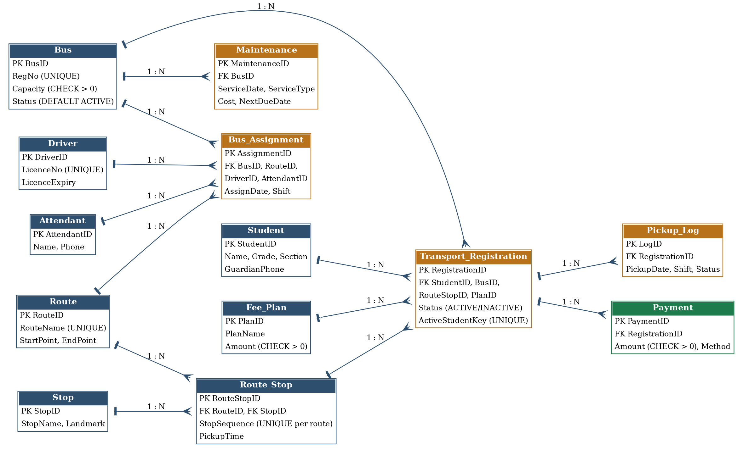
Figure 1. Entity-Relationship Diagram of the Proposed System
The database contains thirteen entities. Route_Stop resolves the many-to-many relationship between Route and Stop and gives each stop an order. Bus_Assignment records which driver and attendant operate which bus on which route and date. Transport_Registration is the active or historical link between a student, a route stop and a bus, and carries the chosen fee plan. Pickup_Log holds one attendance record per registration, day and shift, Payment records money received against a registration, and Maintenance stores the service history of each bus. The main relationships are:
- Route 1–N Route_Stop N–1 Stop (the ordered stops of each route).
- Bus 1–N Bus_Assignment N–1 Route; Driver 1–N Bus_Assignment; Attendant 1–N Bus_Assignment.
- Student 1–N Transport_Registration (one active at a time, any number in history).
- Bus 1–N Transport_Registration; Route_Stop 1–N Transport_Registration; Fee_Plan 1–N Transport_Registration.
- Transport_Registration 1–N Pickup_Log and 1–N Payment.
- Bus 1–N Maintenance.

1.7 Entity and Relationship Summary
Table 4 summarises each entity, its main attributes and cardinality, and the rule it supports.
Table 4. Entity and Relationship Summary
Entity / Relationship | Major Attributes / Cardinality | Purpose / Rule
Bus | BusID (PK), RegNo (unique), Capacity, Model, Status. Bus 1–N Bus_Assignment, Transport_Registration and Maintenance. | Master list of buses; Capacity must be positive and is the upper limit of active students.
Route | RouteID (PK), RouteName (unique), StartPoint, EndPoint. Route 1–N Route_Stop and Bus_Assignment. | Master list of routes.
Stop | StopID (PK), StopName, Landmark. Stop 1–N Route_Stop. | Master list of pickup points; stop details stored only here.
Route_Stop | RouteStopID (PK), RouteID (FK), StopID (FK), StopSequence, PickupTime. Route N–N Stop resolved here. | Gives every stop of a route its order; StopSequence is unique within a route.
Driver | DriverID (PK), Name, Phone, LicenceNo (unique), LicenceExpiry. Driver 1–N Bus_Assignment. | Stores licence validity checked at assignment time.
Attendant | AttendantID (PK), Name, Phone. Attendant 1–N Bus_Assignment. | Staff who travel on the bus and mark attendance.
Bus_Assignment | AssignmentID (PK), BusID, RouteID, DriverID, AttendantID (FKs), AssignDate, Shift. | Which crew operates which bus and route; checked by the licence trigger.
Student | StudentID (PK), Name, Grade, Section, GuardianPhone. Student 1–N Transport_Registration. | Student details stored once.
Fee_Plan | PlanID (PK), PlanName, Amount, Frequency. Fee_Plan 1–N Transport_Registration. | Transport fee amounts.
Transport_Registration | RegistrationID (PK), StudentID, BusID, RouteStopID, PlanID (FKs), Status, StartDate, ActiveStudentKey (generated). | History of student-stop-bus assignments; one ACTIVE per student; capacity trigger.
Pickup_Log | LogID (PK), RegistrationID (FK), PickupDate, Shift, Status. Registration 1–N Pickup_Log. | Daily attendance; (RegistrationID, PickupDate, Shift) is unique.
Payment | PaymentID (PK), RegistrationID (FK), Amount, PaidOn, Method. Registration 1–N Payment. | Fee collected; amount positive and limited by plan fee.
Maintenance | MaintenanceID (PK), BusID (FK), ServiceDate, ServiceType, Cost, NextDueDate. Bus 1–N Maintenance. | Service history and next due date for each bus.

CHAPTER 2
LOGICAL DATABASE DESIGN
This chapter explains how the ER model was converted into a relational design, how that design was checked up to Third Normal Form, and how it was implemented in MySQL.

2.1 Relational Schema
The ER model was mapped to tables using the usual rules. Every entity became a table, every one-to-many relationship became a foreign key on the “many” side, and the many-to-many relationship between Route and Stop was resolved by the associative table Route_Stop, which also records the order of stops [1]. Table 5 lists the thirteen relations; their primary and foreign keys are given in Section 2.2.
Table 5. Relational Schema
S.No. | Table Name | Purpose
1 | Bus | Buses with registration number, seating capacity and status.
2 | Route | Transport routes with start and end points.
3 | Stop | Pickup points with landmark.
4 | Route_Stop | Ordered stops of each route; resolves Route–Stop many-to-many.
5 | Driver | Drivers with licence number and expiry date.
6 | Attendant | Bus attendants.
7 | Bus_Assignment | Driver and attendant allotted to a bus and route for a date and shift.
8 | Student | Student details.
9 | Fee_Plan | Transport fee plans and amounts.
10 | Transport_Registration | Student-stop-bus assignment with status; keeps history.
11 | Pickup_Log | Daily pickup status of each registration.
12 | Payment | Fee payments recorded against a registration.
13 | Maintenance | Service history and next due date of each bus.
During Review 3 the Review 2 design was changed in three deliberate ways so that it could support a real application, and every change keeps the schema in 3NF:
- Transport_Registration gained a Status column and a generated ActiveStudentKey column, so that a student’s old assignments are kept as history while only one can be active.
- Pickup_Log gained a Shift column and a unique key on (RegistrationID, PickupDate, Shift), so that morning and afternoon pickups are recorded separately and never twice.
- Most foreign keys were changed from ON DELETE CASCADE to the default RESTRICT, so that deleting a bus, student or route that has history is now blocked.

2.2 Keys and Integrity Constraints
Table 6 lists the keys and constraints that the database enforces. Referential actions are RESTRICT unless stated otherwise.
Table 6. Keys and Integrity Constraints
Table Name | Key / Constraint | Attribute(s) | Business Rule Enforced
Bus | Primary Key | BusID | Each bus is identified uniquely.
Bus | Unique, Not Null | RegNo | No two buses share a registration number.
Bus | Check | Capacity | Capacity must be greater than zero.
Bus | Default | Status | Status is ACTIVE unless stated otherwise.
Route | Primary Key, Unique | RouteID; RouteName | Each route is identified uniquely and has a unique name.
Stop | Primary Key | StopID | Each pickup point is identified uniquely.
Route_Stop | Primary Key | RouteStopID | Each stop on a route is identified uniquely.
Route_Stop | Foreign Key | RouteID, StopID | A route stop must refer to an existing route and stop.
Route_Stop | Unique, Check | (RouteID, StopSequence); StopSequence > 0 | Stop order is unique and positive within a route.
Driver | Primary Key | DriverID | Each driver is identified uniquely.
Driver | Unique, Not Null | LicenceNo | A valid licence number must be recorded and cannot be shared.
Attendant | Primary Key | AttendantID | Each attendant is identified uniquely.
Bus_Assignment | Primary Key | AssignmentID | Each duty allotment is identified uniquely.
Bus_Assignment | Foreign Key | BusID, RouteID, DriverID, AttendantID | The allotment must refer to an existing bus, route, driver and attendant.
Bus_Assignment | Unique | (BusID, AssignDate, Shift) | A bus has one crew per date and shift.
Student | Primary Key | StudentID | Each student is identified uniquely.
Fee_Plan | Primary Key, Check | PlanID; Amount | Each plan is identified uniquely; amount must be positive.
Transport_Registration | Primary Key | RegistrationID | Each assignment is identified uniquely.
Transport_Registration | Foreign Key | StudentID, BusID, RouteStopID, PlanID | A student, bus, stop or plan with registrations cannot be deleted.
Transport_Registration | Check, Default | Status | Only ACTIVE or INACTIVE; default ACTIVE.
Transport_Registration | Unique | ActiveStudentKey (generated) | At most one ACTIVE registration per student.
Pickup_Log | Primary Key | LogID | Each pickup record is identified uniquely.
Pickup_Log | Foreign Key, Unique | RegistrationID; (RegistrationID, PickupDate, Shift) | One record per registration, date and shift.
Pickup_Log | Check | Status, Shift | Status is PICKED, ABSENT or MISSED; shift is MORNING or EVENING.
Payment | Primary Key, Foreign Key | PaymentID; RegistrationID | Payments belong to a registration.
Payment | Check | Amount | Amount must be greater than zero.
Maintenance | Primary Key, Foreign Key | MaintenanceID; BusID | Service records belong to a bus.
Maintenance | Check | Cost; NextDueDate | Cost cannot be negative; next due date cannot be before the service date.
Three rules cannot be written as a simple constraint, so they are enforced by triggers. The first is the capacity rule: trg_check_bus_capacity (and its twin trg_check_bus_capacity_upd for updates) runs before a registration is inserted or reactivated and rejects the row if the bus already holds as many active students as its capacity. The second is the licence rule: trg_check_driver_licence runs before every insert into Bus_Assignment and rejects the row if the driver’s licence has expired on the assignment date. The third is the payment limit: trg_check_payment_limit runs before every insert into Payment and rejects the row if the total paid would exceed the fee plan amount. The rule that records with history cannot be removed is handled by RESTRICT foreign keys together with a guarded delete in the API.

2.3 Functional Dependencies
The important functional dependencies of the design are listed below. In every case the determinant on the left is a primary or candidate key.
- Bus: BusID → RegNo, Capacity, Model, Status; RegNo → BusID
- Route: RouteID → RouteName, StartPoint, EndPoint; RouteName → RouteID
- Stop: StopID → StopName, Landmark
- Route_Stop: RouteStopID → RouteID, StopID, StopSequence, PickupTime; (RouteID, StopSequence) → RouteStopID
- Driver: DriverID → Name, Phone, LicenceNo, LicenceExpiry; LicenceNo → DriverID
- Attendant: AttendantID → Name, Phone
- Bus_Assignment: AssignmentID → BusID, RouteID, DriverID, AttendantID, AssignDate, Shift; (BusID, AssignDate, Shift) → AssignmentID
- Student: StudentID → Name, Grade, Section, GuardianPhone
- Fee_Plan: PlanID → PlanName, Amount, Frequency
- Transport_Registration: RegistrationID → StudentID, BusID, RouteStopID, PlanID, Status, StartDate
- Pickup_Log: LogID → RegistrationID, PickupDate, Shift, Status; (RegistrationID, PickupDate, Shift) → LogID
- Payment: PaymentID → RegistrationID, Amount, PaidOn, Method
- Maintenance: MaintenanceID → BusID, ServiceDate, ServiceType, Cost, NextDueDate

2.4 Normalization up to Third Normal Form (3NF)
I started from the idea of one wide “transport record” that carries student, route, stop, bus, driver, fee and attendance details together, and then removed the partial and transitive dependencies. Student details now live only in Student, bus details only in Bus, driver details only in Driver, and values that can be derived, such as a bus’s occupancy, a student’s fee due or a bus’s overdue status, are calculated by queries and views instead of being stored twice. Table 7 gives the normalisation status of every relation.
Table 7. Normalization Status up to 3NF
Relation Name | 1NF | 2NF | 3NF | BCNF | Remarks / Decomposition
Bus | ✓ | ✓ | ✓ | ✓ | Bus details kept apart from crew, registrations and maintenance.
Route | ✓ | ✓ | ✓ | ✓ | Route data separated from its stops.
Stop | ✓ | ✓ | ✓ | ✓ | Pickup point details stored once.
Route_Stop | ✓ | ✓ | ✓ | ✓ | Associative table that resolves Route–Stop (M:N) and holds stop order.
Driver | ✓ | ✓ | ✓ | ✓ | Licence details depend only on DriverID.
Attendant | ✓ | ✓ | ✓ | ✓ | Staff details separated from assignments.
Bus_Assignment | ✓ | ✓ | ✓ | ✓ | Crew and bus linked per date and shift without repeating driver details.
Student | ✓ | ✓ | ✓ | ✓ | Student details stored once, referenced by many registrations.
Fee_Plan | ✓ | ✓ | ✓ | ✓ | Fee amounts stored once instead of in every registration.
Transport_Registration | ✓ | ✓ | ✓ | ✓ | Links student, stop, bus and plan; history kept via Status.
Pickup_Log | ✓ | ✓ | ✓ | ✓ | One row per registration, date and shift; avoids repeating groups.
Payment | ✓ | ✓ | ✓ | ✓ | Allows several instalments per registration.
Maintenance | ✓ | ✓ | ✓ | ✓ | Service history separated from the bus master.

2.5 Data Dictionary
Table 8 describes the attributes of all thirteen tables. Data types are those of the MySQL implementation; the complete definitions are in Appendix A.
Table 8. Data Dictionary
Table | Attribute | Data Type | Key / Constraint | Description
Bus | BusID | INT | PK, AUTO_INCREMENT | Unique id of the bus.
Bus | RegNo | VARCHAR(20) | UNIQUE, NOT NULL | Vehicle registration number.
Bus | Capacity | INT | CHECK > 0 | Number of student seats.
Bus | Model | VARCHAR(50) |  | Make and model of the bus.
Bus | Status | VARCHAR(20) | DEFAULT ‘ACTIVE’ | ACTIVE, MAINTENANCE or RETIRED.
Route | RouteID | INT | PK, AUTO_INCREMENT | Unique id of the route.
Route | RouteName | VARCHAR(60) | UNIQUE, NOT NULL | Name of the route.
Route | StartPoint / EndPoint | VARCHAR(80) |  | First and last point of the route.
Stop | StopID | INT | PK, AUTO_INCREMENT | Unique id of the stop.
Stop | StopName | VARCHAR(80) | NOT NULL | Name of the pickup point.
Stop | Landmark | VARCHAR(100) |  | Nearby landmark.
Route_Stop | RouteStopID | INT | PK, AUTO_INCREMENT | Unique id of a stop on a route.
Route_Stop | RouteID | INT | FK → Route | Route that uses the stop.
Route_Stop | StopID | INT | FK → Stop | The pickup point.
Route_Stop | StopSequence | INT | NOT NULL, UNIQUE per route, CHECK > 0 | Order of the stop on the route.
Route_Stop | PickupTime | TIME |  | Scheduled pickup time.
Driver | DriverID | INT | PK, AUTO_INCREMENT | Unique id of the driver.
Driver | Name | VARCHAR(80) | NOT NULL | Driver name.
Driver | Phone | VARCHAR(15) |  | Contact number.
Driver | LicenceNo | VARCHAR(20) | UNIQUE, NOT NULL | Driving licence number.
Driver | LicenceExpiry | DATE | NOT NULL | Last valid date of the licence.
Attendant | AttendantID | INT | PK, AUTO_INCREMENT | Unique id of the attendant.
Attendant | Name / Phone | VARCHAR | NOT NULL (Name) | Attendant name and contact number.
Bus_Assignment | AssignmentID | INT | PK, AUTO_INCREMENT | Unique id of the duty allotment.
Bus_Assignment | BusID | INT | FK → Bus | Bus on duty.
Bus_Assignment | RouteID | INT | FK → Route | Route served.
Bus_Assignment | DriverID | INT | FK → Driver | Driver on duty.
Bus_Assignment | AttendantID | INT | FK → Attendant | Attendant on duty.
Bus_Assignment | AssignDate / Shift | DATE / VARCHAR(10) | UNIQUE with BusID | Duty date and shift.
Student | StudentID | INT | PK, AUTO_INCREMENT | Unique id of the student.
Student | Name | VARCHAR(80) | NOT NULL | Student name.
Student | Grade / Section | VARCHAR(10) |  | Class of the student.
Student | GuardianPhone | VARCHAR(15) |  | Contact number of the guardian.
Fee_Plan | PlanID | INT | PK, AUTO_INCREMENT | Unique id of the plan.
Fee_Plan | PlanName | VARCHAR(50) | NOT NULL | Name of the plan.
Fee_Plan | Amount | DECIMAL(10,2) | CHECK > 0 | Fee for the plan period.
Fee_Plan | Frequency | VARCHAR(15) | DEFAULT ‘TERM’ | MONTHLY, TERM or ANNUAL.
Transport_Registration | RegistrationID | INT | PK, AUTO_INCREMENT | Unique id of the assignment.
Transport_Registration | StudentID | INT | FK → Student | Student assigned.
Transport_Registration | BusID | INT | FK → Bus | Bus allocated.
Transport_Registration | RouteStopID | INT | FK → Route_Stop | Pickup stop on a route.
Transport_Registration | PlanID | INT | FK → Fee_Plan | Fee plan chosen.
Transport_Registration | Status | VARCHAR(10) | CHECK, DEFAULT ‘ACTIVE’ | ACTIVE or INACTIVE.
Transport_Registration | StartDate | DATE | NOT NULL | Date the assignment began.
Transport_Registration | ActiveStudentKey | INT | GENERATED, UNIQUE | StudentID while ACTIVE, otherwise NULL.
Pickup_Log | LogID | INT | PK, AUTO_INCREMENT | Unique id of the record.
Pickup_Log | RegistrationID | INT | FK → Transport_Registration | Registration being logged.
Pickup_Log | PickupDate / Shift | DATE / VARCHAR(10) | UNIQUE with RegistrationID | Day and shift of the pickup.
Pickup_Log | Status | VARCHAR(10) | CHECK (valid values) | PICKED, ABSENT or MISSED.
Payment | PaymentID | INT | PK, AUTO_INCREMENT | Unique id of the payment.
Payment | RegistrationID | INT | FK → Transport_Registration | Registration paid for.
Payment | Amount | DECIMAL(10,2) | CHECK > 0 | Amount paid.
Payment | PaidOn / Method | DATE / VARCHAR(15) |  | Date and mode of payment.
Maintenance | MaintenanceID | INT | PK, AUTO_INCREMENT | Unique id of the service record.
Maintenance | BusID | INT | FK → Bus | Bus serviced.
Maintenance | ServiceDate | DATE | NOT NULL | Date of service.
Maintenance | ServiceType | VARCHAR(40) | NOT NULL | Type of service or repair.
Maintenance | Cost | DECIMAL(10,2) | CHECK ≥ 0 | Cost of the service.
Maintenance | NextDueDate | DATE | CHECK ≥ ServiceDate | Date the next service is due.

2.6 Implementation of Logical Design: DDL and Sample Data
The design was implemented in MySQL 8.0 [3]. Table 9 summarises the implementation environment, and the rest of this section shows representative DDL, the triggers, the indexes and views, and sample records. The complete script is in Appendix A.
Table 9. Database Implementation Environment
Item | Details
DBMS | MySQL
DBMS Version | 8.0 (database name: SchoolTransportDB)
Number of Tables | 13 tables, 10 indexes, 4 triggers and 6 reporting views
Sample Data | Generated by the seed script database/seed.py: 8 stops, 3 routes, 5 buses, 4 drivers, 4 attendants, 12 students, 3 fee plans, 10 registrations, 2 days of pickup logs, 8 payments and 5 maintenance records.
Representative DDL
CREATE TABLE Bus (
BusID INT AUTO_INCREMENT PRIMARY KEY,
RegNo VARCHAR(20) NOT NULL UNIQUE,
Capacity INT NOT NULL CHECK (Capacity > 0),
Model VARCHAR(50),
Status VARCHAR(20) NOT NULL DEFAULT 'ACTIVE'
);

CREATE TABLE Route_Stop (
RouteStopID INT AUTO_INCREMENT PRIMARY KEY,
RouteID INT NOT NULL,
StopID INT NOT NULL,
StopSequence INT NOT NULL CHECK (StopSequence > 0),
PickupTime TIME,
UNIQUE (RouteID, StopSequence),
FOREIGN KEY (RouteID) REFERENCES Route(RouteID),
FOREIGN KEY (StopID) REFERENCES Stop(StopID)
);

CREATE TABLE Driver (
DriverID INT AUTO_INCREMENT PRIMARY KEY,
Name VARCHAR(80) NOT NULL,
Phone VARCHAR(15),
LicenceNo VARCHAR(20) NOT NULL UNIQUE,
LicenceExpiry DATE NOT NULL
);

CREATE TABLE Transport_Registration (
RegistrationID INT AUTO_INCREMENT PRIMARY KEY,
StudentID INT NOT NULL,
BusID INT NOT NULL,
RouteStopID INT NOT NULL,
PlanID INT NOT NULL,
Status VARCHAR(10) NOT NULL DEFAULT 'ACTIVE'
CHECK (Status IN ('ACTIVE','INACTIVE')),
StartDate DATE NOT NULL,
ActiveStudentKey INT GENERATED ALWAYS AS
(CASE WHEN Status = 'ACTIVE' THEN StudentID ELSE NULL END) STORED,
UNIQUE (ActiveStudentKey),
FOREIGN KEY (StudentID) REFERENCES Student(StudentID),
FOREIGN KEY (BusID) REFERENCES Bus(BusID),
FOREIGN KEY (RouteStopID) REFERENCES Route_Stop(RouteStopID),
FOREIGN KEY (PlanID) REFERENCES Fee_Plan(PlanID)
);
Capacity, licence and payment triggers (simplified)
DELIMITER //
CREATE TRIGGER trg_check_bus_capacity
BEFORE INSERT ON Transport_Registration FOR EACH ROW
BEGIN
DECLARE v_cap INT; DECLARE v_used INT;
IF NEW.Status = 'ACTIVE' THEN
SELECT Capacity INTO v_cap FROM Bus WHERE BusID = NEW.BusID;
SELECT COUNT(*) INTO v_used FROM Transport_Registration
WHERE BusID = NEW.BusID AND Status = 'ACTIVE';
IF v_used >= v_cap THEN
SIGNAL SQLSTATE '45000' SET MESSAGE_TEXT = 'Bus capacity exceeded';
END IF;
END IF;
END//

CREATE TRIGGER trg_check_driver_licence
BEFORE INSERT ON Bus_Assignment FOR EACH ROW
BEGIN
DECLARE v_exp DATE;
SELECT LicenceExpiry INTO v_exp FROM Driver WHERE DriverID = NEW.DriverID;
IF v_exp < NEW.AssignDate THEN
SIGNAL SQLSTATE '45000' SET MESSAGE_TEXT = 'Driver licence expired';
END IF;
END//

CREATE TRIGGER trg_check_payment_limit
BEFORE INSERT ON Payment FOR EACH ROW
BEGIN
DECLARE v_fee DECIMAL(10,2); DECLARE v_paid DECIMAL(10,2);
SELECT f.Amount INTO v_fee FROM Transport_Registration r
JOIN Fee_Plan f ON f.PlanID = r.PlanID
WHERE r.RegistrationID = NEW.RegistrationID;
SELECT COALESCE(SUM(Amount), 0) INTO v_paid FROM Payment
WHERE RegistrationID = NEW.RegistrationID;
IF v_paid + NEW.Amount > v_fee THEN
SIGNAL SQLSTATE '45000' SET MESSAGE_TEXT = 'Payment exceeds plan fee';
END IF;
END//
DELIMITER ;
Indexes and views
Ten indexes were created on the columns that are searched or joined most often: active registrations by bus (BusID, Status), registrations by route stop, pickup logs by (PickupDate, Status), payments by registration, bus assignments by (AssignDate, BusID) and by driver, maintenance by (BusID, NextDueDate), driver licence expiry, student name search and student grade and section. Six reporting views sit on top of these tables and feed the reports described in Section 3.6: vw_RouteList, vw_BusCapacityUtilisation, vw_AbsentStudents, vw_FeeDues, vw_DriverAssignments and vw_MaintenanceStatus.
Sample data
The seed script rebuilds the database from the DDL and fills it with representative data, so that both the demonstration and the tests run on a consistent dataset. The records below illustrate the one-active-assignment rule: student 3 has an old INACTIVE registration on Route A and a current ACTIVE registration on Route B, and the generated key is filled only for the active row.
RegistrationID | StudentID | BusID | RouteStopID | Status | ActiveStudentKey
3 | 3 | 1 | 2 | INACTIVE | NULL
9 | 3 | 2 | 5 | ACTIVE | 3

CHAPTER 3
APPLICATION DEVELOPMENT USING LOGICAL DATABASE DESIGN

3.1 Application Overview
The application is used by the transport in-charge, who sets up routes, stops, buses and crews and assigns students; by the fee clerk, who collects fees; by attendants and teachers, who mark pickup attendance; and by the maintenance supervisor, who enters service records. It follows a three-tier architecture made up of a presentation tier, an application tier and a data tier, built with Flask [4]. The browser never talks to the database directly; every request goes through the Flask API, which validates it and runs the required SQL inside transactions. Nothing on screen is static: every list, form and report is read from or written to the MySQL database. Figure 2 shows the architecture.
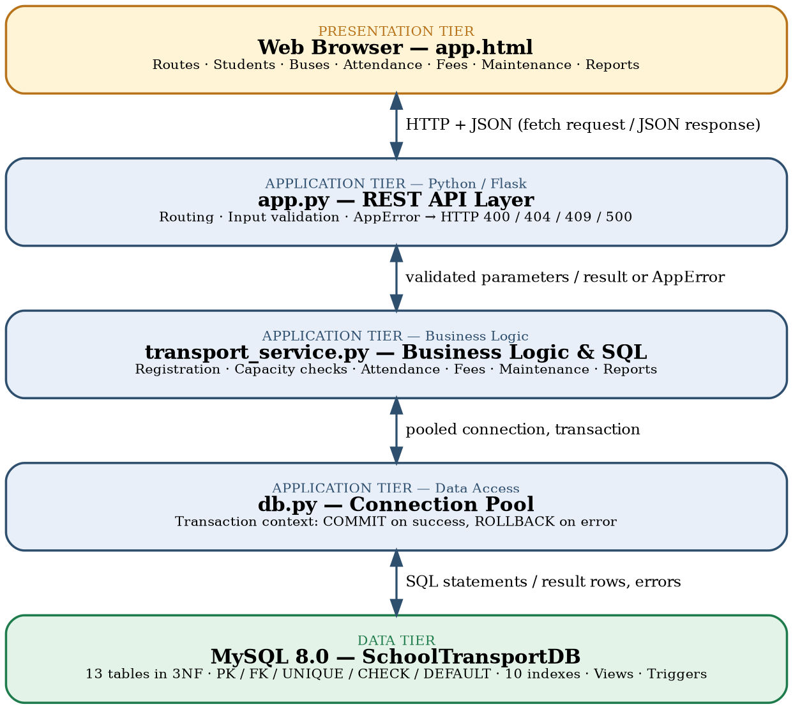
Figure 2. Three-tier System Architecture
Presentation tier: app.html
The front end is a single web page with screens for route and stop setup, student-stop assignment, bus allocation, daily pickup attendance, fee collection, maintenance entry, master-data management and reports with a dashboard. It talks to the backend only by sending JSON requests over HTTP and shows any error message the server returns.
Application tier: app.py (API layer)
This module defines the REST endpoints, reads the request parameters and calls the matching function in the business-logic module. It also handles errors in one place: a typed AppError raised anywhere in the backend is converted into the right HTTP status code, and any unexpected exception is logged and returned as a JSON 500 error.
Application tier: transport_service.py (business logic)
All SQL statements and business rules are kept in this module: route and stop setup, student registration with capacity checks, bus and crew allocation, pickup attendance, fee collection, maintenance entry, guarded CRUD operations and the reporting queries. Keeping all SQL in one place makes the logic easier to review and test.
Application tier: db.py (data access)
This module manages a pool of database connections and provides a context manager for transactions. Every unit of work runs inside it: when the work finishes the transaction is committed, and if any exception is raised the transaction is rolled back automatically.
Data tier: MySQL 8.0
The SchoolTransportDB database stores the thirteen tables in 3NF together with their constraints, ten indexes, the triggers and the reporting views.

3.2 Development Environment and Database Connectivity
Table 10 lists the tools used to develop the application.
Table 10. Application Development Environment
Item | Details
Programming Language | Python (backend); JavaScript (front end)
DBMS | MySQL 8.0 (database: SchoolTransportDB)
IDE / Framework / GUI Toolkit | Flask web framework; HTML, CSS and JavaScript front end (app.html) using fetch() to call the JSON API
Database Connector / Driver | MySQL connector with a connection pool (db.py)
Operating Environment | Browser-based front end; the Flask server runs on any system with Python and MySQL 8.0
Testing and Sample Data | Python black-box API tests (tests/test_api.py); seed script (database/seed.py)
Repository Link | GitHub: [add your repository URL here]
Database connectivity is handled by db.py. It opens a pool of connections through the connector, which follows the Python Database API specification [5], and hands them out through a context manager. The service layer asks for a connection, runs its SQL and leaves the commit or rollback decision to the context manager, so no function can forget to close a transaction.

3.3 Application Modules and Database Mapping
Table 11 maps every module of the application to the tables it uses.
Table 11. Application Module-to-Database Mapping
Module / Screen | Purpose | Tables Used | Main Operations
Route Setup | Create routes and add stops in sequence. | Route, Stop, Route_Stop | INSERT, SELECT, UPDATE, guarded DELETE
Student-Stop Assignment | Register a student on a route stop with a bus and fee plan. | Student, Route_Stop, Bus, Fee_Plan, Transport_Registration | INSERT in one transaction, capacity check, UPDATE of old registration
Bus Allocation | Assign bus, driver and attendant for a date and shift. | Bus, Route, Driver, Attendant, Bus_Assignment | INSERT with licence check, SELECT with joins
Pickup Attendance | Mark picked up, absent or missed for each active registration. | Transport_Registration, Student, Pickup_Log | INSERT, UPDATE, SELECT
Fee Collection | Record payments and show dues. | Transport_Registration, Fee_Plan, Payment | INSERT with limit check, locking read, SELECT with aggregates
Maintenance Entry | Log service records and show next due dates. | Bus, Maintenance | INSERT, SELECT
Master Data | Maintain buses, drivers, attendants, students, stops and fee plans. | Bus, Driver, Attendant, Student, Stop, Fee_Plan | INSERT, SELECT, UPDATE, guarded DELETE
Reports / Dashboard | Route lists, capacity, absentees, dues, assignments and maintenance status. | Views and base tables | SELECT with joins, GROUP BY and HAVING

3.4 CRUD Operations
Table 12 shows where each CRUD operation appears in the application and the screenshot that provides the evidence.
Table 12. CRUD Operations
Operation | Application Feature / Screen | Table(s) Affected | Evidence
Create | Adding a route, stop, student, registration, assignment, payment or maintenance record | Master tables, Route_Stop, Transport_Registration, Bus_Assignment, Payment, Maintenance | Figure 5, Figure 6, Figure 8, Figure 9
Read / Search | Route list, student search, attendance sheet, dues, reports and dashboard | All tables through joins and views | Figure 7, Figure 10
Update | Editing master data; moving a student to another stop or bus; marking attendance | Master tables, Transport_Registration, Pickup_Log | Figure 6, Figure 7
Delete / Controlled Removal | Deleting master records through the guarded delete; ending a registration by marking it INACTIVE | Master tables, Transport_Registration | Table 15 (TC-13)

3.5 Business Rules, Validation and Error Handling
Every endpoint validates its input before touching the database: required parameters, numeric types, positive capacities and amounts, valid dates and allowed status values. Problems are raised as a typed AppError, which app.py converts into the correct HTTP status code (400 for invalid input, 404 for a missing record, 409 for a conflict or blocked delete, and 500 for anything unexpected, which is also logged on the server). The interface therefore always receives a structured JSON error and never a raw stack trace. Destructive actions are protected twice, by the guarded delete in the API and by RESTRICT foreign keys in the database, and every multi-step change runs inside a transaction that is rolled back on error. Table 13 lists the main rules.
Table 13. Business Rules, Validation and Error Handling
Rule / Validation | How Implemented | Evidence / Message
Required fields present; capacity and amounts positive | Checked in the API before any SQL is run, plus CHECK constraints | HTTP 400 Bad Request with a JSON message
A bus cannot carry more active students than its capacity | Count in the registration logic and trigger trg_check_bus_capacity | Insert rejected; conflict returned as HTTP 409
One active assignment per student | UNIQUE constraint on generated ActiveStudentKey; old registration set INACTIVE inside the transaction | HTTP 409 if a second active row is attempted
Stop sequence unique within a route | UNIQUE (RouteID, StopSequence) | HTTP 409 with a clear message
Driver licence valid on duty date | Trigger trg_check_driver_licence | Insert rejected; HTTP 409
Payments positive and within plan fee | CHECK (Amount > 0) and trigger trg_check_payment_limit | HTTP 400 for non-positive amount; HTTP 409 when the limit is exceeded
One attendance record per registration, date and shift | UNIQUE (RegistrationID, PickupDate, Shift) | HTTP 409 for a duplicate record
A change is all-or-nothing | db.py context manager commits on success and rolls back on any error | No partial rows after a failure
Records with history cannot be deleted | Guarded-delete helper plus RESTRICT foreign keys | HTTP 409 Conflict with a clear message
Unexpected failures | Logged on the server and returned as structured JSON | HTTP 500 Internal Server Error

3.6 Reports and Database Operations
Table 14 lists the main reports and database operations of the application and the SQL concept behind each one.
Table 14. Reports and Database Operations
Report / Operation | SQL / Database Concept Used | Application Output
Route list | Join of Route, Route_Stop and Stop ordered by StopSequence | Each route with its stops in order and pickup times
Capacity utilisation | LEFT JOIN with COUNT and GROUP BY on active registrations; view vw_BusCapacityUtilisation | Active students, capacity and utilisation percentage per bus
Absent students | Join of Pickup_Log, Transport_Registration and Student; GROUP BY and HAVING for repeat absentees; view vw_AbsentStudents | Students absent on a date, and students absent repeatedly
Fee dues | LEFT JOIN of registrations with Payment; SUM; HAVING due > 0; view vw_FeeDues | Fee, amount paid and balance due per student
Driver assignments | Join of Bus_Assignment with Driver, Attendant, Bus and Route; view vw_DriverAssignments | Crew and bus allotment per date and shift
Maintenance status | MAX over Maintenance with CASE; nested query for buses never serviced; view vw_MaintenanceStatus | Last service, next due date and OVERDUE or OK flag per bus
Representative report queries
-- Route list: ordered stops of every route (join)
SELECT r.RouteName, rs.StopSequence, s.StopName, rs.PickupTime
FROM Route r
JOIN Route_Stop rs ON rs.RouteID = r.RouteID
JOIN Stop s ON s.StopID = rs.StopID
ORDER BY r.RouteName, rs.StopSequence;

-- Capacity utilisation per bus (aggregate, view)
CREATE VIEW vw_BusCapacityUtilisation AS
SELECT b.BusID, b.RegNo, b.Capacity,
COUNT(r.RegistrationID) AS ActiveStudents,
ROUND(100 * COUNT(r.RegistrationID) / b.Capacity, 1) AS UtilisationPct
FROM Bus b
LEFT JOIN Transport_Registration r
ON r.BusID = b.BusID AND r.Status = 'ACTIVE'
GROUP BY b.BusID, b.RegNo, b.Capacity;

-- Students absent two or more times (aggregate with HAVING)
SELECT st.Name, st.Grade, COUNT(*) AS AbsentDays
FROM Pickup_Log p
JOIN Transport_Registration r ON r.RegistrationID = p.RegistrationID
JOIN Student st ON st.StudentID = r.StudentID
WHERE p.Status = 'ABSENT'
GROUP BY st.StudentID, st.Name, st.Grade
HAVING COUNT(*) >= 2;

-- Fee dues per active registration (join, aggregate)
SELECT st.Name, f.Amount AS Fee,
COALESCE(SUM(p.Amount), 0) AS Paid,
f.Amount - COALESCE(SUM(p.Amount), 0) AS Due
FROM Transport_Registration r
JOIN Student st ON st.StudentID = r.StudentID
JOIN Fee_Plan f ON f.PlanID = r.PlanID
LEFT JOIN Payment p ON p.RegistrationID = r.RegistrationID
WHERE r.Status = 'ACTIVE'
GROUP BY r.RegistrationID, st.Name, f.Amount
HAVING Due > 0;

-- Buses never serviced (nested query)
SELECT RegNo FROM Bus
WHERE BusID NOT IN (SELECT BusID FROM Maintenance);

-- Maintenance status per bus
SELECT b.RegNo, MAX(m.ServiceDate) AS LastService,
MAX(m.NextDueDate) AS NextDue,
CASE WHEN MAX(m.NextDueDate) < CURDATE()
THEN 'OVERDUE' ELSE 'OK' END AS ServiceStatus
FROM Bus b
JOIN Maintenance m ON m.BusID = b.BusID
GROUP BY b.BusID, b.RegNo;
Student registration and bus allocation
The transport in-charge selects a student, a route and stop, a bus and a fee plan. The inputs are validated first: every field must be filled in, the stop must belong to the chosen route, and the bus must be active. Then these steps run inside one transaction:
- The student, stop, bus and fee plan are looked up and the Bus row is locked with SELECT … FOR UPDATE.
- Any older ACTIVE registration of the same student is set to INACTIVE so that history is kept.
- The new Transport_Registration row is inserted as ACTIVE; the capacity trigger counts the active students of the bus and refuses the row if the bus is full.
- If every step succeeds the transaction is committed; otherwise it is rolled back and the user sees a clear error message.
Figure 3 shows the flow.
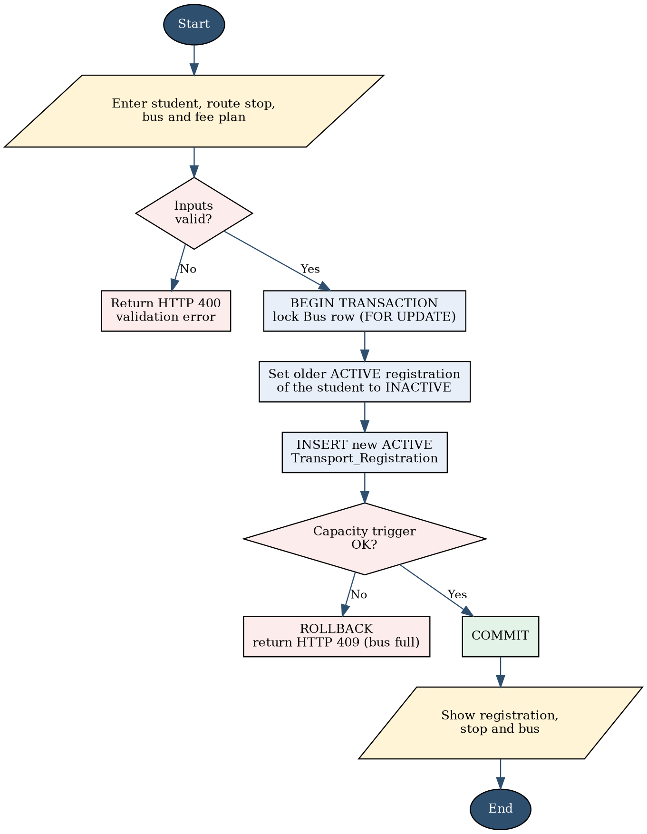
Figure 3. Flowchart of Student-Stop Registration and Bus Allocation
Pickup attendance and fee collection
For attendance, the screen lists every active registration of the selected bus, date and shift, and the attendant marks each student as picked up, absent or missed. The unique key on (RegistrationID, PickupDate, Shift) makes sure that a student is never logged twice for the same shift, and a repeated entry returns HTTP 409.
For fee collection, the clerk enters the registration and the amount. The system starts a transaction, locks the registration row with SELECT … FOR UPDATE, checks that the amount is positive, inserts the Payment row, and lets the trigger refuse the row if the total paid would exceed the fee plan amount. The balance due is then recalculated from the Payment table, not stored. Figure 4 shows the flow.
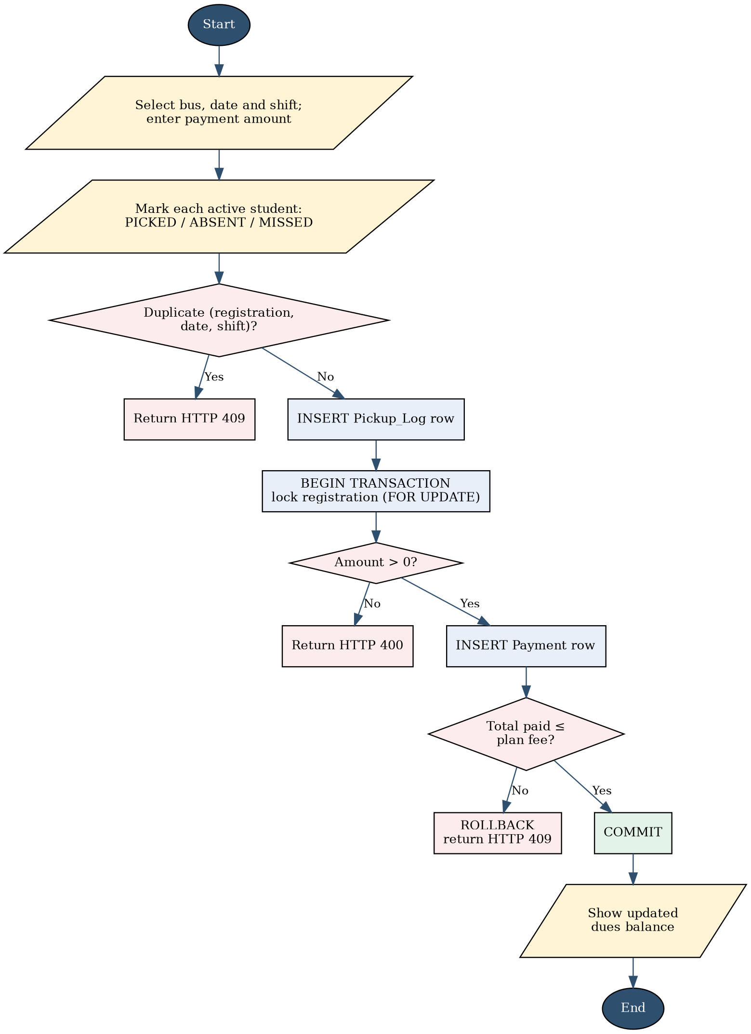
Figure 4. Flowchart of Pickup Attendance and Fee Collection

3.7 Application Screens
The screens below show the application working against the live database. They cover data entry, search and display, update, the transactions of the system (registration and payment), attendance, maintenance and the reports.
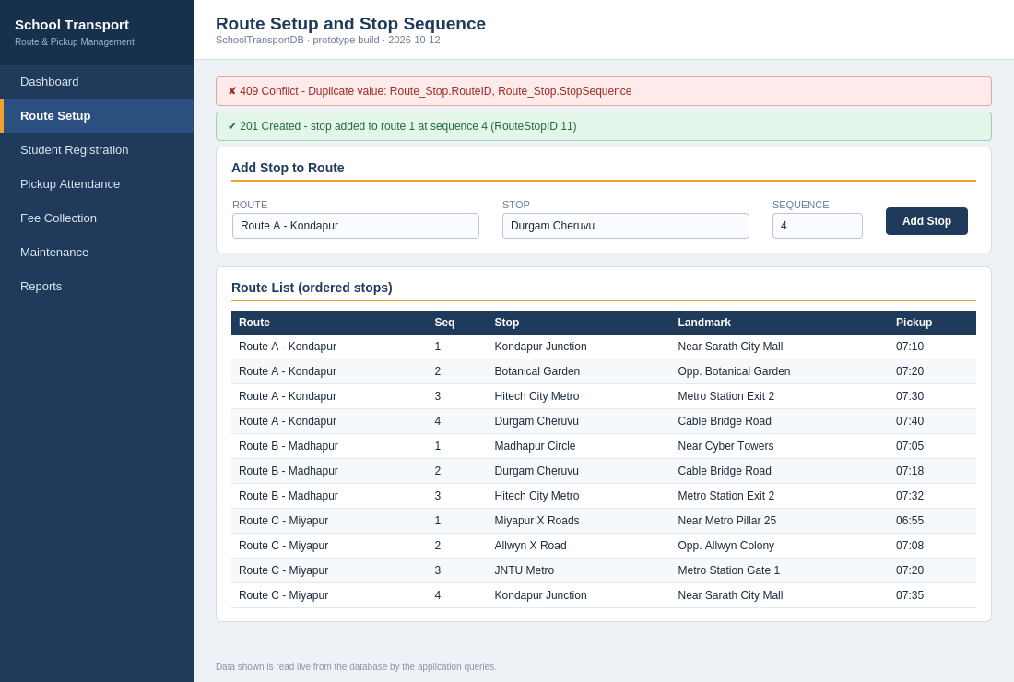
Figure 5. Route Setup and Stop Sequence Screen
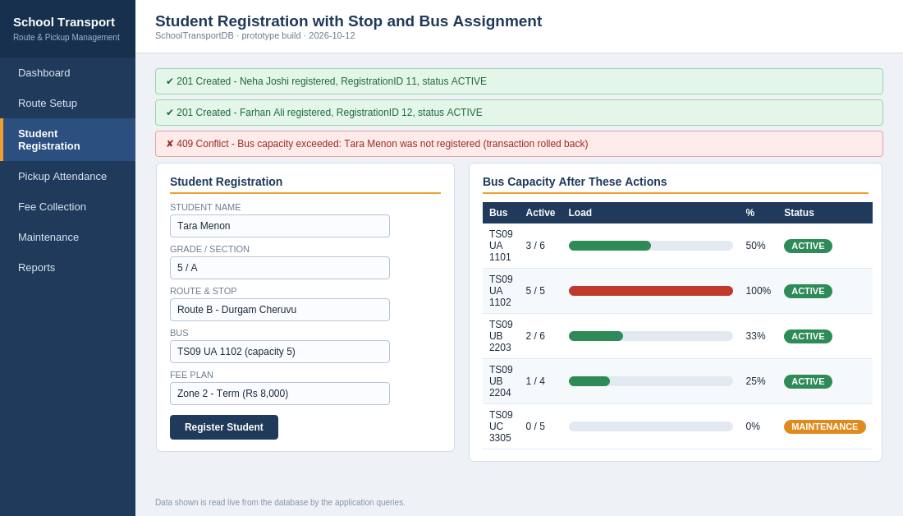
Figure 6. Student Registration with Stop and Bus Assignment
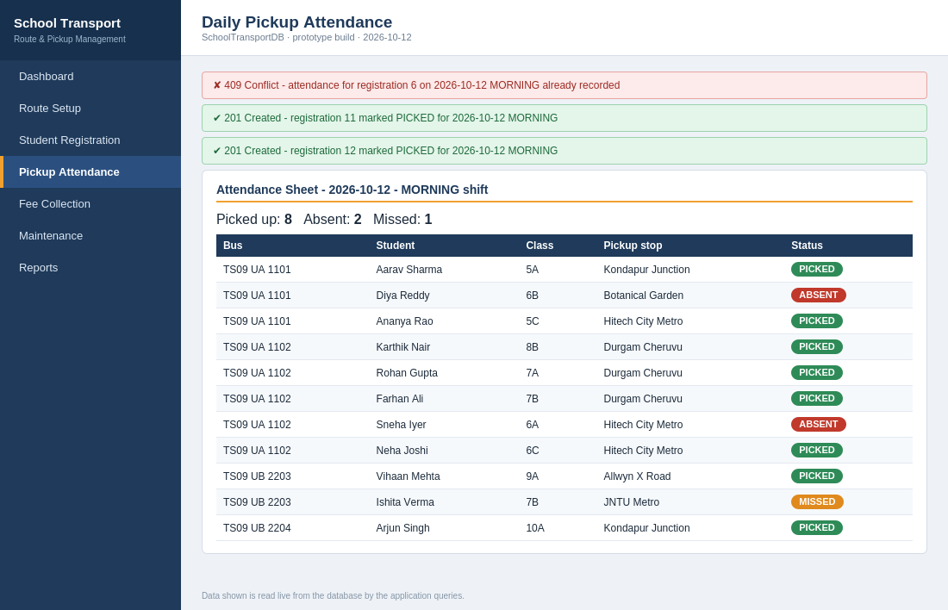
Figure 7. Daily Pickup Attendance Screen
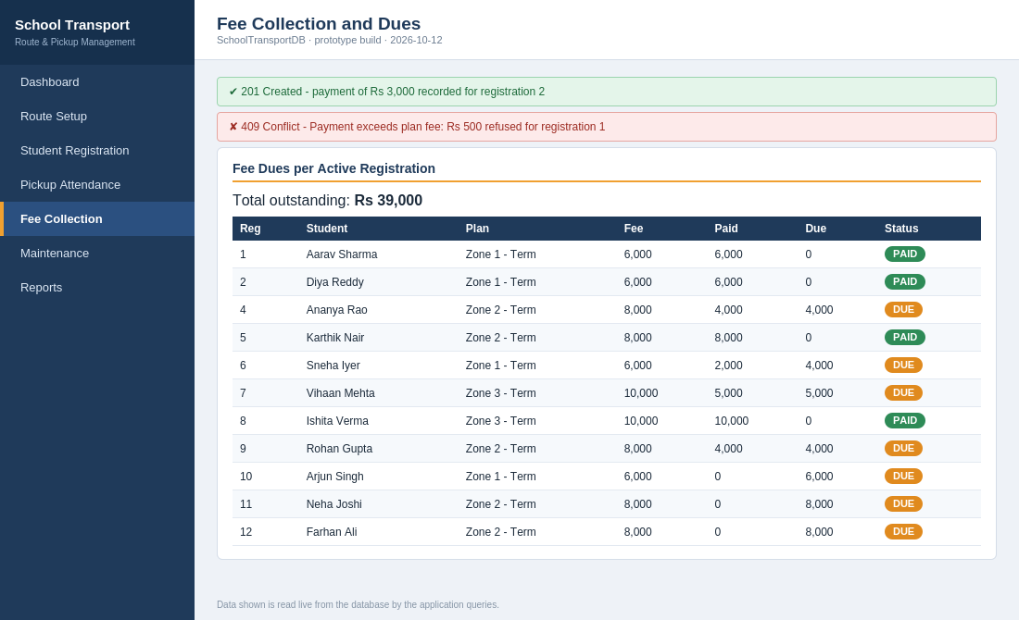
Figure 8. Fee Collection and Dues Screen
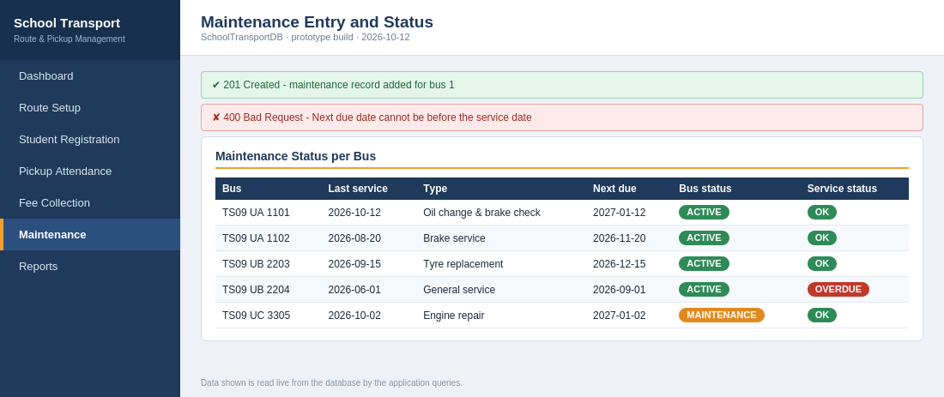
Figure 9. Maintenance Entry and Status Screen
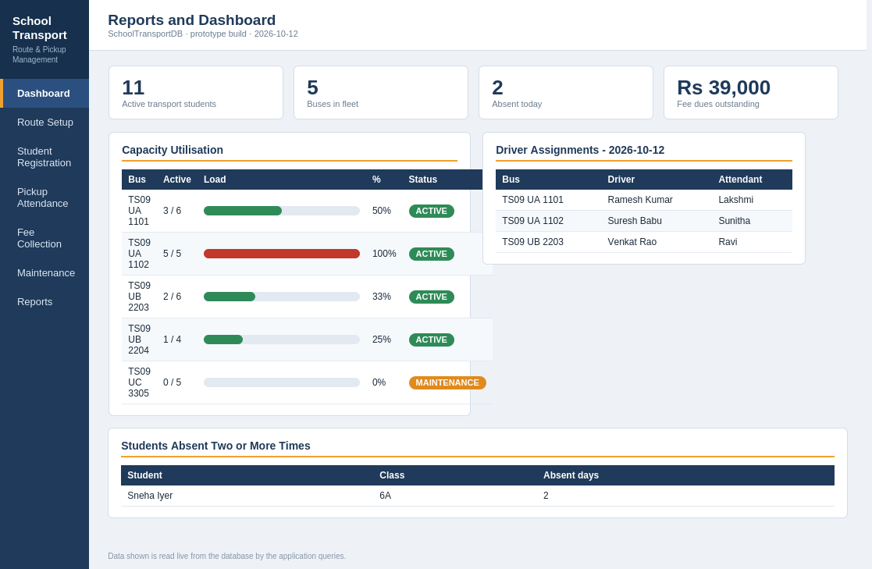
Figure 10. Reports and Dashboard

3.8 Testing and Results
The application is tested with positive and negative cases by calling its REST API against the seeded database. Table 15 lists the cases and the expected results. The Actual Result and Status columns are left blank on purpose and must be filled in from your own test run before submission.
Table 15. Test Cases
Test ID | Feature | Input / Action | Expected Result | Actual Result | Status
TC-01 | Bootstrap data | GET /api/bootstrap | HTTP 200 with routes, stops, buses and fee plans from the database | [record] | [ ]
TC-02 | Dashboard | GET /api/dashboard | HTTP 200 with student, bus and dues counts | [record] | [ ]
TC-03 | Route list | GET /api/routes/1/stops | HTTP 200 with stops ordered by StopSequence | [record] | [ ]
TC-04 | Unique stop sequence | POST /api/routes/1/stops with a sequence already used | HTTP 409; nothing is inserted | [record] | [ ]
TC-05 | Registration | POST /api/registrations for a student with no active registration | HTTP 201; registration ACTIVE | [record] | [ ]
TC-06 | One active assignment | POST /api/registrations again for the same student without ending the first | Old registration set INACTIVE and new one ACTIVE, or HTTP 409 if inserted directly in SQL | [record] | [ ]
TC-07 | Bus capacity | Register one more student on a bus that is already full | HTTP 409, “Bus capacity exceeded” | [record] | [ ]
TC-08 | Driver licence | POST /api/assignments with a driver whose licence has expired | HTTP 409, “Driver licence expired” | [record] | [ ]
TC-09 | Pickup attendance | POST /api/pickups, then the same registration, date and shift again | 201 first time; 409 for the duplicate | [record] | [ ]
TC-10 | Payment | POST /api/payments with an amount within the plan fee | HTTP 201; dues reduced | [record] | [ ]
TC-11 | Payment limit and validation | Payment above the plan fee; payment with amount 0 or negative | HTTP 409 for the excess; HTTP 400 for the invalid amount | [record] | [ ]
TC-12 | Maintenance validation | POST /api/maintenance with NextDueDate before ServiceDate | HTTP 400; record rejected | [record] | [ ]
TC-13 | CRUD and integrity | Create, update and delete a new bus; delete a bus that has registrations | 201, 200, 200 for the new bus; 409 for the bus with history | [record] | [ ]
[After recording the results, replace this line with a short summary: how many of the 13 cases passed, which business rules were demonstrated, and which flows are not covered by the table.]

CHAPTER 4
CONCLUSION
This project took a School Transport Route and Student Pickup Management System from a conceptual ER model to a working, database-backed application over three reviews. The schema was refined step by step and kept in Third Normal Form, and the most important rules of the domain, namely bus-capacity limits, one active assignment per student, unique stop sequences, valid driver licences and payment limits, are enforced inside the database through constraints and triggers. Data correctness therefore does not depend on the application alone.
The final three-tier system, made up of a web front end, a Flask application layer and a live MySQL database, supports route and stop setup, student-stop assignment, bus allocation, pickup attendance, fee collection, maintenance entry and reporting. It is backed by integrity constraints, indexes, transactions with row locking, safe deletion rules, input validation, structured error handling and automated tests. For me, the project showed the core database ideas of normalisation, integrity, indexing and transaction management working together in one application, and it gives a solid base for later improvements.

4.1 Limitations and Future Enhancements
- Locking is applied to bus and registration rows, but heavy concurrent registration on the same bus could still be made safer with stricter isolation levels or a dedicated seat counter.
- Business logic is written in Python; moving frequently used operations into stored procedures could reduce round trips to the database.
- The system has no user login or role-based access, so transport, fee, attendance and maintenance functions are not separated by authentication.
- Payments are only recorded and not processed; integrating an online payment gateway would complete the fee cycle.
- Live bus tracking, parent notifications by SMS or app, and automatic reminders for licence expiry and overdue servicing are natural next steps.

REFERENCES
[1] R. Elmasri and S. B. Navathe, Fundamentals of Database Systems, 7th ed. Pearson, 2016.
[2] Government of India, The Motor Vehicles Act, 1988 (provisions on driving licences and their validity). [Add the exact source link and access date you used.]
[3] Oracle Corporation, MySQL 8.0 Reference Manual. [Online]. Available: https://dev.mysql.com/doc/refman/8.0/en/ (Accessed: [date])
[4] Pallets, Flask Documentation. [Online]. Available: https://flask.palletsprojects.com/ (Accessed: [date])
[5] Python Software Foundation, “PEP 249: Python Database API Specification v2.0.” [Online]. Available: https://peps.python.org/pep-0249/ (Accessed: [date])

APPENDICES
APPENDIX A - COMPLETE DATABASE SCRIPT
The complete database script is submitted with this report in the database folder of the project. It contains the DDL for all thirteen tables with their constraints, the ten indexes, the triggers trg_check_bus_capacity, trg_check_bus_capacity_upd, trg_check_driver_licence and trg_check_payment_limit, and the six reporting views, together with the seed-data generator database/seed.py, which rebuilds the database and loads the sample data.
APPENDIX B - APPLICATION SOURCE CODE
The source code is organised as follows. The repository link is given in Table 10.
- app.py: Flask routes and conversion of errors into HTTP responses.
- transport_service.py: all SQL and business logic.
- db.py: pooled connections and the transaction context manager.
- app.html: single-page front end (HTML, CSS and JavaScript).
- database/seed.py: database rebuild and sample-data generator.
- tests/test_api.py: automated black-box API tests.
Repository: GitHub [add your repository URL here]
APPENDIX C - ADDITIONAL TEST DATA AND OUTPUTS
Worked example of the capacity check. Take a mini bus with Capacity = 20 that already has 20 ACTIVE registrations. The capacity trigger counts the active rows (v_used = 20) and compares them with the capacity (v_cap = 20):
- A new ACTIVE registration for this bus: 20 >= 20 is true, so the insert is refused with “Bus capacity exceeded”.
- A new INACTIVE registration for the same bus (history only): the trigger skips the check because the status is not ACTIVE, so the row is accepted.
- After one student is moved to another bus, the count falls to 19, 19 >= 20 is false, and a new ACTIVE registration is accepted.
Worked example of the one-active-assignment rule. For student 3, ActiveStudentKey equals StudentID only while Status is ACTIVE:
- Registration 3 (INACTIVE): ActiveStudentKey = NULL, so it never conflicts with another row.
- Registration 9 (ACTIVE): ActiveStudentKey = 3, which is allowed because no other row has the key 3.
- A new ACTIVE registration for student 3 would also get the key 3 and be rejected by the UNIQUE constraint, unless the older ACTIVE row is first set to INACTIVE inside the same transaction.
Worked example of the payment limit. Take a registration on a plan with Amount = 8000 and 5000 already paid. A payment of 3000 gives a total of 8000, which does not exceed the fee and is accepted, leaving a due balance of 0. A further payment of 500 would make the total 8500, which exceeds 8000, so trg_check_payment_limit refuses it.

