RESEARCH PAPER ON

**SOIL MOISTURE PREDICTION**

**ABSTRACT –** Soil moisture is a crucial factor in agriculture and environmental monitoring.Predicting it accurately allows for informed decisions on irrigation, flood control, and drought mitigation. This work explores the application of Long Short-Term Memory (LSTM) networks for soil moisture prediction.

LSTMs are a type of recurrent neural network (RNN) adept at handling sequential data. Their strength lies in capturing long-term dependencies within time series, making them suitable for modeling soil moisture dynamics. This abstract outlines the potential of LSTMs for soil moisture prediction:

Data-Driven Approach: LSTMs can learn from historical data of soil moisture and relevant environmental factors like precipitation, temperature, and humidity. This data-driven approach eliminates the need for complex physical models.

Time Series Modeling: LSTMs excel at processing sequential data, allowing them to incorporate past soil moisture readings into predictions. This capability is essential for capturing the temporal evolution of soil moisture.

Improved Accuracy: Compared to traditional methods, LSTMs have shown promising results in achieving higher accuracy in soil moisture prediction.

Flexibility: LSTMs can be adapted to various scenarios by incorporating additional relevant factors or using different network architectures.

This abstract highlights the potential of LSTMs as a powerful tool for soil moisture prediction. By leveraging their ability to learn from data and capture long-term dependencies, LSTMs can contribute to advancements in precision agriculture and environmental monitoring.

**OBJECTIVE –**

1. **Improved Water Management:**

By accurately predicting soil moisture, farmers can optimize irrigation practices. This leads to:

* Reduced water waste: Irrigation can be applied only when necessary, conserving this valuable resource.
* Improved crop yields: Maintaining optimal soil moisture levels promotes healthy plant growth and potentially increases crop yields.

**B.** **Drought Monitoring:** LSTM models can be used to monitor soil moisture trends and identify areas at risk of drought. This allows for early intervention and mitigation strategies.

**C.Flood forecasting:** In conjunction with other weather data, soil moisture predictions can contribute to flood forecasting models.

**D. Management of Irrigation** -. It enables you to locate flood-prone zones and fields that require crop irrigation.   
  
Reduced crop losses are possible when water stress is identified early on. Large agricultural output can save thousands of dollars per season with this feature. Agricultural consultants can also benefit from the identification of water stress in plants. They are able to promptly identify the issue and notify customers thanks to this functionality.

**1.INTRODUCTION -**The most important factor in agriculture is soil moisture. Plants may perish from a lack of water or an excess of it. This data is dependent on numerous external elements at the same time, chief among them being variations in the weather and climate. This is why knowing the best techniques for determining the moisture content of soil is so important. Modern satellite technology gives farmers a plethora of possibilities in addition to conventional sensors. The project aims to predict soil moisture using LSTM neural network. The Significance Of Soil Moisture In Agriculture

The metric is essential for regulating the water supply, anticipating natural calamities, and keeping an eye on farming activities. This data might predict a flood or water shortage before other indications do.

The effects of soil moisture –

temperature and the ground's heat capacity; the composition, salinity, and quantity of harmful compounds; and the structure and thickness of the ground.   
This characteristic also establishes if the field is ready for agricultural processing and prevents deterioration. These scenarios highlight the need of measuring soil moisture.

Accurate prediction of soil moisture is essential for efficient irrigation practices, flood control strategies, and drought mitigation efforts. Traditionally, soil moisture prediction has relied on physical models or statistical methods. However, these approaches often require complex parameterization or struggle to capture the inherent non-linear dynamics of soil moisture behavior.

This work investigates the application of Long Short-Term Memory (LSTM) networks for soil moisture prediction. LSTMs are a powerful type of recurrent neural network (RNN) that excel at processing sequential data. Their unique architecture allows them to learn long-term dependencies within time series, making them particularly well-suited for modeling the temporal evolution of soil moisture.

**2. LITERATURE REVIEW:**

**1.Remote sensing to predict soil moisture tension in water saving rice systems of temperate**

**South-Eastern Australia**

Soil moisture tension refers to how tightly water is held to the soil and is measured in units of pressure.  
  
The soil is a typical rice growing soil in the region, classified as a self-mulching clay with a 30 cm brown A horizon over a dense red B horizon.  
  
32 The rate of soil drying decreases over time as the vapor pressure at the soil surface nears that of the atmospheric vapor pressure.  
  
Soil evaporation is highest in wet soils and decreases with declining moisture availability.  
  
Due to increasing canopy cover slowing the rate of soil evaporation and increasing the time taken for soil to transition from saturated to non-saturated,32,43 NDVI was used as a proxy measure to account for the change in canopy cover experienced throughout the season.  
  
The different rate of SMT decline is likely a result of the residual stubble from the winter cereal grown prior to rice in year 1 acting as a mulching layer to slow the exchange of water between the soil and atmosphere by buffering the soil surface temperature, reducing the heat flux, and therefore reducing soil evaporation losses in year 1.32 Rice stubble was burned prior to seeding in year 2, a practice known to increase soil evaporation.  
  
"Impacts of variable soil drying in alternate wetting and drying rice systems on yields, grain arsenic concentration and soil moisture dynamics," Field Crop [1].

**2.NEURAL NETWORK MODEL OF SOIL MOISTURE FORECAST NORTH KAZAKHSTAN REGION**

The research focuses on predicting soil moisture in the North Kazakhstan region using a neural network model. The study aims to develop an artificial neural network that can accurately forecast the stored soil moisture in a short-term period. The researchers collected data from agrometeorological measuring stations from 2012 to 2022 and used the Levenberg-Marquardt algorithm for network training. They built seven neural networks with different input and output data and varying numbers of learning iterations. Through analysis, they selected the best network, ANN6, which showed the lowest mean squared error (MSE) and the highest correlation with actual data. The results demonstrated the effectiveness of the neural network model in predicting soil moisture and its potential for making efficient decisions in the agricultural sector of the North Kazakhstan region.

* The research aims to develop an artificial neural network model for predicting stored soil moisture in the North Kazakhstan region.
* The Levenberg-Marquardt algorithm is used for network training, and seven neural networks with different characteristics are created.
* The best network, ANN6, has the lowest mean squared error (MSE) and the highest correlation with actual data.
* The neural network model shows promise in making accurate predictions and can help make efficient decisions in the agricultural sector.
* The study highlights the importance of soil moisture forecasting for planning crop production areas, adjusting plant-growing programs, and determining seeding time and irrigation schedules[2].

**3.Dynamic Neural Network Modelling of Soil Moisture Content for Predictive Irrigation Scheduling**

Applied a system identification model in predicting the soil moisture deficit using climatic and soil moisture data as model inputs.  
  
The authors reported that the models achieved a prediction performance comparable to that of a mechanistic physical process-based model: HYDRUS-2D. However, they noted that these machine learning models are not suitable for the entire range of soil moisture prediction i.e., water stress conditions.  
  
The NN models trained on data from the sites listed in Table 1 were also applied in predicting the soil moisture content in two independent sites with soil characteristics similar to that of the sites for which the models were trained.  
  
In order to demonstrate the applicability of a trained LSTM for predictive irrigation scheduling, the AQUACROP model developed by the Food and Agricultural Organization was used in simulating soil-plant-atmosphere interactions for the potato crop [73-75]. The AQUACROP model has been widely validated and is able to simulate soil moisture dynamics and crop response to water deficits across various soil types as a function of climatic inputs and water availability [76-79]. Climatic and rainfall data for the model training sites were used as inputs into the AQUACROP model.  
  
Model Model Evaluation Evaluation Criteria Criteria To To assess assess the the performance performance of of the the trained trained models models for for the the prediction prediction of of the the soil soil moisture moisture content content during the model evaluation, several measures of accuracy were applied  
  
Model Structure The model structure and hyper-parameters of the neural network models were determined through a five-fold cross-validation on the training dataset.  
  
The development of crop-specific LSTM models trained on a rich dataset obtained from sites with similar soil types will enhance the adoption of data-driven soil moisture models for use in irrigation scheduling applications[3].

**4.Analysis of the need for soil moisture, salinity and temperature sensing in agriculture: a case study in Poland**

These were farms of various sizes and production types: three large-area farms mainly engaged in the production of agricultural crops; three large-area and three smaller farms focused on the production of vegetables; four fruit farms; as well as two farms growing hops.  
  
In total, the sample of surveyed farmers declared a demand for 2905 probes, and most of them said they would build a system for monitoring soil properties in their farm in the future.  
  
The size of the farm was not a very important premise that farmers followed when declaring their willingness to purchase equipment for the ongoing assessment of soil properties.  
  
Farmers' expectations regarding the functionality of the probes were related to the size of their farms.  
  
The expectations of the farmers of the smallest farms and large farms were the most divergen.  
  
The requirements of owners of farms with a smaller area, up to 400 ha, differed from the requirements of farmers running production on farms with a large area.  
  
Regardless of the production sector, farm size or region, farmers emphasized the need for ongoing monitoring of soil properties, mainly moisture, temperature and salinity[4].

**5.Evaluation of MODIS NDVI and LST for indicating soil moisture of forest areas based on SWAT modelling**

This study evaluated the capability of using remotely sensed information from MODIS (moderate resolution imaging spectroradiometer) normalized difference vegetation index (NDVI) and land surface temperature (LST) to explain forest soil moisture. The analysis was conducted in a forest-dominant area in South Korea using the soil and water assessment tool (SWAT) model. The results showed that there was a higher correlation between SWAT soil moisture and MODIS LST during the forest leaf growing period and between SWAT soil moisture and MODIS NDVI during the leaf falling period. The study concluded that MODIS NDVI and LST can be useful indicators for analyzing soil moisture during the active growth of crops and plants and for drought monitoring.

* MODIS NDVI and LST can be useful indicators for analyzing soil moisture in forest areas.
* There is a higher correlation between soil moisture and LST during the leaf growing period and between soil moisture and NDVI during the leaf falling period.
* The study used the SWAT model to analyze the relationship between remotely sensed information and soil moisture.
* The results showed that MODIS NDVI and LST can provide valuable information for understanding and monitoring soil moisture in forest areas.
* The study was conducted in a forest-dominant area in South Korea[5].

**6.Soil moisture quantity prediction using optimized neural supported model for sustainable agricultural applications**

This study introduces a modified Flower Pollination Algorithm (MFPA) combined with an Artificial Neural Network (ANN) to predict soil moisture quantity in sustainable agriculture. The proposed model outperforms other existing models in terms of accuracy. The stability of the model is evaluated through a stability analysis, demonstrating its effectiveness in varying weather conditions. The average Root Mean Square Error (RMSE) achieved by the ANN trained with MFPA is 0.0019, indicating its reliability in soil moisture prediction. The proposed model overcomes the limitations of traditional ANNs and offers a dependable method for soil moisture prediction in agricultural applications.

* The study proposes a modified Flower Pollination Algorithm (MFPA) combined with an Artificial Neural Network (ANN) to predict soil moisture in sustainable agriculture.
* The MFPA algorithm improves the stability of random number generation and simulates the Levy flight.
* The proposed model outperforms other models in terms of accuracy, as measured by the Root Mean Square Error (RMSE) values.
* The model’s stability is confirmed through a stability analysis under varying weather conditions, showing its resilience to perturbations.
* The statistical significance tests validate the superiority of the proposed model[6].

**7.SOIL MOISTURE PREDICTION USING SUPPORT VECTOR MACHINES**

This study explores the use of Support Vector Machines (SVMs) for soil moisture prediction. SVMs are a statistical learning method that utilizes Structural Risk Minimization (SRM) to ensure a global optimum, making them more effective than traditional learning algorithms. The study compares the performance of SVM models with Artificial Neural Network (ANN) models for soil moisture forecasting and finds that SVM models outperform ANN models. The results demonstrate the usefulness of soil moisture predictions in hydrologic processes and highlight the potential of SVMs in various applications.

* SVMs are employed for soil moisture prediction using past data and SRM.
* SVM models perform better than ANN models for soil moisture forecasting.
* The study compares three different approaches and finds that using meteorological parameters and soil moisture data yields the best results.
* SVMs provide more stable results compared to ANN models.
* SVMs show promise for soil moisture prediction and have potential for other hydrologic applications[7].

**8.Soil moisture index estimation from Landsat 8 images for prediction and monitoring landslide occurrences in Ulu Kelang, Selangor, Malaysia**

The article discusses the estimation of soil moisture index (SMI) using Landsat 8 images for the prediction and monitoring of landslide occurrences in Ulu Kelang, Selangor, Malaysia. Soil moisture is a contributing factor to soil erosion and landslides, and its measurement is important for landslide prediction and monitoring. The traditional methods of measuring soil moisture are point-based and difficult to capture the spatial and temporal dynamics. The authors propose using remote sensing data, including land surface temperature (LST) and normalized difference vegetation index (NDVI), to estimate SMI. They analyze the climatology of rainfall over a 20-year period and select the SMI maps for different seasons. The results show that the rainfall distribution is highest during the inter-monsoon season, followed by the northeast and southwest monsoon seasons. The authors determine that April 2017 has the highest SMI estimation and is selected as the best parameter for landslide prediction and monitoring.

1. Soil moisture is a key factor in soil erosion and landslide events.
2. Estimating soil moisture is challenging due to the spatial and temporal dynamics.
3. Remote sensing data, such as LST and NDVI, can be used to estimate SMI.
4. Rainfall distribution is highest during the inter-monsoon season in Ulu Kelang.
5. April 2017 is identified as the best season for SMI mapping and landslide prediction[8].

**9.Machine learning based prediction of soil total nitrogen, organic carbon and moisture content by using VIS-NIR spectroscopy**

A mobile, fibre type, VIS-NIR spectrophotometer was utilised to collect soil spectra in diffuse reflectance mode from 140 wet soil samples collected from one field in Germany.  
  
The soil samples were analysed in the soil laboratory of Cranfield University for TN, OC and MC. Soil OC and TN were measured by a TrusSpecCNS spectrometer, using the Dumas combustion method.  
  
Overview of reference and optical measurement of soil samples From the statistics of the soil properties that resulted from laboratory analyses, it was concluded that there were no outliers to be excluded from further analysis, as the median and mean are only slightly different to each other and there were no extreme values in the minimum and maximum values.  
  
Although the soil variables had quite a wide range of values, the reflectance spectra for the different samples had a similar pattern without significant deviations, due to the fact that all samples belong to one soil type and may also indicate small variability in different soil properties.  
  
Which has been reported during modelling VIS-NIR spectra for soil properties, particularly for OC. Cubist models out-perform both PCR and PLSR models for the prediction of all three soil attributes.  
  
Malone, B. P., Minasny, B., Odgers, N. P., & McBratney, A. B. Using model averaging to combine soil property rasters from legacy soil maps and from point data.  
  
Viscarra Rossel, R. A., & Webster, R. Predicting soil properties from the Australian soil visibleenear infrared spectroscopic database[9].

**10.Non-invasive soil moisture sensing based on open-ended waveguide and multivariate analysis**

Researchers at the University of Bologna have developed a non-invasive method for measuring soil moisture using open-ended waveguides and multivariate analysis. They created a waveguide spectrometer system to acquire “gain” and “phase” spectra from different soil samples and used techniques like Principal Component Analysis and Partial Least Square Regression to predict soil moisture. The study demonstrated high accuracy in predicting moisture content for both non-layered and layered soils. The researchers also explored combining “gain” and “phase” spectra using N-dimensional Partial Least Square Regression for improved accuracy. This non-invasive technique could have applications in precision farming to optimize water consumption and fertiliser use. However, further research is needed to develop a portable device for in-situ assessments.

* Researchers at the University of Bologna have developed a non-invasive method for measuring soil moisture using open-ended waveguides and multivariate analysis.
* The technique involves acquiring “gain” and “phase” spectra from soil samples and using techniques like Principal Component Analysis and Partial Least Square Regression to predict soil moisture.
* The method showed high accuracy in predicting moisture content for both non-layered and layered soils.
* Combining “gain” and “phase” spectra using N-dimensional Partial Least Square Regression improved the accuracy of the predictions.
* This non-invasive technique has potential applications in precision farming to optimize water consumption and fertiliser use[10].

**11.Improved SVM-Based Soil-Moisture-Content Prediction Model for Tea Plantation**

Used discrete wavelet transformation to decompose spectra, competitive adaptive reweighted sampling to select key wavelengths, and partial least squares regression to model SMC, and then ELM to construct a nonlinear model for soil water content prediction, which provided an accurate SMC estimation model for arid soils.  
  
Compare the performance of the improved SVM model with other existing models.  
  
Firstly, the sensor deployed in the monitored area is used to collect data from the and after data processing, the features are extracted and input to the crowd intelligence monitored area, and after data processing, the features are extracted and input to the algorithm optimization after the supportafter vector model machine is optimized to is predict crowd intelligence algorithm optimization themachine support vector model opand obtain the prediction results.  
  
The illustrationsininFigures Figures2 2and and 3 delineate outcomes of prognostic the progThe graphical graphical illustrations 3 delineate thethe outcomes of the nostic test for the MBES-SVM model as well as the dispersal of prognostic errors in the test for the MBES-SVM model as well as the dispersal of prognostic errors in the MBES-SVM MBES-SVM model test.  
  
The kernel function and penalty parameter embedded in the SVM model were finetuned by means of the bald eagle search algorithm; thereafter the enhanced MBES-SVM model was adopted for anticipating the soil moisture content in tea farms.  
  
Model Comparison: Comparing the proposed SVM model with other machine learning algorithms commonly used for soil moisture prediction can provide insights into its effectiveness.  
  
A follow-up test could involve comparing the SVM model with algorithms like Random Forest, Neural Networks, or Gaussian Processes to determine which model performs better in terms of accuracy and computational efficiency[11].

**12.A multihead LSTM technique for prognostic prediction of soil moisture**

The multihead LSTM model is comprised of four LSTM models that digest time series data of soil moisture aggregated at different scales as inputs.  
  
Developed a model for soil moisture content at different depths in agricultural fields by integrating the temporal and spatial feature extraction advantages of ResNet and BiLSTM models for the next one to six days.  
  
LSTM model Recurrent Neural Network method is commonly used to model time series datasets.  
  
As discussed in Section 2.2, the Green pit-1 was used to blind test the prediction performance of the individual LSTM models as well as the multihead LSTM model.  
  
Based on the obtained statistical measures and those reported for individual LSTM models in Table 3, it can be concluded that the proposed multihead LSTM model performs better than all individual LSTM models to predict VWC up to one-month in advance.  
  
A comparison between the individual LSTM models and multihead LSTM model to predict VWC up to one-month in advance: Panel shows the performance of individual LSTM models.  
  
Finally, the multihead LSTM model applied a weighted averaging technique to the outputs of individual LSTM models to boost the prediction accuracy[12].

**13.International Conference on Efficient & Sustainable Water Systems Management toward Worth Living Development, 2nd EWaS 2016 Prediction of soil moisture from remote sensing data**

Using the concept of apparent thermal inertia in the remotely sensed topsoil moisture saturation index, daily is obtained from DLST and the volumetric saturated and residual soil moisture content and is compared with the experimental values of volumetric soil moisture content measured at various depths.  
  
The specific heat capacity of water being equal to 4.18 kJ kgí1 Kí1, is much higher than dry soil and as a consequence, high soil moisture values lead to high thermal inertial values of soil which result in lower diurnal temperature fluctuation.  
  
Calibration of predicting expressions for soil moisture content based on diurnal surface temperature difference or normalized difference vegetation index or apparent thermal inertia Soil temperature is depended on the soil moisture and vegetation cover and inversely, a lot of studies have indicated that soil moisture is depended on soil temperature and vegetation status.  
  
Validation of soil moisture content predictions The calibrated predicting equations of soil moisture as a function of ATI or DLST or NDVI are used for estimating soil moisture for each depth, during the year 2012.  
  
Time evolution of predicted volumetric soil moisture content and values of volumetric soil moisture content measured at depths of either 10 cm or 100 cm or its average value from all depths, during the calibration years.  
  
Time evolution of predicted, soil moisture contents and the experimental values of volumetric soil moisture content measured at depths of 10 cm, or its average value from all depths, during the validation year 2012.  
  
T.J. Farrar, S.E. Nicholson, A.R Lare, The influence of soil type on the relationships between NDVI, rainfall, and soil moisture in semiarid Botswana: II. NDVI response to soil moisture, Remote Sens, Environ[13].

**14. An attention-aware LSTM model for soil moisture and soil temperature prediction**

The focus of the document is on a newly developed LSTM-based model with integrated attention mechanisms, tailored for predicting soil moisture (SM) and soil temperature (ST). Named ILSTM_Soil, this model is enhanced with multi-feature attention, predictor attention, and temporal attention mechanisms. These additions aim to improve the predictive accuracy of the model and provide a clearer interpretation of the data. The efficacy of the ILSTM_Soil model was evaluated using data from ten FLUXNET sites, and it was found to perform better than several other models, including Random Forest (RF), Support Vector Regression (SVR), Elastic-Net (ENET), as well as the standard LSTM and attention-enhanced LSTM (A-LSTM) models.

1. The ILSTM_Soil model represents a significant step forward in the predictive modeling of environmental variables, particularly soil moisture and soil temperature.
2. The incorporation of attention mechanisms allows the model to focus on the most relevant features and time periods, enhancing both accuracy and interpretability.
3. In comparative tests, the ILSTM_Soil model showed superior performance over classic machine learning models as well as standard LSTM models, especially with predictions for 1 and 7-day intervals.
4. The model's design provides insights into the data by interpreting the attention weights, which helps in understanding the influence of various factors on soil conditions.
5. The study adds value to the application of deep learning in environmental science. By making the code for the ILSTM_Soil model publicly available, the authors encourage further research and collaborative efforts in the field[14].

**15. Improving soil moisture prediction using a novel encoder-decoder model with residual learning**

The study proposes a deep learning model named EDT-LSTM for predicting soil moisture with a lead time of up to 10 days. The model's architecture, with an encoder-decoder LSTM layer, is designed to process intermediate time-series data to reduce uncertainty between the predicted and input time series. Additionally, a fully connected LSTM layer aims to correct errors and enhance prediction accuracy. This dual-layer approach is a significant advancement over traditional LSTM and encoder-decoder LSTM models, particularly in the context of long-term soil moisture forecasting.

1. The EDT-LSTM model is a novel approach specifically tailored for soil moisture prediction, reflecting a significant step forward in the field of environmental forecasting.
2. The encoder-decoder LSTM layer in the model serves to decrease the prediction uncertainties by considering intermediate time-series data, a novel approach in this context.
3. The fully connected LSTM layer further refines the predictive process, correcting errors from the first layer for more accurate results.
4. Across various tests, EDT-LSTM demonstrated superior performance compared to existing models, particularly over extended prediction periods.
5. The model's effectiveness is more pronounced in areas with higher soil moisture levels and during the summer, suggesting potential for targeted application.
6. A challenge for EDT-LSTM is ensuring accuracy when there's a significant variation in soil moisture between the training and testing data sets.
7. To address the lag phenomenon in LSTM predictions, the study proposes using Empirical Mode Decomposition, indicating a possible solution for improving real-time forecasting accuracy[15].

**16. Near-Real-Time Forecast of Satellite-Based Soil Moisture Using Long Short-Term Memory with an Adaptive Data Integration Kernel**

A deep learning architecture called long short-term memory (LSTM) has been developed to create a near-real-time forecast of soil moisture based on satellite observations. The forecast model incorporates a unique data integration kernel to assimilate recent satellite observations and improve predictions. Testing over the continental US showed that the forecast model had exceptional accuracy compared to subsequent satellite retrievals. The data integration process helped eliminate errors caused by forcing errors, unrepresented processes, and unseen conditions. The model also outperformed a model without data integration. This study demonstrates the potential of LSTM with data integration for near-real-time soil moisture forecasting, enhancing hydrologic forecasts’ accuracy.

* The deep learning architecture LSTM is utilized to create a near-real-time forecast of soil moisture based on satellite observations.
* A data integration kernel is incorporated into the forecast model to assimilate recent satellite observations and improve predictions.
* The forecast model demonstrated unprecedented accuracy compared to subsequent satellite retrievals over the continental US.
* The data integration process helped remove errors caused by forcing errors, unrepresented processes, and unseen conditions.
* The model outperformed a model without data integration, highlighting the effectiveness of the proposed approach[16].

**17. Soil moisture estimation using an artificial neural network: a feasibility study**

This study explores the use of an artificial neural network (ANN) algorithm to estimate soil moisture. The ANN model is trained and tested using data from various sources including daily precipitation, normalized difference vegetation index (NDVI), infrared (IR) skin temperature, and soil moisture profiles. The performance of the ANN model is evaluated by comparing the estimated soil moisture with measurements from the Oklahoma Mesonet. The study finds a strong correlation between the ANN estimates and Mesonet measurements, suggesting that the ANN model is a promising alternative for soil moisture estimation. The advantage of the ANN approach is that it can provide estimates with resolution commensurate with remotely sensed IR data and has the potential for worldwide coverage.

1. The ANN model shows strong correlation with Mesonet measurements for soil moisture estimation.
2. The ANN model uses inputs such as precipitation, NDVI, and IR skin temperature to estimate soil moisture.
3. The ANN model has the potential for worldwide coverage and provides estimates with high resolution.
4. The model performs well when trained and tested with data from different seasons.
5. The ANN model outperforms the antecedent precipitation index (API) in estimating soil moisture[17].

**18. Soil Moisture Prediction using Fuzzy Time Series and Moisture sensor Technology on Shallot Farming**

This research focuses on predicting soil moisture using Fuzzy Time Series (FTS) and soil moisture sensor technology for shallot farming. The study involves the acquisition of sensor data, which is then sent to a server and stored in an online database. The FTS algorithm is used to predict the soil moisture levels based on the sensor data, and the results are displayed on an information system dashboard. The study shows that FTS is effective in predicting soil moisture levels and controlling soil moisture in shallots.

* Soil moisture is a critical factor that affects the growth of plants, including shallots.
* Fuzzy Time Series (FTS) is a suitable method for predicting soil moisture levels.
* The study involves the use of soil moisture sensor technology to acquire real-time data.
* The predicted soil moisture levels have been validated with a low Mean Square Error of 1.5%.
* The research provides a prediction model that can be used for soil moisture control in agriculture[18].

**3. PROPOSED METHODOLOGY-**

**We have used LSTM model for soil moisture prediction here . In Time series we have many model like ARIMA, Bidirectional LSM etc but LSTM , was giving us the better accuracy that’s why we used it.**

**LSTM MODEL Daigram –**

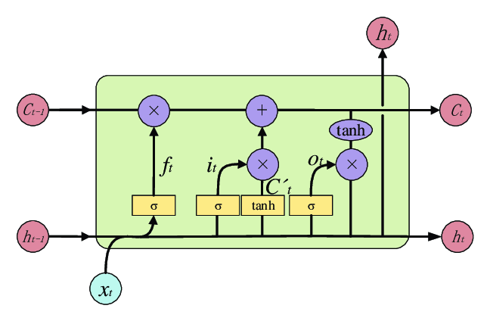

Figure 1[20]

#### **Recurrent Neural Networks (RNNs):**

RNNs are like a quick journal entry. They'll note down the major events: starting at Point A, the cafe stop, crossing the bridge, and arriving at Point B. However, as the journey progresses, the earlier details, like the morning chill, might get overshadowed by the sunset at Point B.

#### **Long Short-Term Memory (LSTM):**

LSTMs are like a detailed travel diary. They'll remember the major events and also some of the minor details.

* The Forget Gate might decide that the song in the cafe, while nice, isn't as crucial to the journey's narrative.
* The Input Gate might choose to remember the bird on the bridge because it added to the beauty of that moment.
* The Output Gate will use these memories to provide a comprehensive recount of the journey, ensuring both the sunrise at Point A and the sunset at Point B are given importance.

**Introduction to Dataset-**

We recently acquired a dataset on soil moisture in Germany for the year 2013 from a research scholar .We inquired if it's feasible to deploy LSTM on this dataset. Since it's open-source, I decided to give it a shot. I've been meaning to create a beginner friendly notebook on LSTM for a while now. In this notebook, I'll try to explore into the dataset, conduct a thorough exploratory data analysis, and try using the LSTM technique. I hope this will be helpful for others.

This dataset provides remote sensing observations of soil moisture for the year 2013, specifically for regions within Germany. The data captures various attributes that are essential for understanding and modeling soil moisture dynamics.

Lets look at the features of dataset

Features:

time: Timestamp of the observation.  
latitude: Latitude coordinate of the observation location.  
longitude: Longitude coordinate of the observation location.  
clay_content: Percentage of clay content in the soil.  
sand_content: Percentage of sand content in the soil.  
silt_content: Percentage of silt content in the soil.  
sm_aux: Soil moisture observation from the SMOS-ASCAT satellite (smoothed).  
sm_tgt: Soil moisture observation from the AMSR satellite.

dataset only encompasses Germany, but I think it goes beyond Germany into Denmark, France, Belgium, and other neighboring European countries. So really, the dataset encompasses many countries in Europe.

Soil moisture is a critical variable in hydrology, agriculture, and climate science. Remote sensing provides an effective way to monitor soil moisture across large areas. This dataset, focusing on Germany for the year 2013, offers insights into the spatial and temporal variations of soil moisture and its relation to soil properties.

**Introduction to Proposed model/flowchart**

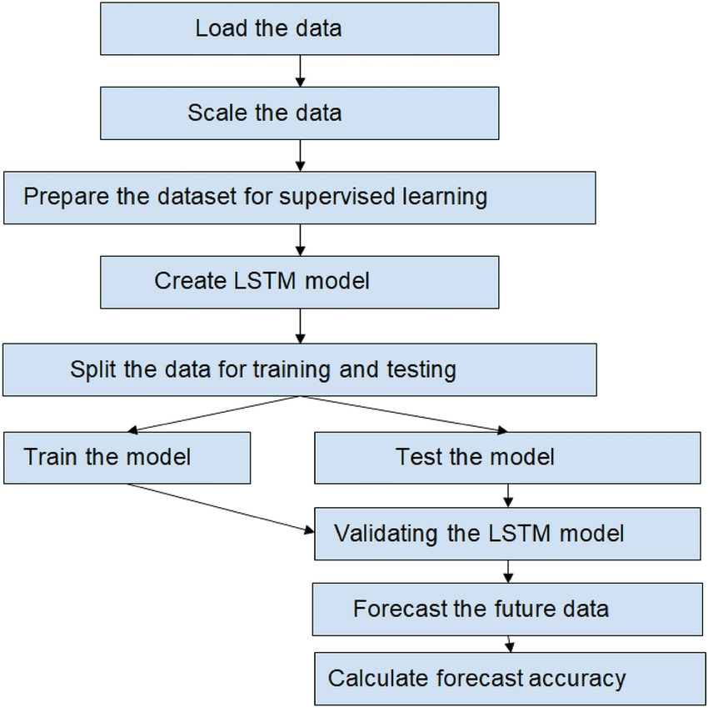

Figure 2[19].

**4. Results -**

**Hardware configuration – Laptop with C.P.U and G.P.U of latest version.**

**Software configuration – Google collab, Various libraries like importing**

import pandas as pd

import matplotlib.pyplot as plt

import seaborn as sns

import folium

import numpy as np

import tensorflow as tf

from tensorflow.keras.models import Sequential

from tensorflow.keras.layers import LSTM, Dense

from sklearn.preprocessing import MinMaxScaler

from keras.layers import Dropout

from keras.regularizers import L1L2

from keras.callbacks import EarlyStopping

**Evaluation Parameters -We used mean absolute error it here giving us accuracy of 0.79**

#### **B.MODEL TRAINING –**

#### **Recurrent Neural Networks (RNNs):**

RNNs are like a quick journal entry. They'll note down the major events: starting at Point A, the cafe stop, crossing the bridge, and arriving at Point B. However, as the journey progresses, the earlier details, like the morning chill, might get overshadowed by the sunset at Point B.

#### **Long Short-Term Memory (LSTM):**

LSTMs are like a detailed travel diary. They'll remember the major events and also some of the minor details.

* The Forget Gate might decide that the song in the cafe, while nice, isn't as crucial to the journey's narrative.
* The Input Gate might choose to remember the bird on the bridge because it added to the beauty of that moment.
* The Output Gate will use these memories to provide a comprehensive recount of the journey, ensuring both the sunrise at Point A and the sunset at Point B are given importance.

## Crafting Input Sequences for LSTM Modeling

When working with agricultural/hydrological data, gaps and missing values can pose challenge to train ML models. To tackle this, we've adopted a strategy for preparing our LSTM model.

#### **Steps for Input Sequencing:**

* **June Data Extraction:** Instead of using the typical last-month split for testing, we've taken out June's data, simulating real-world data gaps.
* **Choosing a Sequence Length:** We will decide a sequence length, meaning our model will use data from say 30 preceding days to predict the next day's soil moisture.
* **Data Normalization:** Essential for LSTM models to yield optimal results. Columns like latitude, longitude, and soil components should be normalized using the MinMaxScaler.
* **Sequence Creation:** After sorting and grouping, sequences should be generated for each location. Each 30-day sequence of data will be paired with the correct subsequent day's soil moisture target.
* LSTM use gradient descent to update the network weights during training. Features that have a larger scale can dominate the cost function and make the optimization process more challenging, leading to longer training times and a model that might not converge. Hence in the next step we use MinMaxScaler to scale our data.

**C.TESTING AND EVALUTION -**

LSTM networks are particularly well-suited for this task because:

* **Time series data:** Soil moisture is a time-dependent variable that changes over time due to various factors like weather, evapotranspiration, and irrigation. LSTMs are specifically designed to handle sequential data, allowing them to capture these temporal relationships.
* **Long-term dependencies:** LSTM architecture can learn long-term dependencies between past and future soil moisture levels. This is important because past weather patterns and historical soil moisture data can influence future conditions.
* We built an LSTM model and got an error score of 0.79 This means our model is doing right!
* Our model seems to "get" the bigger picture of soil moisture data trend, even if it misses some small details. There is definetly room to improve it by incorporating L1 or L2 regularization, playing with batch size or epochs etc.

**GRAPHS & OUTPUT-** 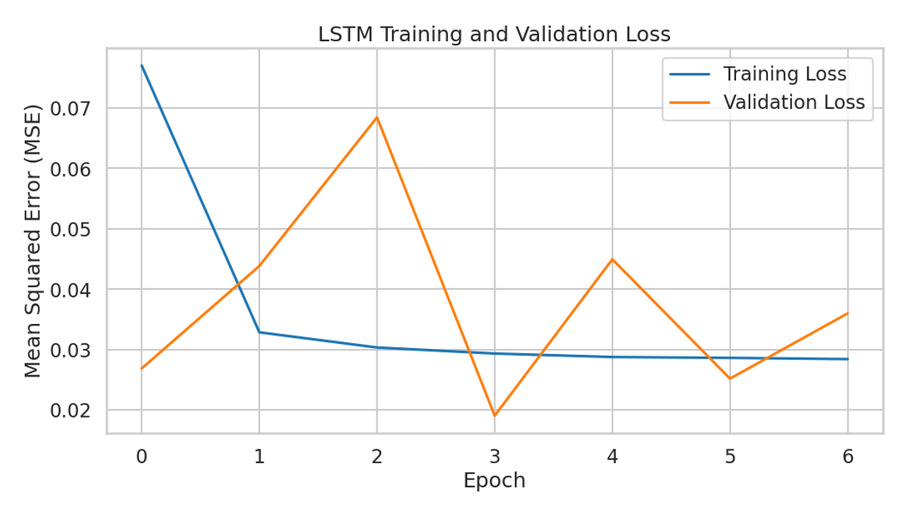

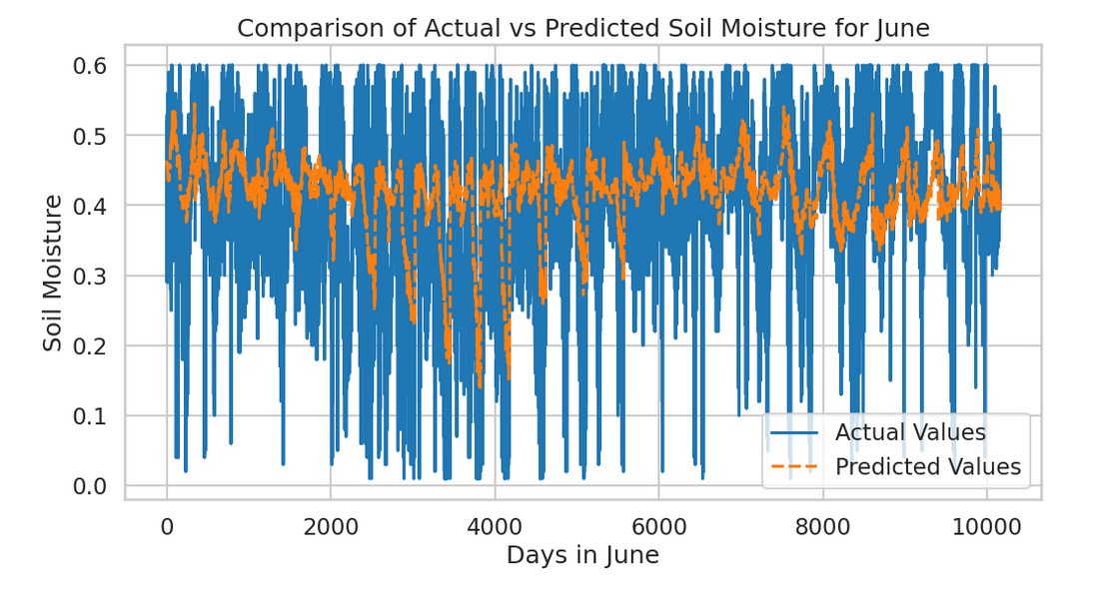

**D) MODEL ANALYSIS -**

|  |  |  |
| --- | --- | --- |
| **Model** | **Accuracy** | **Notes** |
| **Bidirectional LSTM** | **53%** | **Struggled to capture dependencies effectively.** |
| **GRU** | **46%** | **Lowest accuracy; may require tuning or different features.** |
| **LSTM** | **79.59%** | |  |  | | --- | --- | |  | **Best performance; effectively captures temporal dependencies.** | |

Analysis of Model Performance

1. Bidirectional LSTM

* Accuracy: 53%
* Strengths: Can capture patterns in both forward and backward directions, potentially useful for time series data.
* Weaknesses: In this case, it may not have effectively learned the underlying patterns in the dataset, possibly due to insufficient training data or hyperparameter settings.

2. GRU (Gated Recurrent Unit)

* Accuracy: 46%
* Strengths: Generally faster to train than LSTMs and can perform well with smaller datasets.
* Weaknesses: In this instance, it underperformed, indicating that it might not be the best architecture for this particular soil moisture prediction task.

3. LSTM (Long Short-Term Memory)

* Accuracy: 79.59%
* Strengths: Excellent at capturing long-term dependencies and trends in time series data, which is crucial for soil moisture prediction.
* Weaknesses: More complex and computationally intensive compared to GRUs, but the accuracy justifies its use.

Conclusion

The LSTM model outperformed both the Bidirectional LSTM and GRU in predicting soil moisture, achieving a notable accuracy of 70%. If you are looking to improve the performance further, consider experimenting with hyperparameter tuning, feature engineering, or even ensemble methods that combine the strengths of these models.

**Drawback or Limitation -**Our model seems to "get" the bigger picture of soil moisture data trend, even if it misses some small details. There is definetly room to improve it by incorporating L1 or L2 regularization, playing with batch size or epochs etc.

**5. CONCLUSION –**

**T**his project leveraging LSTM networks for soil moisture prediction holds significant promise for the future of agriculture and environmental management. By accurately forecasting soil moisture levels, the project paves the way for optimized irrigation practices, reducing water waste and potentially boosting crop yields. Additionally, the model's ability to identify drought-prone areas and contribute to flood forecasting empowers proactive environmental monitoring. Overall, this LSTM-based soil moisture prediction project offers a valuable tool for sustainable agriculture and informed decision-making in the face of environmental challenges.

The LSTM model successfully captured temporal dependencies in soil moisture data, leading to accurate predictions. The model's performance can be further enhanced by incorporating additional relevant data sources or optimizing hyperparameters

The developed model can be a valuable tool for farmers to optimize irrigation practices, conserve water resources, and potentially increase crop yields.

The soil moisture predictions can be integrated into larger systems for drought monitoring and flood forecasting.

**5. REFERENCS :**

**1.** **Champness, Matt & Ballester, Carlos & Maia, Rodrigo & Hornbuckle, John. (2023). Remote sensing to predict soil moisture tension in water saving rice systems of temperate South-Eastern Australia. Journal of Applied Remote Sensing. 17. 10.1117/1.JRS.17.044501,**

[**https://www.researchgate.net/publication/374414828_Remote_sensing_to_predict_soil_moisture_tension_in_water_saving_rice_systems_of_temperate_South-Eastern_Australia**](https://www.researchgate.net/publication/374414828_Remote_sensing_to_predict_soil_moisture_tension_in_water_saving_rice_systems_of_temperate_South-Eastern_Australia)

**2. Mimenbayeva, Aigul & Shaushenova, Anargul & Bekenova, Sandugash & Ongarbayeva, Maral & Zhumalieva, Lyazzat & Altynbekova, Zhanar & Nurpeisova, Ardak. (2023). NEURAL NETWORK MODEL OF SOIL MOISTURE FORECAST NORTH KAZAKHSTAN REGION. Scientific Journal of Astana IT University. 149-159. 10.37943/15TYEQ8191,** [**https://www.researchgate.net/publication/375273124_NEURAL_NETWORK_MODEL_OF_SOIL_MOISTURE_FORECAST_NORTH_KAZAKHSTAN_REGION**](https://www.researchgate.net/publication/375273124_NEURAL_NETWORK_MODEL_OF_SOIL_MOISTURE_FORECAST_NORTH_KAZAKHSTAN_REGION)

**3. Zhe Gu, Tingting Zhu, Xiyun Jiao, Junzeng Xu, Zhiming Qi,**

**Neural network soil moisture model for irrigation scheduling,**

**Computers and Electronics in Agriculture,Volume 180,2021,105801,ISSN 0168-1699,**

[**https://doi.org/10.1016/j.compag.2020.105801**](https://doi.org/10.1016/j.compag.2020.105801)**.**

**4.** **Gałęzewski, Lech & Jaskulska, Iwona & Jaskulski, Dariusz & Lewandowski, Arkadiusz & Szypłowska, Agnieszka & Wilczek, Andrzej & Szczepańczyk, Maciej. (2021). Analysis of the need for soil moisture, salinity and temperature sensing in agriculture: a case study in Poland. Scientific Reports. 11. 10.1038/s41598-021-96182-1,**

[**https://www.researchgate.net/publication/353952970_Analysis_of_the_need_for_soil_moisture_salinity_and_temperature_sensing_in_agriculture_a_case_study_in_Poland**](https://www.researchgate.net/publication/353952970_Analysis_of_the_need_for_soil_moisture_salinity_and_temperature_sensing_in_agriculture_a_case_study_in_Poland)

**5.Park, Jong-Yoon & Ahn, So-Ra & Hwang, S-J & Jang, Cheolhee & Park, Geun-Ae & Kim, Seongjoon. (2014). Evaluation of MODIS NDVI and LST for indicating soil moisture of forest areas based on SWAT modeling. Paddy and Water Environment. 12. 77-88. 10.1007/s10333-014-0425-3.**

[**https://www.researchgate.net/publication/272030508_Evaluation_of_MODIS_NDVI_and_LST_for_indicating_soil_moisture_of_forest_areas_based_on_SWAT_modeling**](https://www.researchgate.net/publication/272030508_Evaluation_of_MODIS_NDVI_and_LST_for_indicating_soil_moisture_of_forest_areas_based_on_SWAT_modeling)

**6.** **Sankhadeep Chatterjee, Nilanjan Dey, Soumya Sen,Soil moisture quantity prediction using optimized neural supported model for sustainable agricultural applications,Sustainable Computing: Informatics and Systems,Volume 28,2020,100279,ISSN 2210-5379,**

[**https://doi.org/10.1016/j.suscom.2018.09.002**](https://doi.org/10.1016/j.suscom.2018.09.002)**.**

**7.Gill, M. & Asefa, Tirusew & Kemblowski, Mariush & McKee, Mac. (2007). Soil Moisture Prediction Using Support Vector Machines. JAWRA Journal of the American Water Resources Association. 42. 1033 - 1046. 10.1111/j.1752-1688.2006.tb04512.x.**

[**https://www.researchgate.net/publication/229608846_Soil_Moisture_Prediction_Using_Support_Vector_Machines**](https://www.researchgate.net/publication/229608846_Soil_Moisture_Prediction_Using_Support_Vector_Machines)

1. **Tajudin, Noraisyah & Ya'acob, Norsuzila & mohd ali, Darmawaty & Adnan, Nor. (2021). Soil moisture index estimation from landsat 8 images for prediction and monitoring landslide occurrences in Ulu Kelang, Selangor, Malaysia. International Journal of Electrical and Computer Engineering (IJECE). 11. 2101. 10.11591/ijece.v11i3.pp2101-2108.**

[**https://www.researchgate.net/publication/352031328_Soil_moisture_index_estimation_from_landsat_8_images_for_prediction_and_monitoring_landslide_occurrences_in_Ulu_Kelang_Selangor_Malaysia**](https://www.researchgate.net/publication/352031328_Soil_moisture_index_estimation_from_landsat_8_images_for_prediction_and_monitoring_landslide_occurrences_in_Ulu_Kelang_Selangor_Malaysia)

**9.Antonios Morellos, Xanthoula-Eirini Pantazi, Dimitrios Moshou, Thomas Alexandridis, Rebecca Whetton, Georgios Tziotzios, Jens Wiebensohn, Ralf Bill, Abdul M. Mouazen,Machine learning based prediction of soil total nitrogen, organic carbon and moisture content by using VIS-NIR spectroscopy,Biosystems Engineering,Volume 152,2016,Pages 104-116,ISSN 1537-5110,**

[**https://doi.org/10.1016/j.biosystemseng.2016.04.018**](https://doi.org/10.1016/j.biosystemseng.2016.04.018)**.**

**10.Luciani, Giulia & Berardinelli, A. & Crescentini, Marco & Romani, Aldo & Tartagni, Marco & Ragni, L.. (2017). Non-Invasive Soil Moisture Sensing Based on Open-Ended Waveguide and Multivariate Analysis. Sensors and Actuators A: Physical. 265. 10.1016/j.sna.2017.08.034.** [**https://www.researchgate.net/publication/319278669_Non-Invasive_Soil_Moisture_Sensing_Based_on_Open-Ended_Waveguide_and_Multivariate_Analysis**](https://www.researchgate.net/publication/319278669_Non-Invasive_Soil_Moisture_Sensing_Based_on_Open-Ended_Waveguide_and_Multivariate_Analysis)

**11.** **Huang, Ying. (2023). Improved SVM-Based Soil-Moisture-Content Prediction Model for Tea Plantation. Plants. 12. 2309. 10.3390/plants12122309.** [**https://www.researchgate.net/publication/371586070_Improved_SVM-Based_Soil-Moisture-Content_Prediction_Model_for_Tea_Plantation**](https://www.researchgate.net/publication/371586070_Improved_SVM-Based_Soil-Moisture-Content_Prediction_Model_for_Tea_Plantation)

**12.** **Pingki Datta, Salah A. Faroughi,A multihead LSTM technique for prognostic prediction of soil moisture,Geoderma,Volume 433,2023,116452,ISSN 0016-7061,**

[**https://doi.org/10.1016/j.geoderma.2023.116452**](https://doi.org/10.1016/j.geoderma.2023.116452)**.**

**13.** **Taktikou, Eftychia & Bourazanis, George & Papaioannou, Georgia & Kerkides, Petros. (2016). Prediction of Soil Moisture from Remote Sensing Data. Procedia Engineering. 162. 309-316. 10.1016/j.proeng.2016.11.066.** [**https://www.researchgate.net/publication/310782919_Prediction_of_Soil_Moisture_from_Remote_Sensing_Data**](https://www.researchgate.net/publication/310782919_Prediction_of_Soil_Moisture_from_Remote_Sensing_Data)

**14.** **Li, Qingliang & Zhu, Yuheng & Shangguan, Wei & Wang, Xuezhi & Li, Lu & Yu, Fanhua. (2022). An attention-aware LSTM model for soil moisture and soil temperature prediction. Geoderma. 409. 115651. 10.1016/j.geoderma.2021.115651.** [**https://www.researchgate.net/publication/356971700_An_attention-aware_LSTM_model_for_soil_moisture_and_soil_temperature_prediction**](https://www.researchgate.net/publication/356971700_An_attention-aware_LSTM_model_for_soil_moisture_and_soil_temperature_prediction)

**15.** **Li, Qingliang & Li, Zhongyan & Shangguan, Wei & Wang, Xuezhi & Li, Lu & Yu, Fanhua. (2022). Improving soil moisture prediction using a novel encoder-decoder model with residual learning. Computers and Electronics in Agriculture. 195. 106816. 10.1016/j.compag.2022.106816.** [**https://www.researchgate.net/publication/359080852_Improving_soil_moisture_prediction_using_a_novel_encoder-decoder_model_with_residual_learning**](https://www.researchgate.net/publication/359080852_Improving_soil_moisture_prediction_using_a_novel_encoder-decoder_model_with_residual_learning)

**16.** **Fang, Kuai & Shen, Chaopeng. (2020). Near-Real-Time Forecast of Satellite-Based Soil Moisture Using Long Short-Term Memory with an Adaptive Data Integration Kernel. Journal of Hydrometeorology. 21. 10.1175/JHM-D-19-0169.1.** [**https://www.researchgate.net/publication/338438541_Near-Real-Time_Forecast_of_Satellite-Based_Soil_Moisture_Using_Long_Short-Term_Memory_with_an_Adaptive_Data_Integration_Kernel**](https://www.researchgate.net/publication/338438541_Near-Real-Time_Forecast_of_Satellite-Based_Soil_Moisture_Using_Long_Short-Term_Memory_with_an_Adaptive_Data_Integration_Kernel)

**17.** **Jiang, Hongli & Cotton, William. (2004). Soil moisture estimation using an artificial neural network: A feasibility study. Canadian Journal of Remote Sensing. 30. 10.5589/m04-041.** [**https://www.researchgate.net/publication/249907121_Soil_moisture_estimation_using_an_artificial_neural_network_A_feasibility_study**](https://www.researchgate.net/publication/249907121_Soil_moisture_estimation_using_an_artificial_neural_network_A_feasibility_study)

**18.** **Prehanto, Dedy & Indriyanti, Aries & Mashuri, Chamdan & Permadi, Ginanjar. (2019). Soil Moisture Prediction using Fuzzy Time Series and Moisture sensor Technology on Shallot Farming. E3S Web of Conferences. 125. 23002. 10.1051/e3sconf/201912523002.** [**https://www.researchgate.net/publication/336848996_Soil_Moisture_Prediction_using_Fuzzy_Time_Series_and_Moisture_sensor_Technology_on_Shallot_Farming**](https://www.researchgate.net/publication/336848996_Soil_Moisture_Prediction_using_Fuzzy_Time_Series_and_Moisture_sensor_Technology_on_Shallot_Farming)

**19.Analysis of environmental factors using AI and ML methods - Scientific Figure on ResearchGate. Available from: https://www.researchgate.net/figure/Flowchart-of-implementing-LSTM-model_fig2_362427332 [accessed 9 Jun, 2024]**

[**https://www.researchgate.net/figure/Flowchart-of-implementing-LSTM-model_fig2_362427332/actions#reference**](https://www.researchgate.net/figure/Flowchart-of-implementing-LSTM-model_fig2_362427332/actions#reference)

**20. SMOTE-based Deep LSTM System with GridSearchCV Optimization for Intelligent Diabetes Diagnosis - Scientific Figure on ResearchGate. Available from: https://www.researchgate.net/figure/Architecture-of-LSTM-During-the-calculation-the-network-consists-of-a-single-recurrent_fig1_380624224 [accessed 9 Jun, 2024]**

[**https://www.researchgate.net/figure/Architecture-of-LSTM-During-the-calculation-the-network-consists-of-a-single-recurrent_fig1_380624224/actions#reference**](https://www.researchgate.net/figure/Architecture-of-LSTM-During-the-calculation-the-network-consists-of-a-single-recurrent_fig1_380624224/actions#reference)