Section 1 – Introduction
Section 2 – Related work
Section 3 – Dataset
3.1 Data Source
This research uses the Pediatric Intensive Care (PIC) database (version 1.1.0), a publicly available dataset from a tertiary care, de-identified dataset containing electronic health records (EHR) of ill pediatric patients admitted to intensive care unit (ICU) at the Children’s Hospital of Zhejiang University School of Medicine in China. The dataset is accessible to researchers via PhysioNet following credentialed access requirements.
The dataset was constructed from routine clinical care data between 2010 to 2018, it includes detailed information on patient demographics, laboratory measurements, vital signs, medications, microbiology results, fluid balance, and clinical symptoms.
All timestamps in the dataset are shifted to preserve patient privacy; however, relative temporal relationships between events are maintained, enabling valid time-series analysis.
It contains 12881 patients and 13941 intensive care unit (ICU) stays and is one of the largest available PIC datasets. It’s structure is like widely used benchmarked MIMIC database, but tailored to pediatric population.
Metric | Value
Dataset | Pediatric Intensive Care (PIC)
Version | V1.1.0
Total Patients | 12,881
Total ICU stays | 13,941
Time Period | 2010-2018
Population | Pediatric (0-18)
Data Type | EHR (labs, vitals, meds, symptoms)
Number of tables | 11 (clinical + 3 reference table
Source | Children’s Hospital, Zhejiang University
Access | PhysioNet

3.2 Data Tables and Modalities
To construct the dataset required for early onset sepsis prediction a comprehensive representation of each ICU stay data was extracted from multiple relational tables within the PIC database.

Primary clinical data tables:
- Demographics and admissions: PATIENTS, ADMISSIONS, ICUSTAYS
- Laboratory and physiological measurements: LABEVENTS, CHARTEVENTS
- Treatment and interventions: PRESCRIPTIONS, INPUTEVENTS, OUTPUTEVENTS
- Infection-related data: MICROBIOLOGYEVENTS
- Clinical context: EMR_SYMPTOMS, SURGERY_INFO
Reference tables (used for variable mapping only):
- D_ITEMS
- D_LABITEMS
- D_ICD_DIAGNOSES
All tables were linked using patient and ICU stay identifiers to construct a unified, dataset for each ICU admission.
3.3 Cohort Definition
The initial dataset consisted of 13,914 ICU stays and 12,881 unique pediatric patients. Cohurt selection was performed through a filtering process to ensure clinical relevance.
The inclusion criteria:
- Age 0 to 18 years at the time of ICU admission
- First ICU stay per patient
- Minimum length of 6 hours at ICU stay
Step | Count | % of Total
Initial ICU stays | 13941 | 100%
Excluded: Age out of range | 42 | 0.3%
Excluded: Non-first ICU stay | 1060 | 7.6%
Excluded: LOS < 6 hours | 392 | 2.8%
Final Cohort | 12,447 | 89.3%
The majority of exclusions were due to repeat ICU admissions (7.6%), ensuring independence of observations.
Section 4 – Data Preprocessing
4.1 Overview
Data preprocessing was implemented as a 6-stage modular pipeline. Each state produces output and relevant logs and enables full reproducibility and systematic validation of each stage.
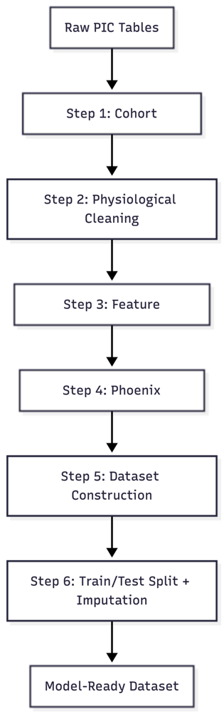

4.2 Cohort Filtering
Filtering was implemented as the first stage of the pipeline to define population
Started from 13,941 ICU stays, exclusions resulted in:
- Age outside 0-18 years (n = 42)
- Non first ICU admissions (n = 1,060)
- ICU length of stay < 6 hours (n=392)
This resulted in 12,447 final cohort stays.
4.3 Physiological Data Cleaning and Validation
The objective was to filter out implausible or unrealistic values arising from measurement or data entry errors, without deleting extremely sick but real patient readings and preserving clinically valid extreme observations. Caps were set conservatively; for each variable upper and lower bounds were defined with additional buffer based on physiological feasibility and extreme literature reported clinically documented readings.
Values outside the bound were treated as missing during this stage rather than corrected, to avoid distortion of further statistical summaries.
Full variable constraints can be found in Appendix A.
4.3.1 Iterative corrections
During validation, major systematic data issues were identified and corrected:
- Hemoglobin unit mismatch:
Values stored in g/L were wrongly evaluated against g/dL thresholds, leading to invalidation (87.9% of values). Corrected by applying conversion factor prior to validation
- Anion gap lower bound:
The lower bound was revised from 0 to -5 mmol/L to account for errors in measurement and calculation inconsistencies.
- SpO₂ upper bound:
Cap was revised from 100.0 to 100.5% to account analyzer rounding artifacts.
Following these corrections, data quality improved with negligible to none impact on valid observation
4.4 Feature extraction (First 24 hours)
Feature extraction was performed over a fixed 24-hour window following ICU admission, ensuring that all predictors precede the pr

